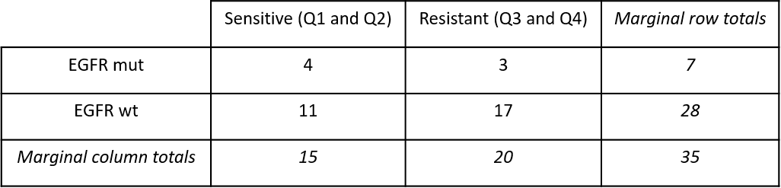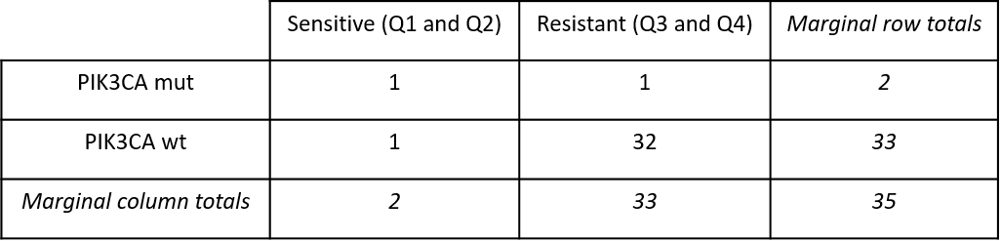

b)

a)

**Supplementary Table 2**