**Supplementary Figure S1. Generation and validation of CT26 G12C CRISPR model *in vitro* and *in vivo***

(A) Workflow for generation of CT26G12C model by CRISPR/Cas9 technology. (B) Genotyping of CT26G12C clones PD511 and P5E6 compared to parental cell line (negative control) by ddPCR. Fluorescence amplitude plots for droplets in the FAM channel (G12C mutant) and HEK channel (reference). Each dot represents a single droplet or “event.” The x-axis represents event number, and the y-axis represents fluorescence amplitude. Two distinct populations are seen in each channel, one with high fluorescence intensity (positive droplets) and one with low intensity (negative droplets). HDR fractional abundance of the edited allele was determined by the ratio of FAM/HEK droplets. (C) G12D parental and CT26G12C clones were assessed for sensitivity to AZD4625 in a 5-day proliferation assay. Mean GI50 (μM) from a representative experiment is shown. (D) Biomarker modulation in lysates from G12D parental and CT26G12C clones following treatment with 1 μM AZD4625. (E) Tumour volume of subcutaneous CT26G12C P5E6 tumours in mice treated orally with vehicle or the indicated dose of AZD4625. Data from individual animals is shown.

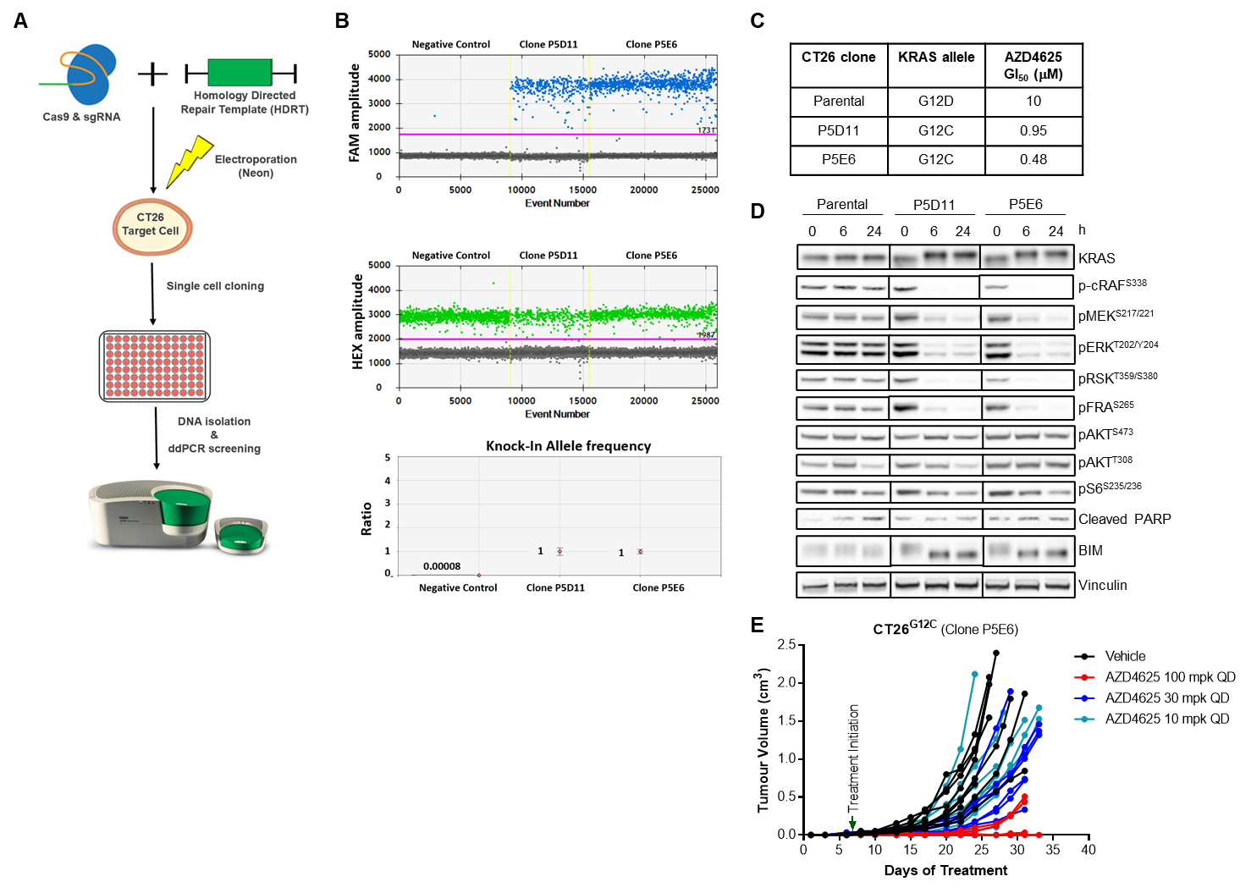

**Supplementary Figure S2. Dose-dependent binding and inhibition of KRASG12C by AZD4625**

(A) Representative mass spectrometry plots showing the KRASG12C or KRASWT peptides detected in NCI-H358 cell lysates. Peptides from NCI-H358 cell lysates treated with compound for 16 hours shown in red. Peptides from internal standard lysate shown in blue. With increasing concentration of AZD4625 the red peak diminishes in the KRASG12C panel due to binding of the compound, while in the KRASWT panel the red peak remains constant indicating the peptide is not bound by AZD4625. (B) Western blot analysis of lysates from NCI-H358 cells treated with AZD4625 for 16 hours. Active KRAS was determined by assessing the levels of KRAS bound to the RBD of CRAF.

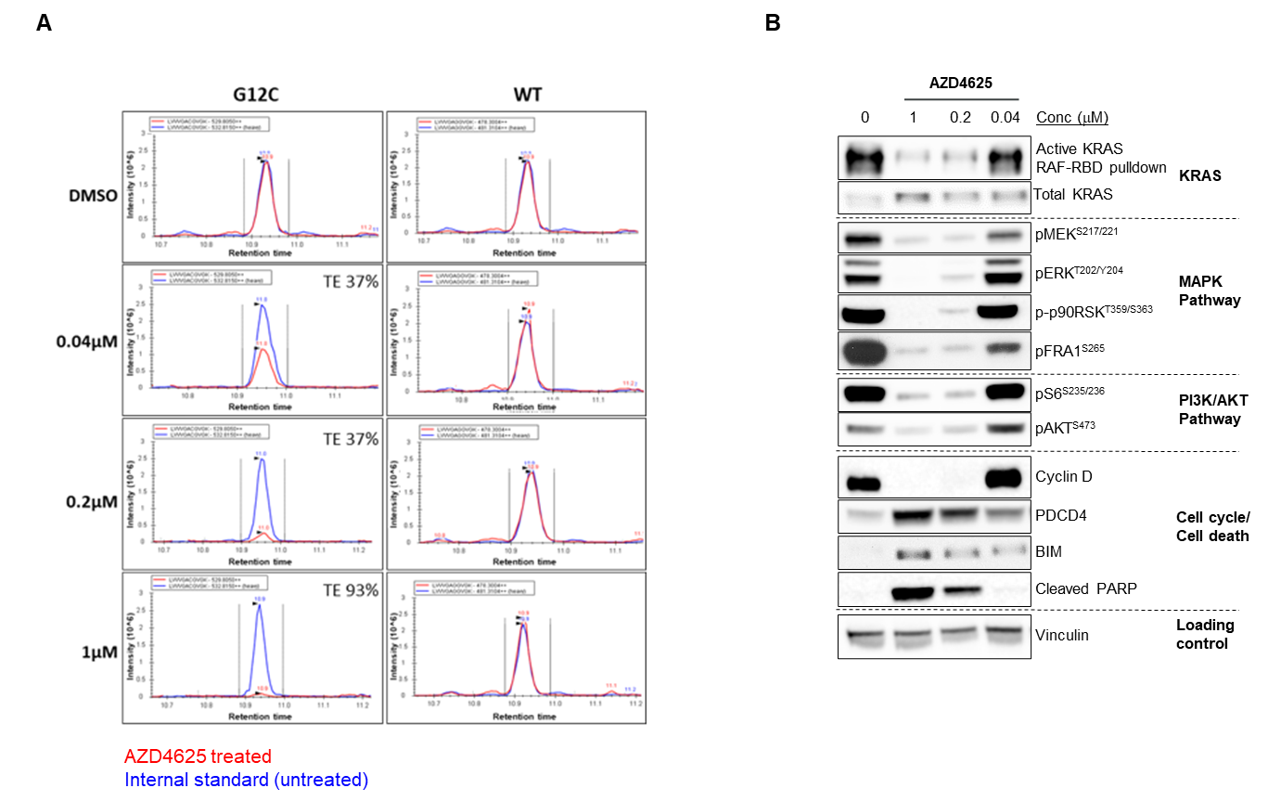

**Supplementary Figure S3. Target engagement and RAS pathway modulation by AZD4625 across *KRAS*G12C models**

AZD4625 target engagement measured by mass spectrometry and biomarker modulation by western blot in cell lysates from HOP62, NCI-H358, HCC44, NCI-H23 or NCI-H1792 *KRAS*G12C mutant cell lines treated with DMSO, 0.1 or 1 μM of AZD4625 for 6 or 48 hours. Target engagement and biomarker modulation was measured from the same samples.

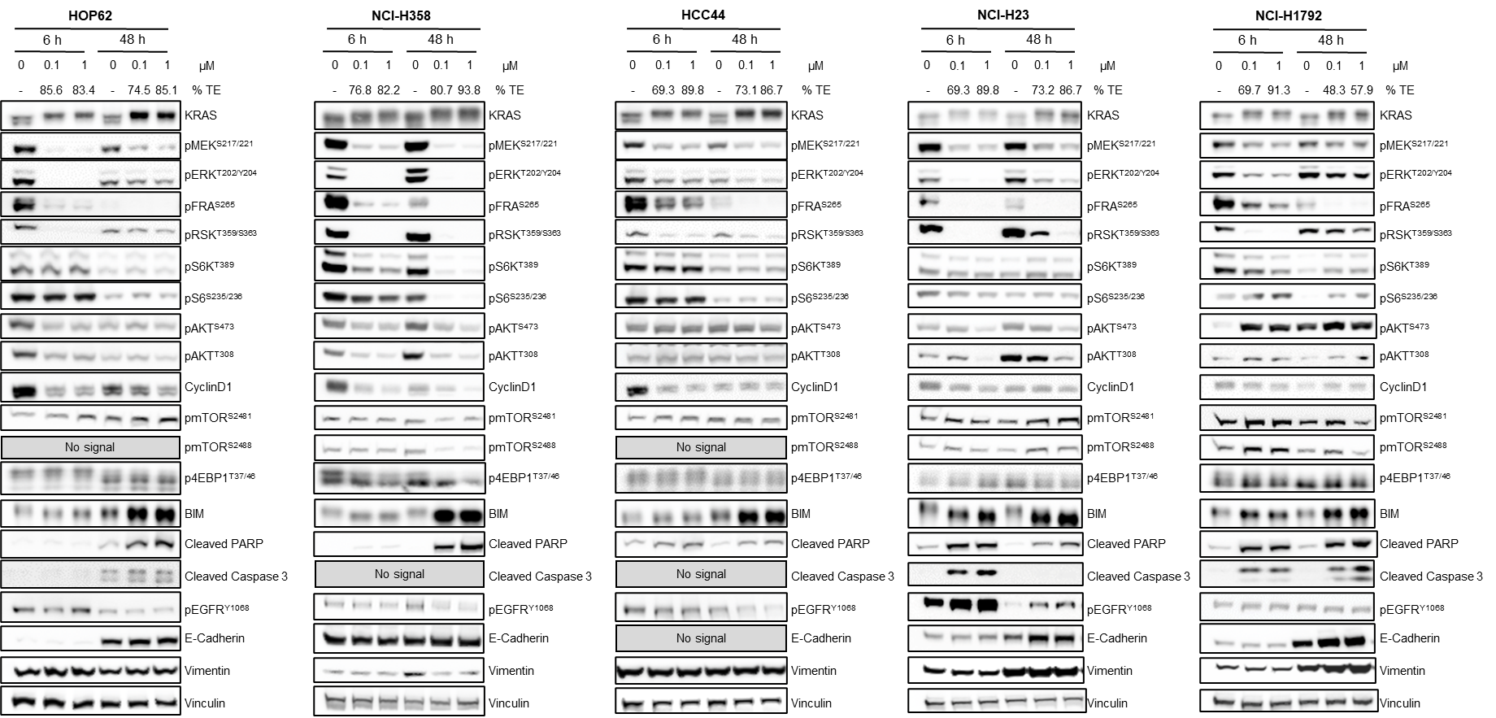

**Supplementary Figure S4. *In vitro* anti-proliferative activity of AZD4625, sotorasib (AMG510) and adagrasib (MRTX849)**

Anti-proliferative activity of AZD4625, AMG510 and MRTX849 in a panel of *KRAS*G12C, *KRAS*mt (nonG12C) and *KRAS*WT cells. Data represents the geometric mean of GI50 (A) and maximum effect (Emax) at 10 μM of compound (B). Individual cell data and box plot of median, min and max response are shown. Emax above zero indicates a cytostatic response or growth inhibition and Emax below zero indicates cytotoxic response or induction of cell death.

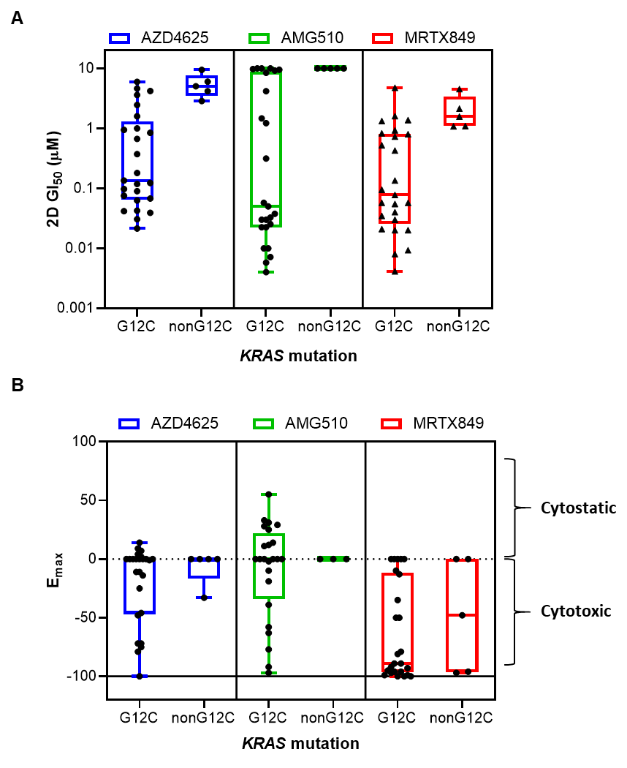

**Supplementary Figure S5. PK and PD properties of AZD4625 in preclinical models**

(A and B) Free concentrations of AZD4625 in plasma of tumour bearing mice treated orally with a single treatment of the indicated dose of AZD4625. Dotted lines indicate the biochemical and cellular IC50 of AZD4625. (C and D) Western analysis of protein lysates from NCI-H358 or NCI-H2122 xenografts following treatment of tumour bearing mice with a single 100 mg/kg dose of AZD4625 for 3, 6 24 or 48 hours. Proteins were normalised to vinculin levels and relative to time-matched control. Data represents expression in tumours from individual animals, mean and SEM.

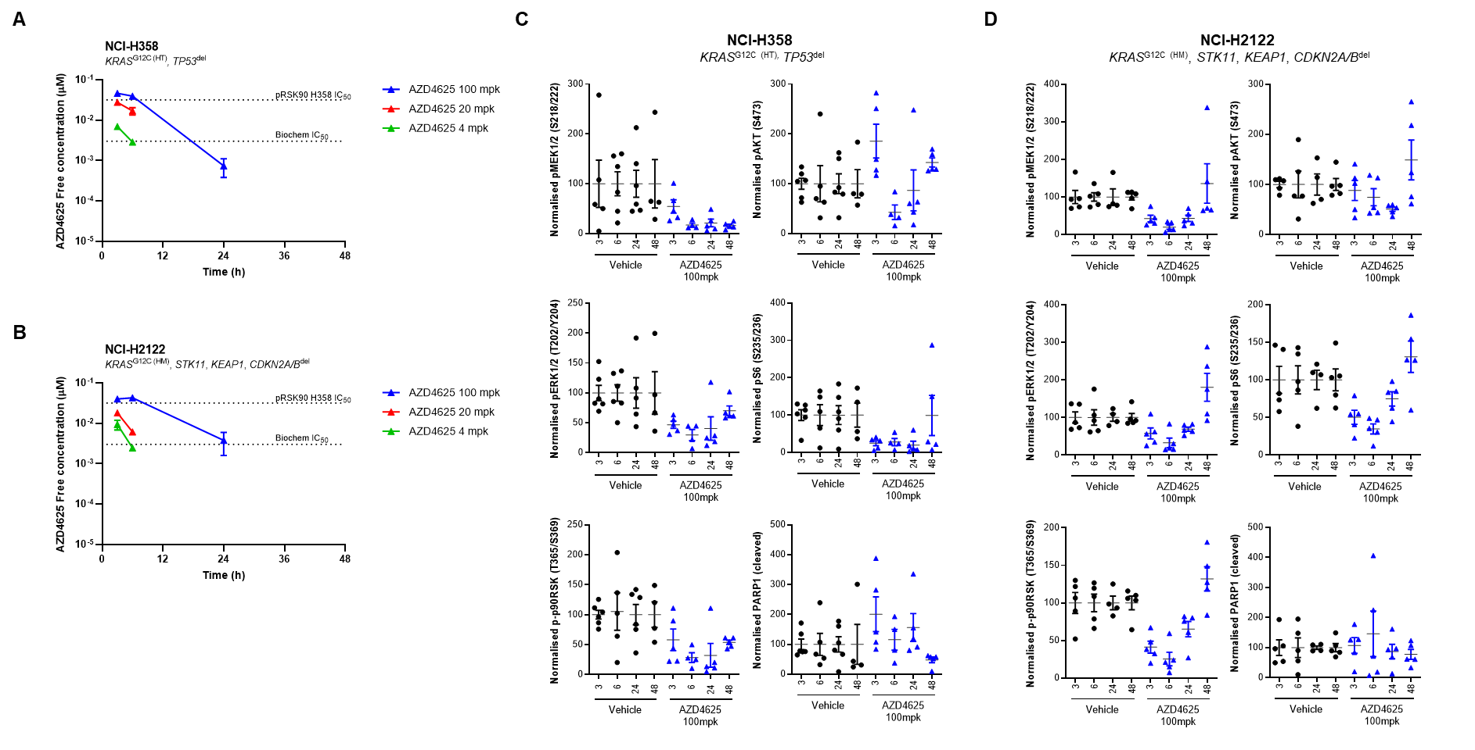

**Supplementary Figure S6. Impact of continuous chronic dosing of AZD4625 on bodyweight of tumour bearing mice and tumour MAPK pathway biomarkers**

(A and B) Bodyweights of mice bearing NCI-H358 or NCI-H2122 tumours with continuous daily dosing of AZD4625. (C) MAPK pathway inhibition in NCI-H358 tumour samples taken 6 hours post-last dose at the end of the efficacy study (24 daily doses). (D) MAPK pathway inhibition in NCI-H2122 tumour samples taken 3 hours post-last dose at the end of efficacy study (21 daily doses). Expression of *DUSP6* and *FOSL1* were normalised to *POLR2A* and relative to the vehicle control.

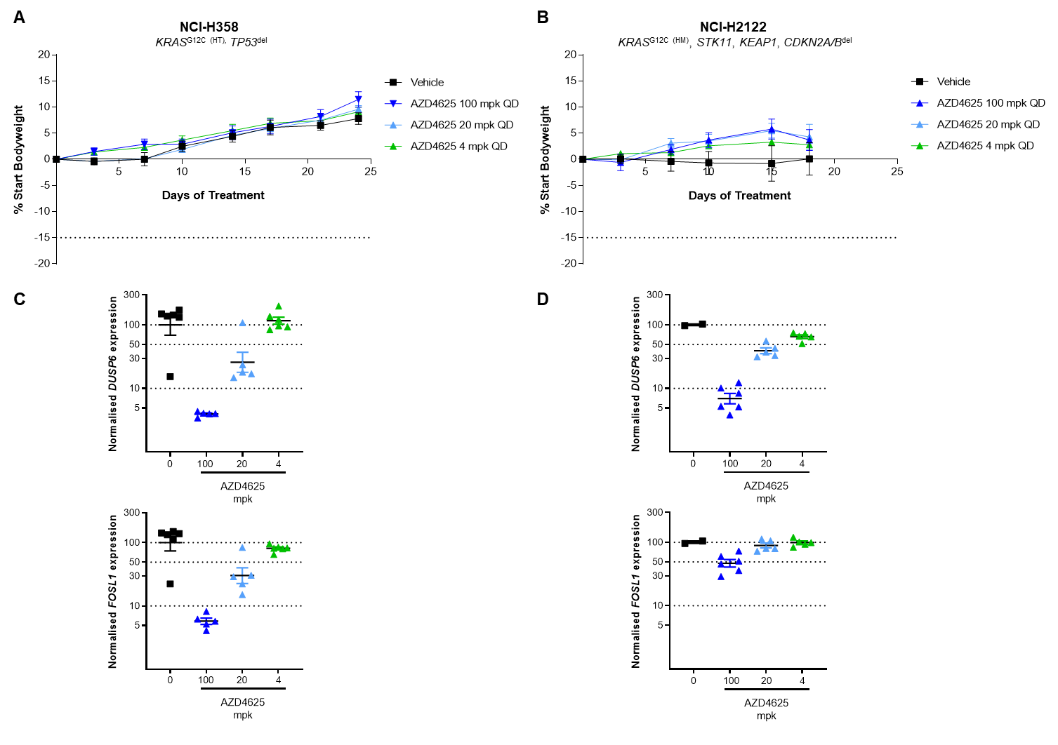

**Supplementary Figure S7. Binding of AZD4625 to KRASG12C is increased in combination with RTK inhibitors**

Binding of AZD4625 to KRASG12C in NCI-H358 cell lysates following treatment with 0.1 μM AZD4625 alone or in combination with 0.04 μM afatinib, 2.5 μM SHP099 or RMC4550 was measured by mass spectrometry. A decrease in the amounts of unbound G12C peptide demonstrates binding of drug. Statistical comparisons are made to time-matched AZD4625 monotherapy. *** indicates p value ≤ 0.001.



**Supplementary Figure S8. Impact of AZD4625, afatinib and SHP2 inhibitor monotherapy and combination treatments on mice bodyweights**

Bodyweight changes of male nude mice bearing NCI-H358 or LU99 subcutaneous tumours with the indicated treatments. Data shown is mean % change relative to starting bodyweight, error bars represent SEM. (A and B) Mice were dosed daily with AZD4625 and/or afatinib. (C and D) Mice were dosed daily with AZD4625 and/or SHP099. (C) AZD4625 in combination with 100 mg/kg daily dose of SHP099 caused bodyweight losses and dosing was stopped on day 14. (E and F) Mice were dosed daily with AZD4625 and/or with SHP2 inhibitors daily or scheduled twice weekly as indicated. SHP099 at 100 mg/kg continuous schedule in the monotherapy and combination groups had some impact on bodyweight so dosing was stopped if individual animal bodyweight dropped below 15% and dosing re-introduced when bodyweight recovered to -8%. Dosing of SHP099 was also stopped on days 16 + 17 for all animals in the 100 mg/kg continually dosing groups.

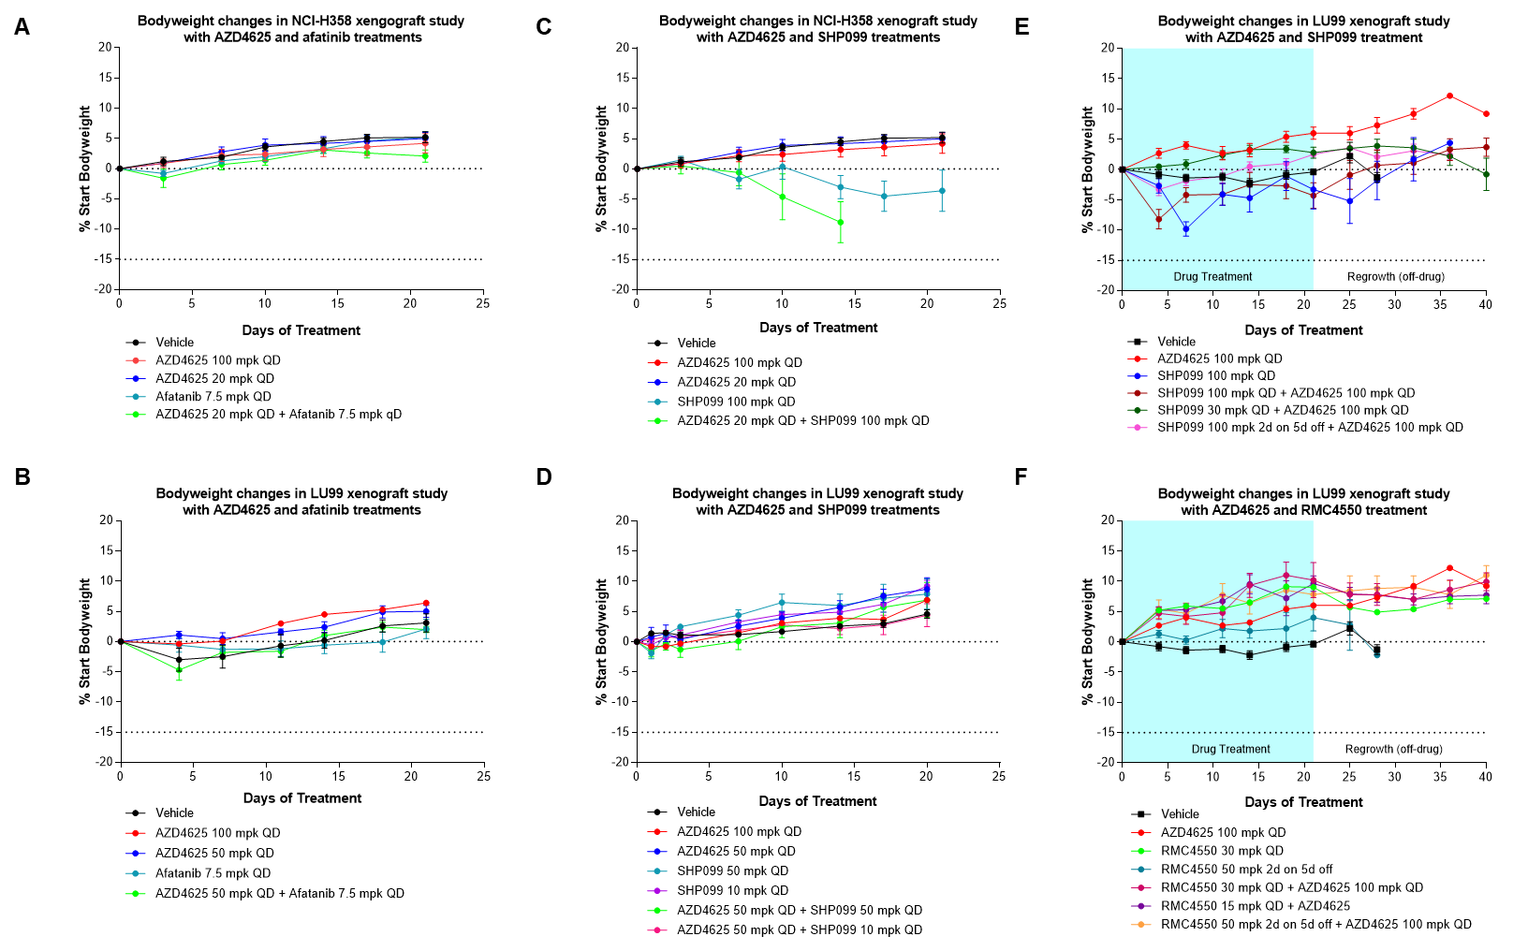

**Supplementary Figure S9. AZD4625 combinations with RTK pathway inhibitors in colorectal PDX models *in vivo***

Relative tumour volume and bodyweight changes in female nude mice bearing subcutaneous CTG-1489 or CTG-0387 human colorectal tumours following treatment with AZD4625 in monotherapy or in combination with afatinib, SHP099 or cetuximab as indicated. Data shown is mean and SEM.

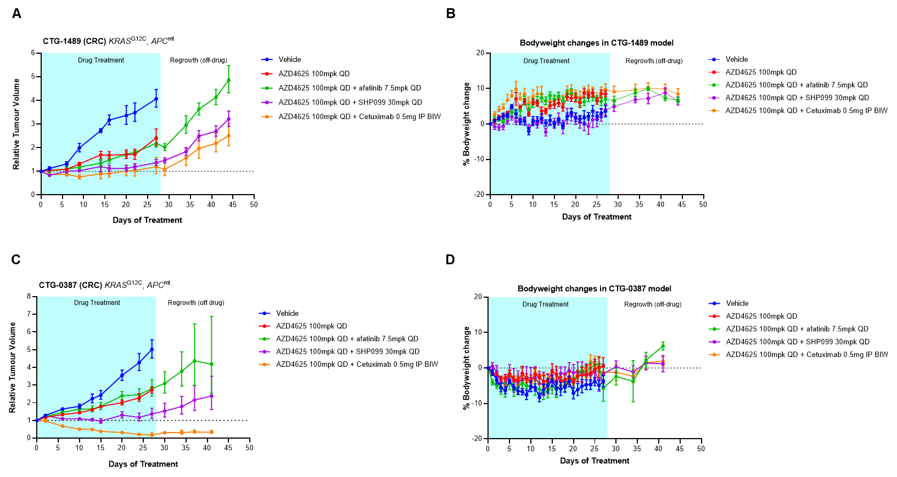

**Supplementary Figure S10. Impact of AZD4625, anti-mPD-1 and anti-mPD-L1 monotherapy and combination treatments on tumour immune microenvironment genes in the CT26G12C syngeneic tumour**

CT26G12C tumour bearing mice were dosed daily for 3 or 7 days with 100 mg/kg AZD4625 in monotherapy or combination with anti-mPD-1 or anti-mPD-L1 dosed on day 1 and 4. Samples were collected 6 hours post-dose of AZD4625. Expression of genes associated with (A) immune cell types and (B) immune cell function and (C) modulation of the tumour immune microenvironment. The data shown are the mean –ddct values for treatment groups normalised to house-keeping genes (*Ipo8* and *Polr2a*) and time matched vehicle controls. Asterisks indicate significant changes compared to vehicle control with a p-value of <0.05 (*), <0.01 (**), <0.001 (***).

