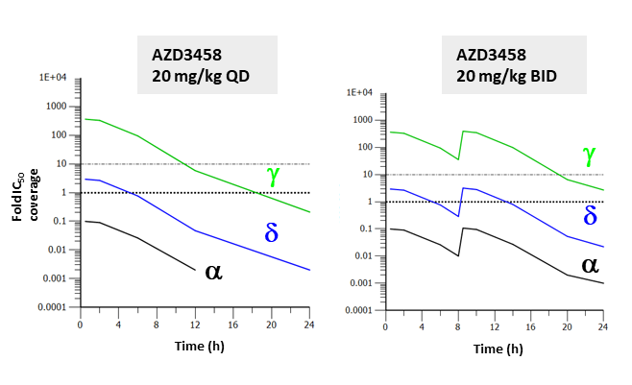

**Supplementary Figure 1. Pharmacokinetic (PK) properties of AZD3458 in mouse.**

In vivo PK and cell IC50 coverage over PI3K isoforms given as number of hours with plasma concentration above PI3K, corrected for plasma protein binding at 20mg/kg daily (QD) and twice daily (BID). 1 fold cover and 10 fold cover over cell cellular IC50 are indicated by the dotted and dashed lines respectively.  - PI3K,  - PI3K,  - PI3K



A

**CD11b**

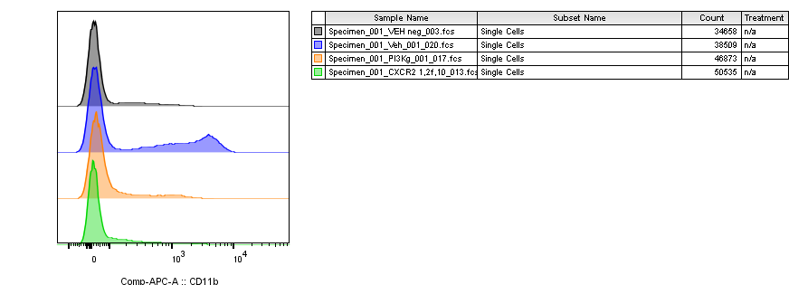

**PI3Ki**

**Vehicle**

**neg**

**CXCR2i**

C

B

Neutrophil

AZD3458 (PI3Kgi)

AZD5069 (CXCR2i)

2h

0h

MIP2

0.1ng/ul

CD11b

Ly6G

**Supplementary Figure 2. In vivo pharmacodynamic properties of AZD3458 in mouse neutrophils.**

**A)** Mouse blood neutrophil activation after 2 hours in vivo inhibition of PI3Kg (AZD3458-20mg/kg), CXCR2 (AZD5069-100mg/kg), vehicle and vehicle non-stimulated (neg). **B)** Flow cytometry histogram showing shift in CD11b positive neutrophils and **C)** quantification of CD11b positive neutrophils by flow cytometry (MFI) **D)** Data representative form n≥2 experiments and n=3 mice/group. One-way anova statistical test * p≤0.05, ** p≤0.01, *** p≤0.001, **** p≤0.0001.



HIF-1α

pS6 (S235/236)

Vinculin (loading)



pAKT (S473)



HKII

pSTAT3 (Y705)



pmTOR (S2448)

0 1 2 4 6 8 0 1 2 4 6 8 0 1 2 4 6 8 0 1 2 4 6 8

DMSO AZD3458 AZD2014 2-DG

LPS (hrs)



pNFkB p65 (S536)

pNDRG1 (T346)

pSTAT3 (S727)



pC/EBPβ (T235)

A



B

**Supp Fig 3. PI3K-/mTOR pathway regulates expression of IL-10/IL-12 via LPS-induced glycolytic burst.**

**A)** Human macrophage cultures were pre-treated for 30 minutes with AZD3458 at the indicated concentrations prior to 100 ng/mL LPS for 30 minutes and analysis by SDS-PAGE / pAKT densitometry (n=3). **B)** Macrophage cultures were treated with AZD3458 (0.3 μM), AZD2014 (0.3 μM) and 2-Deoxyglucose (2-DG; 1 mM) and analysed for ECAR in real time before and after LPS treatment (n=3 donors from 1 experiment is shown; data representative of 3 independent experiments).

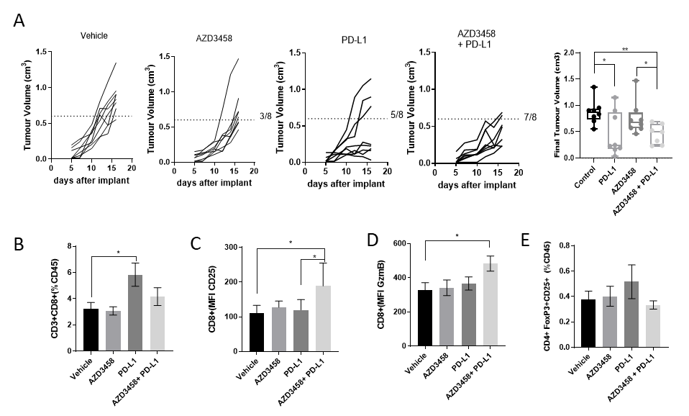

**Supplementary Figure 4. AZD3458 improves checkpoint activity in CT-26 tumor models.**

**A)** Anti-tumor activity of AZD3458 (20mg/kg twice daily) in combination with PD-L1 blocking antibody (10mg/kg twice weekly) in CT-26 model, spider plots and final tumor volumes (error ±SEM). Flow cytometry analysis at day 16 after implant **B)** CD8 T cell frequency, **C)** CD25 and **D**) GzmB mean protein expression in CT-26 tumors. Results are representative of two separate experiments with n≥6 mice per group. Error bars ±SEM. *P < 0.05, ***P < 0.005, ****P < 0.001.

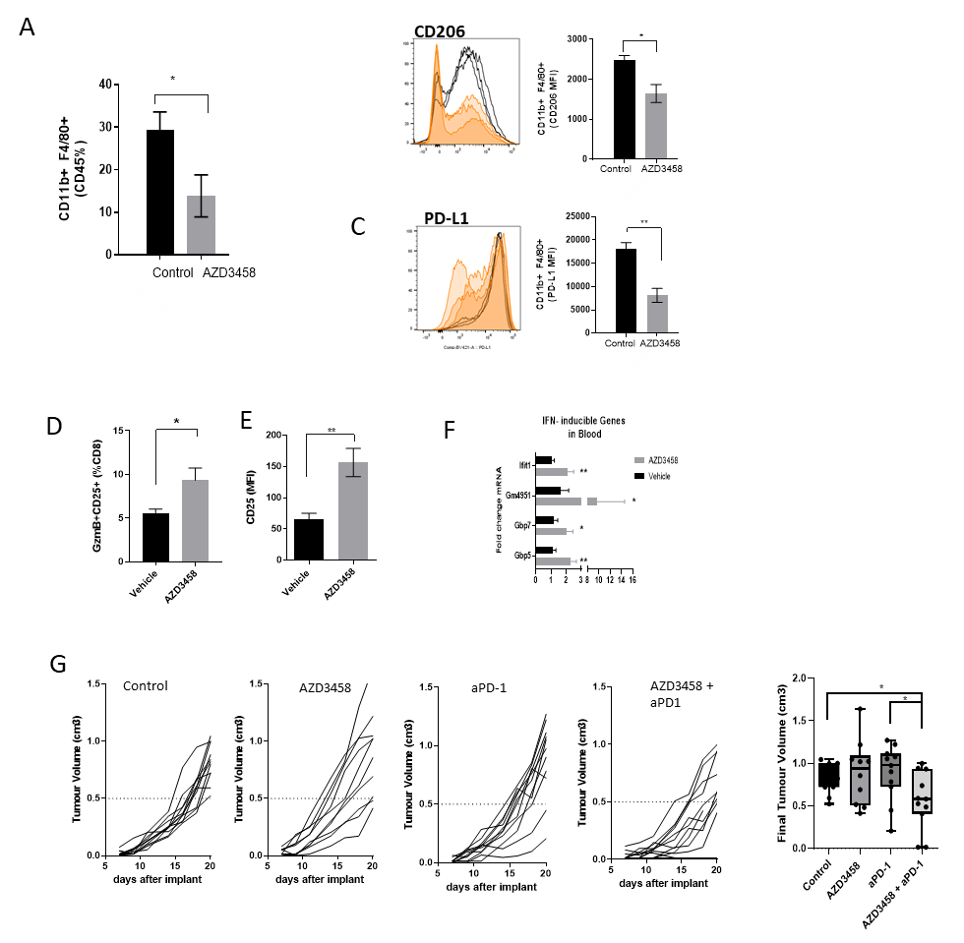

**Supplementary Figure 5. AZD3458 improves checkpoint activity in 4T1 tumor models.**

Flow cytometry analysis of tumor macrophages. **A**) CD11b+F480+ cell frequency, **B**) CD206 and C) PD-L1 protein mean expression in CD11b+F480+ cells . **D**) Frequency of tumor CD8+ CD25+ GzmB+ T cells and **E**) mean CD25 protein expression. **F**) Fold change mRNA of interferon-inducible genes in 4T1 tumors **G**) Anti-tumor activity of AZD3458 (20mg/kg twice daily) in combination with PD-1 blocking antibody (10mg/kg twice weekly) in 4T1 model, spider plots and final tumor volumes. Results are representative of two separate experiments with n≥6 mice per group. Error bars ±SEM. *P < 0.05, ***P < 0.005, ****P < 0.001.

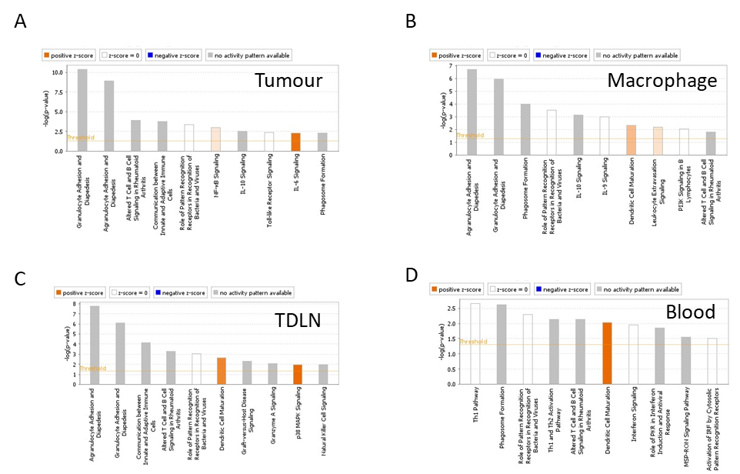

**Supplementary Figure 6. Top canonical IPA pathways across tissues in AZD3458+PD-1 combination group.**

Canonical pathway analysis of differentially expressed genes using IPA. Top 10 Canonical pathways as per p-value >0.5 and per z-score to measure predicted direction of the pathway activity . Most significant in **A**) tumor, **B**) tumor macrophages, **C**) tumor draining lymphnodes and **D**) blood comaparing AZD3458+ aPD1 treatment and vehicle control group.

**Supplementary Figure 7. Graphical abstract**