Antibody Co-Administration Can Improve Systemic and Local Distribution of Antibody Drug Conjugates to Increase In Vivo Efficacy

Jose F. Ponte¹, Leanne Lanieri¹, Eshita Khera², Rassol Laleau¹, Olga Ab¹, Chris Espelin¹, Neeraj Kohli¹, Bahar Matin¹, Yulius Setiady¹, Michael L. Miller¹, Thomas Keating¹, Ravi Chari¹, Jan Pinkas¹, Richard Gregory¹, and Greg M. Thurber^{2,3}

1 – ImmunoGen, Waltham, MA, 02451

2 - Department of Chemical Engineering, University of Michigan, Ann Arbor, MI 48109

3 - Department of Biomedical Engineering, University of Michigan, Ann Arbor, MI 48109

Supplementary Information
Supplementary Figures – Fig S1-S6
Supplementary Methods – Deparaffinization and antigen retrieval
Krogh Cylinder Tumor Model
- Differential Equations
- Model Parameters
Supplementary Discussion
- Selection of ADC cellular internalization rate
Supplementary Figures – Fig S8-S9
- Tumor growth curves statistical analysis and mouse body weight
Supplementary References
Supplementary Figures
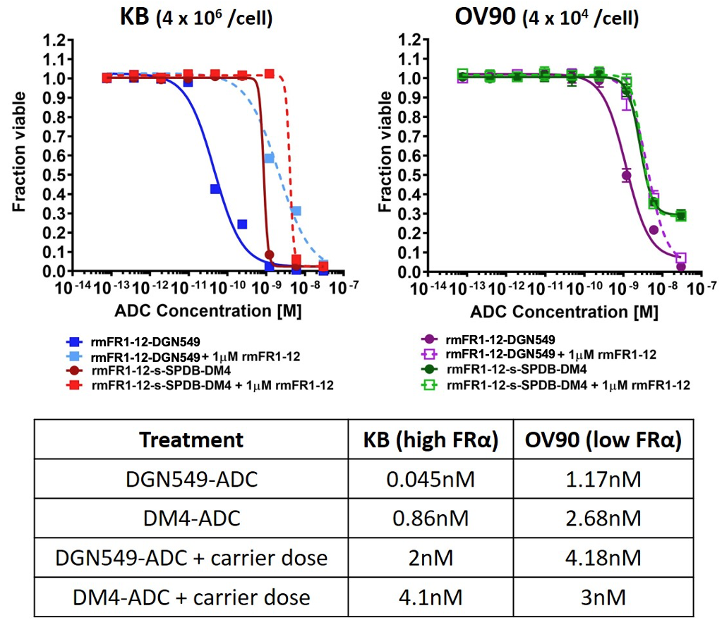
Fig. S1. Impact of receptor expression and payload potency on toxicity of cross-reactive FRα antibody-drug conjugate. In vitro viability/toxicity assays of the cross-reactive ADC with the ‘high’ (DGN549) and ‘low’ (DM4) potency payloads in ‘high’ (KB) and ‘low’ (OV90) FRα expression systems. DGN549-ADC shows higher potency in both systems compared to DM4-ADC. Additionally, both payloads showed higher toxicity in the higher expression system (KB), indicating greater overall cellular ADC uptake due to lack of transport limitations in an in vitro system. The addition of an antibody carrier dose to both DGN549-ADC and DM4-ADC antagonizes ADC uptake due to competition from the excess antibody for surface receptors, resulting in 10-20-fold increase in IC50.
For DGN549, in vitro calculations indicate that the fraction of bound ADCs required for 50% cell death is 3-fold higher in KB cells than OV90 cells, suggesting that OV90 may be more sensitive (assuming the internalization rate is the same). This is relevant for the simulations in Fig 2B and 2D, where the absolute ADC concentration in OV90 appears to be lower than KB, despite an overall better efficacy in OV90.

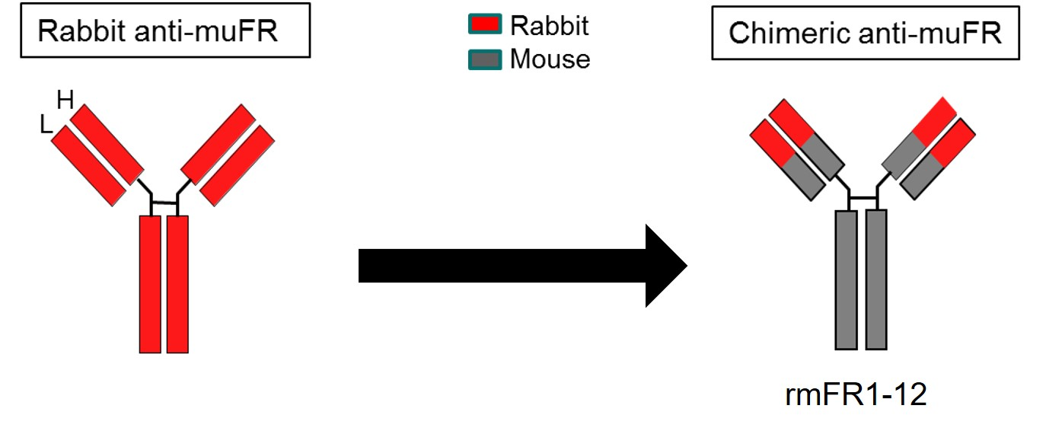

Fig. S2. Generation of chimera cross-reactive antibody rmFR1-12 that recognizes both human and murine FRα.

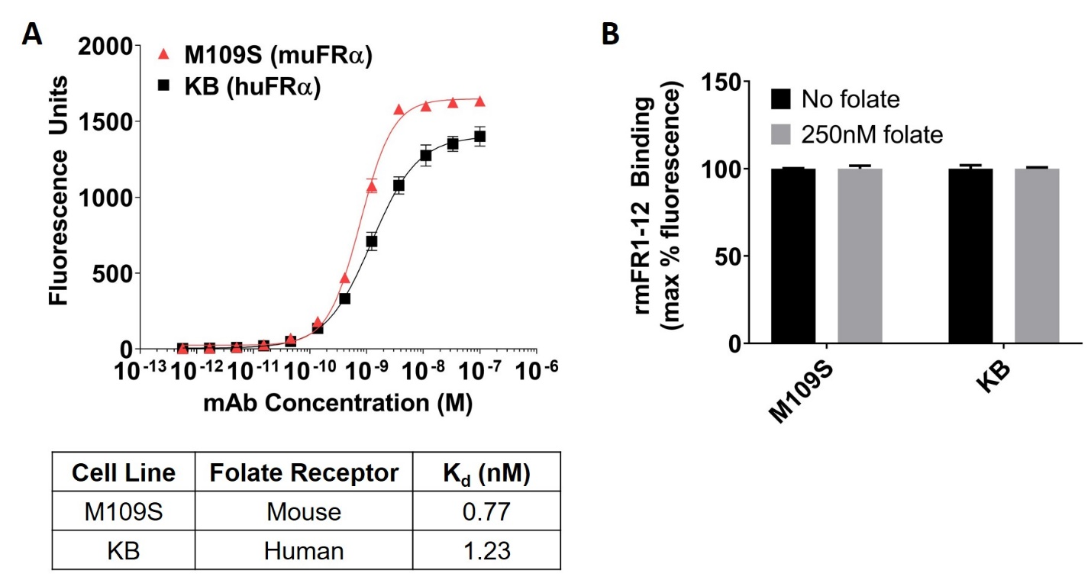

Fig. S3. Binding of cross-reactive antibody rmFR1-12 to human and murine FRα.
(A) In vitro assays with the cross-reactive antibody showed comparable binding affinity with both mouse FRα (M109S cell line) and human FRα (KB cell line). Binding affinity of non-cross-reactive antibody in KB cells is 0.08nM(1) Importantly, while this difference in affinity is expected to impact the in vitro IC₅₀, the difference in affinity has a negligible impact on total tumor uptake and distribution in this range according to computational simulations and experimental measurements(2) (B) The cross-reactive antibody exhibited equivalent binding to both mouse and human FRα in the presence of a supraphysiological concentration of folate, indicating binding does not significantly compete for the same FRα epitope as folate.

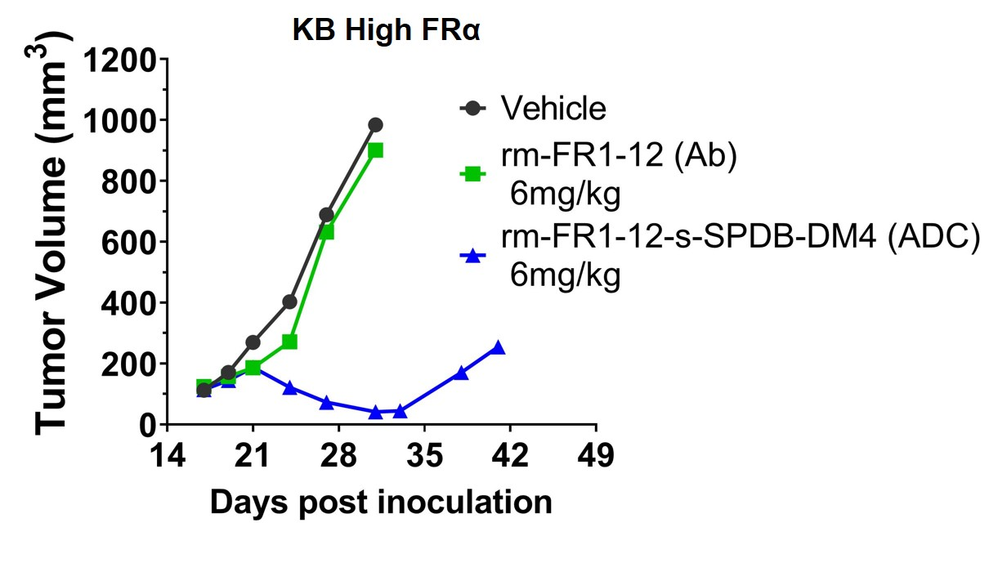
Fig. S4. Unconjugated rmFR1-12 antibody without cytotoxic payload shows no efficacy in KB (high FR∝) tumors when administered alone (singe dose).

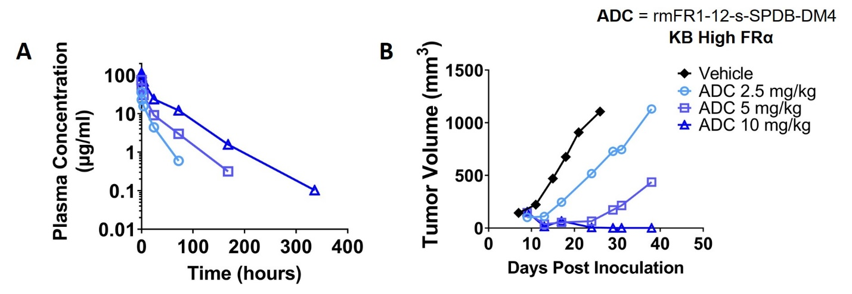
Fig. S5. Dose-dependent pharmacokinetics and efficacy of cross-reactive rmFR1-12 antibody-drug conjugate. Administration of increasing doses of ADC in KB (high FRα) tumor-bearing mice results in (A) improved pharmacokinetics indicated by reduced TMDD-mediated clearance and (B) better efficacy (single dose).

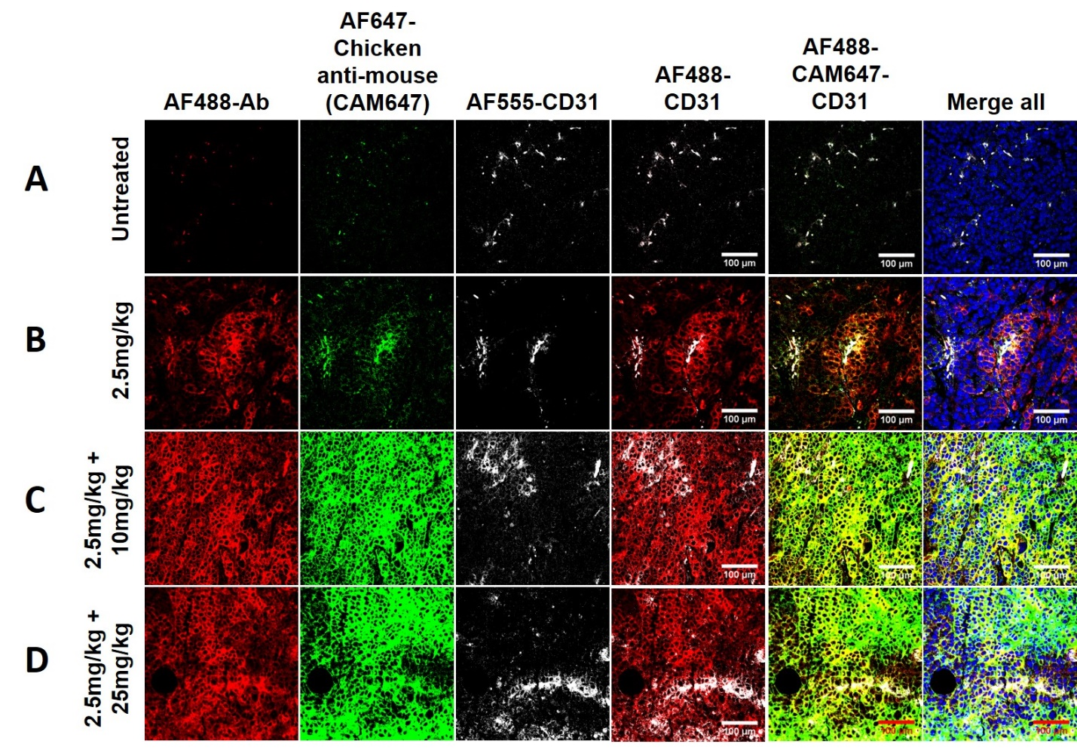
Fig. S6. Immunofluorescence tumor imaging to assess ADC distribution heterogeneity. KB (high FRα) xenograft tumors harvested 48 hours post-administration from SCID mice injected with (A) saline, (B) 2.5mg/kg AF488-Ab, (C) 2.5mg/kg AF488-Ab + 10mg/kg Ab, or (D) 2.5mg/kg AF488-Ab + 25mg/kg Ab were preserved via FFPE sectioned (5µm) and processed for immunofluorescence imaging. In addition to AF488 signal from the bound/internalized fluorescent antibody (red), secondary staining using AlexaFluor647 chicken anti-mouse antibody (green) was performed. The secondary antibody binds both fluorescent and non-fluorescent antibody, indicated by the dramatic difference in distribution and intensity between panel (B) and (C)/(D). The lack of complete overlap between red and green images might be due to incomplete epitope unmasking (which limits ex-vivo binding of secondary antibody) and/or AF488 signal from degraded ADC (undetectable by ex-vivo secondary antibody). Ab = cross-reactive rmFR1-12 antibody
red - AF488 (bound & internalized fluorescent antibody), green – AlexaFluor647-chicken anti-mouse secondary (all surface antibody), gray – AlexaFluor555-CD31 (blood vessels), blue – Hoechst33342 (nucleus).

Supplementary Methods
Tissue section deparaffinization and antigen retrieval
Deparaffinization of tumor sections was performed by washing in the following solvents - histology-grade xylene (2x for 3 min each), followed by 50/50 xylene:100% histology-grade ethanol (3 min), followed by 100% ethanol (2x for 3 min each). The sections were then rehydrated by successive washes in 95%, 70%, and 50% ethanol (3 min each), followed by rinsing in distilled water for 5 minutes. Slides were prevented from drying out between each step to minimize non-specific immunofluorescence staining. Slides were stored in the dark in cold distilled water until antigen retrieval, which was performed using citrate buffer. Briefly, slides were submerged in 10mM anhydrous citric acid containing 0.5% Tween-20, adjusted to a pH of 6.0 using 1N NaOH. Slides were heated in a microwave until boiling point (95-100ºC), then allowed to cool at room temperature for 45 minutes. Slides were washed using PBS and stored in the dark in cold distilled water until imaging.
Krogh Cylinder Model(3)
Krogh Cylinder Model Equations
- Free unconjugated antibody (C_{mab})

$$\frac{∂C_{mab}}{∂t}= D_{eff}\left(\frac{1}{r}\frac{∂}{∂r}\left(r\frac{∂C_{mab}}{∂r}\right)\right)-k_{on}\frac{C_{mab}}{ε}T_{free}+k_{off}B_{mab}$$
- Free ADC (C_{ADC})
$$\frac{∂C_{ADC}}{∂t}= D_{eff}\left(\frac{1}{r}\frac{∂}{∂r}\left(r\frac{∂C_{ADC}}{∂r}\right)\right)-k_{on}\frac{C_{ADC}}{ε}T_{free}+k_{off}B_{ADC}$$
- Free Receptor (T_{free})

$$\frac{∂T_{free}}{∂t}= R_{s}-k_{on}\frac{C_{mab}}{ε}T_{free}-k_{on}\frac{C_{ADC}}{ε}T_{free}+k_{off}B_{mab}+k_{off}B_{ADC}-k_{e}T_{free}$$

- Bound mAb (B_{mab})
$$\frac{∂B_{mab}}{∂t}=k_{on}\frac{C_{mab}}{ε}T_{free}-k_{off}B_{mab}-k_{int}B_{mab}$$
- Bound ADC (B_{ADC})
$$\frac{∂B_{ADC}}{∂t}=k_{on}\frac{C_{ADC}}{ε}T_{free}-k_{off}B_{ADC}-k_{int}B_{ADC}$$
- Internalized mAb (C_{int,mab})
$$\frac{∂C_{int,mab}}{∂t}=k_{int}B_{mab}-k_{deg}C_{int,mab}$$
- Internalized ADC (C_{int, ADC})
$$\frac{∂C_{int,ADC}}{∂t}=k_{int}B_{ADC}- k_{deg}C_{int,ADC}$$

Boundary Conditions
1.
$${-D}_{eff}{\left.\frac{dC_{free}}{dr}\right|}_{r=R_{capillary}}=P\left(C_{plasma, ADC}-\frac{C_{free}}{ε}\right)$$
2.
$$D_{eff}{\left.\frac{dC_{free}}{dr}\right|}_{r=R_{Krogh}}=0$$
3.
$$C_{plasma, ADC}= {[C]}_{0}*\left(A*\left.\exp\left(-k_{α}*t\right.\right)+\left(1-A\right)*\left.\exp\left(-k_{β}*t\right)\right.\right)$$
Table S1. Parameters
Parameter | Value | Unit | Description | Reference
R_{Krogh} | 40 | μm | Krogh cylinder (tumor) radius | Estimated for high vascularity (S/V=100/cm)
R_{Capillary} | 8 | μm | Capillary radius | (4)
A | 0.6 | ND | Fraction of alpha clearance | Plasma clearance biexponential decay fit
k_{α, M} | 0.0533 | hr⁻¹ | Alpha phase clearance rate of Mirvetuximab
k_{α, rmFR1-12} | 3.466 | hr⁻¹ | Alpha phase clearance rate of cross reactive rmFR1-12
k_{β, M} | 0.0033 | hr⁻¹ | Beta phase clearance rate of Mirvetuximab
k_{β, rmFR1-12,2.5} | 0.063 | hr⁻¹ | Beta phase clearance rate of 2.5mg/kg rmFR1-12
k_{β, rmFR1-12,2.5+10} | 0.0533 | hr⁻¹ | Beta phase clearance rate of 2.5mg/kg rmFR1-12 ADC co-dosed with 10mg/kg rmFR1-12 Ab
k_{β, rmFR1-12,2.5+25} | 0.0247 | hr⁻¹ | Beta phase clearance rate of 2.5mg/kg rmFR1-12 ADC co-dosed with 25mg/kg rmFR1-12 Ab
D_{ADC} | 10 | μm²/s | Antibody/ADC diffusivity | (5)
P_{ADC} | 3 x10⁻⁹ | m/s | Vascular permeability of antibody/ADC | (6)
Q | 0.0015 | mL/g/s | Blood flow rate to tumor | (7)
H | 0.45 | ND | Hematocrit | (8)
ε | 0.24 | ND | Tumor void fraction | (9)
[Ag]₀ | 1.2495 | μM | Initial antigen concentration  KB (High FRα) | (10)
[Ag]₀ | 0.0333 | μM | Initial antigen concentration  OV90 (Low FRα)
k_{on, Ab} | 1x10⁵ | M⁻¹s⁻¹ | Antibody/ADC binding rate | Estimated
k_{off, Ab} | 8x10⁻⁶ | s⁻¹ | Antibody/ADC dissociation rate | Calculated
K_{d} | 0.08 | nM | Antibody/ADC dissociation constant | (1)
k_{e} | 0.6x10⁻⁵ | s⁻¹ | Antibody/ADC internalization rate | Estimated, see supplementary discussion
R_{s} | k_{e}*[Ag₀] | μM/s | Antigen recycle rate | -
k_{deg} | 8.0x10⁻⁶ | s⁻¹ | ADC lysosomal degradation rate | Assumed half-life 24 hours(10,11)

Selection of ADC cellular internalization rate
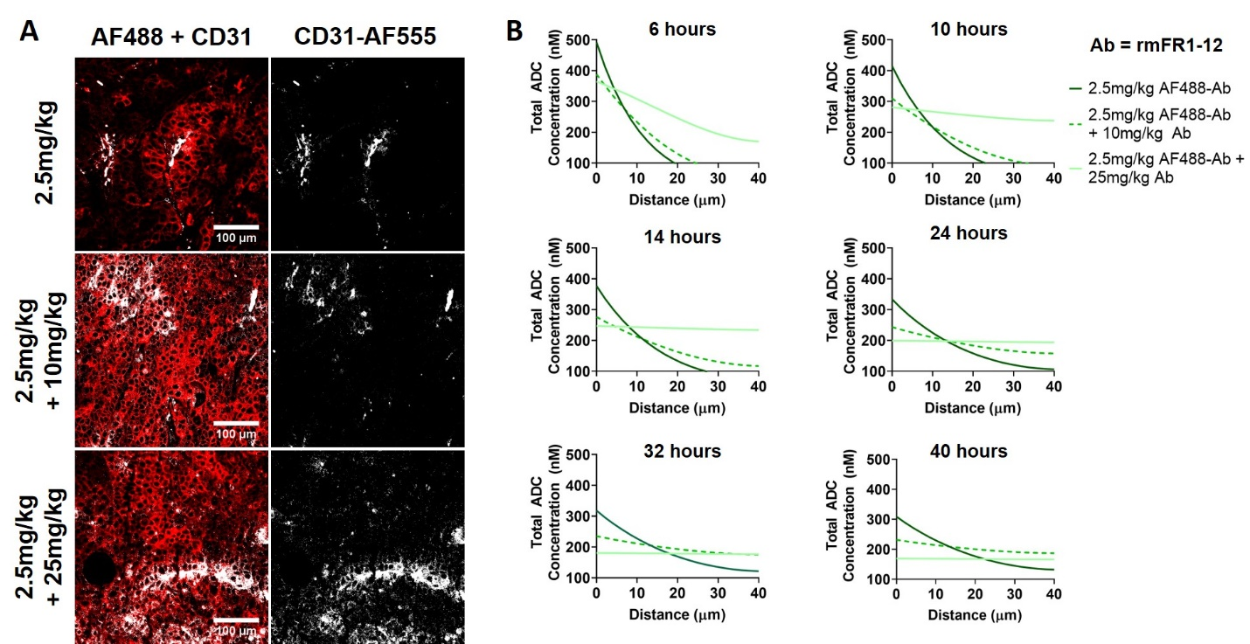
Fig. S7. Distribution analysis of cross-reactive rmFR1-12 to select cellular internalization rate. (A) Immunofluorescence histology analysis shows differential distribution of 2.5mg/kg cross-reactive antibody rmFR1-12 (red, AlexaFluor488) without and with carrier dosing (10mg/kg and 25mg/kg) relative to blood vessels (gray, CD31-AlexaFluor555). (B) Krogh cylinder simulations showing radial distribution of bound and internalized fluorescent antibody with and without carrier dosing using literature reported range of FRα internalization rates. Simulation run time is 48 hours to correspond to tumors in (A) harvested 48 hours post-injection.

Internalization Rate
Distribution heterogeneity of ADCs is a result of the ‘binding site-barrier’ effect where antibody-binding to receptors outcompetes intratumoral antibody diffusion, resulting in concentration of the drug in perivascular cells. A less appreciated but equally critical factor that contributes to this heterogeneity is the rate of cellular internalization of the antibody-receptor complex, which irreversibly traps the drug in cells. Therefore, ADC cellular internalization rate is an important parameter required to predict the intratumoral distribution of M-s-SPDB-DM4 in Fig. 2. However, literature analysis reveals a wide range of reported folate receptor internalization rate, from 6-40 hours(12) with antibodies (versus folate ligands) typically on the order of 24 to 40 hrs. In order to identify the most representative internalization rate for the system reported here, we performed a qualitative comparison between the observed distribution of 2.5mg/kg AlexaFluor488-rmFR1-12 antibody co-dosed with and without a carrier, non-fluorescent dose of rmFR1-12 (10mg/kg, 25mg/kg) and predictive simulations(3) differing in only internalization half-life ranging from 6-40 hours. Since rmFR1-12 is a cross-reactive antibody, we accounted for TMDD effects by estimating individual plasma clearance rates for each of the three dosing schemes As expected, the fraction of alpha clearance (A) and alpha phase clearance rate (k_{α}) remained consistent across the dosing schemes, and only the beta phase clearance (k_{β}) changed, with 2.5mg/kg showing the fastest clearance due to TMDD and 2.5mg/kg + 25mg/kg with the slowest clearance due to saturation of receptor sinks in healthy tissue (Table S1.).
Immunofluorescence imaging shows the relative difference in tissue penetration (red, AlexaFluor488) for the three dosing schemes relative to blood vessels (gray, CD31-AlexaFluor555). Cross-reactive fluorescence antibody when administered by itself distributes heterogeneously, but when co-administered with unlabeled carrier dose (10mg/kg and 25mg/kg) exhibits more homogeneous distribution (Fig. S7A). Using this as the “expected” simulation outcome for total cellular ADC (surface bound and internalized), various internalization rates were tested in the model (Fig. S7B). For the simulations with 6 hours internalization half-life, both 2.5mg/kg and 2.5+10mg/kg doses show highly perivascular distribution of the total cellular ADC (AUC ~ 6000), while 2.5+25mg/kg shows homogeneous distribution with improved total ADC binding and uptake (AUC~10,000). This does not match the observed behavior of the ADC in the histology images and suggests that a predicted internalization half-life of 6 hours is too fast. Iterative simulations helped converge to an internalization half-life of 30-40 hours, which showed relatively heterogeneous distribution of the 2.5mg/kg only dose, and similarly homogeneous distribution of the carrier-dosed tumors, similar that observed in the histology images. Additionally, in this internalization rate range, area under curve (AUC) analysis shows increased ADC binding and uptake of ADC going from 2.5mg/kg to 2.5+10mg/kg dosing scheme, but a subsequent decrease for the 2.5+25mg/kg dosing scheme, representative of the efficacy trends observed in Fig. 6A. Therefore, we selected 32 hours as the predicted internalization half-life of the ADC and performed subsequent simulations for maximum ADC internalization in KB and OV90 tumors (Fig. 2B & 2D) using this value.

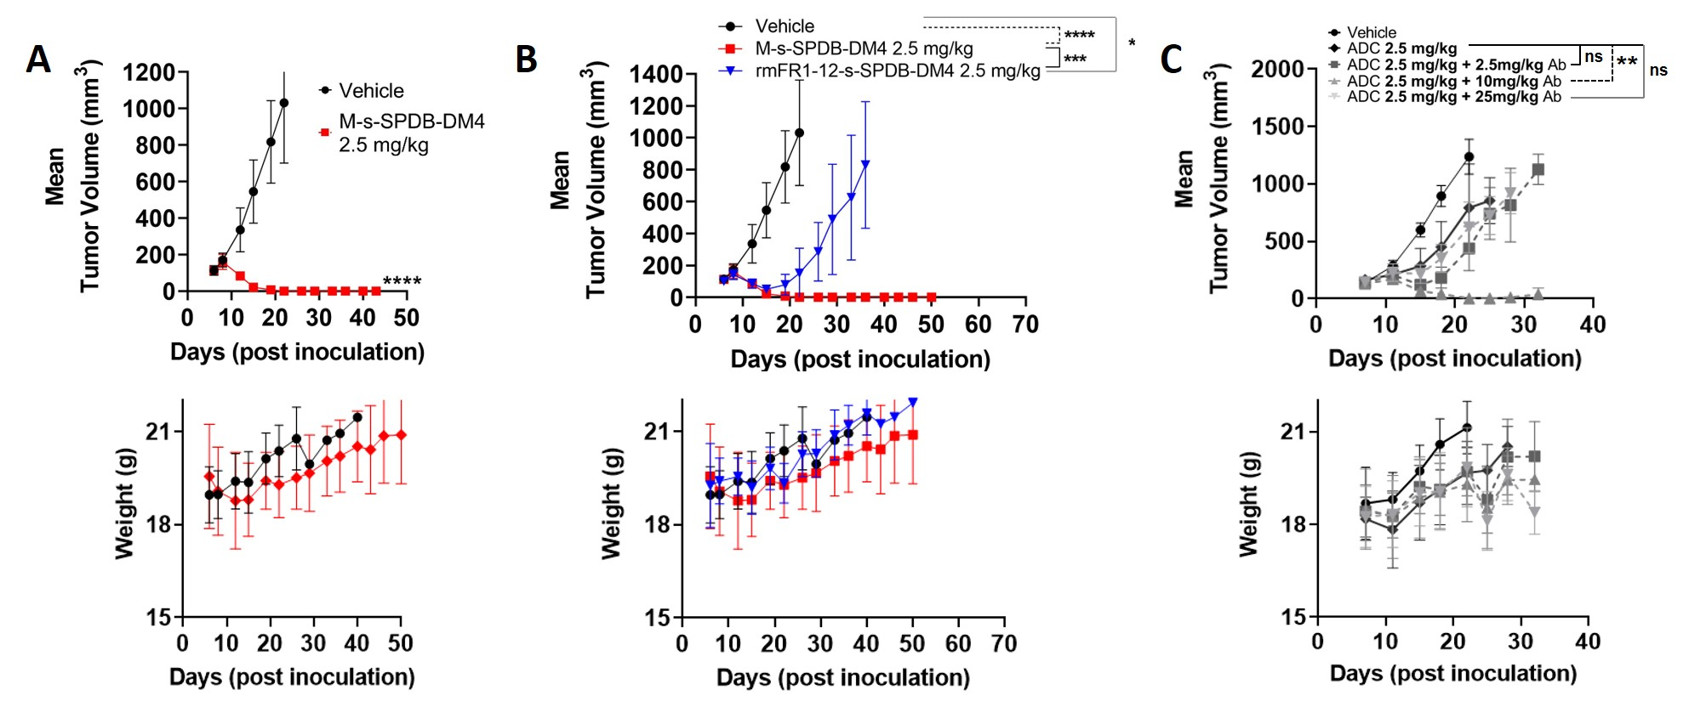
Fig. S8. Mean and standard deviation of tumor volumes, statistical analysis (unpaired t-test), and corresponding weight changes for DM4 ADC treated mice. (ns = not significant, * p < 0.05, ** p < 0.01, *** p < 0.001, **** p < 0.0001)
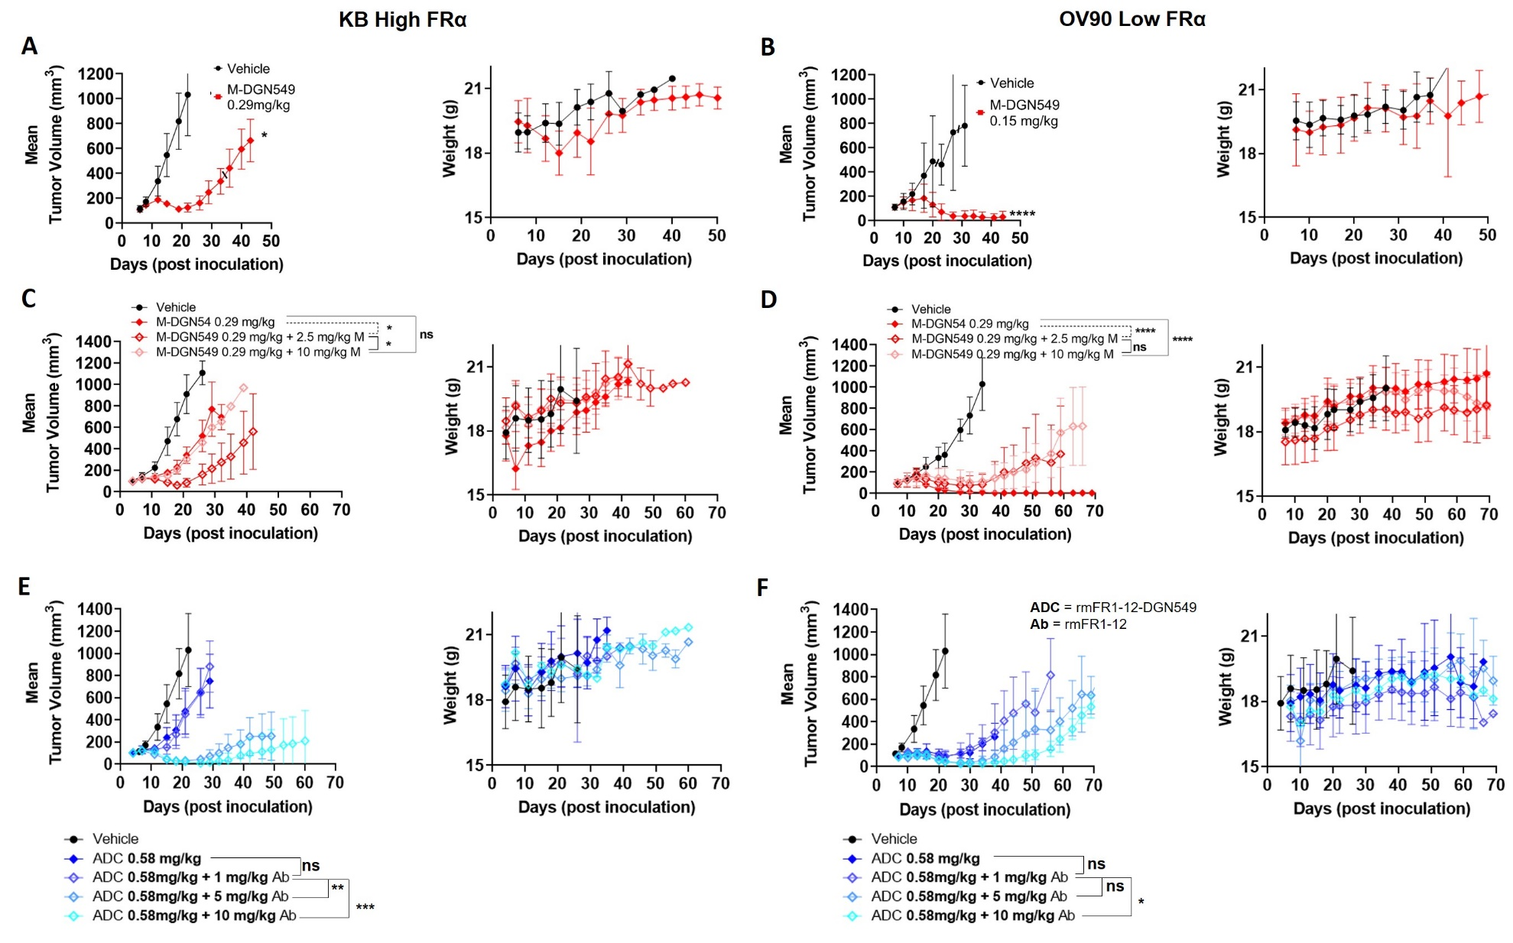
Fig. S9. Mean and standard deviation of tumor volumes , statistical analysis, and corresponding weight changes for DGN549 ADC treated mice. (ns = not significant, * p < 0.05, ** p < 0.01, *** p < 0.001, **** p < 0.0001)

Supplementary References
1. Ab O, Whiteman KR, Bartle LM, Sun X, Singh R, Tavares D, et al. IMGN853, a Folate Receptor-α (FRα)–Targeting Antibody–Drug Conjugate, Exhibits Potent Targeted Antitumor Activity against FRα-Expressing Tumors. Molecular Cancer Therapeutics 2015;14(7):1605 doi 10.1158/1535-7163.MCT-14-1095.
2. Rudnick SI, Lou J, Shaller CC, Tang Y, Klein-Szanto AJ, Weiner LM, et al. Influence of affinity and antigen internalization on the uptake and penetration of Anti-HER2 antibodies in solid tumors. Cancer Res 2011;71(6):2250-9 doi 10.1158/0008-5472.CAN-10-2277.
3. Khera E, Cilliers C, Bhatnagar S, Thurber GM. Computational transport analysis of antibody-drug conjugate bystander effects and payload tumoral distribution: implications for therapy. Molecular Systems Design & Engineering 2018;3(1):73-88 doi 10.1039/C7ME00093F.
4. Hilmas D, Gillette E. Morphometric Analyses of the Microvasculature of Tumors During Growth and After X-Irradiation. Cancer 1974;33(1):103-10.
5. Thurber GM, Weissleder R. A Systems Approach for Tumor Pharmacokinetics. PLoS One 2011;6(9):e24696 doi 10.1371/journal.pone.0024696.g001.
6. Yuan F, Dellian M, Fukumura D, Leunig M, Berk DA, Torchilin VP, et al. Vascular Permeability in a Human Tumor Xenograft: Molecular Size Dependence and Cutoff Size. Cancer Res 1995;55(17):3752-6.
7. Ferl GZ, Kenanova V, Wu AM, DiStefano JJ. A two-tiered physiologically based model for dually labeled single-chain Fv-Fc antibody fragments. Mol Cancer Ther 2006;5(6):1550-8 doi 10.1158/1535-7163.MCT-06-0072.
8. Green EL. Biology of the laboratory mouse. New York: Dover Publications & The Jackson Laboratory; 1975.
9. Schmidt MM, Wittrup KD. A modeling analysis of the effects of molecular size and binding affinity on tumor targeting. Mol Cancer Ther 2009;8(10):2861-71 doi 10.1158/1535-7163.MCT-09-0195.
10. Forster MD, Ormerod MG, Agarwal R, Kaye SB, Jackman AL. Flow cytometric method for determining folate receptor expression on ovarian carcinoma cells. Cytometry A 2007;71(11):945-50 doi 10.1002/cyto.a.20456.
11. Maass KF, Kulkarni C, Betts AM, Wittrup KD. Determination of Cellular Processing Rates for a Trastuzumab-Maytansinoid Antibody-Drug Conjugate (ADC) Highlights Key Parameters for ADC Design. AAPS J 2016;18(3):635-46 doi 10.1208/s12248-016-9892-3.
12. Paulos CM, Reddy JA, Leamon CP, Turk MJ, Low PS. Ligand binding and kinetics of folate receptor recycling in vivo: impact on receptor-mediated drug delivery. Mol Pharmacol 2004;66(6):1406-14 doi 10.1124/mol.104.003723.

