Table S1. List of primers designed for each of the selected genes.
Gen | Primers 5´- 3´
CCL5 (NM_002985 variant 1, NM_001278736 variant 2) | FW | CTCATTGCTACTGCCCTCTG
 | RV | GAAATACTCCTTGATGTGGGC
CCR5 (NM_000579.3 variant A, NM_001100168.1 variant B) | FW | CTCCCCGGGTGGAACAAGA
 | RV | GAACACCAGTGAGTAGAGCG
CXCL10 (NM_001565) | FW | GCTTAGACATATTCTGAGCCT
 | RV | GAGAGGTACTCCTTGAATGC
CXCL11 (NM_005409) | FW | CCTTGGCTGTGATATTGTGTGC
 | RV | CTTTCACTGCTTTTACCCCAG
IFNλ1 (NM_172140) | FW | GAGGCTTCTCCAGGTGAGG
 | RV | CTCCAGGACCTTCAGCGTC
IFNλ2 (NM_172138) | FW | CCTGGTGGACGTCTTGGAC
 | RV | GGCTGGTCCAAGACGTCCA
ATP5E (NM_006886.2: (NM_001001977.1) | FW | CCGGCGTCTTGGCGATTC
 | RV | GATCTGGGAGTATCGGATG

Figure S1. List of 25 genes differentially expressed (2 ≤ logFC ≤ -2; p-value<0.05) between BT-474 and BT-474.rT cell lines, as identified by gene expression analysis (Affymetrix Human Gene ST 2.0 Arrays ST).
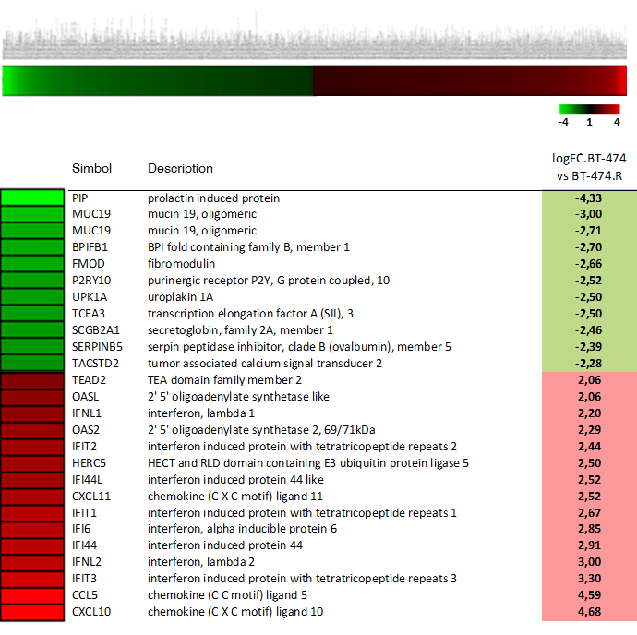

Figure S2. Representative image of Gene Set Enrichment Analysis with the data obtained from the expression array made in BT-474 and BT-474-rT lines. The image above shows the enrichment score chart of the ERBB2 gene set, together with the genes from this list. In the image below we can see the chart corresponding to the Neoplastic Transformation gene set (Seitz, 2005) and the list of genes that contribute to the enrichment of the gene set.
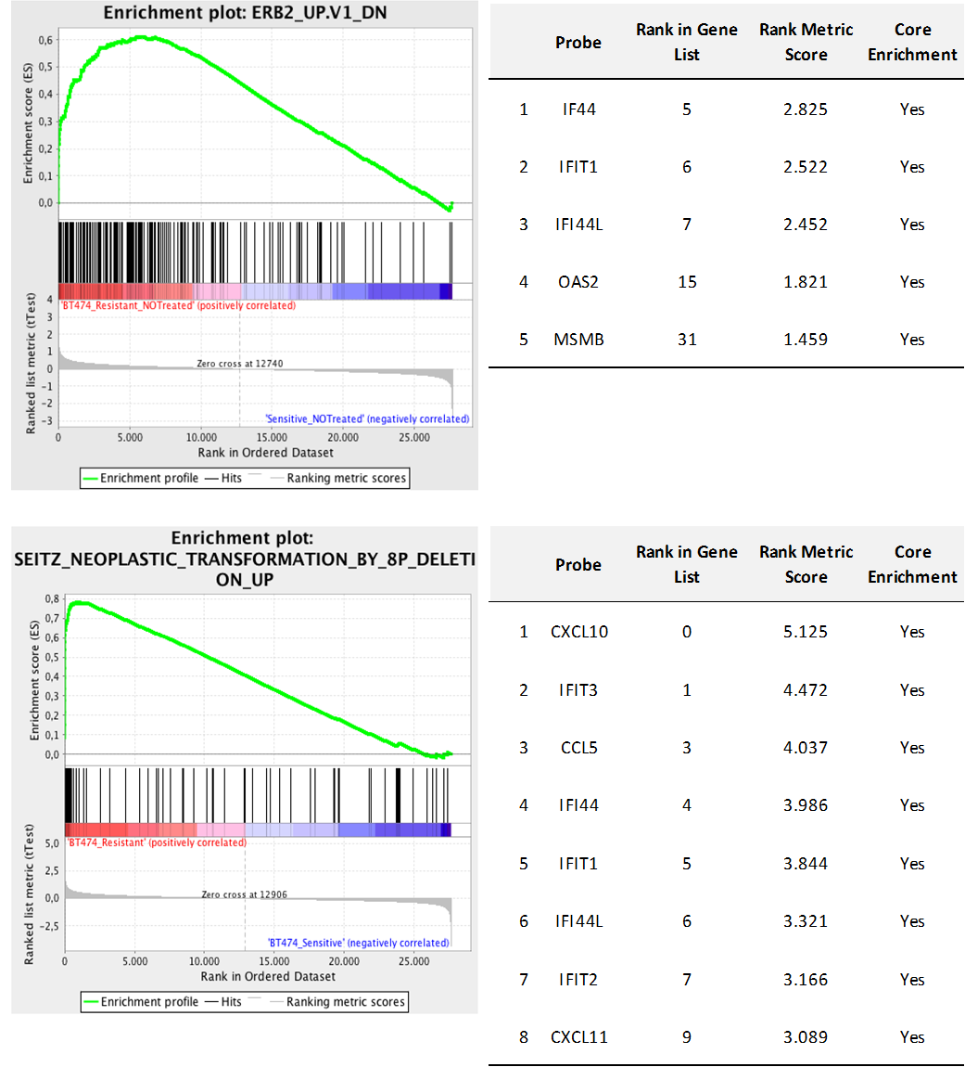

Figure S3. Validation by qPCR of the results obtained in the gene expression array for the genes CCL5, CXCL10, CXCL11, IFNL1, and IFNL2 in the five cell lines.
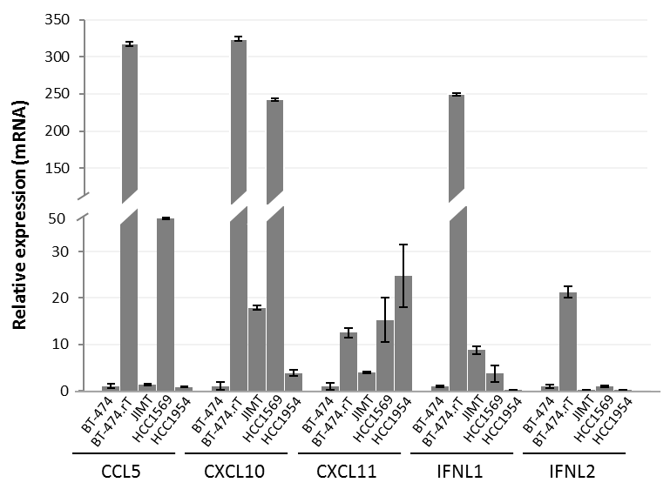

Figure S4. Representative image of a clonogenic assay showing that BT-474.rT cell line was able to form growing colonies under trastuzumab treatment, in a number and over the time, in a similar manner to untreated control cells.
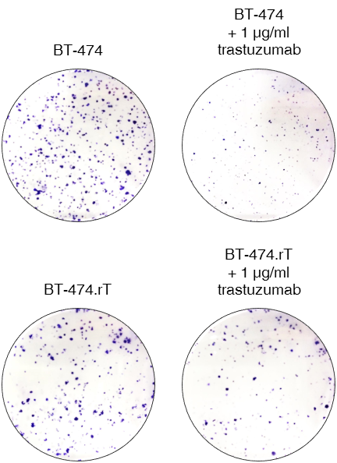

Figure S5. Assessment of RNA and protein efficiency of CCL5 silencing in BT-474.rT and HCC1569 cell lines. A. The effectiveness of CCL5 silencing was confirmed by qPCR from mRNA obtained 48 hours after transfection with siCCL5 (siCT for control). Silencing was confirmed by a decrease in the relative expression levels of CCL5 (p-value=0.01 in BT-474.rT, and p-value=0.02 in HCC1569). B. An ELISA assay confirmed the reduction in protein levels secreted to the medium to ~40% in BT-474.rT (p-value<0.01) and HCC1569 (p-value<0.01). C. mRNA expression levels of CCR5 as determined by qPCR (p-value=0.03). Conditions as in panel A.
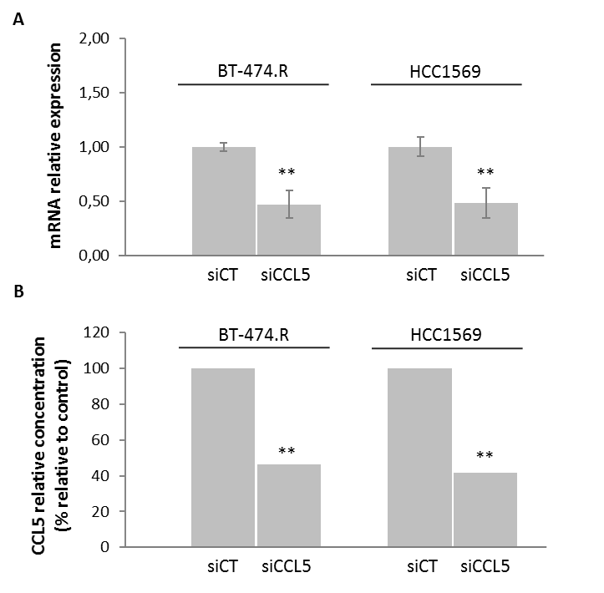
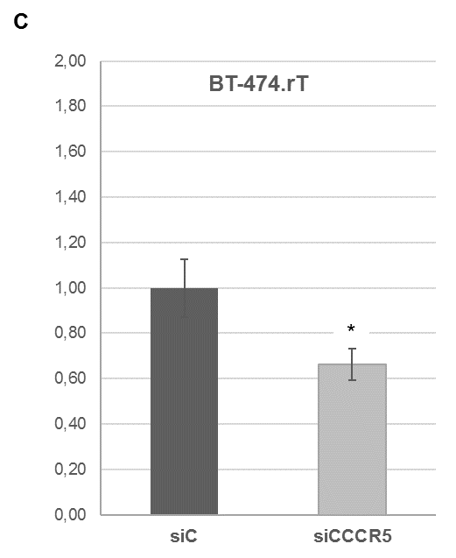
Figure S6. Silencing of CCL5 produced a significant decrease in cell proliferation in BT-474.rT (p-value=3,16E-08) cells, reversing acquired resistance to trastuzumab. Further addition of exogenous recombinant CCL5 (rCCL5) caused a significant increase in cell proliferation, even in combination with trastuzumab 15 µg/ml for 7 days (p-value=0.003).
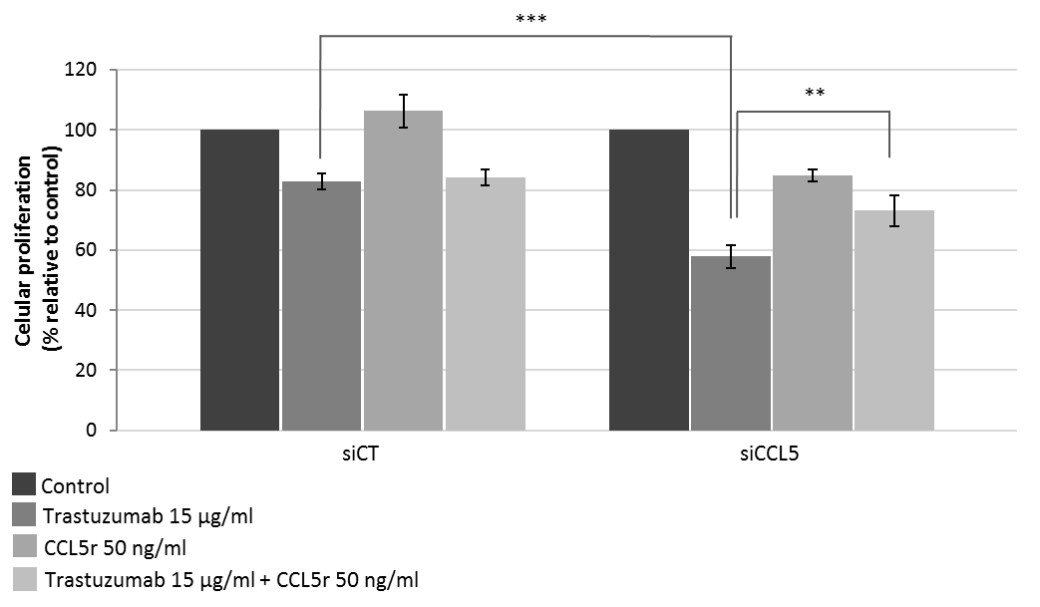

Figure S7. Dephosphorylation of AKT (both on Thr308 and Ser473 residues) was a consequence of trastuzumab treatment, but not of maraviroc treatment alone. BT-474-rT line under conditions of no treatment, treatment with 15 µg/ml trastuzumab, 50 µM maraviroc, and a combination of 15 µg/ml trastuzumab plus 50 µM maraviroc for 24 hours.
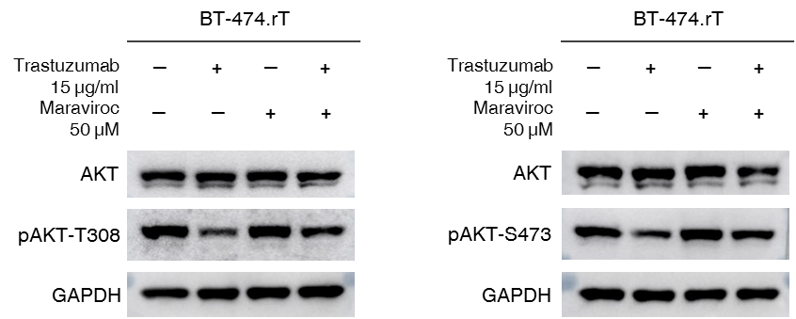
Figure S8. ROC curve of CCL5 overexpression for determining the optimal H-score value. According to the ROC curve analysis the H-score was set at 150 with a sensitivity of 75% and a specificity of 100%. This cutoff point was used to define the overexpression of CCL5.
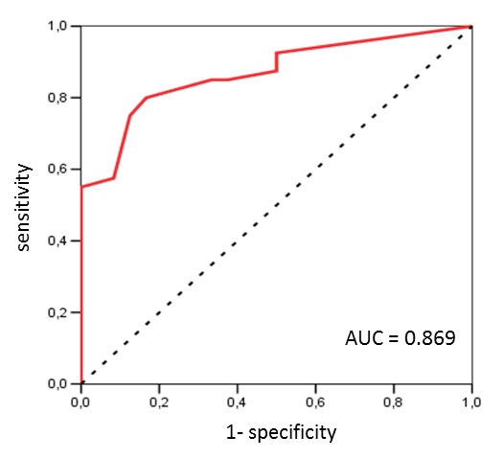

Table S2. Clinical-pathological characteristics of HER2-positive early breast cancer patients in neoadjuvant treatment, and distribution of CCL5 expression in relation to clinical-pathological characteristics.
 |  | nº cases (n=64) | % | CCL5 low expression (n=43) |  | CCL5 high expression (n=21) |  | χ² p
 |  |  |  | n | % | n | %
CCL5 expression |  | 64 |  | 43 | 67.2 | 21 | 32.8
Age |  |  |  |  |  |  |  | 0.727
 | median (range) | 53 (36-87)
 | 35-60 | 47 | 73.4 | 31 | 72.1 | 16 | 76.2
 | >60 | 17 | 26.6 | 12 | 27.9 | 5 | 23.8
Hormonal status |  |  |  |  |  |  |  | 0.661
 | pre-menopausal | 22 | 34.4 | 14 | 32.6 | 8 | 38.1
 | post-menopausal | 42 | 65.6 | 29 | 67.4 | 13 | 61.9
Morphologic type |  |  |  |  |  |  |  | 0.280
 | CDI | 62 | 96.9 | 42 | 97.7 | 20 | 95.2
 | CLI | 1 | 1.6 | 1 | 2.3 | 0 | 0.0
 | others | 1 | 1.6 | 0 | 0.0 | 1 | 4.8
Histological grading (Scarff-Bloom-Richardson) |  |  |  |  |  |  |  | 0.808
 | I | 2 | 3.1 | 1 | 2.3 | 1 | 4.8
 | II | 35 | 54.7 | 23 | 53.5 | 12 | 57.1
 | III | 27 | 42.2 | 19 | 44.2 | 8 | 38.1
Estrogen receptors |  |  |  |  |  |  |  | 0.101
 | negative | 21 | 32.8 | 17 | 39.5 | 4 | 19.0
 | positive | 43 | 67.2 | 26 | 60.5 | 17 | 81.0
Progesterone receptors |  | 64 |  | 43
 | negative | 32 | 50.0 | 25 | 58.1 | 7 | 33.3
 | positive | 32 | 50.0 | 18 | 41.9 | 14 | 66.7
HER2 amplification |  |  |  |  |  |  |  | 0.884
 | no amplification | 0 | 0.0 | 0 | 0.0 | 0 | 0.0
 | amplification | 64 | 100.0 | 43 | 67.2 | 21 | 32.8
Ki-67 |  |  |  |  |  |  |  | 0.734
 | median (range) | 40 (5-90)
 | <20 | 10 | 15.6 | 5 | 11.6 | 5 | 23.8
 | ≥20 | 54 | 84.4 | 37 | 86.0 | 17 | 81.0
T |  |  |  |  |  |  |  | 0.747
 | x | 1 | 1.6 | 1 | 2.3 | 0 | 0.0
 | 1 | 2 | 3.1 | 2 | 4.7 | 0 | 0.0
 | 2 | 38 | 59.4 | 26 | 60.5 | 12 | 57.1
 | 3 | 19 | 29.7 | 11 | 25.6 | 8 | 38.1
 | 4 | 4 | 6.3 | 3 | 7.0 | 1 | 4.8
N |  |  |  |  |  |  |  | 0.284
 | x | 5 | 7.8 | 4 | 9.3 | 1 | 4.8
 | 0 | 29 | 45.3 | 21 | 48.8 | 8 | 38.1
 | 1 | 26 | 40.6 | 17 | 39.5 | 9 | 42.9
 | 2 | 1 | 1.6 | 1 | 2.3 | 0 | 0.0
 | 3 | 3 | 4.7 | 0 | 0.0 | 3 | 14.3
Pathological response (Miller&Payne) |  |  |  |  |  |  |  | <0.001
 | G1-G3 | 21 | 32.8 | 6 | 14.0 | 15 | 71.4
 | G4 | 18 | 28.1 | 12 | 27.9 | 6 | 28.6
 | G5 | 25 | 39.1 | 25 | 58.1 | 0 | 0.0
Node biopsy response |  |  |  |  |  |  |  | 0.013
 | A | 23 | 35.9 | 18 | 41.9 | 5 | 23.8
 | B | 6 | 9.4 | 2 | 4.7 | 4 | 19.0
 | C | 11 | 17.2 | 4 | 9.3 | 7 | 33.3
 | D | 24 | 37.5 | 19 | 44.2 | 5 | 23.8
Pathological response |  |  |  |  |  |  |  | <0.001
 | no complete | 40 | 62.5 | 19 | 44.2 | 21 | 100.0
 | complete | 24 | 37.5 | 24 | 55.8 | 0 | 0.0
Relapse |  |  |  |  |  |  | 100.0 | 0.002
 | no | 53 | 82.8 | 40 | 93.0 | 13 | 61.9
 | yes | 11 | 17.2 | 3 | 7.0 | 8 | 38.1

Table S3. Clinical-pathological characteristics of HER2-positive early breast cancer patients in adjuvant treatment, and distribution of CCL5 expression in relation to clinical-pathological characteristics.
 |  | nº cases (n=82) | % | CCL5 low expression (n=64) |  | CCL5 high expression (n=18) |  | χ² p
 |  |  |  | n | % | n | %
CCL5 expression |  | 82 |  | 64 | 78.0 | 18 | 22.0
Age |  |  |  |  |  |  |  | 0.727
 | median (range) | 55 (33-81)
 | 35-60 | 47 | 57.3 | 31 | 48.4 | 16 | 88.9
 | >60 | 17 | 20.7 | 12 | 18.8 | 5 | 27.8
Hormonal status |  |  |  |  |  |  |  | 0.079
 | pre-menopausal | 31 | 37.8 | 21 | 32.8 | 10 | 55.6
 | post-menopausal | 51 | 62.2 | 43 | 67.2 | 8 | 44.4
Morphologic type |  |  |  |  |  |  |  | 0.058
 | CDI | 81 | 98.8 | 64 | 100.0 | 17 | 94.4
 | CLI | 1 | 1.2 | 0 | 0.0 | 1 | 5.6
Histological grading (Scarff-Bloom-Richardson) |  |  |  |  |  |  |  | 0.255
 | I | 0 | 0 | 0 | 0 | 0 | 0
 | II | 45 | 54.9 | 33 | 51.6 | 12 | 66.7
 | III | 37 | 45.1 | 31 | 48.4 | 6 | 33.3
Estrogen receptors |  |  |  |  |  |  |  | 0.915
 | negative | 31 | 37.8 | 24 | 37.5 | 7 | 38.9
 | positive | 51 | 62.2 | 40 | 62.5 | 11 | 61.1
Progesterone receptors |  |  |  |  |  |  |  | 0.515
 | negative | 40 | 48.8 | 30 | 46.9 | 10 | 55.6
 | positive | 42 | 51.2 | 34 | 53.1 | 8 | 44.4
HER2 amplification |  |  |  |  |  |  |  | 0.754
 | no amplification | 0 | 0
 | amplification | 82 | 100 | 64 | 78.0 | 18 | 22.0
Ki-67 |  |  |  |  |  |  |  | 0.533
 | median (range) | 30 (5-90)
 | <20 | 23 | 28.0 | 19 | 29.7 | 4 | 22.2
 | ≥20 | 59 | 71.9 | 45 | 70.3 | 14 | 77.8
pT |  |  |  |  |  |  |  | 0.744
 | 1 | 33 | 40.2 | 25 | 39.1 | 8 | 44.4
 | 2 | 42 | 51.2 | 34 | 53.1 | 8 | 44.4
 | 3 | 5 | 6.1 | 4 | 6.3 | 1 | 5.6
 | 4 | 2 | 2.4 | 1 | 1.6 | 1 | 5.6
pN |  |  |  |  |  |  |  | 0.213
 | 0 | 43 | 52.4 | 36 | 56.3 | 7 | 38.9
 | 1 | 18 | 21.9 | 14 | 21.9 | 4 | 22.2
 | 2 | 8 | 9.8 | 4 | 6.3 | 4 | 22.2
 | 3 | 13 | 15.8 | 10 | 15.6 | 3 | 16.7
Relapse |  |  |  |  |  |  |  | <0.001
 | no | 53 | 64.6 | 48 | 75.0 | 5 | 27.8
 | yes | 29 | 35.4 | 16 | 25.0 | 13 | 72.2

Figure S9. Box-plot showing the IHC levels of pERK1/2 expression in the group of 82 patient samples that received adjuvant trastuzumab plus chemotherapy, stratified by CCL5 expression levels (the horizontal bar indicates median Hscore, the box represents the interquartile range, and the whiskers above and below the box show the minimum and maximum within a category. A p-value for pERK is shown). The diagram reveals that a group of patients with overexpression of CCL5 significantly present high levels of pERK protein (CCL5-negative cases: median 5, range 0-80; CCL5-positive cases: median 85, range 5-120).
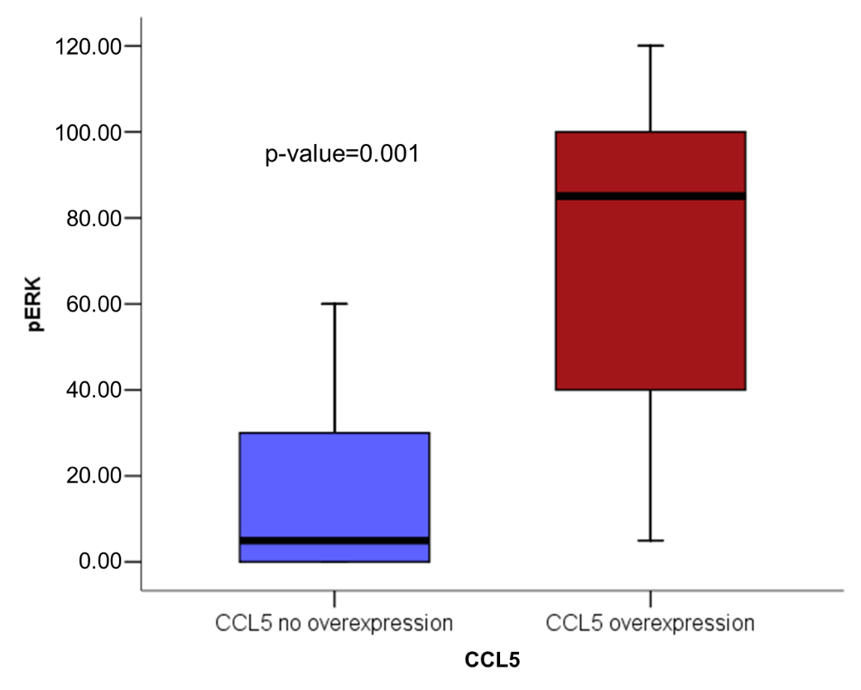

Figure S10. Kaplan-Meier's analysis of DFS in the cohorts of primary breast tumors that received: A. Neoadjuvant therapy containing trastuzumab; B. Adjuvant therapy.
A.
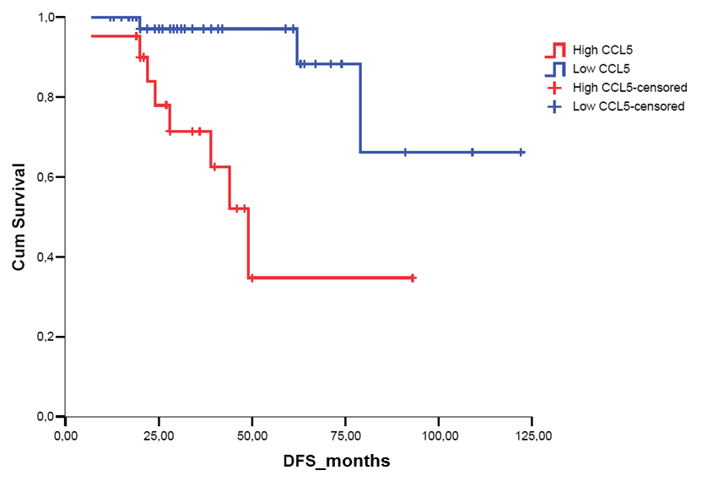
B.
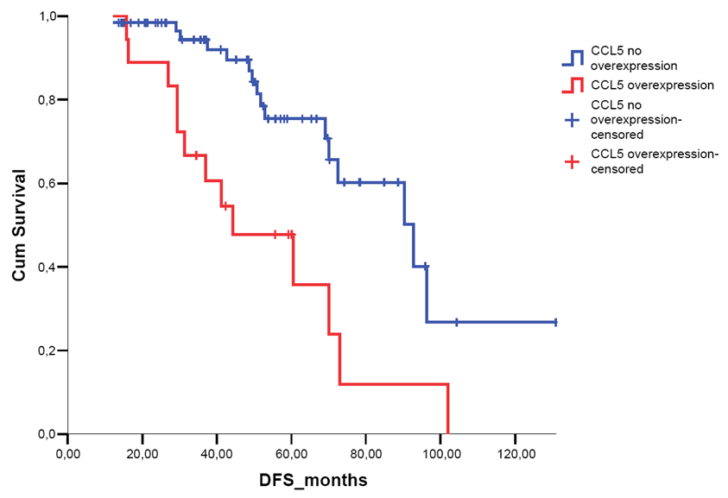

Table S4. Multivariate analysis of CCL5 expression and clinical-pathological factors. CCL5 behaves as an independent prognostic factor independent of other clinical-pathological factors. AC-Tx: anthracycline-cyclophosphamide-taxane; A: anthracyclines; TC: taxane-cyclophosphamide. Tx: taxane.
 |  | Multivariant analysis
 |  | HR | CI (95%) |  | significance
 |  |  | inferior | superior
Estrogen receptors |  | 2.51 | 0.68 | 9.3 | 0.17
Chemotherapy |  |  |  |  | 0.41
 | AC-Tx | 0.54 | 0.11 | 2.64 | 0.45
 | A | 0.51 | 0.11 | 2.46 | 0.40
 | TC | 0.10 | 0.01 | 1.24 | 0.07
 | Tx | 0.23 | 0.02 | 2.4 | 0.22
CCL5 expression |  | 13.62 | 3.38 | 54.85 | <0.001

Table S5. Distribution of CCL5 concentration in relation to clinical-pathological characteristics in serum samples of HER2-positive early breast cancer patients in neoadjuvant treatment.
 |  | nº cases | CCL5 low concentration |  | CCL5 high concentration |  | χ² p
 |  |  | n | % | n | %
CCL5 concentration |  | 14 | 8 | 54.1 | 6 | 42.9
Pathological response |  | 14 | 8 |  | 6 |  | 0.031
 | no complete | 7 | 2 | 25.0 | 5 | 83.3
 | complete | 7 | 6 | 75.0 | 1 | 16.7

Figure S11. Kaplan-Meier's analysis of OS in the HER2-positive breast cancer patient cohort from the public database TCGA. Only the increase in CCR3 expression is statistically significantly associated with a lower OS (p-value=0.038).
