Molecular Cancer Therapeutics
Supplemental Information

MMAE delivery using the Bicycle toxin conjugate BT5528
Gavin Bennett, Amy Brown, Gemma Mudd, Philip Huxley, Katerine van Rietschoten, Silvia Pavan, Liuhong Chen, Sophie M. Watcham, Johanna Lahdenranta, Nicholas Keen.
Inventory of supplemental information
Figure S1: Plasma concentration-time curves of BT5528 and MMAE following IV dosing of BT5528 1 in mouse, rat, and cynomolgus Monkey at 1 mg/kg (n=3 per species). Related to in vivo PK.
Figure S2: EphA2 expression and tumour growth inhibition in CDX and PDX xenograft models are correlated. BT5528 3 mg/kg qw dosing has a range of anti-tumour activities across different cell-line derived and patient-derived xenograft models (*p<0.05, **p<0.01, ***p<0.001 2way ANOVA from D0 to last day of vehicle tumour measurement).Data used to generate Figure 3.
Figure S3: EphA2 Immunohistochemistry staining of CDX and PDX xenograft models. A range of EphA2 expression is observed in stained tumour tissue from mouse xenograft models. Related to figure 3.
Table T1: K_{i} values for BT5528, 1C1-mcMMAF and control compounds binding to human, mouse and rat Epha2 receptor. Ki values for Bicycle, BTC and DOTA analogues used to generate data in Figures 1, 4 and 5.
Table T2: Binding affinities for BT5528 binding to EphA and EphB tyrosine kinases receptors determined by Surface Plasmon Resonance. Data defining BTC and Bicycle K_{D} values for EphA2 orthologues.
Table T3: In vitro ADME properties of BT5528 in mouse, rat, NHP and human: plasma protein binding, plasma stability and metabolic stability in hepatocytes. Related to in vitro ADME properties of BT5528.
Table T4: Summary of experimentally determined and calculated PK Parameters for BT5528 and MMAE Following IV Dosing of 1 mg/kg BT5528 in Mouse, Rat and Cynomolgus Monkey. Related to in vivo PK
Table T5a: Anti-Human EphA2 Antibody Binding Sites on CDX Cell Lines. Expression data used to generate Figure 3.
Table T5b:Anti-Human EphA2 Antibody Binding Sites on PDX Cell Lines. Expression data used to generate Figure 3.
Table T6: Doses of BT5528 and corresponding toxin (MMAE) used in preclinical toxicology studies compared with the clinical dose of MED-547 and corresponding toxin (MMAF)¹. Related to the discussion (ADC versus BTC toxicology responses).

Figure S1: Plasma concentration-time curves of BT5528 and MMAE following IV dosing of BT5528 1 in mouse, rat, and cynomolgus Monkey at 1 mg/kg (n=3 per species)
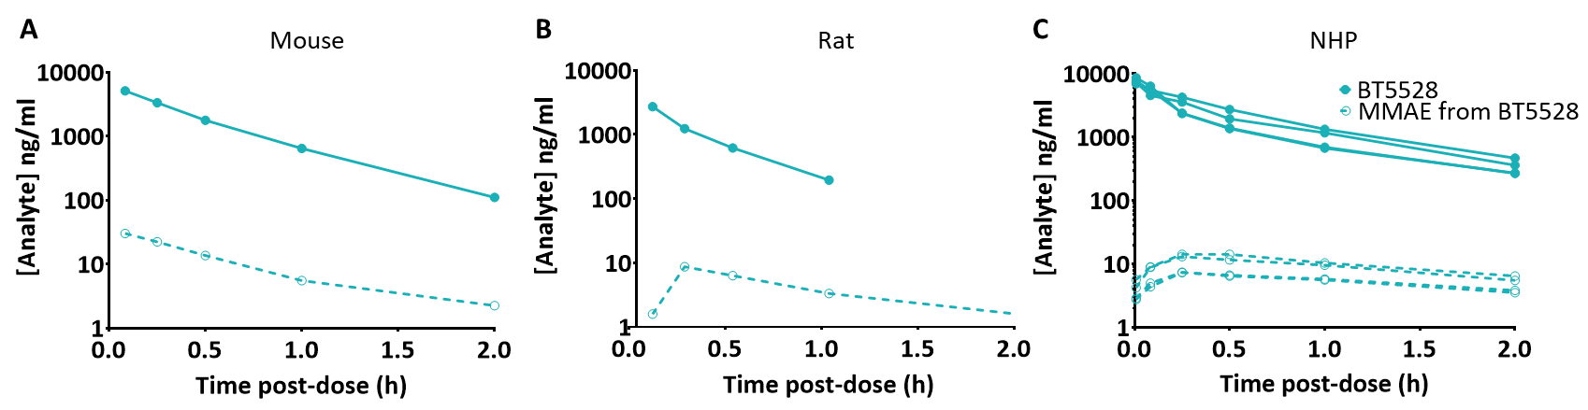

Abbreviations: h=hour, IV=intravenous, MMAE=monomethyl auristatin E, NHP=non-human primate.
n=3 per species

Figure S2: EphA2 expression and tumour growth inhibition in CDX and PDX xenograft models are correlated. BT5528 3 mg/kg qw dosing has a range of anti-tumour activities across different cell-line derived and patient-derived xenograft models (*p<0.05, **p<0.01, ***p<0.001 2way ANOVA from D0 to last day of vehicle tumour measurement).

Figure S3: EphA2 Immunohistochemistry staining of CDX and PDX xenograft models. A range of EphA2 expression is observed in stained tumour tissue from mouse xenograft models.
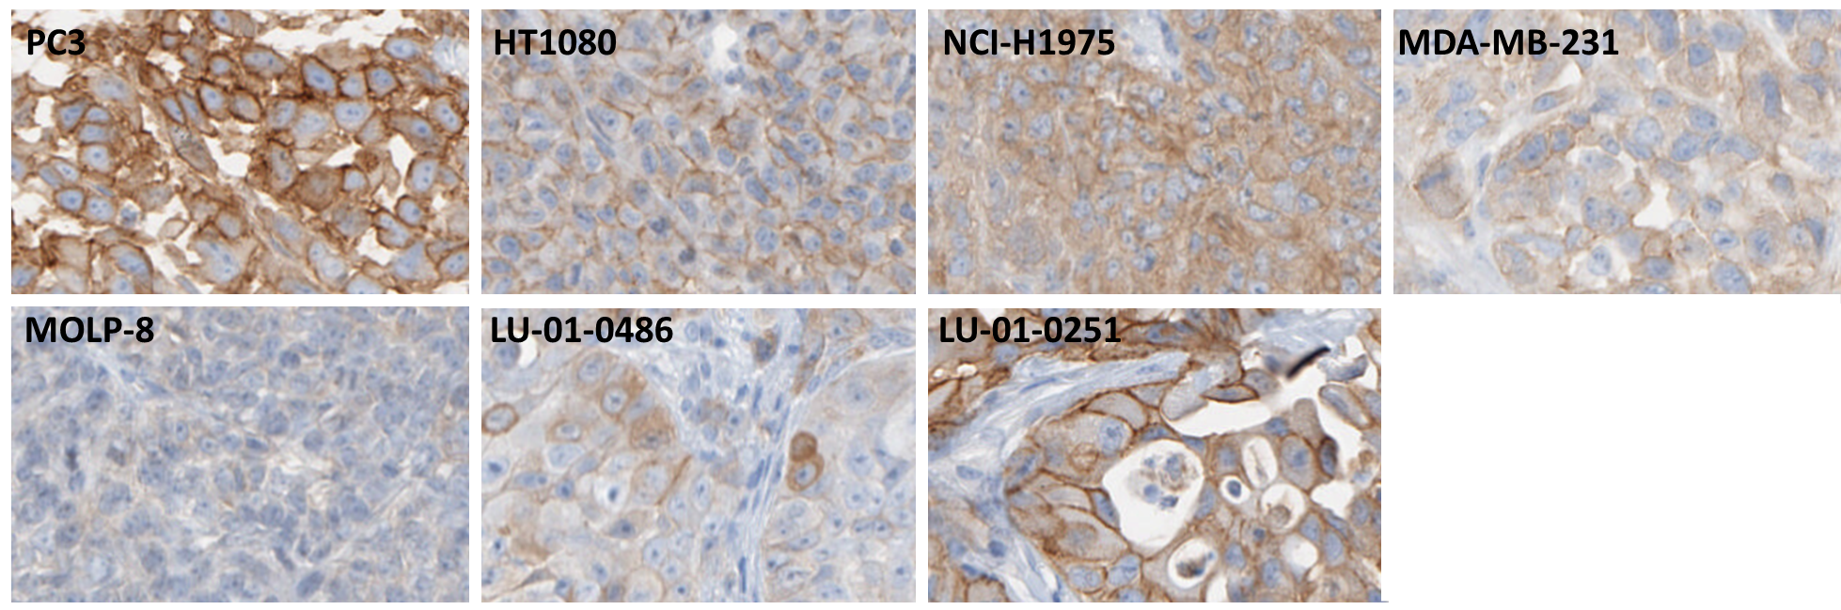

Table T1: K_{i} values for BT5528, 1C1-mcMMAF and control compounds binding to human, mouse and rat Epha2 receptor
 | Human (K_{i} nM) | Mouse (K_{i} nM) | Rat (K_{i} nM)
BT5528 | 1.94 ± 0.91, n=31 | 5.60 ± 1.96, n=20 | 2.16 ± 1.25, n=14
BCY6099 | 5.74 ± 11.08, n=28 | 5.64 ± 3.14, n=11 | 2.23 ± 0.80, n=6
BCY6164 | 5.0 ± 0.8, n=2 | ND | ND
BCY6079 | >5000 (n=14) | >5000 (n=6) | >5000 (n=4)
BCY6063 | 22.2 ± 8.13 n=12
BCY8245 | >5000 n=2
BCY10188 | 2.35 n=1
1C1-mcMMAF | 22.44 ± 12.96, n=7 | 12.60 ± 4.14, n=3 | 3.73 ± 1.52, n=2

Table T2: Binding affinities for BT5528 binding to EphA and EphB tyrosine kinases receptors determined by Surface Plasmon Resonance
Ephrin domain | % identity to human EpHA2 | Binding affinity (SPR K_{D} nM)
 |  | Human | Mouse | Rat | Cynomolgus
EphA2 | 100 | 0.88 ± 0.40, n=2 | 2.07 ± 0.61, n=3 | 2.67 ± 0.42, n=2 | 1.01 n=1
EphA1 | 54 | > 5000
EphA3 | 58 | > 5000 | > 5000 | > 5000
EphA4 | 55 | > 5000 | > 5000 | > 5000
EphA5 | 56 | > 5000
EphA6 | 56 | > 5000
EphA7 | 56 | > 5000
EpHb1 | 49 |  |  | > 5000
EphB4 | 39 | > 5000

Table T3: In vitro ADME properties of BT5528 in mouse, rat, NHP and human: plasma protein binding, plasma stability and metabolic stability in hepatocytes

 | Mouse | Rat | NHP | Human
Plasma Protein Binding (fu,p) | 0.49 | 0.38 | 0.42 | 0.32
Stability in plasma (t½, h) | 1.6 | >14.5 | >14.5 | >14.5
Stability in hepatocytes (CL,int mL/min/g liver) | 2.7 | 0.75 | 0.77 | 0.89

Table T4: Summary of Calculated PK Parameters for BT5528 and MMAE Following IV Dosing of 1 mg/kg BT5528 in Mouse, Rat and Cynomolgus Monkey
Mouse | PK Parameters | BT5528 | MMAE
 | C_{max} (ng/mL) | 6321 | 30.2
 | T_{1/2} (h) | 0.377 | 0.539
 | Vd_{ss} (L/kg) | 0.180 | --
 | Cl (mL/min/kg) | 6.17 | --
 | AUC_{0-last} (ng.h/mL) | 2643 | 18.1
 | AUC_{0-inf} (ng.h/mL) | 2703 | 19.9
Rat | PK Parameters | BT5528 | MMAE
 | C_{max} (ng/mL) | 4048 | 8.69
 | T_{1/2} (h) | 0.285 | 0.736
 | Vd_{ss} (L/kg) | 0.329 | --
 | Cl (mL/min/kg) | 15.5 | --
 | AUC_{0-last} (ng.h/mL) | 998 | 6.67
 | AUC_{0-inf} (ng.h/mL) | 1078 | 9.23
Cynomolgus Monkey | TK Parameters | BT5528 | MMAE
 | C_{max} (ng/mL) | 7643 | 11
 | T_{1/2} (h) | ~0.6
 | Vd_{ss} (L/kg) | 0.21 | --
 | Cl (mL/min/kg) | 4.9 | --
 | AUC_{0-last} (ng.h/mL) | 3516 | 23

Table T5a: Anti-Human EphA2 Antibody Binding Sites on CDX Cell Lines
Cell line | Antibody binding sites
SK-OV-3 | 20525 ± 6986, n=3
OE-21 | 12107 ± 5766, n=7
NCI-N87 | 18548 ± 1740, n=3
MDA-MB-231 | 24740 ± 3499, n=4
NCI-H1975 | 15872 ± 7412, n=7
HT-1080 | 30750 ± 8679, n=5
PC-3 | 57158 ± 14303 >ULOQ, n=4
NCI-H292 | 60 ± 82.5 <LLOQ, n=4
MDA-MB-468 | 1051 ± 352.6, n=3
HCC1806 | 17037, n=1
HCT-15 | 8931, n=1
HT-29 | 9187, n=1
SNU-16 | 1601 ± 1763, n=5
EBC-1 | 24685, n=1
MOLP-8 | 6 <LLOQ, n=1
NCI-H322 | 2155 ± 797.2, n=3
HT-1376 | 6865 ± 2023, n=3
NCI-H526 | 387.2 ± 95.1<LLOQ, n=3

LLOQ: Lower Limit of Quantitation
ULOQ: Upper Limit of Quantitation
All data are mean antibody binding sites± standard deviation and n= number of replicates. <LLOQ = values below lower limit of quantitation

Table T5b:Anti-Human EphA2 Antibody Binding Sites on PDX Cell Lines
PDX Line | Antibody binding sites
LU-01-0046 purified | 1500 ± 288.9, n=4
LU-01-0251 purified | 8627 ± 12103, n=4
LU-01-0486 purified | 843.9 ± 324, n=2
LU-01-0412 (purified) | 139.5 ± 7.78 <LLOQ, n=2
LU-01-0007 purified | 876.5 ± 317.5, n=2
LU-01-0130 purified | 58 >LLOQ, n=1
PC-07-0013 purified | 10399, n=1
PC-07-0022 purified | 984, n=1
PC-07-0018 purified | 478 ± 289.1 <LLOQ n=4
HN-13-0001 purified | 2028, n=1
ST-02-0248 purified | 365.7 ± 326.8 <LLOQ, n=3
ES-06-0130 purified | 58.33 ± 29.14 <LLOQ, n=3
ES-06-0012 purified | 94.83 ± 69.12 <LLOQ, n=3
ES-06-0104 purified | 476.3 ± 291.4 <LLOQ, n=2

All data are mean antibody binding sites± standard deviation and n= number of replicates. <LLOQ = values below lower limit of quantitation

Table T6: Doses of BT5528 and corresponding toxin (MMAE) used in preclinical toxicology studies compared with the clinical dose of MED-547 and corresponding toxin (MMAF)¹.
Treatment | ADC/BTC (mg/kg) | ADC/BTC (mg/m²) | Toxin  (mg/kg) | Toxin (mg/m²)
BT5528 (Rat) | 4 | 24.00 | 0.65* | 3.91*
BT5528 (Monkey) | 1.5 | 18.00 | 0.24* | 2.88*
MEDI-547 (Human) | 0.08 | 2.96 | 0.002** | 0.07**
*MMAE, **MMAF

1. Annunziata, C. M. et al. Phase 1, open-label study of MEDI-547 in patients with relapsed or refractory solid tumors. Invest New Drugs 31, 77–84 (2013).

