Supplementary Figure S3

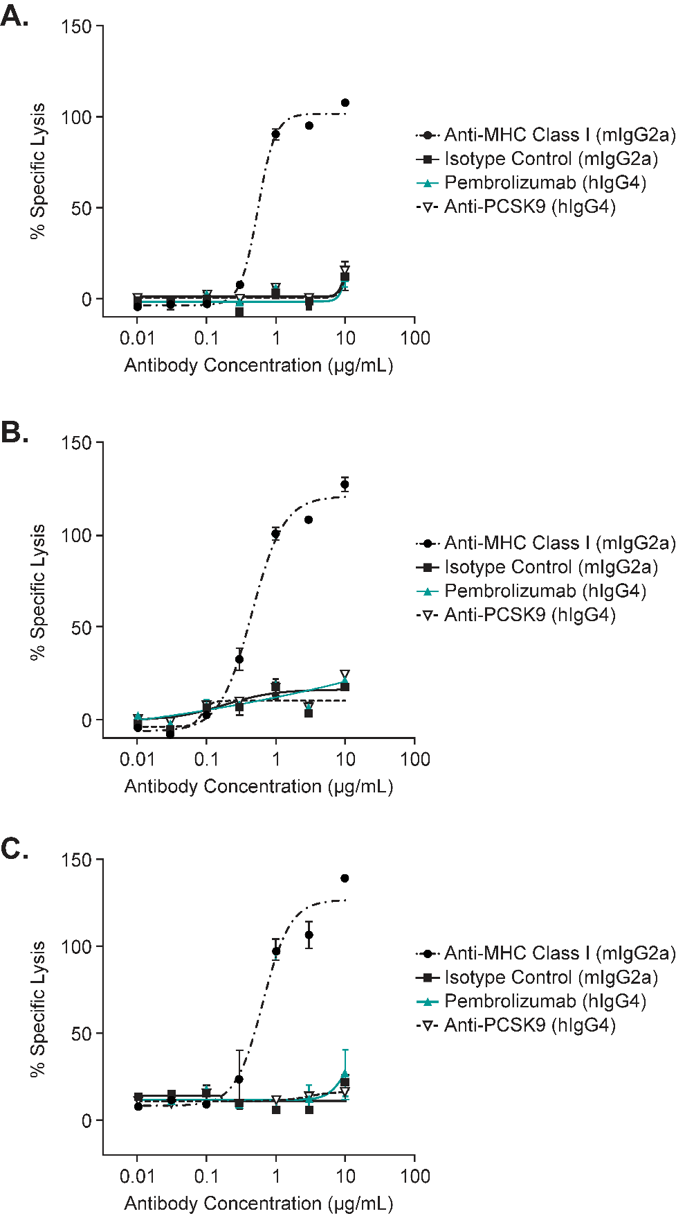
Supplementary Figure S3 shows that pembrolizumab does not induce complement-dependent cytotoxicity (CDC). CDC assays were conducted using activated human CD4+ T cells as target cells and human serum complement as effector molecules. The results are presented as mean ± standard deviation; for some data points, the degree of error was small enough to be contained within the area of the symbol for that data point.
Panels A-C each show the results from a single donor.

