Supplementary Figure S2

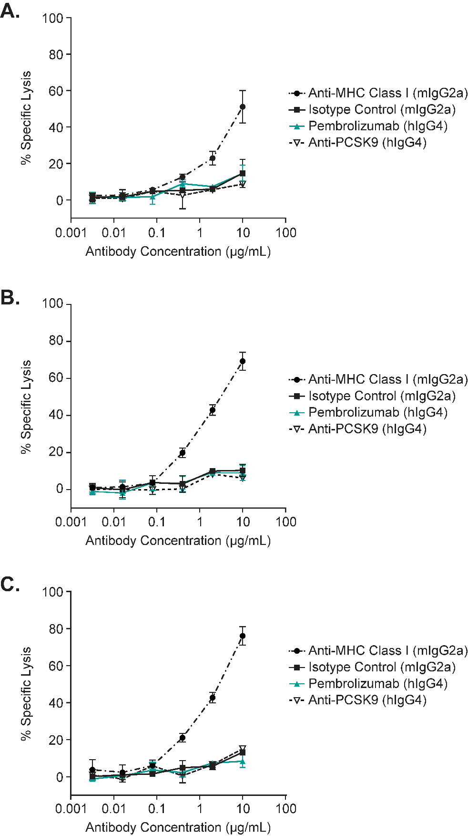
Supplementary Figure S2 shows that pembrolizumab does not induce antibody-dependent cell-mediated cytotoxicity (ADCC). ADCC assays were conducted using activated human PBMC as effector cells and activated human CD4+ T cells as target cells. The results are presented as mean ± standard deviation. Panels A-C each show the results from a single donor.

