Supplementary Figure S1

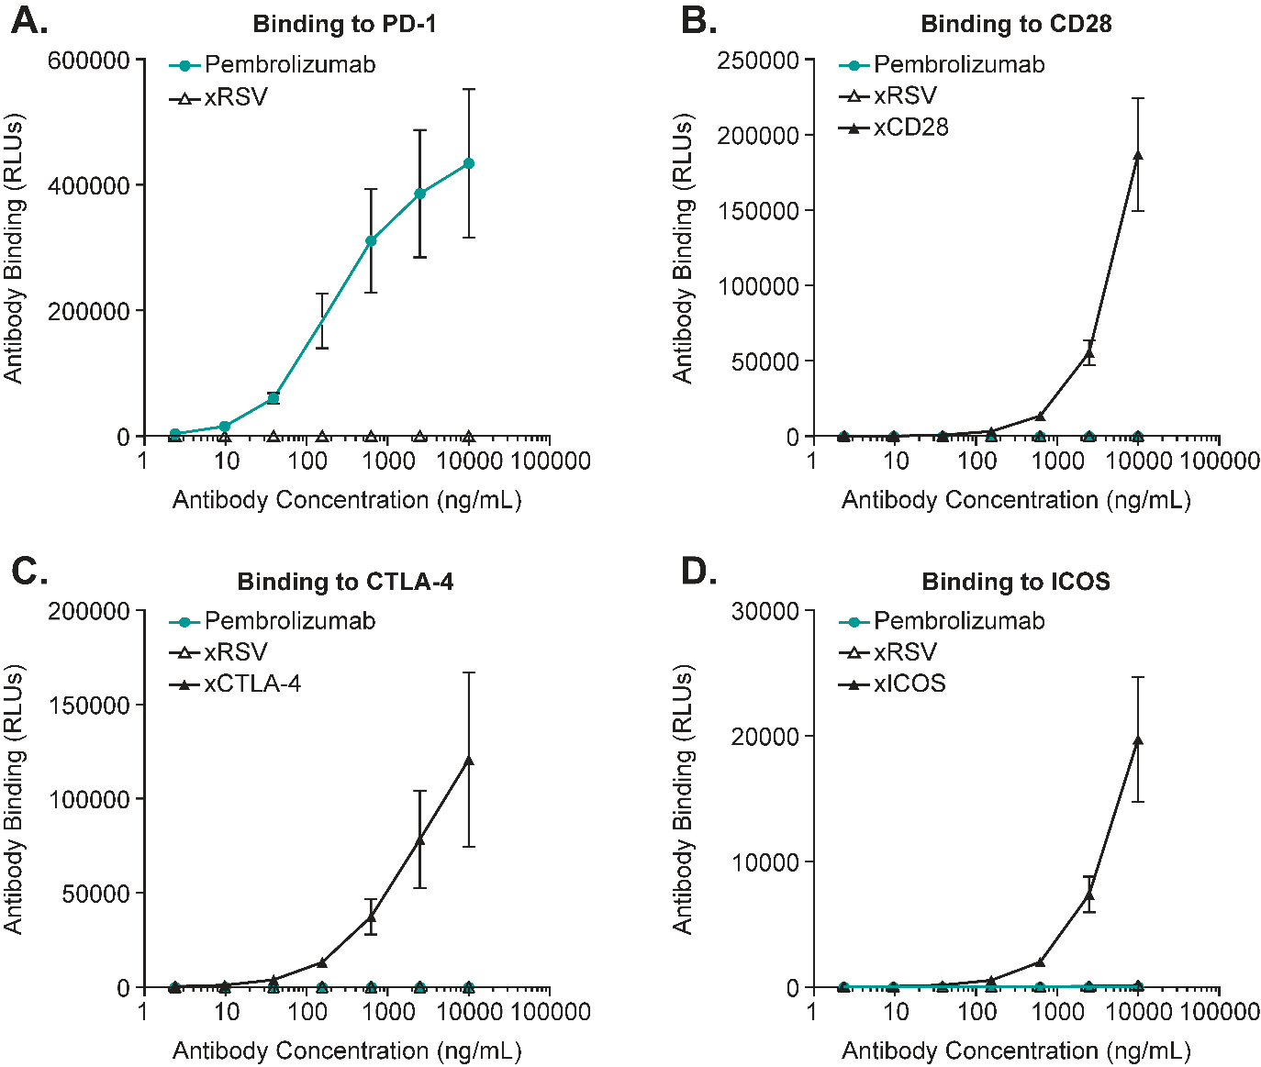

Supplementary Figure S1 shows that pembrolizumab does not bind to immunoglobulin superfamily members CD28, CTLA-4, or ICOS. The results of the electrochemiluminescence immunoassays ECL to assess pembrolizumab binding to immunoglobulin superfamily members are presented as mean relative luminescence units (RLU) ± standard error. Panel A shows binding of pembrolizumab and anti-RSV antibodies to plate-bound human PD-1. Binding to CD28, binding of pembrolizumab, anti-RSV, and anti-CD28 antibodies to plate-bound human CD28 is depicted in Panel B. Panel C shows binding to plate-bound CTLA-4. Panel D depicts binding to plate-bound ICOS.
xRSV = anti-RSV; xCD28 = anti-CD28; xCTLA4 = anti-CTLA-4; xICOS = anti-ICOS.

