Supplementary Data
Supplementary Figure S1
The figure represents the mean tumor volume of each of the four groups of animals that were xenografted with HCT116 cells namely control, irinotecan, pelareorep, and the combination. Error bars represents SEM.
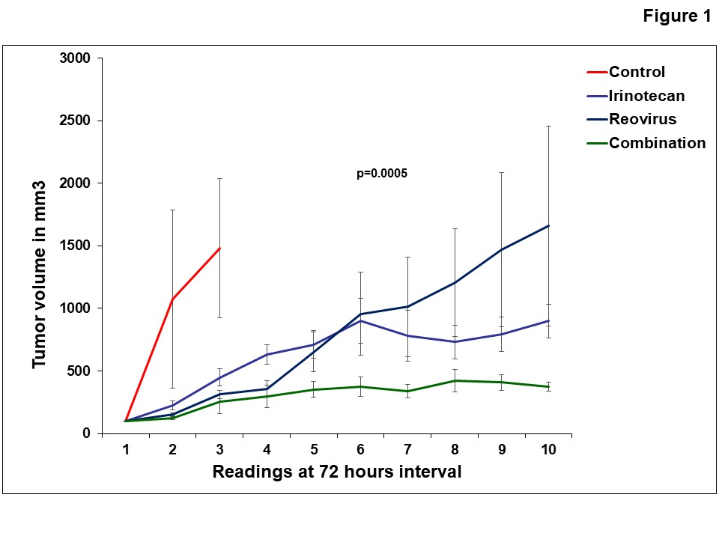

Supplementary Figure S2
This figure reflects the PFS and OS of all enrolled patients and those specifically at the RPTD.

