Supplemental Information

**Overview**

**Supplementary Table S1:** Evaluation of M3814 (MSC2490484) in kinase assays

**Supplementary Table S2:** In vitro activity of M3814 in combination with a single dose of gamma radiation in a panel of 93 cell lines.

**Supplementary Table S3:** Pharmacokinetic data for M3814

**Supplementary Figure S1:** 3 Gy IR – M3814 combination profiling: Bliss data

**Supplementary Figure S2:** 70 Drug – M3814 combination profiling: Bliss data

**Supplementary Figure S3:** Concentration of M3814 in vitro*,* following administration of M3814 intravenously (0.2 mg/kg) or orally (0.5 mg/kg)

**Supplementary Figure S4:** Additional 1-week IR combination efficacy data (A549, BxPC3, Capan-1, HCT-116)

**Supplementary Figure S5:** Scheduling of M3814 relative to IR

**Supplementary Figure S6:** Body weight curves from efficacy studies

**Supplementary Table S1:** Evaluation of M3814 (MSC2490484) in kinase assays

Test facility:

Merck Millipore; Millipore UK Ltd

Gemini Crescent, Dundee Technology Park

Dundee DD2 1SW, UK

Description: In the presence of radioactively-labeled ATP, protein kinases transfer the -phosphate to peptide substrates that are immobilized on filter membranes and quantified by scintillation counting. In the case of lipid kinases, a non-radioactive assay type (Homogeneous Time Resolved Fluorescence HTRF) was used. Recombinantly produced and purified protein/lipid kinases or conventionally purified protein/lipid kinases. Determination of “percent of effect” activity compared with vehicle-treated controls corrected for background activity. M3814 tested at 1 µM (some cases 10 µM) or serially diluted M3814 for IC50 determination

























**Supplementary Table S2:** In vitro activity of M3814 (MSC2490484A) in combination with a single dose of gamma radiation in a panel of 93 cell lines.

Test principle: The test measured the cytotoxicity of the agents using the sulforhodamine B, total protein stain assay. This assay was performed following the recommendations of NCI, as developed through the Developmental Therapeutics Program (NCI/NIH).

Description: Cells were seeded in 96-well microtiter plates and pre-grown for 48 hours before treatment. Treatment was performed for 72 hours and stopped by the addition of trichloracetic acid followed by sulforhodamine B staining. Bliss independence was used as a basis for the calculations. The methods used to calculate synergy have been previously reported [Berenbaum, 1989].

All 94 cell lines (one plate per cell line) were exposed to gamma radiation for 20 min at room temperature at 0.15 Gy/min (part S2A of table). Gamma irradiated and non-irradiated cell lines were handled equally, e.g. the nonirradiated cell lines were placed at room temperature for the same duration of time.

Gamma irradiation with 3Gy showed a broad effect (part S2C-D). Some cell lines were very sensitive to radiation, e.g. 75% effect in MINO cells (only 15% remained alive after exposure), and some showed no effect upon exposure, e.g. SKOV3.

M3814 showed a narrow but > 20-fold activity range, from 500 nM in a set of cell lines to above 10 μM (part S2D of table). For some cell lines, the GI50 values could only be estimated above 10 μM. No activity in resting peripheral blood mononuclear cells (PBMCs) could be detected.

Supplementary Table S2A: Concentrations of M3814 and radiation tested in vitro.

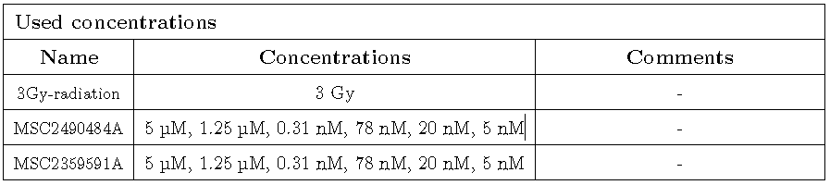

Supplementary Table S2B: Summary of M3814 activity alone and 3 Gy gamma radiation alone.

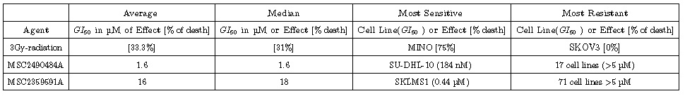

Supplementary Table S2C: Summary of M3814 activity alone and in combination with 3 Gy gamma radiation.

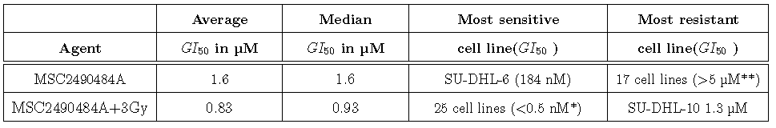

Supplementary Table S2D: IC50 and EC­50 data per cell line

|  |  |  |  |  |  |
| --- | --- | --- | --- | --- | --- |
|  |  | IC50 | | EC50 | |
| **Origin** | **Cell line** | **M3814** | **M3814+3Gy** | **M3814** | **M3814+3Gy** |
| **Prostate** | **22RV1** | 1,450E-06 | 7,210E-08 | 1,942E-06 | 5,845E-08 |
| **Bladder** | **5637** | 2,984E-06 | 1,164E-07 | 4,221E-06 | 1,093E-07 |
| **Kidney** | **786O** | 2,296E-06 | 1,288E-07 | 1,662E-06 | 8,249E-08 |
| **Muscle** | **A204** | 5,155E-07 | 1,162E-07 | 5,074E-07 | 1,133E-07 |
| **Ovary** | **A2780** | 2,106E-06 | 4,728E-08 | 2,840E-06 | 5,773E-08 |
| **Skin** | **A375** | 7,383E-06 | 1,246E-07 | 2,345E-06 | 1,083E-07 |
| **Skin** | **A431** | 1,153E-06 | 1,107E-07 | 1,035E-06 | 8,955E-08 |
| **Lung** | **A549** | 1,031E-06 | 5,645E-08 | 1,019E-06 | 5,169E-08 |
| **Muscle** | **A673** | 3,304E-06 | 1,211E-07 | 4,416E-06 | 1,024E-07 |
| **Kidney** | **ACHN** | 1,230E-06 | 1,614E-07 | 1,008E-06 | 1,483E-07 |
| **Pancreas** | **ASPC1** | 1,473E-06 | 5,186E-07 | 1,781E-06 | 3,820E-07 |
| **Breast** | **BT20** | 2,375E-06 | 1,431E-07 | 7,347E-06 | 1,283E-07 |
| **Pancreas** | **BXPC3** | 1,895E-06 | 8,300E-08 | 1,440E-06 | 5,628E-08 |
| **Cervix** | **C33A** | 2,872E-06 | 8,287E-08 | 5,029E-06 | 7,593E-08 |
| **Colon** | **CACO2** | 2,086E-06 | 2,891E-07 | 2,320E-05 | 1,861E-07 |
| **Kidney** | **CAKI1** | 4,703E-07 | 9,955E-08 | 3,924E-07 | 8,336E-08 |
| **Lung** | **CALU6** | - | 1,126E-07 | 2,521E-06 | 8,596E-08 |
| **Cervix** | **CASKI** | 6,672E-07 | 1,509E-07 | 6,183E-07 | 1,321E-07 |
| **Bladder** | **CLS439** | 1,171E-06 | 2,679E-07 | 1,094E-06 | 1,489E-07 |
| **Colon** | **COLO205** | 4,249E-06 | 9,758E-08 | 3,172E-06 | 8,223E-08 |
| **Colon** | **COLO678** | - | - | 1,322E-06 | 8,026E-08 |
| **Colon** | **DLD1** | 3,803E-06 | 2,454E-07 | 2,644E-06 | 2,294E-07 |
| **Prostate** | **DU145** | 1,812E-06 | 1,260E-07 | 1,524E-06 | 1,132E-07 |
| **Ovary** | **EFO21** | 5,556E-07 | 3,095E-07 | 4,134E-07 | 1,431E-07 |
| **Bladder** | **EJ28** | - | 1,001E-07 | 2,192E-06 | 8,538E-08 |
| **Hematological** | **GRANTA-519** | 1,407E-06 | 1,794E-07 | 7,499E-07 | 1,193E-07 |
| **Colon** | **HCT116** | 5,052E-06 | 1,247E-07 | 4,054E-06 | 1,117E-07 |
| **Colon** | **HCT15** | 2,356E-06 | 9,423E-08 | 1,785E-06 | 1,001E-07 |
| **Kidney** | **HEK293** | - | 9,399E-07 | 5,231E-06 | 8,414E-07 |
| **Cervix** | **HELA** | 9,076E-06 | 1,704E-07 | 2,795E-06 | 1,284E-07 |
| **Liver** | **HEPG2** | 3,004E-06 | 8,095E-08 | 3,378E-06 | 6,228E-08 |
| **Hematological** | **HL-60** | 1,517E-06 | 7,423E-08 | 1,194E-06 | 6,932E-08 |
| **Breast** | **HS578T** | 1,315E-06 | 2,735E-07 | 1,205E-06 | 1,919E-07 |
| **Muscle** | **HS729** | 3,214E-06 | 2,934E-07 | 1,296E-06 | 1,542E-07 |
| **Connective Tissue** | **HT1080** | - | 1,518E-07 | - | 1,382E-07 |
| **Colon** | **HT29** | 2,239E-06 | 1,146E-07 | 2,258E-06 | 1,020E-07 |
| **Ovary** | **IGROV1** | 7,066E-07 | 1,457E-07 | 7,009E-07 | 1,448E-07 |
| **Lung** | **IMR90** | 3,320E-07 | 3,084E-07 | 1,939E-07 | 1,168E-07 |
| **Bladder** | **J82** | 2,875E-06 | 4,420E-07 | 1,211E-06 | 5,807E-08 |
| **Placenta** | **JAR** | - | 4,809E-07 | 2,669E-06 | 4,379E-07 |
| **Placenta** | **JEG3** | - | 1,997E-07 | 1,632E-06 | 1,925E-07 |
| **Breast** | **JIMT1** | 2,869E-06 | 7,990E-07 | 1,795E-06 | 3,895E-07 |
| **Hematological** | **K-562** | 3,567E-06 | 1,249E-07 | 4,118E-06 | 9,310E-08 |
| **Hematological** | **KASUMI-1** | 7,826E-07 | 8,654E-07 | 5,686E-07 | 4,062E-07 |
| **Hematological** | **L-363** | 9,957E-07 | 1,630E-07 | 9,551E-07 | 1,010E-07 |
| **Colon** | **LOVO** | 6,394E-07 | 1,440E-07 | 4,621E-07 | 9,268E-08 |
| **Breast** | **MCF7** | 9,436E-07 | 1,262E-07 | 9,557E-07 | 1,175E-07 |
| **Breast** | **MDAMB231** | - | 1,104E-07 | 1,958E-06 | 1,022E-07 |
| **Skin** | **MDAMB435** | 2,474E-06 | 1,960E-07 | 2,556E-06 | 1,815E-07 |
| **Breast** | **MDAMB436** | 8,676E-07 | 1,558E-07 | 7,313E-07 | 7,092E-08 |
| **Breast** | **MDAMB468** | 1,470E-06 | 1,075E-07 | 1,261E-06 | 9,177E-08 |
| **Bone** | **MG63** | 2,205E-06 | 1,039E-07 | 1,744E-06 | 1,005E-07 |
| **Bone** | **MHHES1** | 5,751E-06 | 4,795E-08 | 2,919E-06 | 4,950E-08 |
| **Pancreas** | **MIAPACA2** | 4,589E-06 | 6,289E-08 | 2,208E-06 | 5,922E-08 |
| **Hematological** | **MINO** | 6,755E-07 | 5,445E-08 | 6,632E-07 | 5,548E-08 |
| **Breast** | **MT3** | 9,727E-07 | 1,252E-07 | 9,075E-07 | 8,421E-08 |
| **Hematological** | **MV4-11** | 1,064E-06 | 7,815E-08 | 1,010E-06 | 7,946E-08 |
| **Lung** | **NCIH292** | 1,164E-06 | 3,241E-07 | 9,818E-07 | 1,991E-07 |
| **Lung** | **NCIH358M** | 2,279E-06 | 2,928E-06 | 2,587E-06 | 8,748E-07 |
| **Lung** | **NCIH460** | 1,105E-06 | 6,838E-08 | 1,063E-06 | 7,500E-08 |
| **Lung** | **NCIH82** | 7,612E-06 | 8,446E-08 | 1,350E-06 | 6,880E-08 |
| **Ovary** | **OVCAR3** | 1,449E-06 | 2,732E-07 | 1,219E-06 | 1,819E-07 |
| **Ovary** | **OVCAR4** | 6,151E-06 | - | 4,070E-06 | 7,265E-08 |
| **Pancreas** | **PANC1** | 3,873E-06 | 1,484E-07 | 2,217E-06 | 1,188E-07 |
| **Pancreas** | **PANC1005** | 2,338E-06 | 1,471E-07 | 2,361E-06 | 1,091E-07 |
| **Hematological** | **PBMC** | - | - | 3,600E-06 | 1,108E-07 |
| **Prostate** | **PC3** | 1,133E-06 | 2,420E-07 | 6,305E-07 | 1,498E-07 |
| **Liver** | **PLCPRF5** | 3,574E-06 | 1,553E-07 | 2,792E-06 | 1,151E-07 |
| **Hematological** | **RAMOS** | 8,715E-07 | 6,365E-08 | 7,800E-07 | 7,051E-08 |
| **Muscle** | **RD** | 6,496E-06 | 3,924E-07 | 2,837E-06 | 1,413E-07 |
| **Bone** | **RDES** | 1,118E-06 | 5,173E-08 | 8,219E-07 | 4,349E-08 |
| **Bone** | **SAOS2** | 1,006E-06 | 1,133E-07 | 8,926E-07 | 6,505E-08 |
| **Brain** | **SF268** | 5,504E-06 | 1,499E-07 | 2,602E-06 | 1,292E-07 |
| **Brain** | **SF295** | 2,026E-06 | 1,332E-07 | 1,824E-06 | 1,233E-07 |
| **Breast** | **SKBR3** | 1,456E-06 | 3,704E-07 | 1,453E-06 | 2,678E-07 |
| **Liver** | **SKHEP1** | - | 1,087E-07 | - | 7,647E-08 |
| **Uterus** | **SKLMS1** | 8,803E-07 | 1,088E-07 | 6,838E-07 | 6,246E-08 |
| **Skin** | **SKMEL28** | 2,893E-06 | 8,171E-07 | 8,142E-07 | 3,339E-07 |
| **Skin** | **SKMEL5** | 2,716E-06 | 2,836E-07 | 1,948E-06 | 2,137E-07 |
| **Brain** | **SKNAS** | - | 3,766E-07 | 7,923E-07 | 1,914E-07 |
| **Ovary** | **SKOV3** | 1,888E-06 | 5,562E-07 | 1,490E-06 | 3,467E-07 |
| **Brain** | **SNB75** | 6,412E-07 | 4,205E-07 | 4,829E-07 | 2,226E-07 |
| **Hematological** | **SU-DHL-10** | - | 9,564E-06 | 3,519E-06 | 1,765E-06 |
| **Hematological** | **SU-DHL-6** | 2,015E-07 | 8,242E-08 | 1,844E-07 | 6,370E-08 |
| **Colon** | **SW620** | 2,956E-06 | 5,827E-08 | 9,581E-07 | 5,691E-08 |
| **Bladder** | **T24** | - | 9,658E-08 | 3,473E-06 | 9,570E-08 |
| **Muscle** | **TE671** | 2,333E-06 | 1,595E-07 | 2,650E-06 | 1,370E-07 |
| **Hematological** | **THP-1** | 1,785E-06 | 1,269E-07 | 1,460E-06 | 7,145E-08 |
| **Bone** | **U2OS** | 4,002E-06 | 3,540E-07 | 2,901E-06 | 2,544E-07 |
| **Brain** | **U87MG** | 5,890E-07 | 1,567E-07 | 4,773E-07 | 1,267E-07 |
| **Bladder** | **UMUC3** | - | 2,552E-07 | 4,598E-06 | 1,478E-07 |
| **Kidney** | **UO31** | 1,231E-06 | 3,244E-07 | 1,353E-06 | 2,287E-07 |
| **Hematological** | **WSU-NHL** | 4,705E-07 | 6,669E-08 | 4,566E-07 | 6,375E-08 |
|  |  |  |  |  |  |
|  | **Mean** | 2,3E-06 | 3,4E-07 | 2,1E-06 | 1,7E-07 |

**Supplementary Table S3:** Pharmacokinetic data for M3814

Description: Five female NMRI mice each were dosed with 0.2 mg/kg M3814 intravenously or 0.5 mg/kg orally. Compounds were dissolved in vehicle (DMSO/PEG200/Water). Plasma and feces samples (0-24 hrs) were taken. Plasma samples were taken at the following time points: i.v. : 0.1, 0.25, 0.5, 1, 2, 4, 6 hrs; oral: 0.25, 0.5, 1, 2, 4, 6 hrs and M3814 was quantified by LC-MS/MS (API 5500 Q-TRAP, MRM, positive ionization method)

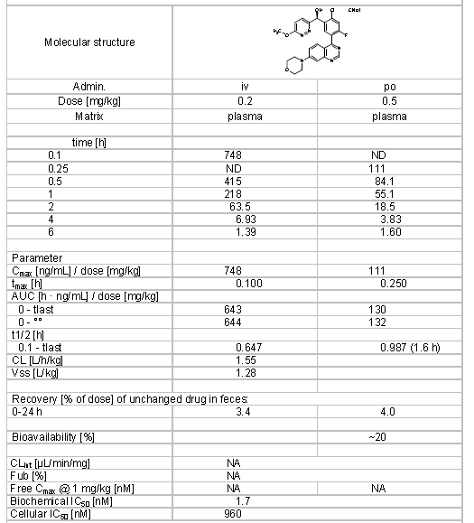

**Supplementary Figure S1:** 3 Gy IR – M3814 combination profiling: Bliss data

Description: The compiled Bliss Independence values clearly demonstrate potentiation - most of the cell lines showed a strongly synergistic effect of interaction.

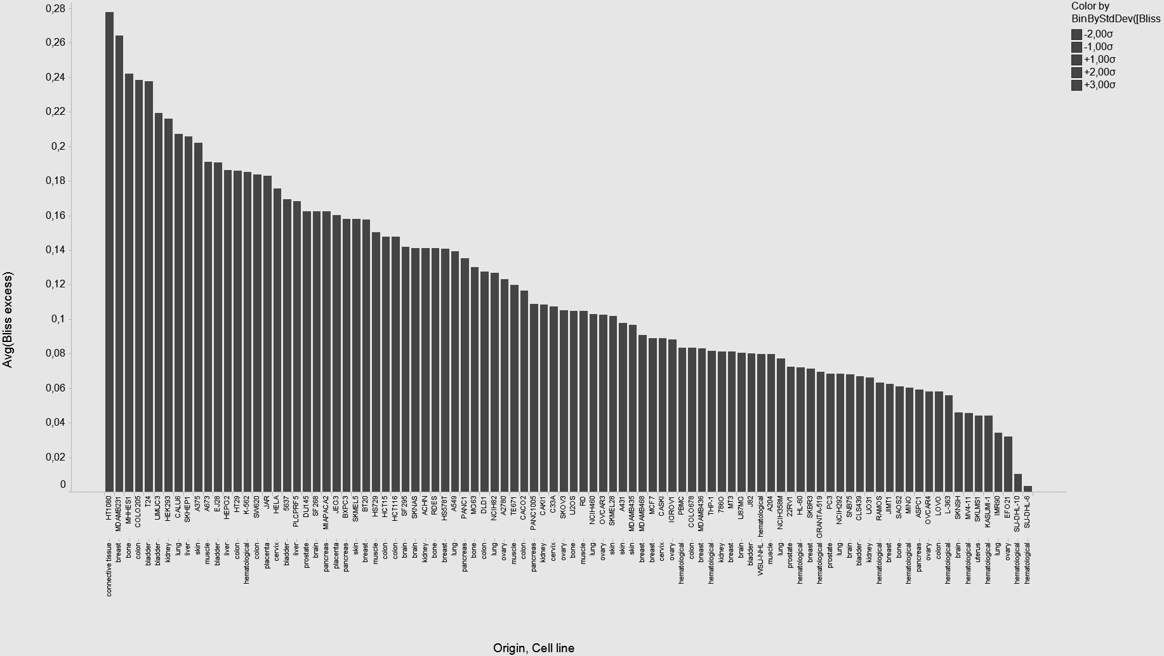

**Supplementary Figure S2:** 70 Drug – M3814 combination profiling: Bliss data

Description: The inhibitory effect of each drug was measured in the presence or absence of 300 nM M3814 and Bliss synergy was calculated. Bliss scores were classified as synergistic (>0.1; red), additive (–0.1≤X≤0.1; white), or antagonistic (<‑0.1; blue)



**Supplementary Figure S3: Concentration of M3814 in vitro*,* following administration of M3814 intravenously (0.2 mg/kg) or orally (0.5 mg/kg)**

Description: Five female NMRI mice each were dosed with 0.2 mg/kg M3814 intravenously or 0.5 mg/kg orally. Compounds were dissolved in vehicle (DMSO/PEG200/Water). Plasma and feces samples (0–24 hrs) were taken. Plasma samples were taken at the following time points: i.v. : 0.1, 0.25, 0.5, 1, 2, 4, 6 hrs; oral: 0.25, 0.5, 1, 2, 4, 6 hrs and M3814 was quantified by LC-MS/MS (API 5500 Q-TRAP, MRM, positive ionization method)

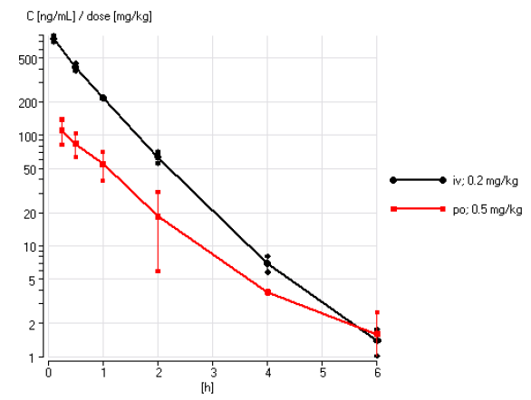

**Supplementary Figure S4:** Additional 1-week IR combination efficacy data (A549, BxPC3, Capan-1, HCT-116)

Description: M3814 (oral gavage 10-minutes before IR) in combination with a 5-day fractionated radiation regime (2 Gy IR fraction/mouse per day) dose-dependently reduced tumor growth in a human A549 (upper left), BxPC3 (upper right), Capan-1 (lower left), and HCT116 (lower right) to a greater extent than IR alone. Data represent the mean +/- SEM (group size N=10).



**Supplementary Figure S5:** Scheduling of M3814 relative to IR

Description: A total dose of 100 mg/kg, split in two fractions of 50 mg/kg, with a 3 hour lag time, was administered by oral gavage in combination with a 5-day fractionated radiation regime (2 Gy IR fraction/mouse per day). Different onset times for M3814 with respect to IR were tested. The first dose of M3814 was administered either 10 minutes prior to IR, 3 hours after IR, or 6 hours after IR. M3814 showed a clear combination benefit with IR when dosed 10 minutes prior to IR. Administration of M3814, 3 or 6 hours after IR, did not result in a significant antitumor effect when compared with IR alone. Data represents the mean +/- SEM (group size N=10).



**Supplementary Figure S6:** M3814 in combination with IR has antitumor activity in mouse xenograft models.

Description: M3814 (oral gavage 10-minutes before IR) was administered in combination with a 1-week (2 Gy IR fraction/mouse per day, 5 days on – 2 days off) or 6-week fractionated radiation regime. The body weight curves for the xenograft studies shown in Figures 4 A-D are shown from top to bottom.

Supplementary Figure S6A: Relative body curves for FaDu xenograft study from Figure 4A.



Supplementary Figure S6B: Relative body curves for NCI-H460 xenograft study from Figure 4B.



Supplementary Figure S6C: Relative body curves for FaDu xenograft study from Figure 4C.

Supplementary Figure S6D: Relative body curves for NCI-H460 xenograft study from Figure 4D.

