Supplementary Data

Supplementary Figure S2. CEA response over time in a 47-year-old patient with GEC responding to telisotuzumab
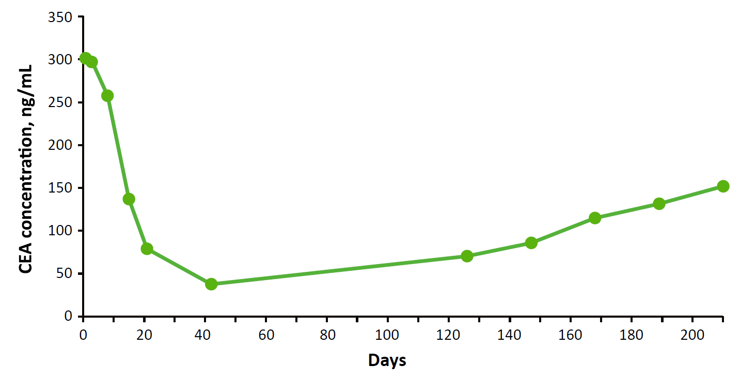
CEA, carcinoembryonic antigen; GEC, gastric or esophageal cancer.

