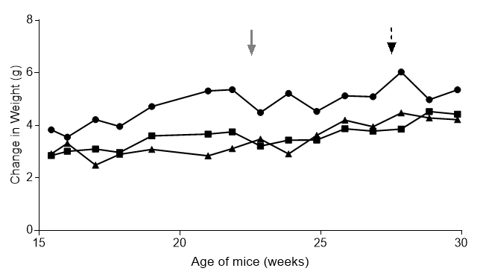

Supplemental Figure 6. Weights were collected from n=7 to 20 TgMMTV-neu mice per group at various times throughout the study; average weight is represented over age of untreated (circle), 20mM 2FF (square) and 50mM 2FF (triangle) treated mice. The solid gray arrow represents end of 50mM 2FF treatment, dashed black arrow represents end of 20mM 2FF treatment.

