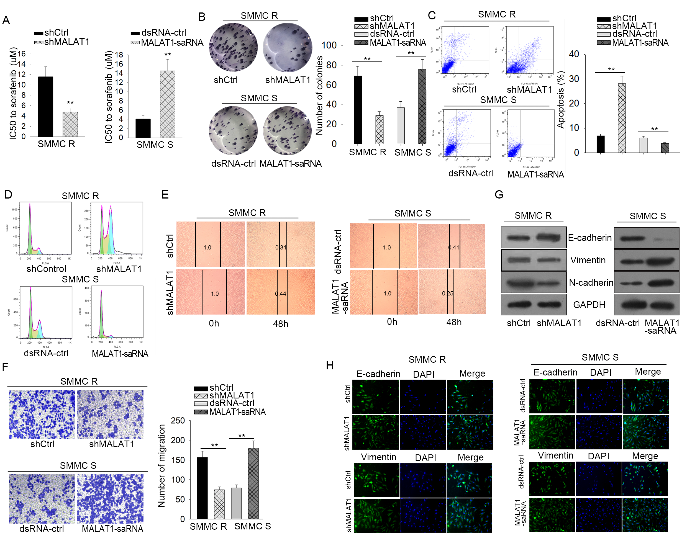
Supplementary Figure 1. MALAT1 modulated the sensitivity of HCC cells to sorafenib and facilitated HCC progression. A total of 4 groups of cells were applied in this part: SMMC R cells transfected with shMALAT1 or shCtrl; SMMC S cells transfected with MALAT1-saRNA or dsRNA-Ctrl; (A) MTT assay was used to evaluate IC50 of above cells. (B-H) The effects of MALAT1 on HCC cells proliferation, apoptosis, migration and EMT were assessed by using colony formation assay (B), flow cytometry analysis (C-D), would healing assay (E), Transwell assay (F), western blotting (G), and IF staining (H). *p < 0.05; **p < 0.01.
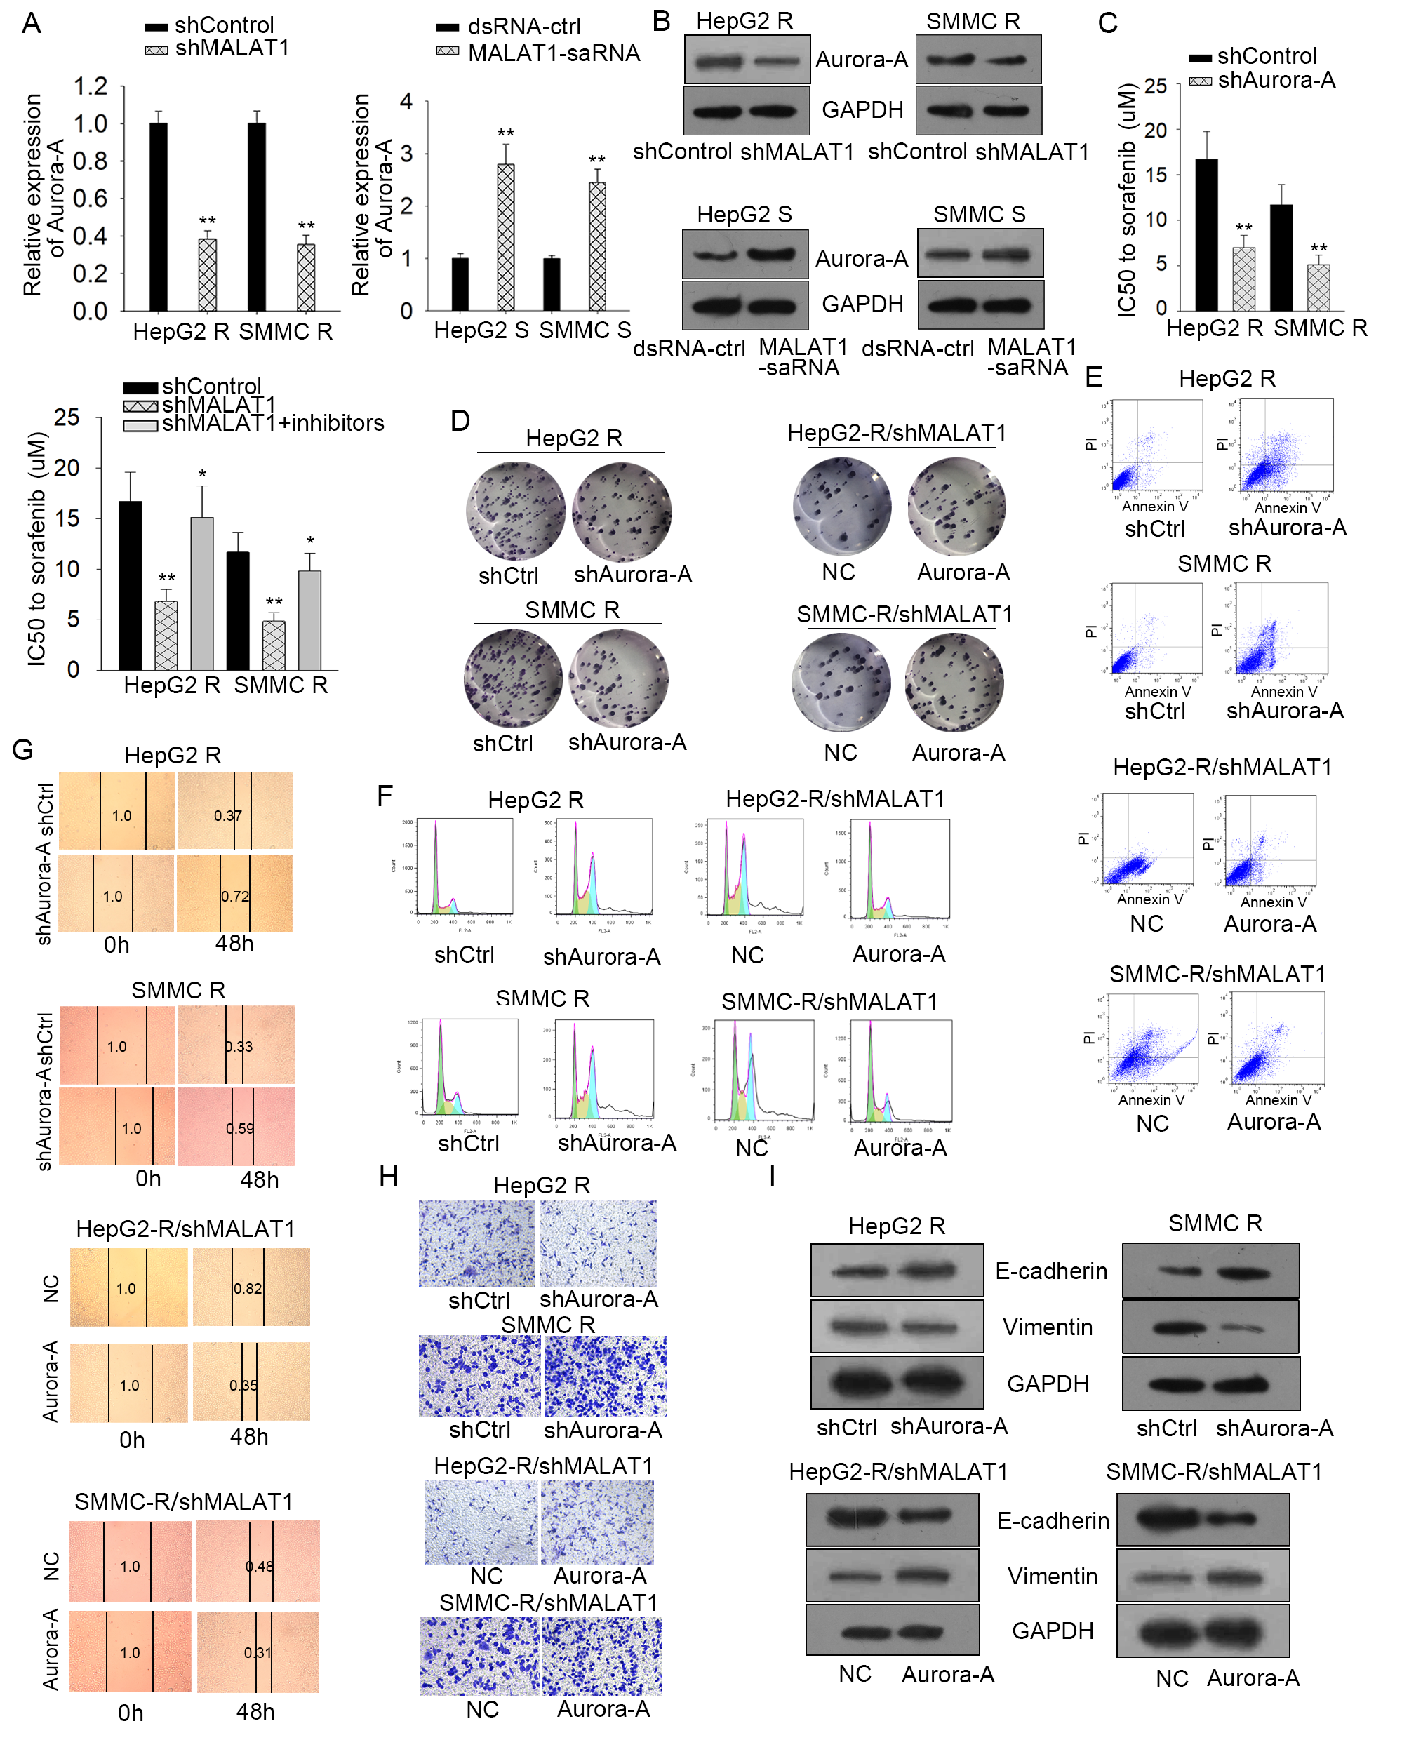

Supplementary Figure 2. Aurora-A involved in MALAT1-promoting sorafenib resistance of HCC cells. (A-B) The mRNA and protein levels of Aurora-A were tested by qRT-PCR analysis in HCC cells transfected with shMALTA1 and MALAT1-saRNA. (C-I) The role of Aurora-A in MALAT1 mediated sorafenib resistance in HCC cells was determined by MTT assay (C), colony formation assay (D), flow cytometry analysis (E-F), would healing assay (G), Transwell assay (H), western blotting of EMT markers (I). *p < 0.05; **p < 0.01.

