Supplementary Figure S9.

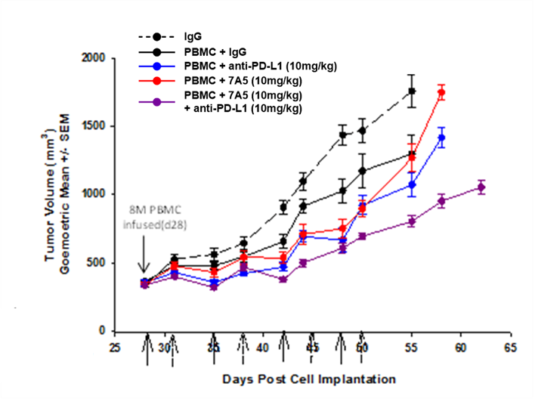

Figure S9. Antitumor efficacy of combination therapy in the L55 NSCLC tumor xenograft model. On day 28 post L55 tumor cell implantation, human PBMCs were injected into NSG mice and treatment initiated. Mice received 10mg/kg of control human IgG1, 7A5, anti-PD-L1 antibody, or the combination of both 7A5 and anti-PD-L1. Weekly dosing is indicated by solid arrow (anti-PD-L1 and IgG) and dashed arrow (7A5). Tumor volume data was analyzed from day 28 through day 55. Geometric tumor volumes are presented as mean ± SEM. Monotherapy did not inhibit tumor growth (7A5 T/C% =99, P=0.832 and anti-PD-L1 T/C% =77, P=0.079) whereas combination of both agents showed antitumor efficacy (T/C% =49, P<0.001). The combination effect was additive as defined by Bliss Independence Method (P=0.03 vs anti-PD-L1, P<0.001 vs 7A5).

