**Supplementary Figure S7.**

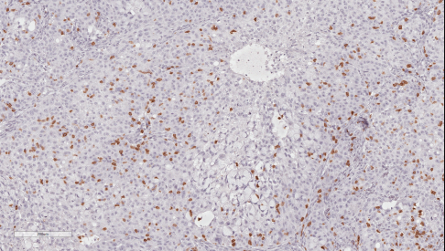

++

**IgG**

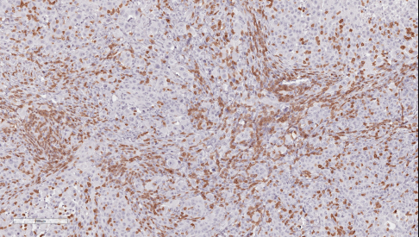

+++

**7A5**

Figure S7. Enhanced T cells in 7A5 treated L55 established human tumor xenografts reconstituted with human immune cells in vivo. CD3 T cell IHC of L55 tumors collected from 7A5 or control human IgG1 treated NSG mice. Representative images of CD3 staining are depicted (200x magnification).