Supplementary Figure S5.

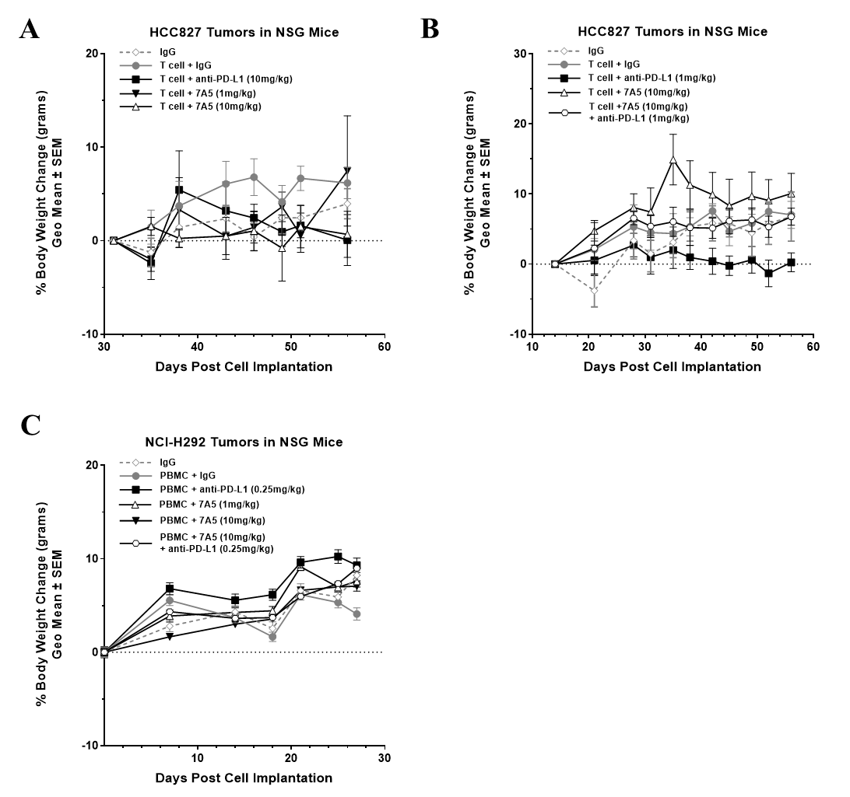

Figure S5. Body weight graphs of humanized murine in vivo models treated with CD137 antibody 7A5. (A) Dose response study in HCC827 established tumor model. (B) Combination therapy study in HCC827 established tumor model. (C) Dose response and combination therapy study in NCI-H292 human tumor xenograft mouse model.

