Supplementary Figure S1. Comparative potency of tucatinib, neratinib, and lapatinib in cellular HER2 and EGFR phosphorylation assays
Inhibition of HER2 and EGFR phosphorylation by tucatinib, neratinib, or lapatinib in tumor-derived cell lines. BT-474, A431, and NCI-N87 cells were treated with tucatinib, neratinib, or lapatinib using an 11-point titration. Samples were analyzed by ELISA using a protein or phospho-specific protein (anti-HER2, anti–phospho-HER2, anti-EGFR, anti–phospho-EGFR). Results are expressed as total phosphoprotein signal normalized to total protein ± SD.
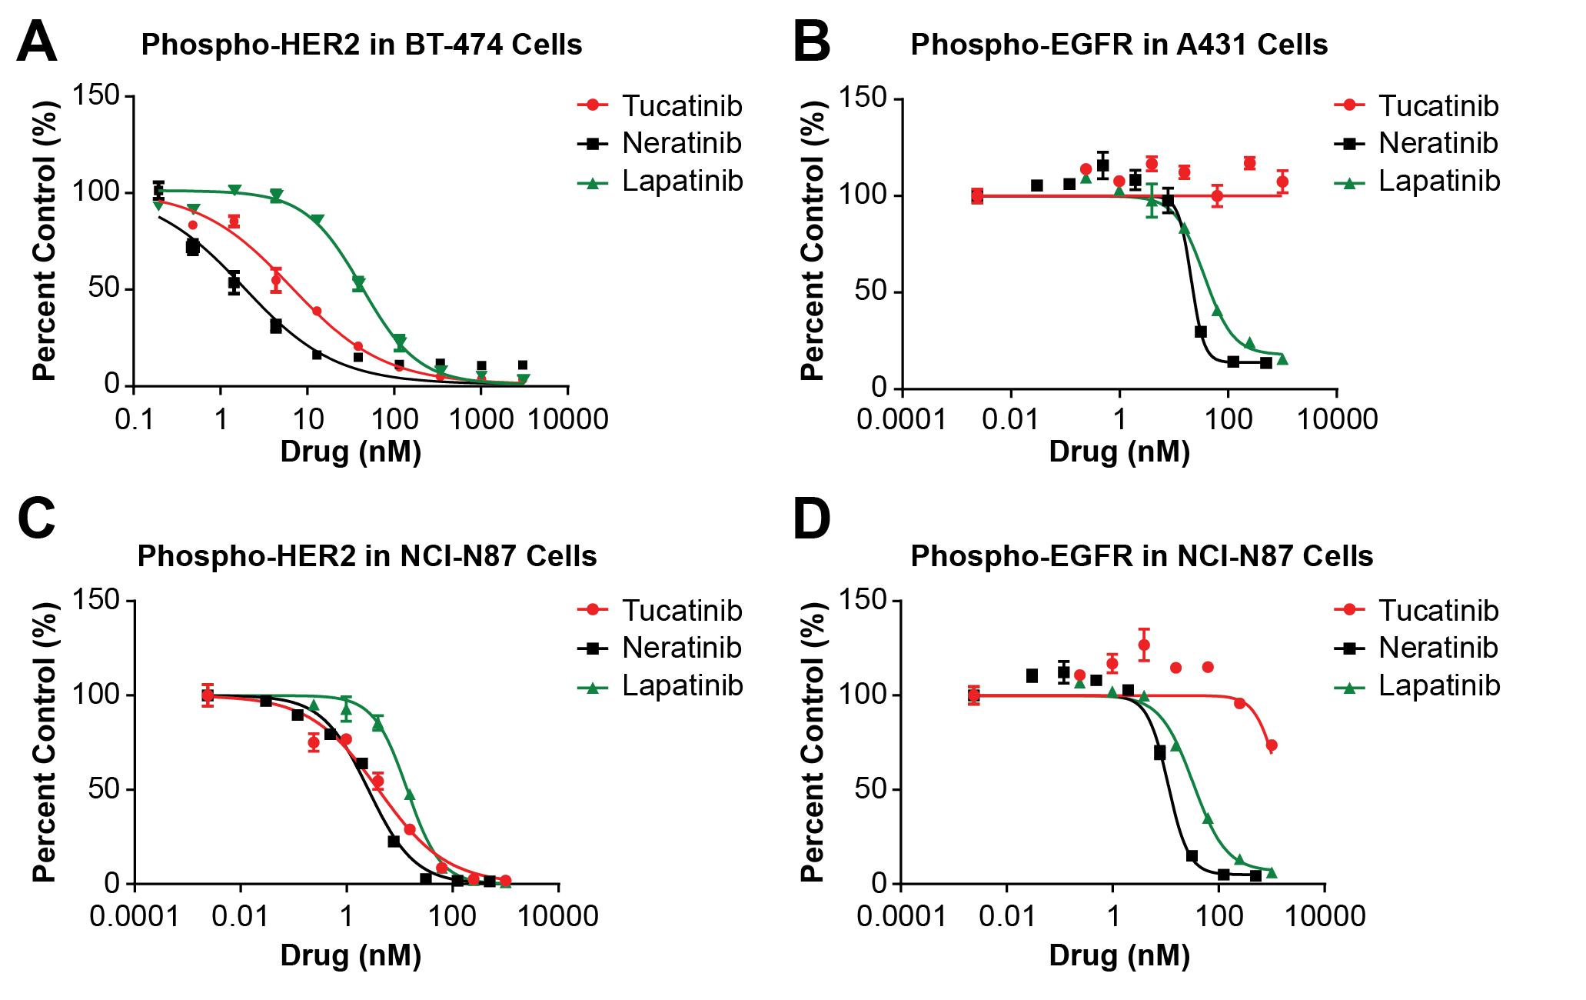

Supplementary Figure S2. Effect of tucatinib, trastuzumab, or combination treatment on mouse body weight in HER2+ PDX models
Percent body weight change in mice treated with vehicle, 50 mg/kg BID tucatinib, 20 mg/kg QW trastuzumab or the combination of tucatinib + trastuzumab. Error bars represent ± SEM.
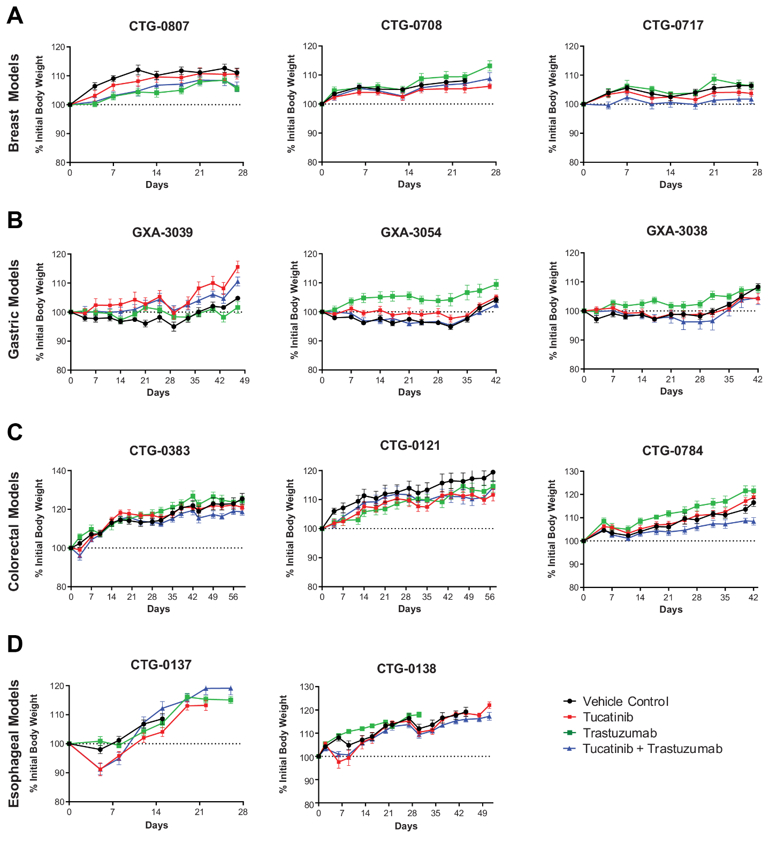
Supplementary Table S1. Tucatinib activity correlates with HER2 surface receptor density
Cell line | HER2 status | HER2 expression | Tucatinib potency  (EC₅₀ in nM) | T-DM1 potency  (EC₅₀ in ng/mL)
HCC-1419 | High | 1,515,661 | 23 | 704
SK-BR-3 | High | 1,384,157 | 27 | 13
HCC-1954 | High | 1,259,398 | 50 | 7
ZR-75-30 | High | 1,240,426 | 156 | 79
AU-565 | High | 1,153,419 | 33 | 31
HCC-1569 | High | 938,858 | 249 | 118
HCC2218 | High | 905,340 | 18 | 52
BT-474 | High | 864,064 | 33 | 191
UACC-893 | High | 775,719 | 431 | > 25000
UACC-812 | High | 722,241 | 64 | 37
HCC-202 | High | 303,584 | 282 | 40
JIMT-1 | Low | 123,626 | 15147 | 1395
BT-483 | Low | 82,187 | > 25000 | > 25000
CAMA-1 | Low | 57,568 | 7309 | 4997
T47D | Low | 25,797 | 4938 | > 25000
MCF7 (ATCC) | Low | 20,855 | 10020 | > 25000
MCF7 (NCI) | Low | 17,859 | > 25000 | > 25000
MDA-MB-231 | Low | 4,350 | 16482 | > 25000
MDA-MB-436 | Negative | 1,702 | 17601 | 23878
Hs578T | Negative | 1,663 | 12394 | 11493
MDA-MB-468 | Negative | 1ª | 9617 | 7695
DU4475 | Negative | 1ª | 8973 | > 25000
T-DM1, ado-trastuzumab emtansine.
ª Expression below the quantifiable level of detection.
Tucatinib activity was investigated in 22 breast cancer cell lines with or without HER2 overexpression.

Supplementary Table S2. HER2 copy number variation in PDX models
Model | Histology | HER2 Copy Number (NGS)
CTG-0807  CTG-0708  CTG-0717 | Breast Cancer  Breast Cancer  Breast Cancer | 68*  69*  77*
CTG-0137 | Esophageal Cancer | 85*
CTG-0138 | Esophageal Cancer | 60*
CTG-0121 | Colorectal | 34*
CTG-0383 | Colorectal | 41*
CTG-0784 | Colorectal | 80*
Model | Histology | HER2 Copy Number (PICNIC score)
GXA-3038 | Gastric | 12#
GXA-3039 | Gastric | 14#
GXA-3054 | Gastric | 14#

*HER2 copy number provided by Champions Oncology and are based on NGS analysis of PDX tumor samples.
#HER2 copy number provided by Charles River Laboratories and are based on Affymetrix® Genome-Wide Human SNP Array 6.0.

