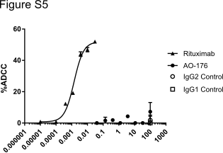

Figure S5: AO-176 does not induce ADCC of Raji tumor cells. Raji cells loaded with calcein-am were incubated with 0.01 ng/ml – 100 µg/ml AO-176 followed by co-culture with NK cells. Targeted killing of Raji cells was determined by measurement of released calcein by measuring fluorescence at 490 nm excitation/520 emission. Rituxan was used as a positive control.

