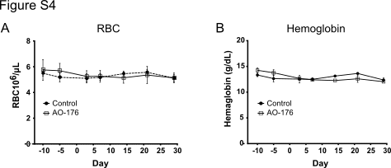

Figure S4: Minimal reduction in RBC and hemoglobin in cynomolgus monkeys treated with 5 and 50 mg/kg AO-176. Female cynomolgus monkeys (3 animals/group) were treated with vehicle (PBS) or with 5 mg/kg of AO-176 on day 1 and 50 mg/kg of AO-176 on days 8, 15 and 22, respectively, by 1 hour intravenous infusions. Blood samples were obtained at various times after the infusions and assessed for hematological parameters including (A) RBCs and (B) hemoglobin.
positive control.

