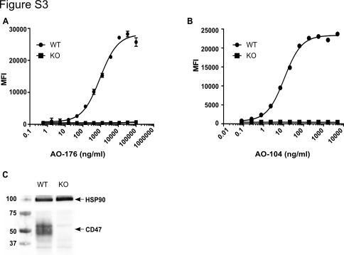

Figure S3: AO-176 binding to Jurkat CD47 wildtype (WT) and CD47 knockout (KO) cells. (A) Binding of AO-176 to Jurkat T-ALL and Jurkat knockout cells that do not express CD47 was determined by flow cytometry. (B) Binding of AO-104 to Jurkat T-ALL and Jurkat knockout cells that do not express CD47 was determined by flow cytometry. (C) Western blot detection of CD47 in Jurkat CD47 WT and KO cells. CD47 was detected using B6H12 antibody. Detection of HSP90 levels was used to compare protein loading.

