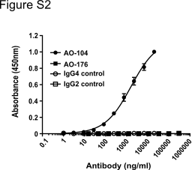
Figure S2: AO-176 does not bind to mouse CD47. Binding of AO-176 to recombinant His-tagged mouse CD47 was determined by solid phase ELISA. AO-104, a mouse CD47 cross reactive antibody, was used a positive control.

