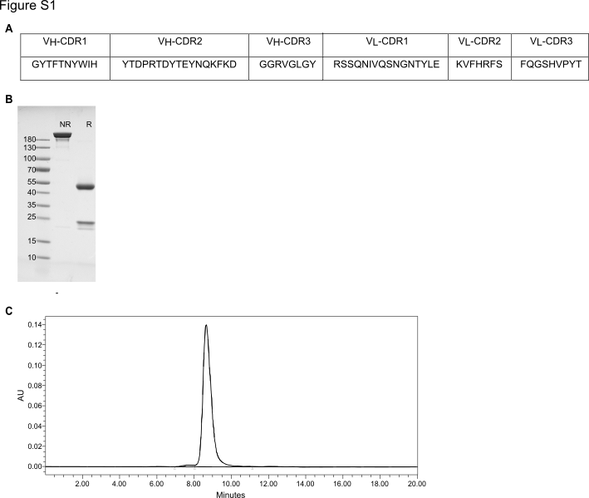
Figure S1: AO-176 CDR sequence and analytical profile. (A) antigen binding regions (CDRs 1-3) from the light and heavy variable regions of AO-176 (B) non-reducing (NR) and reducing (R) gel electrophoresis of AO-176. Protein was resolved by SDS-PAGE and the gel was stained using Coomassie brilliant blue R-250 dye. (C) analytical size exclusion chromatography (TSKgel G3000SWxl, 1ml/min, mobile phase 1xPBS) of native non-denatured AO-176 (monomer 98.4%, HMW 1.6%).

