Supplementary Figure S2. Pharmacodynamic Biomarkers (IHC for Ki-67, p27 and p-ERK)
Supplementary Figure S2 shows two cases of patients treated at the RP2D. IHC at Clarient for p-ERK, p27 and Ki-67 were assessed for PD effect using monoclonal rabbit phospho-p44/42 MAPK (ERK1/2), 20G11 Clone; monoclonal mouse anti-Ki67, MIB-1 clone; and monoclonal mouse anti-p27, SX53G8 clone. In (A), the patient is a 56-year old female patient with rectal neuroendocrine cancer who is KRAS and BRAF wild-type. No differences in staining for the 3 biomarkers were observed when baseline and Day 28 samples were compared. In (B), the patient is a 26-year old male patient with hepatocellular carcinoma with unknown mutational status. No differences in staining for Ki-67 or p27 were observed when baseline and Day 28 samples were compared. The p-ERK staining is poor quality and not interpretable.
Abbreviations: IHC, immunohistochemistry; PD, pharmacodynamics; RP2D, recommended phase 2 dose
- Patient with Rectal Neuroendocrine cancer who is KRAS and BRAF wild-type.
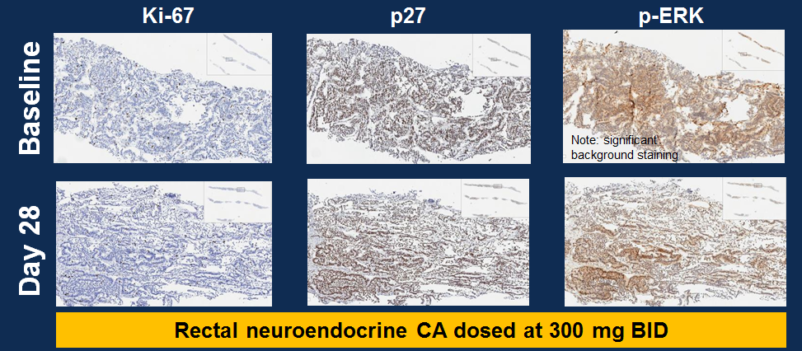

B) Patient With Hepatocellular Carcinoma With Unknown Mutational Status
