SUPPLEMENTARY MATERIAL AND METHODS
Cell culture, and PARP inhibitor resistance establishment
PEO1 cells were obtained from The University of Colorado Gynecologic Tumor and Fluid Bank. Cells were cultured in RPMI1640 supplemented with 10% fetal bovine serum and 1% penicillin/streptomycin. The PEO1 olaparib resistant cell line was established by a stepwise exposure to increasing concentrations of olaparib from 15 nM to 128 μM. The established resistant cells were maintained in 2 μM olaparib. All cells lines were tested for mycoplasma using LookOut mycoplasma PCR detection kit (Sigma, cat. # MP0035). PEO1 and PEO1 olaparib resistant were tested on August 26th 2019. Cell lines were authenticated at University of Arizona Genetics Core.

Doxorubicin release
Cells were treated with 5μM doxorubicin for 2 hours and cells were then incubated in doxorubicin-free medium for 2 hours. FACS was performed on a LSR18 and analyzed with FlowJo software.

Reagents and Antibodies
As previously described [1]. Anti-BrdU (BD Biosciences, cat. No. 347583). Cells were imaged with Eclipse Ti microscope (Nikon).

SUPPLEMENTARY FIGURE LEGENDS

Figure S1. Characterizing Capan1 olaparib resistant cells and establishment of rucaparib resistant Capan1 cells. A) Equal numbers of Capan1 (Black line) Capan1-OR-Het (Red line) cells plated and treated with increasing doses of rucaparib. After 12 days colonies were fixed and stained with crystal violet. Crystal violet was dissolved and absorbance was used to determine percent colony formation. B) Equal numbers of Capan1 (blue line) Capan1-OR-Het (Red line) cells plated and counted over time. Two sided t-test, **p<0.001. C) Equal numbers of Capan1 (blue line) Capan1-OR-Het (Red line) cells plated and c incubated with BrdU for 60 min. Cells were fixed and stained against BrdU-FITC. D) Same as C, BrdU positive cells were quantified. Two sided t-test, **p<0.001. E) A BRCA2-mutated cell line (Capan1) was treated with increasing doses of a PARP inhibitor (PARPi; rucaparib) in step-wise fashion. Rucaparib Resistant (RR) Capan1-RR sub-clones were plated in equal numbers and treated with indicated doses of rucaparib. IC50 doses for each clone are indicated. F) Same as A, but Capan1-RR sub-clones were treated with indicated doses of olaparib. G) Same as A, but Capan1-RR sub-clones were treated with indicated doses of cisplatin. Data is representative of 3 independent experiments. Error bars = S.E.M.

Figure S2. Drug efflux is unchanged in Capan1 olaparib resistant cells and truncated BRCA2 is overexpressed in rucaparib resistant Capan1 cells. A) Capan1 (parental), Capan1-OR-Het, Capan1-OR-1, and -2 cells were treated with doxorubicin for 2 hours or doxorubicin for 2 hours followed by 2 hours without doxorubicin. Cells were then used for FACS analysis to determine percentage of doxorubicin positive cells. Percentage change for each cell is shown. B) Genomic DNA was isolated from Capan1, Capan1-OR-Het, CAPAN1-OR-1 and 2. BRCA2 was sequenced at mutation site (6174delT). Error bars = S.E.M. C) BROCA-HRv7 targeted sequencing assay.

Figure S3. Capan1 olaparib resistant cells express truncated BRCA2. A) Schematic of wild-type and truncated BRCA2 protein with indicated antibody binding sites. B) Protein was extracted from BRCA2 wild-type (TOV-21G), Capan1 (parental), Capan1-OR-1 and -2 (resistant clone 1 and 2) cells. Protein was utilized for immunoprecipitation (IP) against BRCA2 (Ab-1 or Ab-2). Immunoprecipitated protein was used for immunoblot against for BRCA2. C) Nuclear (N) and cytoplasmic (C) protein was isolated from Capan1 parental (P) and Capan1-RR-6, -7, -8, and -13. Protein was used for an immunoblot against BRCA2 (Ab-1, n-terminus) and Tubulin (Loading control). Data is representative of at least 3 independent experiments.

Figure S4. Capan1 PARP inhibitor resistant cells form Rad51 and BRCA1 foci after irradiation. A) Capan1 (parental) and Capan1-OR-Het (resistant) cells were irradiated with 5 Gy and incubated for 4 hours, fixed, and used for immunofluorescence against RAD51 (green), BRCA1 (red) and nuclei (DAPI). White arrowheads indicate BRCA1 and Rad51 foci. White arrowheads indicate representative RAD51/BRCA1 foci. B) Quantification of irradiated Capan1-OR-Het cells from panel A. Counted 200 cells per condition. P-values calculated with ANOVA. C) Capan1-RR sub-clones were irradiated with 10 Gy for and incubated for 4 hours, fixed, and used for immunofluorescence against RAD51 (green) and nuclei (DAPI). D) Quantification of C. Counted 200 cells per condition. P-values calculated with ANOVA. Data is representative of 3 independent experiments. Error bars = S.E.M.

Figure S5. BRCA2 knockdown sensitizes Capan1 olaparib resistant cells. A) Capan1-OR-Het cells were transduced with shControl or shBRCA2. Following drug selection equal number of cells were plated in 24-well plates and incubated with increasing doses of olaparib for 12 days. Cells were then fixed and stained with crystal violet. Representative images of foci formation are shown. B) Same as A, but quantification of foci formation. C) Capan1-RR-8 cells were transduced with shControl or shBRCA2. Following drug selection equal number of cells were plated in 24-well plates and incubated with increasing doses of olaparib for 12 days. Cells were then fixed and stained with crystal violet. Percentage of colony numbers over control is graphed. Data is representative of 2 independent experiments. Data is representative of 3 independent experiments. Error bars = S.E.M.

Figure S6. BRCA2 peptide coverage and pinometostat-mediated reduction in H3K79Me. A) Protein from irradiated (5 Gy) Capan1-OR-1 cells was used for a BRCA2 immunoprecipitation followed by mass spectrometry. The peptides detected are highlighted in yellow. B) Capan1-OR-1 cells were treated with increasing dose of the DOT1L inhibitor (pinometostat) for 24 hrs, histones were isolated, and immunoblotted for H3K79Me. Ponceau = Loading control. C) Kaplan-Meier curve of patients with serous histotype ovarian cancer with either “high” or “low” DOT1L expression. Median expression of DOT1L used to identify high or low expression. Statistical test = log rank. D) DOT1L expression (x-axis) in cisplatin sensitive and resistant ovarian serous cystadenocarcinoma from the TCGA dataset. E) The PEO1 (TP53 and BRCA2-mutated) ovarian cancer cell line incubated with increasing doses of olaparib established a PEO1 olaparib resistant (PEO1-OR) cell line. Resistance was confirmed using colony formation assay with increasing doses of olaparib. F) An shControl (shCtrl) or two independent shDOT1L (#1 and #2) were transduced into PEO1-OR cells and a viability was assessed via colony formation. G) Same as F but is a quantification via integrated density of colonies. ANOVA, ***p < 0.0001. H) BRCA2^{-/-} and BRCA2 del6174T DLD-1 cells transduced with an overexpression lentiviral construct specific for DOT1L. Protein lysates were immunoblotted against DOT1L. Loading Control = Vinculin. Statistical test = ANOVA. Error bars = SEM.

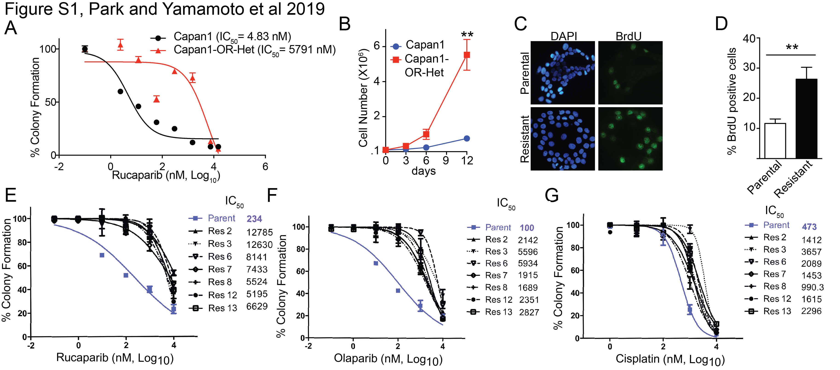

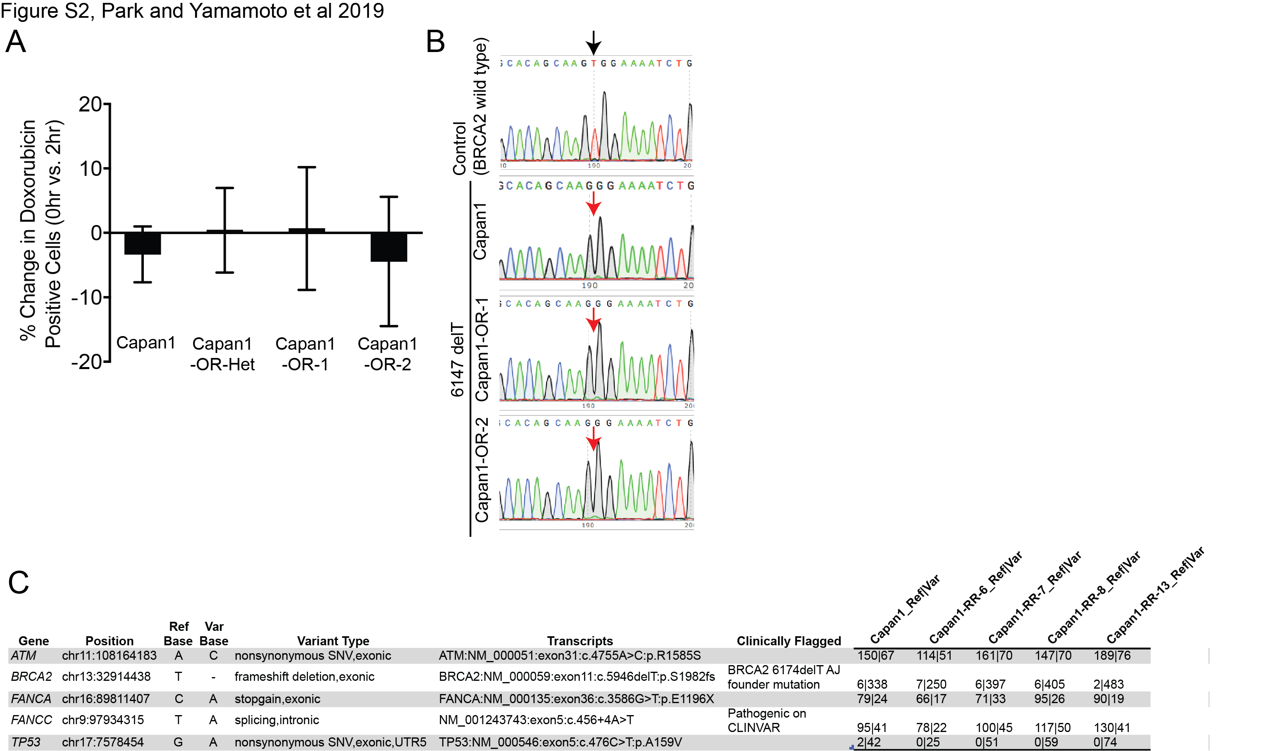

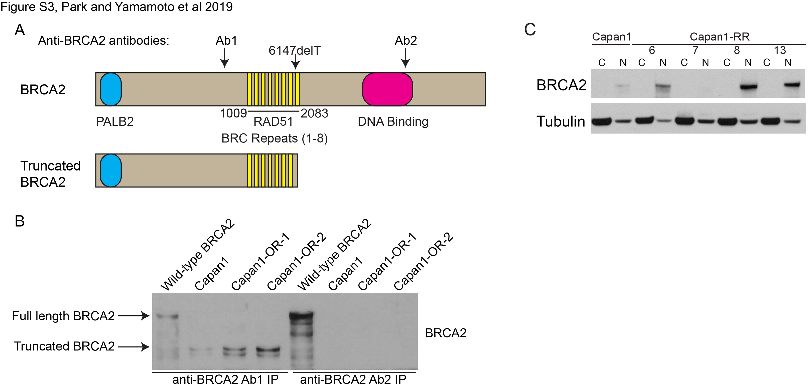
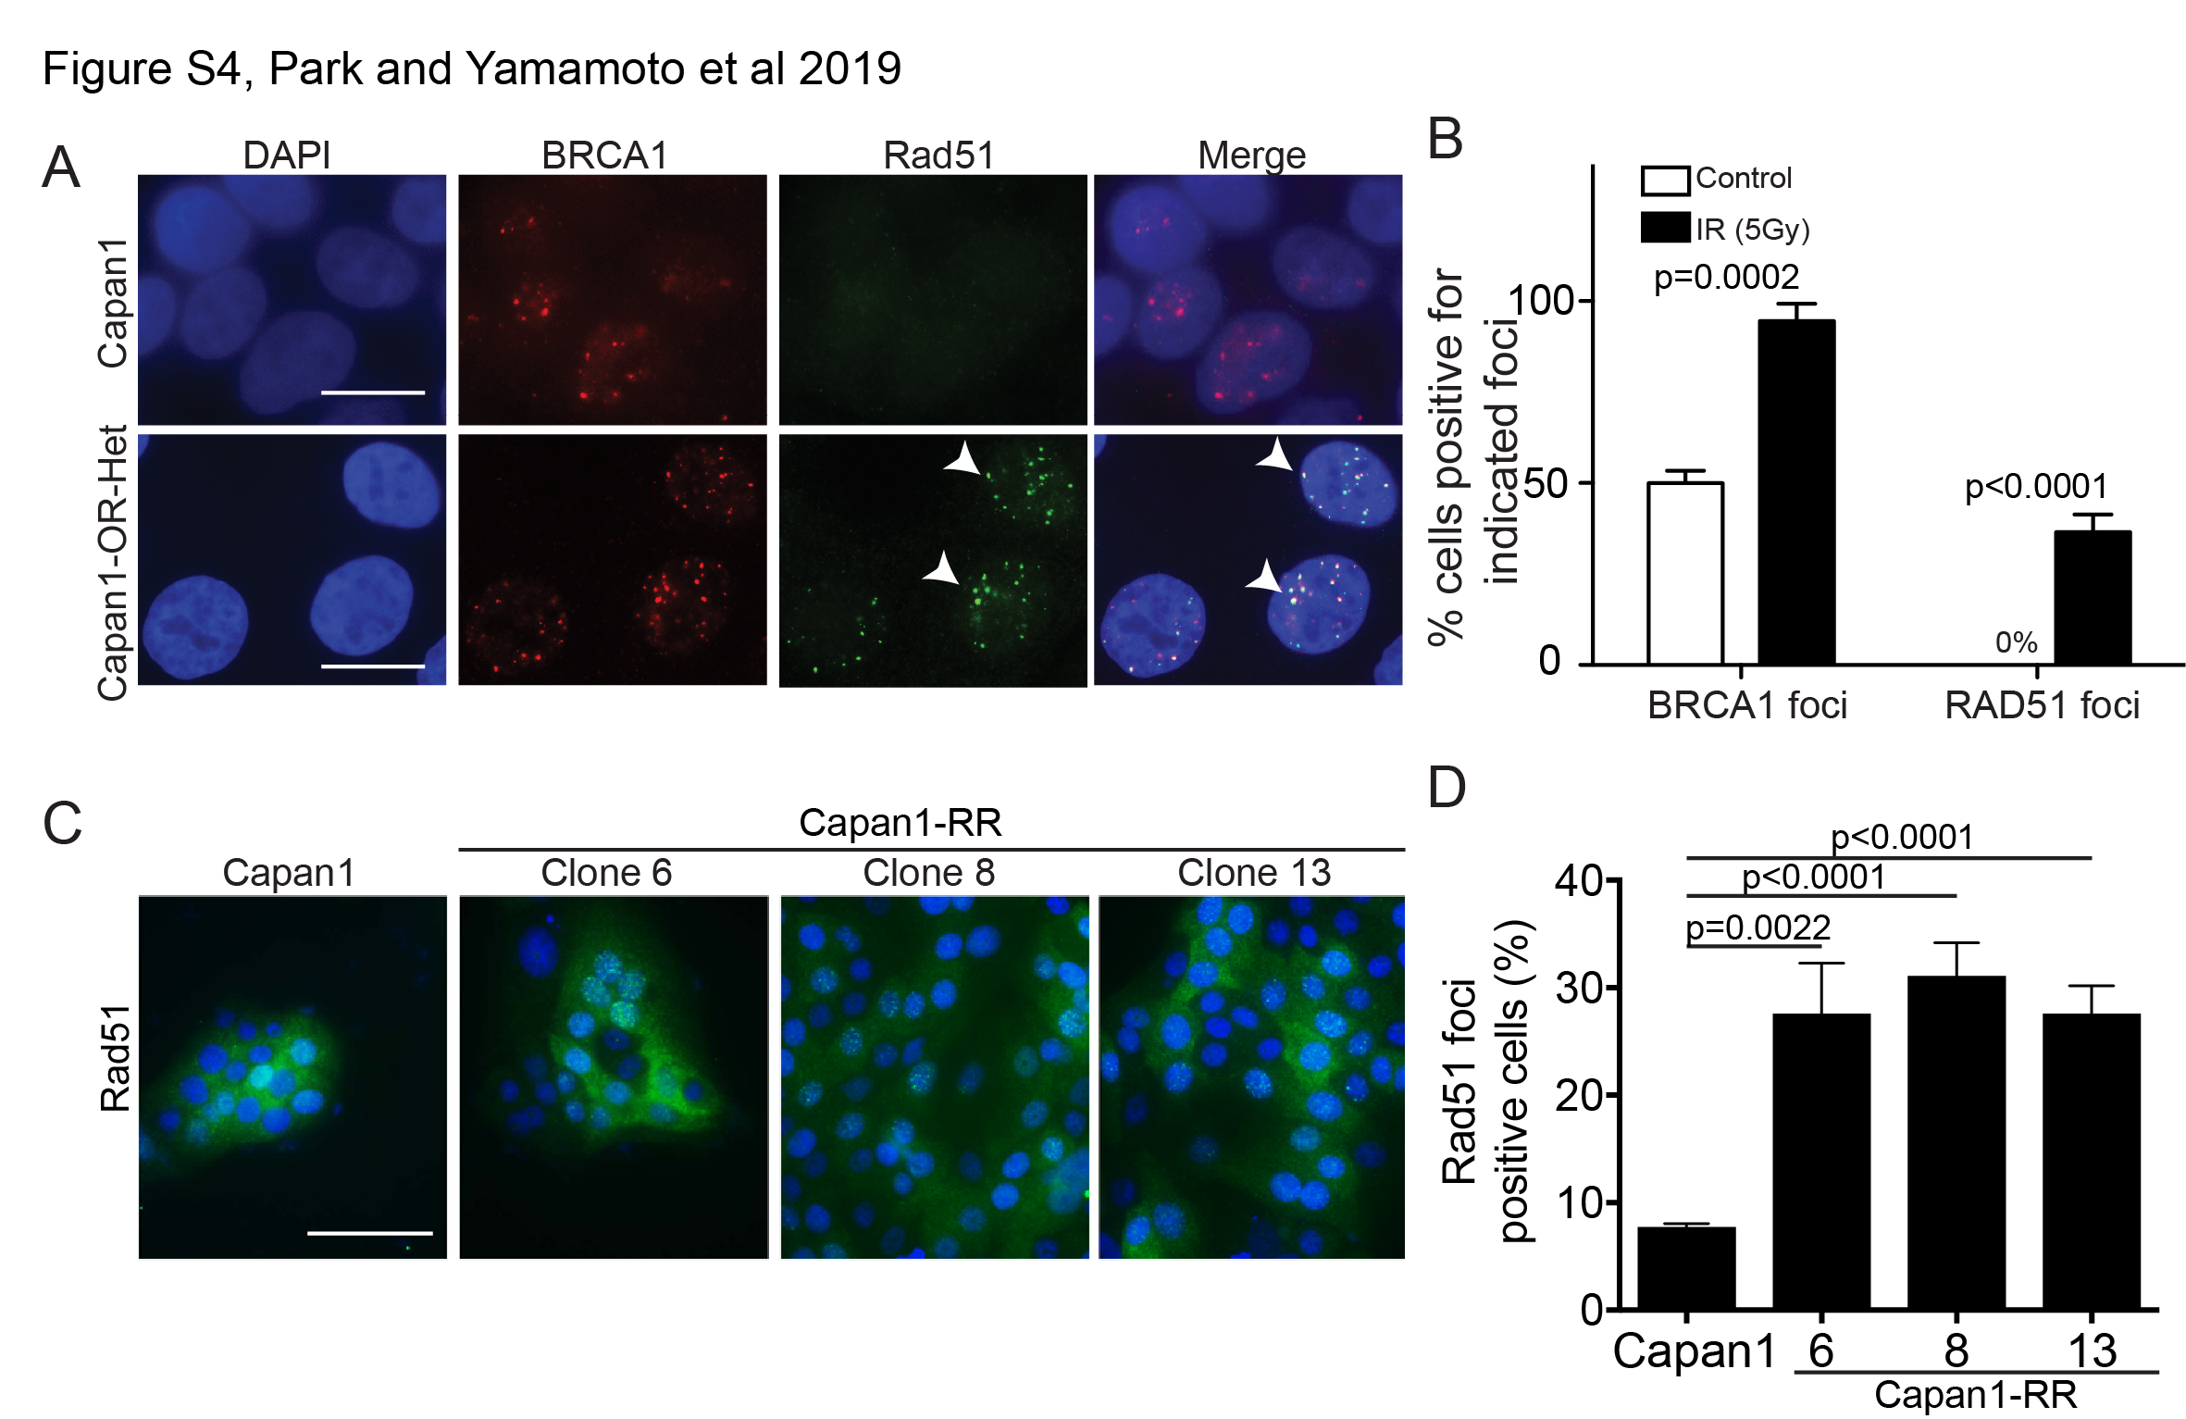

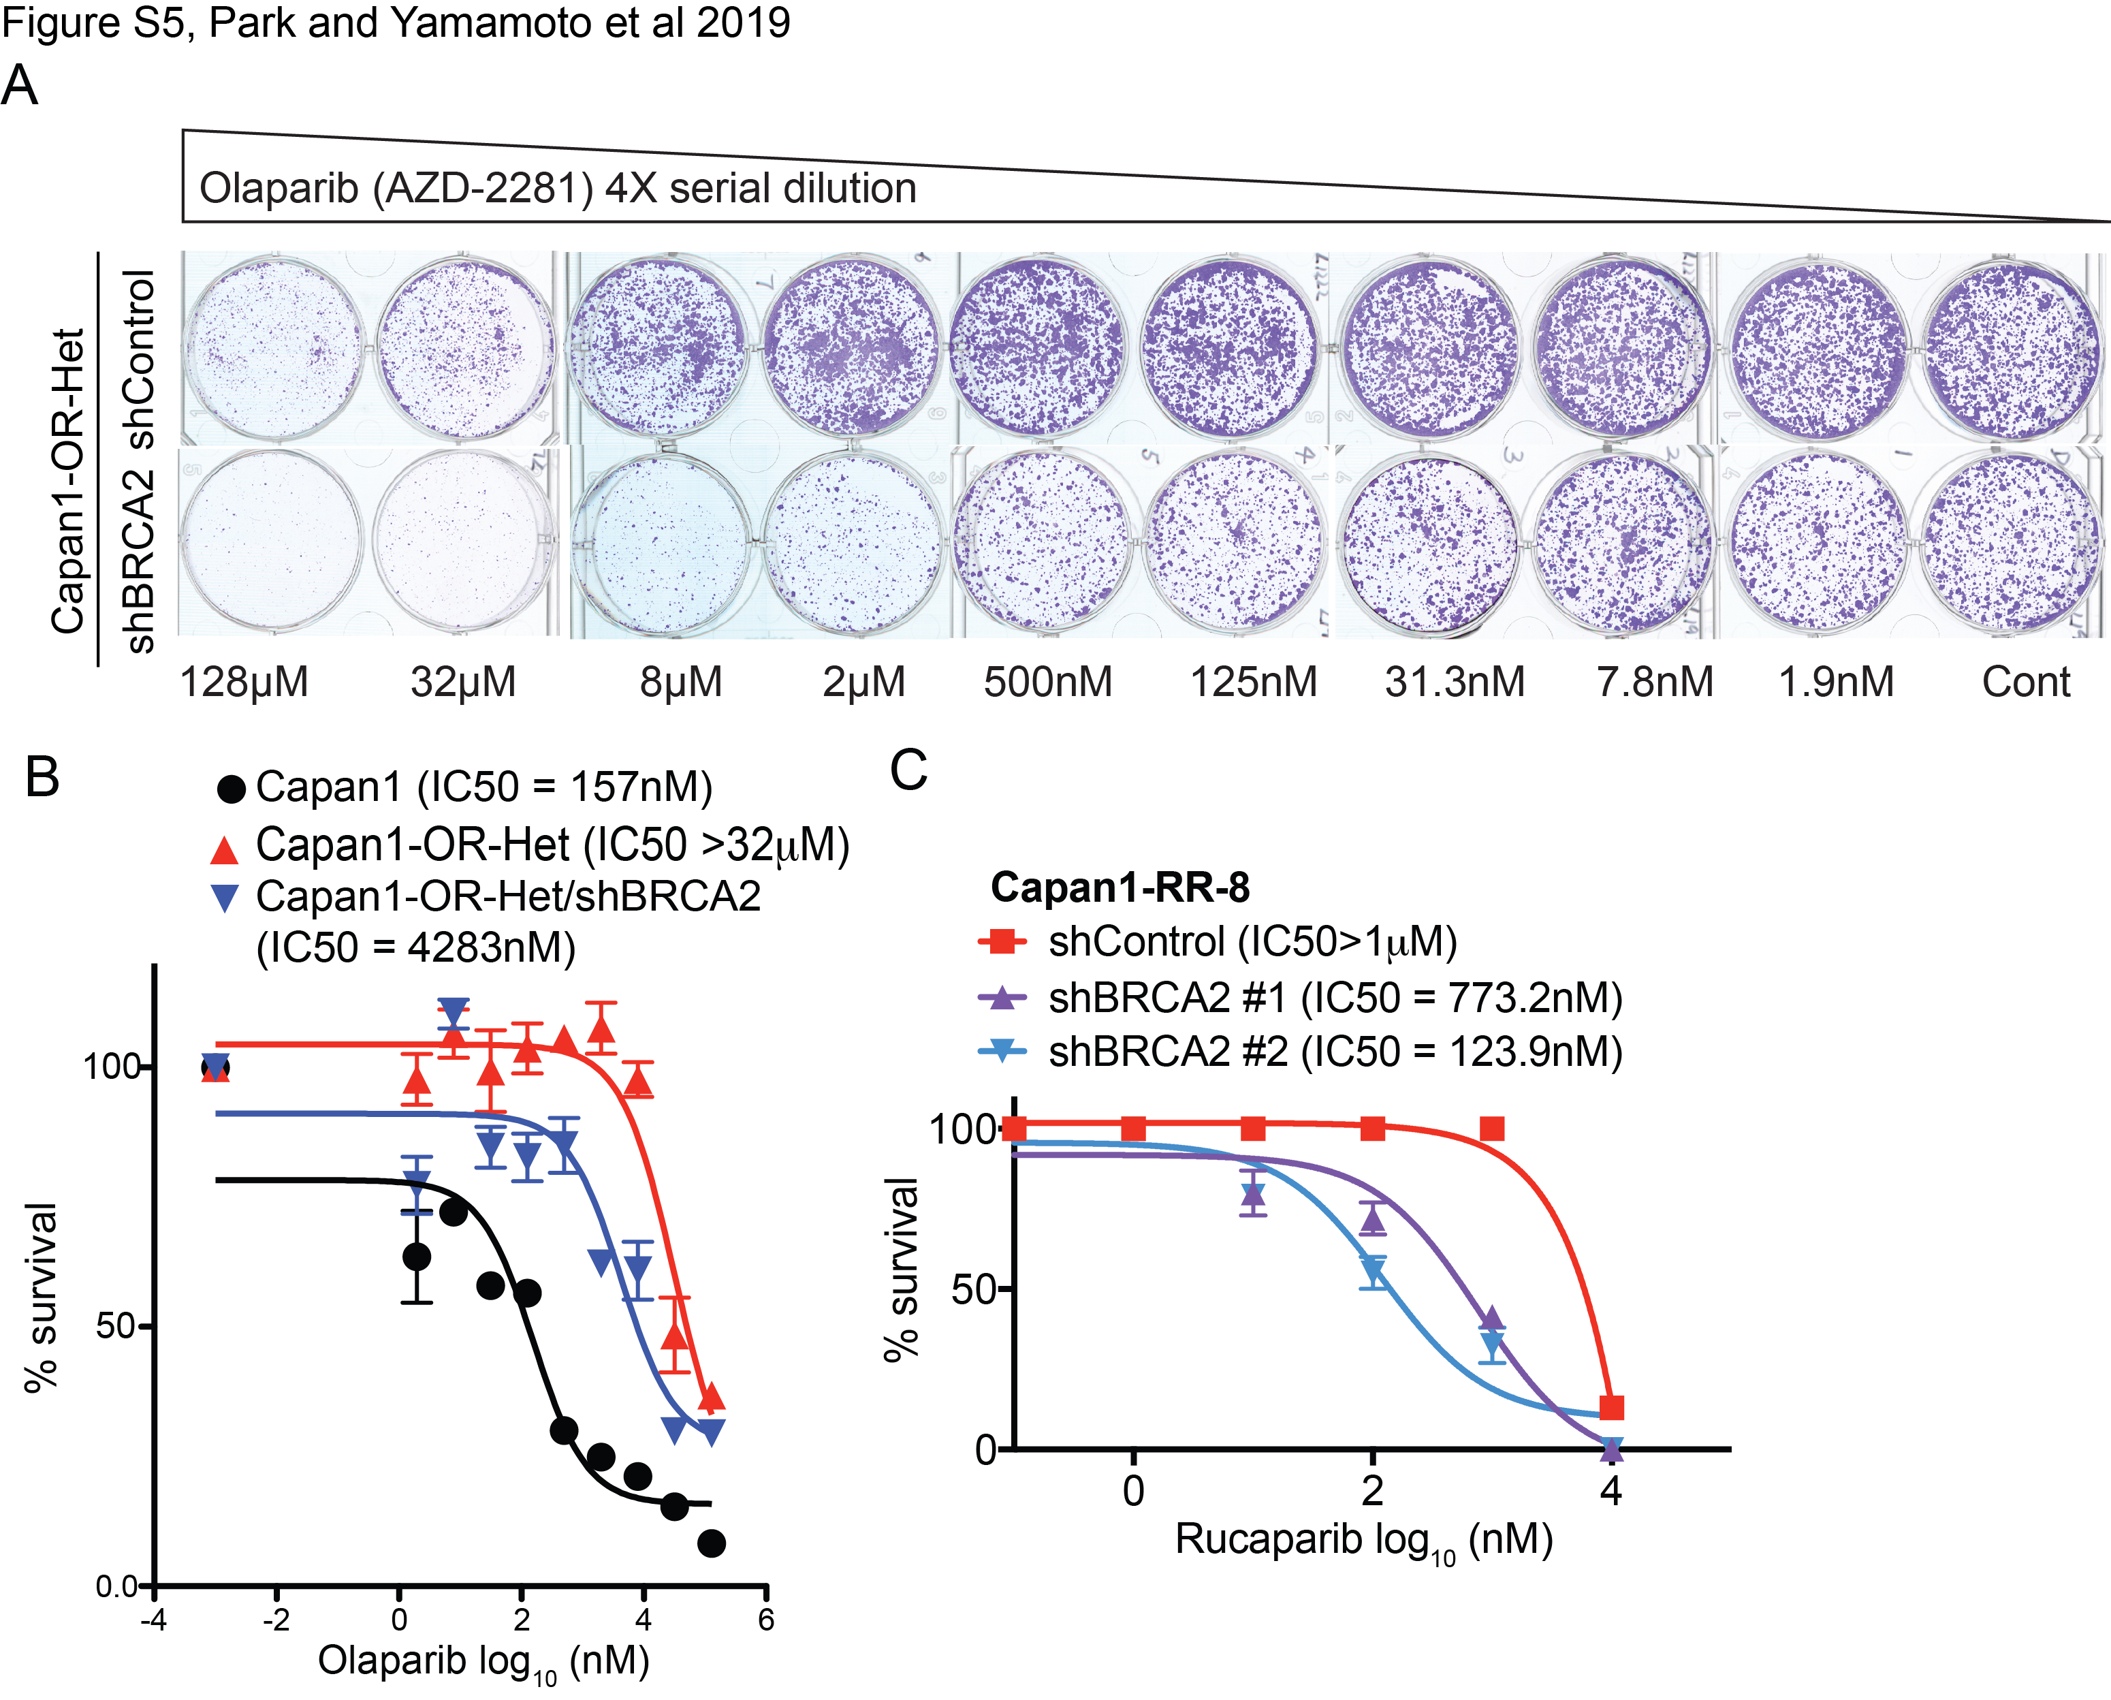

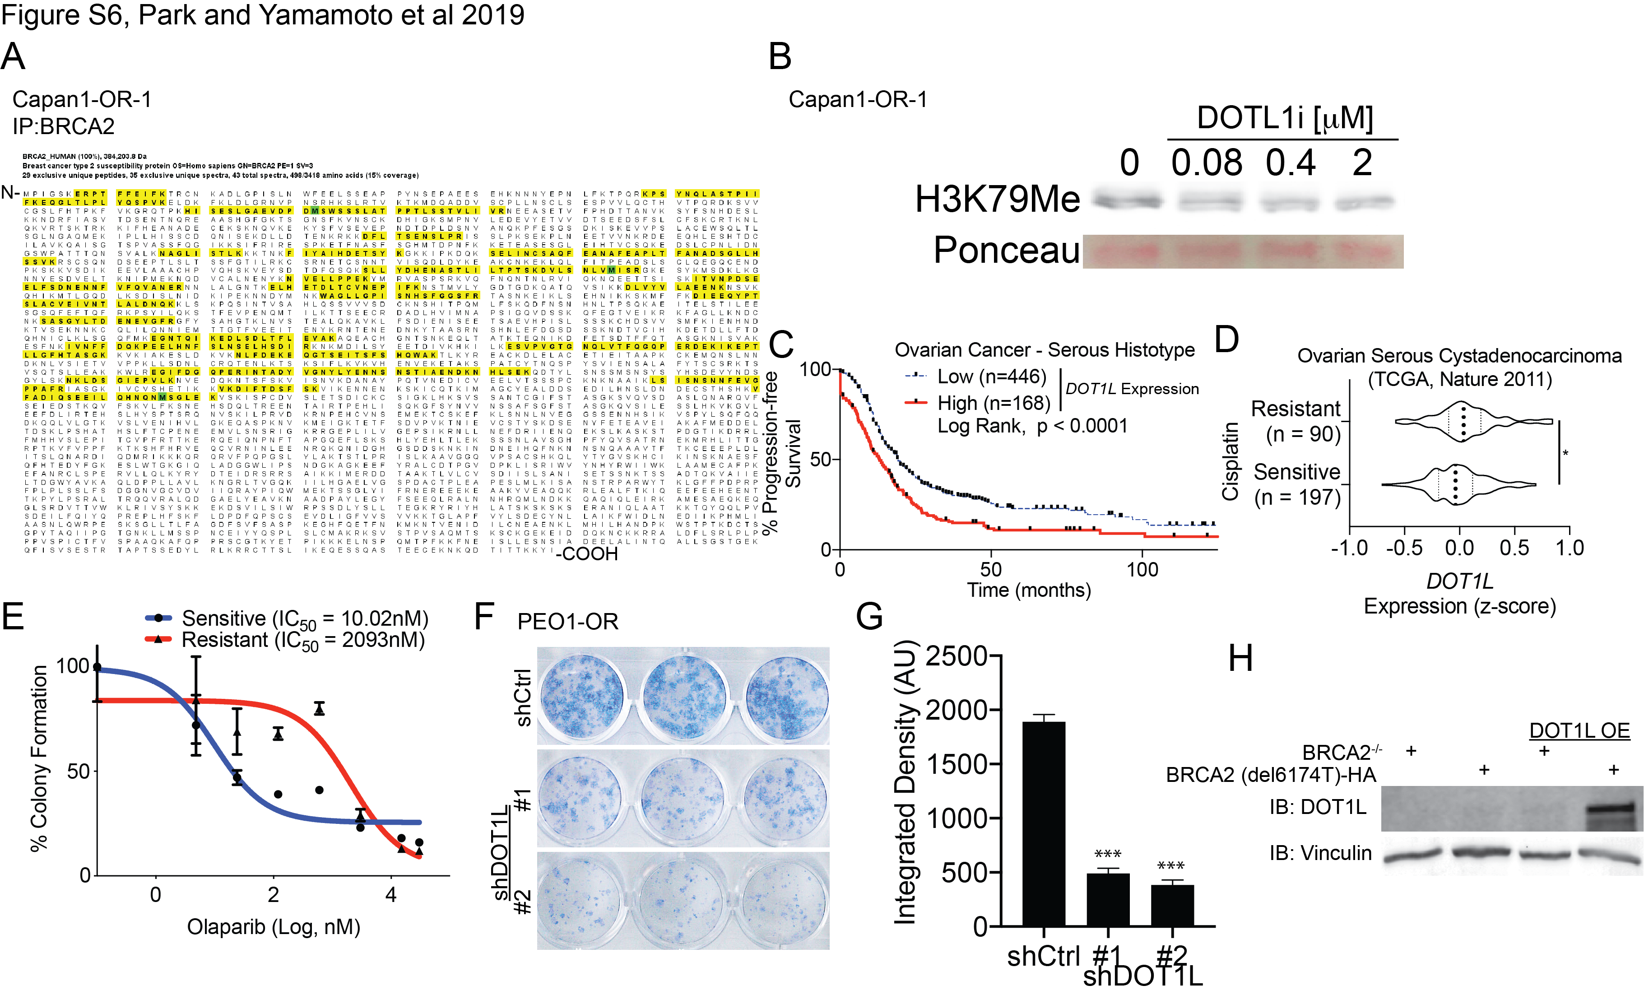
REFERNCES
1. Tu, Z., et al., Oncogenic RAS regulates BRIP1 expression to induce dissociation of BRCA1 from chromatin, inhibit DNA repair, and promote senescence. Dev Cell, 2011. 21(6): p. 1077-91. PMID: 22137763

