MP-Pt(IV): A MAOB-sensitive mitochondrial-specific drug for treating glioblastoma
Sudhir Raghavan^{1,2}, David S. Baskin^{1,2*} and Martyn A. Sharpe^{1,2*}
¹ Kenneth R. Peak Brain and Pituitary Treatment Center and the Department of Neurosurgery, Houston Methodist Hospital, and 2 Houston Methodist Research Institute, 6565 Fannin Street, Houston, TX 77030.

Running title: MP-Pt(IV): A MAOB-sensitive prodrug against GBM

*Corresponding authors: Martyn A Sharpe: Department of Neurosurgery, Kenneth R. Peak Brain and Pituitary Tumor Center, Houston Methodist Hospital, 6565 Fannin Street, Houston, TX 77030; masharpe@houstonmethodist.org; or David S. Baskin, MD: Department of Neurosurgery, Kenneth R. Peak Brain and Pituitary Tumor Center, Houston Methodist Hospital, 6445 Main Street, OPC 24, Houston, TX 77030; dbaskin@houstonmethodist.org

Supplementary Information:
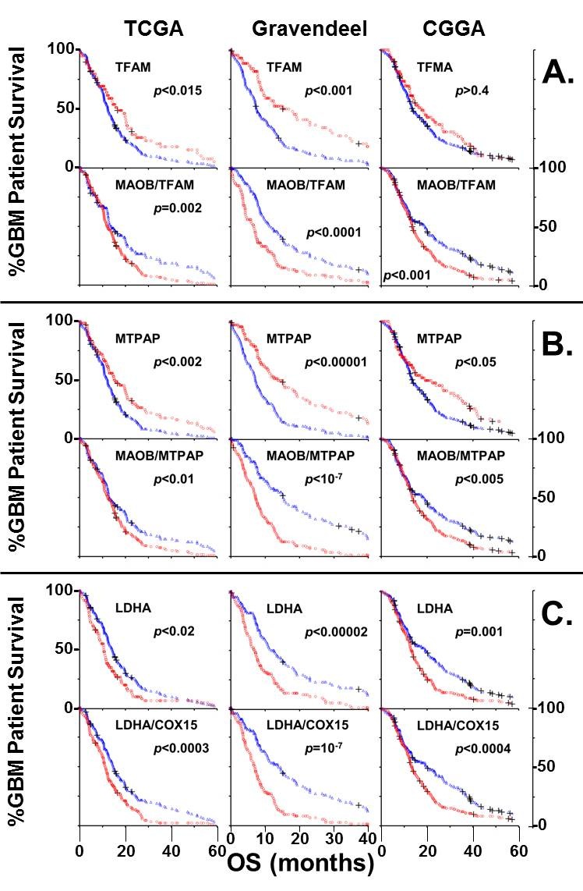
Supplemental Figure 1.
In Supplemental Figure 1 we show a series of Kaplan-Meier curves, using data of GBM patient survival drawn from the TCGA RNASeq, the Gravendeel, and the Chinese Glioma Genome Atlas (CGGA) databases. The effects of the mitochondrial proxies, TFAM (A) and MTPAP (B), and the ratio of MAOB to these mitochondria-proxies, is the essentially the same as that observed in Figure 1 using the mitochondrial proxy COX15. Patients whose tumors have low levels of the mitochondrial-proxies have poor outcomes and a high MAOB/Mitochondrial-proxy ratio is also linked to early death. In Supplemental Figure 1C., we show that expression of the Warburg-linked gene, LDHA (Lactate dehydrogenase A), negatively effects GBM patient survival. Large Warburg-shifts are indicative of aggressive GBM, which is seen from examining the tumor LDHA/COX15 ratio and outcome.
Survival curves of tumors with high transcript levels/ratios are shown with red circles and low transcript levels/ratios using blue triangles. The Kaplan-Meier curves were analyzed using the chi-square log-rank test and the calculated p-value is indicated on each plot.

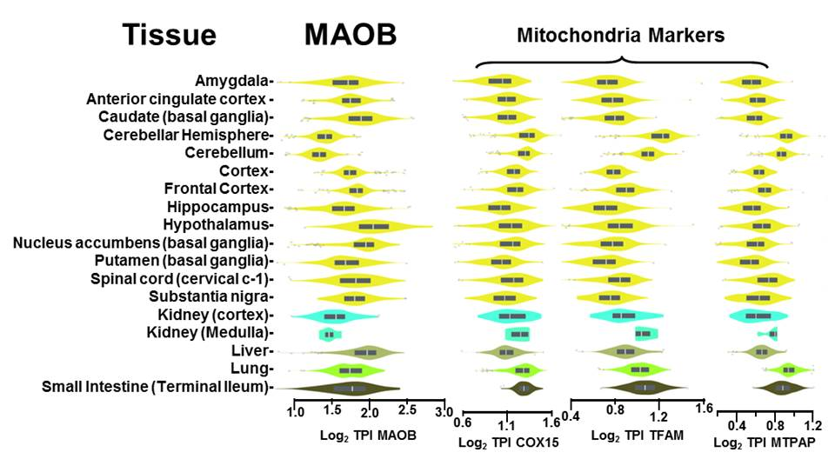Supplemental Figure 2.
In Supplemental Figure 2 we show the MAOB mRNA transcript levels in human tissues and three mRNA transcript levels of mitochondrial-proxy genes; proxies used in Figure 2 and Supplemental Figure 1. Data was drawn from the Gtex database (https://gtexportal.org/home/). MAOB levels are highest in the hypothalamus and liver. The levels of normal human brain and liver are comparable, and MAOB activity in GBM is ≈8-fold greater in GBM than in normal brain tissue.

Supplemental Figure 3.
Reduction of MP-Pt(IV) by ascorbate (Asc). MP-Pt(IV) undergoes a two-step transformation into the active Pt(II) species and releases the MP-ethylene glycol conjugate. (A) Mass spectra (ESI, positive mode) of the cell lysates shows unchanged MP-Pt(IV) (m/z 596.9, M⁺Na⁺H₂O) and the single electron reduced Pt(III) species (m/z 551.9, M⁺H₂O). MP-ethylene glycol adducts are also observed at m/z 214.1 (M⁺H) and 236.1 (M⁺Na). Cisplatin (m/z 300, M⁺H) and the MP-carboxylic acid (m/z 169. M⁺H) are not seen in the ESI mass spectra. (B) Proposed route for the sequential activation of MP-Pt(IV) by Asc-mediated reduction into the Pt(II) species in the mitochondria. (C) Kinetics of Pt(IV) reduction show that it is first order with respect to Pt(IV).
We monitored the reduction of Pt(IV) to Pt(II) by Asc using mass spectrometry and uv spectroscopy. Asc (5 mM) was incubated with 100 µM MP-Pt(IV) in PBS (pH 7.0) for 1 hour, 37 ºC, and an ESI (+) mass spectrum was obtained (Supplemental Fig5A).
We see the unreacted prodrug either as an aqua/sodium adduct or as the aqua/methanol protonated species (m/z centered at 596.9). We also observe the Na⁺/H⁺ adducts of the MP-ethylene glycol (m/z 236.1 and 214.1 respectively), indicating loss of the platinum from the prodrug. We do not observe the MP-carboxylate (M⁺H, m/z 169), indicating the absence of reductive de-esterification. We also did not observe cisplatin, which is not surprising as this species forms few charged adducts. The released MP-carboxylate species could not be observed in mass spectra conducted under identical conditions for MP-Pt(IV) without incubation with Asc.

Supplemental Figure 4
Representative images of GBM115 and GBM157 cells, treated with increasing concentrations of MP-Pt(IV) for 24 hours. The cells labeled with Mitotracker, DAPI and with an antibody to MAOB. MAOB levels, and cytosolic volume, increase with [MP-Pt(IV)]. Mitochondria levels increase in response to this prodrug, until near the ≈IC₅₀ level, after when Mitotracker levels per cell fall. There is also a change in cellular morphology, with cells generally becoming larger, and the nuclei appear to be swollen, distended or misshapen.

Supplemental Figure 5.
We show the mean animal weights, obtained during their treatment with drugs/radiation, beginning day 11 post-intracranial xenograft. The panel on the left is the recording of animals which did not receive radiation and those on the right from the three groups which received 6 treatments of whole head radiation, each at 2 Gy. Of note is the loss of weight, and rebound that is apparent in animals received radiation compared to SHAM treatment. Other than the raising of the cesium source, the SHAM-treated animals underwent identical treatment to the radiation group.

 |  | Statistical significance
Group | Control | MP-Pt(IV) | TMZ | MP-Pt(IV)  & TMZ | MP-Pt(IV)  & IR | TMZ  &IR | MP-Pt(IV)  & TMZ  & IR
Control |  | **** | **** | ******* | **** | ***** | *****
MP-Pt(IV) | 4.2 |  | NS | * | NS | NS | NS
TMZ | 2.8 | 0.66 |  | ** | NS | NS | NS
MP-Pt(IV)  & TMZ | 6.4 | 1.5 | 2.2 |  | ** | ** | ***
MP-Pt(IV)  & IR | 2.6 | 0.6 | 0.93 | 0.4 |  | NS | NS
TMZ  &IR | 2.9 | 0.7 | 1.1 | 0.46 | 1.13 |  | NS
MP-Pt(IV)  & TMZ  & IR | 5.4 | 1.3 | 1.95 | 0.85 | 2.1 | 1.9
 | Cumulative mouse survival ratio

p value and symbol used; <0.05 = ∗, <0.01 = **, <0.005 = ***, <0.001 = ****, <0.0005 = *****, <0.0001 = ******, <0.00005 = *******

Supplemental Table 1.
Supplemental Table 1 shows the ratios of cumulative mouse survival days (left of diagonal) and statistical significance (right of diagonal) between the different treatment and control groups in the animal studies. Numerical values which have been underlined are statistically significant. The best survival ratios, compared to control, are obtained for the treatment arm that combined MP-Pt(IV) and TMZ (6.4-fold longer survival compared to control) and this combination is slightly better than the triple-treatment arm (MP-Pt(IV), TMZ and radiation, 5.4-fold longer survival). Row 1 shows that all treatment arms demonstrate statistically significant improvements in survival ratios compared to control. Combining MP-Pt(IV) and TMZ (row 4) significantly improved mouse survival compared to MP-Pt(IV) or TMZ alone. Comparing TMZ and MP-Pt(IV) treatment arms shows that MP-Pt(IV) when used alone is slightly better than TMZ, but the difference is not significant.

Synthesis of MP-Pt(IV)
Scheme 1: Synthesis of MP-Pt(IV)
MP-Pt(IV) was synthesized using the key Pt(IV) compound 1, previously reported by Ravera et al. (25) Their method uses the oxidative chlorination of cisplatin by N-chlorosuccinamide, leading to the addition of ethylene glycol to cisplatin, and providing 1. We have previously described the synthesis of the methyl-tetrahydropyridine intermediate 2 (21). MP-Pt(IV) was synthesized by 2-(1H-benzotriazol-1-yl)-1,1,3,3-tetramethyluronium hexafluorophosphate (HBTU) mediated coupling of 1 and 2 followed by chromatographic separation. The published procedure for the synthesis of 1 was slightly modified at the purification stage by the sequential use of acetone and diethyl ether (5 x 3 mL) and refrigeration of the partially-purified ether solution of 1 at 4 ˚C, protected from light, for 72 h to induce complete precipitation of 1 as a bright yellow precipitate that was washed with cold diethyl ether and dried under vacuum.
2-[(trichlorodiiminoplatinio)oxy]ethyl 2-(1-methyl-1,2,3,6-tetrahydropyridin-4-yl)propanoate, MP-Pt(IV)
HBTU (101 mg, 266 µM) was added to a solution of 2 (30 mg, 177 µM) in anhydrous N-,N-dimethylformamide (3 mL) and the reaction was stirred under N₂. After 30 min, N-,N-diisopropylethylamine (95 µL, 355 µM) was added and the reaction was stirred for 15 min. Compound 1 (70 mg, 266 µM) was added and the reaction was stirred for an additional 12 h. The solvent was removed under reduced pressure. The product MP-Pt(IV) was obtained by direct-phase chromatography over silica gel using 9:1 ethyl acetate:ethanol as the eluent. Yield: 37 mg (38%). ESI-MS (⁺ve mode): Anal. 548; Found 596.90 (M⁺Na⁺H₂O) ¹HNMR (DMSO-d₆): δ 1.28 (s, 3H, CH₃), 2.40-2.59 (m, 2H, CH_{2,} J = 5.5 Hz), 2.89 (s, 3H, N-CH₃, J=7.0 Hz), 3.05-3.10 (m, 1H, C-H, J=6.0 Hz), 3.39−3.42 (m, 4H, Pt−O−CH₂−CH₂), 5.58 (m, 7H, NH₃, and C-H).

