Supplementary Figure 1 Panel A
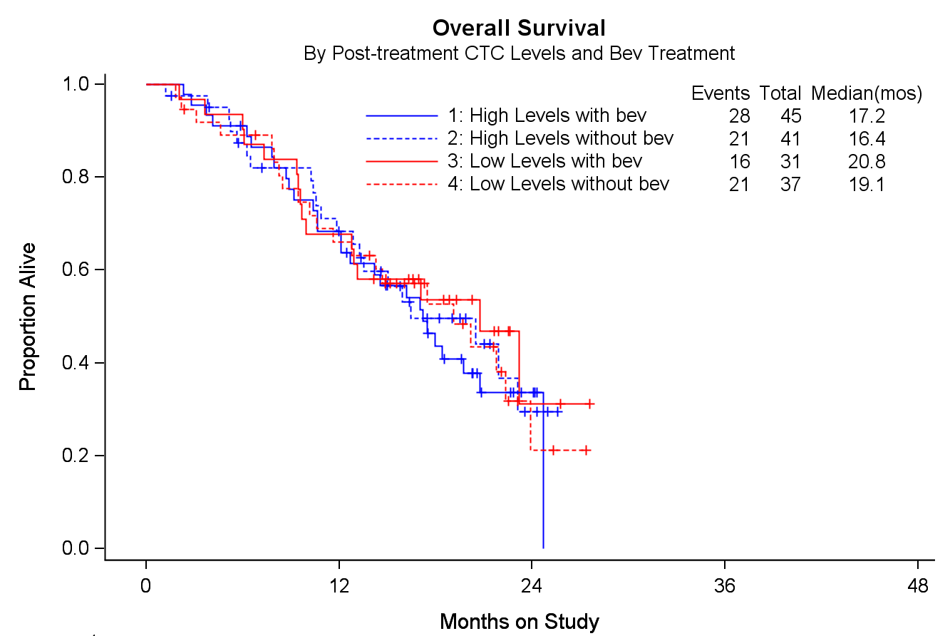

Supplementary Figure 1 Panel B
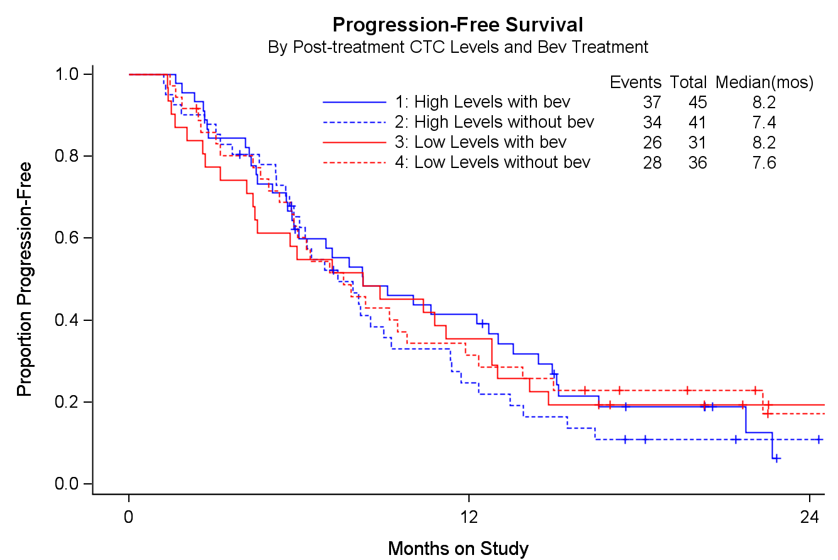

Supplementary Figure 1: Kaplan-Meier curves demonstrating overall survival [HR 1.12; 95% CI, 0.64-1.98] (panel A) and progression-free survival [HR 0.79; 95% CI, 0.49-1.27] (panel B) among patients with high vs low levels of 36 days post-Cycle 1 CTCs stratified by treatment with and without bevacizumab. In this exploratory analysis of 36-day post-Cycle 1 CTC counts, neither overall survival nor progression-free survival appear to be impacted by intervening therapy in which bevacizumab has been integrated.

