**Scribner et al., MGC018, a duocarmycin-based ADC targeting B7-H3 for cancer**

**Supplemental Data**

**Supplemental Table S1. Summary of analytical characteristics of MGC018**

| Attribute | Analytical Method | MGC018 |
| --- | --- | --- |
| Intact mass | Native electrospray mass spectrometry | DAL2: 149963.7 Da  DAL4: 152630.4 Da |
| Amino acid sequence | Reduced tryptic peptide mapping LC-MS/MS | Light chain coverage: 100%  Heavy chain coverage: 99.6% |
| Percent purity | RP-HPLC | 95.8% |
| Aggregation | SE-HPLC | 98.2% monomer |
| Disulfide bridges (tertiary structure) | Non-reduced tryptic peptide mapping LC-MS/MS | All 8 expected disulfide peptides identified |
| Level of free thiols | Fluorescence assay | 0.86%  (0.011 mole/mole) |
| Abbreviations: DAL: drug-to-antibody linkage; LC-MS/MS: liquid chromatography with tandem mass spectrometry; RP-HPLC: reversed phase high-performance liquid chromatography; SE-HPLC: size exclusion high-performance liquid chromatography. | | |

**Supplemental Table S2. Equilibrium dissociation constant (KD) of binding of MGC018 and MGA017 to human and cynomolgus monkey B7-H3**

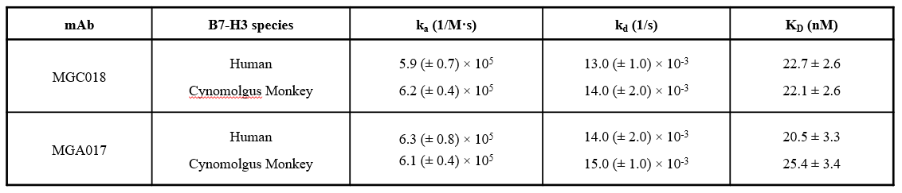

Abbreviations: mAb: monoclonal antibody; ka: association constant; kd: dissociation constant; KD: equilibrium constant; M: mol/L concentration; s: second.

The data are the mean +/- standard deviation of 3 independent experiments, each performed in duplicate.

**Supplemental Table S3. Summary of total and conjugated antibody pharmacokinetic parameters from noncompartmental analysis following incubation in the indicated sera**

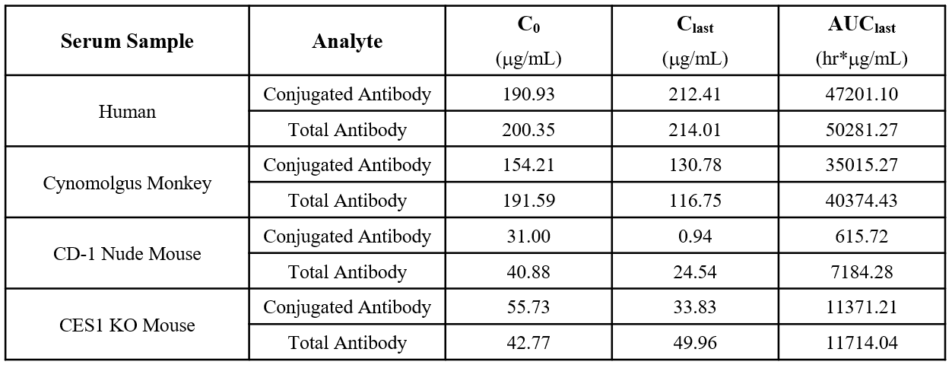

Abbreviations: C0: concentration at time 0; Clast: concentration at the last timepoint (240 hours); AUClast: area under the concentration curve to the last quantifiable concentration; hr: hour; KO: knockout.

**Supplemental Table S4. Summary of conjugated antibody pharmacokinetic parameters from noncompartmental analysis of first MGC018 dose data in cynomolgus monkeys**

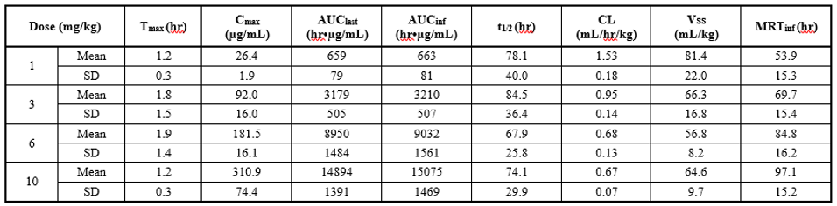

Abbreviations: Tmax: time of maximal concentration; Cmax: observed maximal serum concentration; AUClast: area under the concentration curve to the last quantifiable concentration; AUCinf: area under the concentration curve extrapolated to infinity based on the last predicted concentration; t1/2: terminal elimination half-life; CL: predicted total body clearance; Vss: volume of distribution at steady state based on the last predicted concentration; MRTinf: mean residence time extrapolated to infinity based on the last predicted concentration; SD: standard deviation; hr: hour.

**Supplemental Table S5. Summary of total antibody pharmacokinetic parameters from noncompartmental analysis of first MGC018 dose data in cynomolgus monkeys**

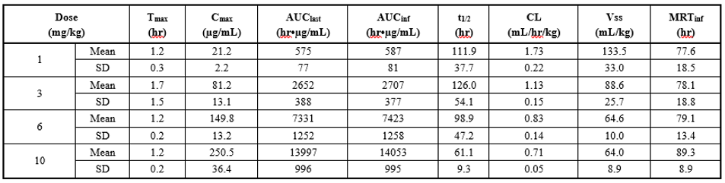

Abbreviations: Tmax: time of maximal concentration; Cmax: observed maximal serum concentration; AUClast: area under the concentration curve to the last quantifiable concentration; AUCinf: area under the concentration curve extrapolated to infinity based on the last predicted concentration; t1/2: terminal elimination half-life; CL: predicted total body clearance; Vss: volume of distribution at steady state based on the last predicted concentration; MRTinf: mean residence time extrapolated to infinity based on the last predicted concentration; SD: standard deviation; hr: hour.

**Supplemental Table S6. Summary of unconjugated SYD986 pharmacokinetic parameters from noncompartmental analysis of first MGC018 dose data in cynomolgus monkeys**

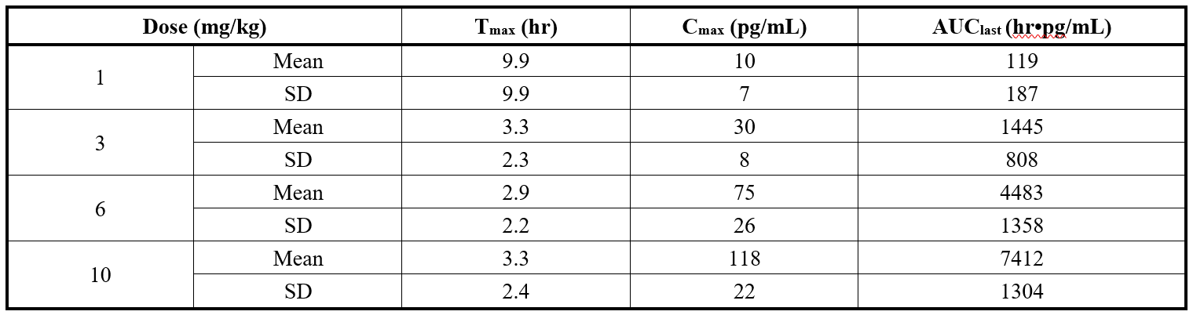

Abbreviations: Tmax: time of maximal concentration; Cmax: observed maximal serum concentration; AUClast: area under the concentration curve to the last quantifiable concentration; SD: standard deviation; hr: hour.

**Supplemental Table S7. Summary of total and conjugated antibody pharmacokinetic parameters from noncompartmental analysis of first MGC018 dose data in CD1 nude mice or SCID/CES1c knock out mice**

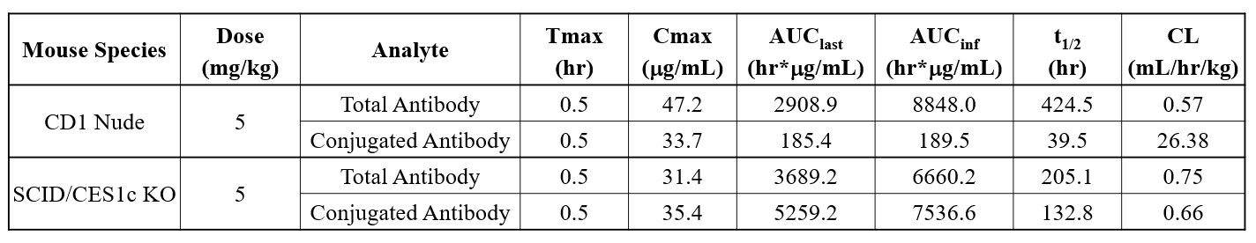

Abbreviations: Tmax: time of maximal concentration; Cmax: observed maximal serum concentration; AUClast: area under the concentration curve to the last quantifiable concentration; AUCinf: area under the concentration curve extrapolated to infinity based on the last predicted concentration; t1/2: terminal elimination half-life; CL: predicted total body clearance; hr: hour; KO: knockout.

**Supplemental Figure S1**

**Light Chain Amino Acid Sequence**

1 DIQMTQSPSSLSASVGDRVTITCRASESIYSYLAWYQQKPGKAPKLLVYN

51 TKTLPEGVPSRFSGSGSGTDFTLTISSLQPEDFATYYCQHHYGTPPWTFG

101 QGTRLEIKRTVAAPSVFIFPPSDEQLKSGTASVVCLLNNFYPREAKVQWK

151 VDNALQSGNSQESVTEQDSKDSTYSLSSTLTLSKADYEKHKVYACEVTHQ

201 GLSSPVTKSFNRGEC

**Heavy Chain Amino Acid Sequence**

1 EVQLVESGGGLVKPGGSLRLSCAASGFTFSSYGMSWVRQAPGKGLEWVAT

51 INSGGSNTYYPDSLKGRFTISRDNAKNSLYLQMNSLRAEDTAVYYCARHD

101 GGAMDYWGQGTTVTVSSASTKGPSVFPLAPSSKSTSGGTAALGCLVKDYF

151 PEPVTVSWNSGALTSGVHTFPAVLQSSGLYSLSSVVTVPSSSLGTQTYIC

201 NVNHKPSNTKVDKRVEPKSCDKTHTCPPCPAPELLGGPSVFLFPPKPKDT

251 LMISRTPEVTCVVVDVSHEDPEVKFNWYVDGVEVHNAKTKPREEQYNSTY

301 RVVSVLTVLHQDWLNGKEYKCKVSNKALPAPIEKTISKAKGQPREPQVYT

351 LPPSREEMTKNQVSLTCLVKGFYPSDIAVEWESNGQPENNYKTTPPVLDS

401 DGSFFLYSKLTVDKSRWQQGNVFSCSVMHEALHNHYTQKSLSLSPGK

Supplemental Figure S1. Amino acid sequence of light and heavy chain of MGC018. Sequences are presented from N-terminus to C-terminus. The letters shown represent the one-letter code for the 20 common amino acids. The linker-drug moiety (SYD980) is preferentially linked to cysteine residues involved in interchain disulfide bridges (highlighted in grey). The amino acid sequences were verified with liquid chromatography-mass spectrometry using electrospray ionization on reduced peptide map for MGC018.

**Supplemental Figure S2**

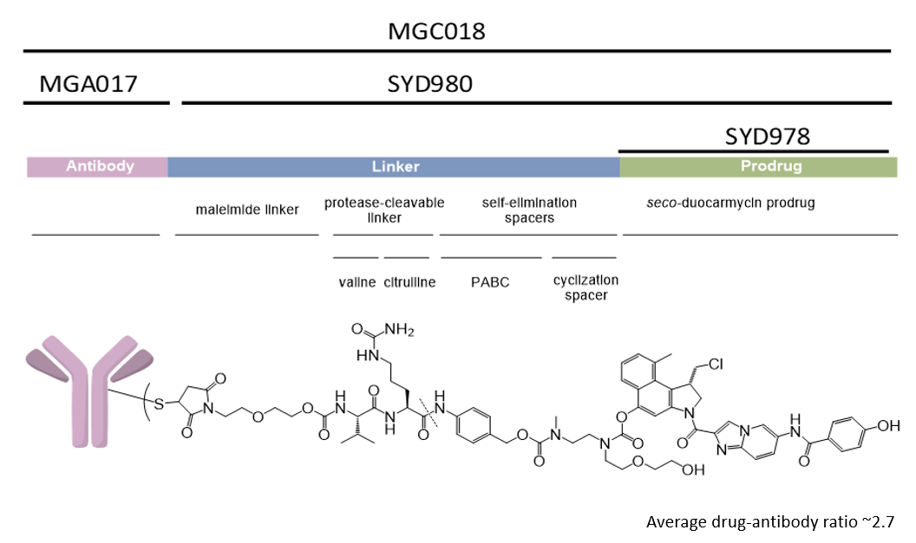

**Supplemental Figure S2. Schematic Representation of MGC018.** MGC018 is an antibody-drug conjugate (ADC) composed of the humanized monoclonal IgG1 antibody MGA017 covalently linked to a restricted number of linker-drug (SYD980) moieties, containing a *seco*-duocarmycin derivative. MGA017 is a humanized monoclonal IgG1 antibody that recognizes human B7-H3. The linker-drug (SYD980) contains a cleavable linker and the prodrug *seco*-duocarmycin-hydroxybenzamide-azaindole (*seco*‑DUBA, SYD978).

Abbreviations: PABC: para-aminobenzyloxycarbonyl.

Representation is not to scale

**Supplemental Figure S3**



**Supplemental Figure S3. Drug distribution and drug antibody ratio (DAR) average analyzed by hydrophobic interaction (HIC) chromatography.** Representative HIC chromatogram of MGC018. The HIC chromatogram shows two main species: DAL2 and DAL4.

Abbreviations: DAR: drug antibody ratio; DAL: drug-to-antibody linkage; HIC: hydrophobic interaction chromatography.

**Supplemental Figure S4**

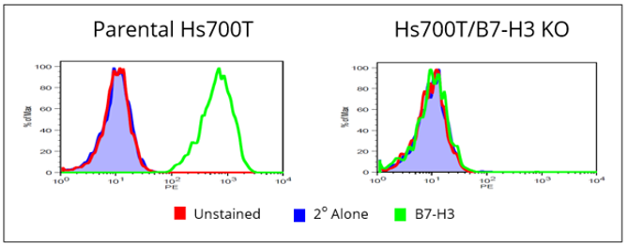

**Supplemental Figure S4. Analysis of B7-H3 expression on parental Hs700T and Hs700T/B7-H3 KO line by flow cytometry.** B7-H3 expression on parental Hs700T (left) and a derivative of Hs700T in which B7-H3 was stably knocked out (right), monitored by flow cytometry. Green open peak is anti-B7-H3 antibody (BRCA69D) plus goat anti-mouse IgG-R-phycoerythrin secondary antibody staining, red closed peak is unstained control, and blue open peak is goat anti-mouse IgG-R-phycoerythrin secondary antibody alone control.

**Supplemental Figure S5**

**Supplemental Figure S5. Time lapse video of in vitro bystander killing by MGC018.** An in vitro co-culture experiment was conducted in which Hs700T/B7-H3 KO cells, engineered to express stabilized red fluorescent protein (Hs700T/B7-H3 KO/RFP), were cultured alone, or in the presence of progressively larger amounts of unlabeled parental Hs700T cells. The cultures were incubated in the absence or presence of 6.7 nM MGC018 and the number of viable RFP-labeled cells (only Hs700T/B7-H3 KO cells are visible) were monitored by time-lapse fluorescent microscopy over a period of 5 days.

**Video** **A**, 5000 Hs700T parental cells only without treatment.

**Video** **B**, 5000 Hs700T/B7-H3 KO/RFP cells only without treatment.

**Video** **C**, 5000 Hs700T parental cells only in the presence of 6.7 nM MGC018.

**Video** **D**, 5000 Hs700T/B7-H3 KO/RFP cells alone in the presence of 6.7 nM MGC018.

**Video E**, Co-culture of 5000 Hs700T parental cells and 5000 Hs700T/B7-H3 KO/RFP cells in the presence of 6.7 nM MGC018.

**Supplemental Figure S6**

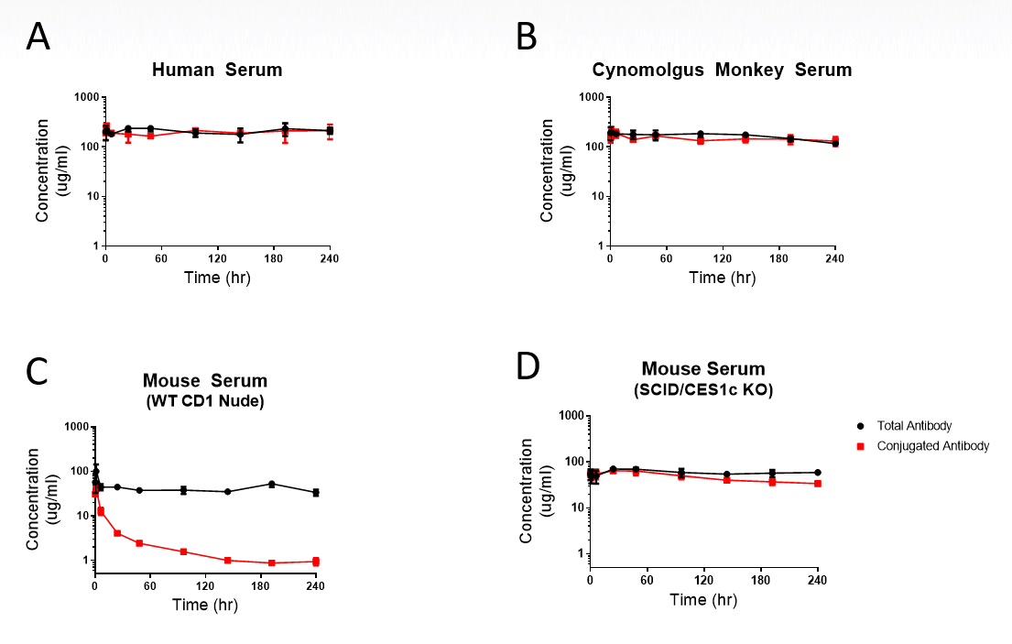

**Supplemental Figure S6. Stability of MGC018 following incubation in human, cynomolgus monkey and mouse serum.** Serum concentration-time profiles for conjugated mAb (red squares) and total mAb (black circles). **A**, human serum; **B**, cynomolgus monkey serum; **C**, wild-type CD1 nude mouse serum; **D**, SCID/CES1c knock out mouse serum.

**Supplemental Figure S7**

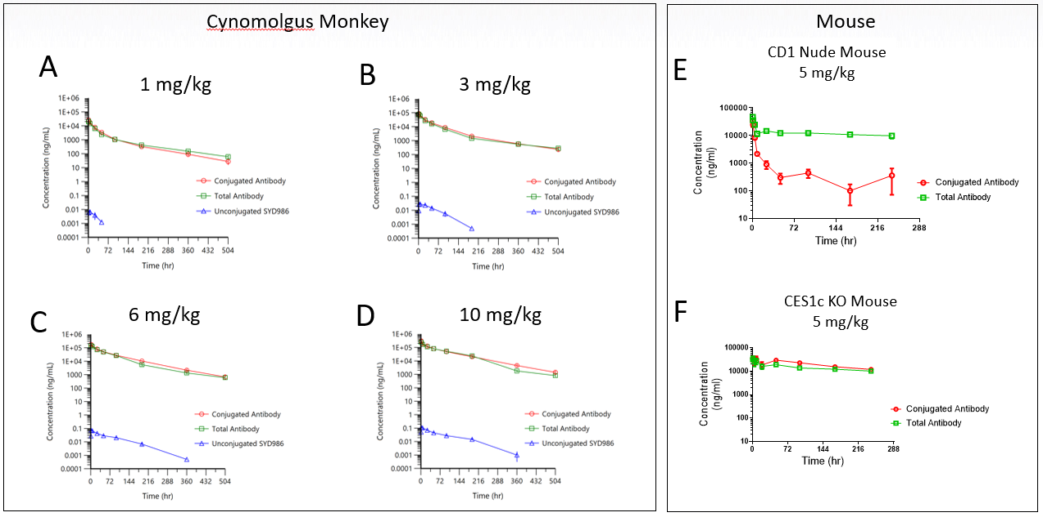

**Supplemental Figure S7. Pharmacokinetics of MGC018 in cynomolgus monkey and mice**. **A-D**, serum concentration-time profiles for conjugated mAb (red open circles), total mAb (green open squares), and unconjugated DUBA (blue open triangles) in cynomolgus monkey following IV administration of MGC018 at the indicated concentrations. **E**, serum concentration-time profiles for conjugated mAb (red open circles) and total mAb (green open squares) in CD1 nude mice following IV administration of MGC018 at 5 mg/kg. **F**, serum concentration-time profiles for conjugated mAb (red open circles) and total mAb (green open squares) in SCID/CES1c knock out mice following IV administration of MGC018 at 5 mg/kg.

**Supplemental Figure S8**

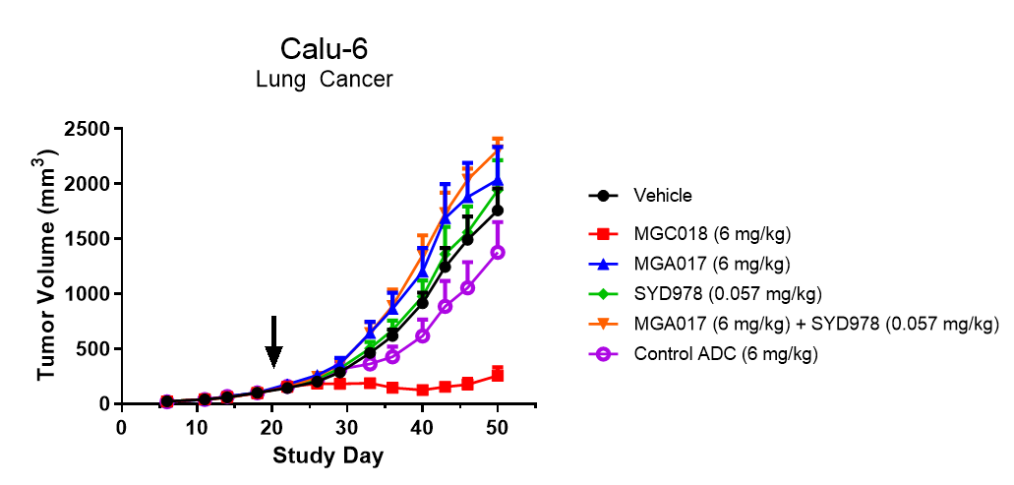

**Supplemental Figure S8. Antitumor activity of MGC018, MGA017 and SYD978 in CD-1 nude mice.** Calu-6 lung cancer subcutaneous xenografts in CD-1 nude mice were treated with a single dose of MGC018, MGA017, Control ADC (anti-CD20 ADC) or SYD978 (free payload), or the combination of MGA017 and SYD978, at the indicated dose levels. Treatment day is indicated by the arrow. Tumor volume is shown as group mean ± SEM.