**Supplementary Figures**

**Chemical structure of SBI-183: C18H20N2O2**

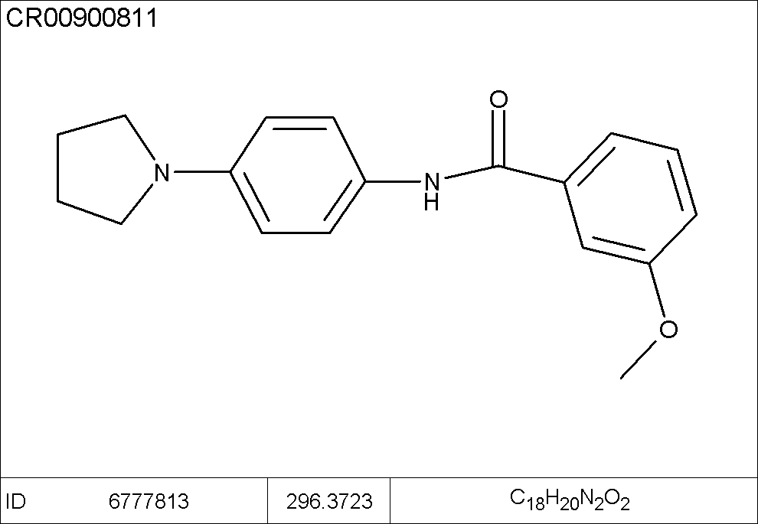

**Supplementary Figure 1.** Chemical structure of SBI-183.

**Verification of shRNA QSOX1 KD by qRT-PCR**

Data are from three different experiments performed in triplicate and normalized against beta actin (ΔCt on the Y axis). Data are indicative of a 90% KD as indicated by the following formula: (2^-ΔΔCt) = fold change, then (100 – (1/fold change)) = % KD.

**Supplementary Figure 2.** Stably transduced 786-O cells have reduced QSOX1 mRNA expression. Error represents SEM. Significance was determined by Welch’s t-test. **p<.01.

**Results from docking protocols**



**Supplementary Table 1.** Results from SBI-183 docking protocols.

**Determination of IC50’s by CellTiter Glo**

**

**Supplemental Figure 3.** Dose Response Curve: SBI-183 inhibits viability of RCC and TNBC with IC50’s of 4.6 µM for 786-O, 3.9 µM for RCJ-41T2, and 2.4 µM for MDA-MB-231.

**SBI-183 reduces proliferation**

Cells were incubated with the indicated concentrations of SBI-183. The percent growth is indicated in the table below, and is graphically represented in Figure 3.



**Supplementary Table 2.** SBI-183 reduces the proliferation of RCC and TNBC on days 3 and 5 at concentrations ranging from 20 μM - .625 μM.

**SBI-183 is not toxic to athymic nude mice**

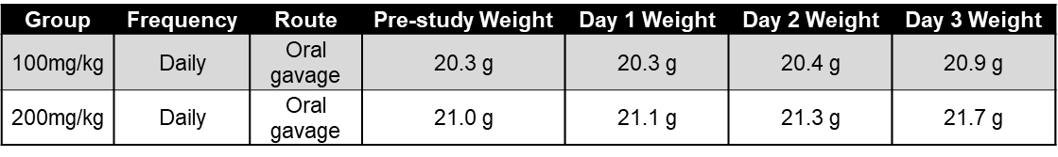**Supplementary Table 3.** SBI-183 solubilized in 10% dimethylacetamide (DMA) and 90% PEG400 was administered by oral gavage to 3 mice per group for 3 days. Neither 100 mg/kg, nor 200 mg/kg appeared to be toxic to athymic nude mice.

**SBI-183 does not reduce primary tumor growth of MDA-MB-231 *in vivo***

Tumor growth was measured at the intervals indicated in S. Table 4. According to IACUC protocol, mouse 1 from the control group was humanely sacrificed on Day 25 due to tumor size. A second mouse (mouse 8) from the control group was found dead on Day 28.



**Supplementary Table 4.** SBI-183 does not reduce primary tumor growth of MDA-MB-231 *in vivo*. Daily treatment with SBI-183 (100 mg/kg) did not result in a decrease of primary tumor volume. Twelve mice per group were utilized for this experiment. X = moribund sacrifice.

**SBI-183 inhibits metastasis of the triple negative breast cancer line MDA-MB-231**

MDA-MB-231 is a TNBC cell line that generates spontaneous lung metastases in mice after injection into the lymph nodes or mammary fat pad. Since our data suggests that QSOX1 plays a role in tumor-derived ECM and ECM genes are upregulated in metastases [5], we tested the activity of SBI-183 in a MDA-MB-231 TNBC mouse model. After luciferase expressing MDA-MB-231 tumors were established for 7 days, SBI-183 or vehicle control was orally administered to mice daily (100 mg/kg). Bioluminescence of lung metastases were quantified ex vivo upon termination of the experiment. In this metastatic model, there was no difference in primary tumor growth, but a 76% difference was observed in lung metastasis between vehicle and SBI-183-treated mice as measured by lung radiance (S. Fig. 4). Additionally, on day 25 of the study, one mouse in the control group was moribund and humanely terminated, and another in the control group was found dead on day 28. These two mice were not analyzed for lung metastasis by mean lung radiance, but presumably died due to tumor growth. This result suggests that in the highly metastatic MDA-MB-231 model, SBI-183 suppresses lung metastasis of a triple negative breast cancer.

  
**Supplementary Figure 4.** SBI-183 reduces lung metastasis *in vivo*. Daily treatment with SBI-183 (100 mg/kg) resulted in a 76% decrease in lung metastasis of triple negative MDA-MB-231 breast cancer cells as determined by bioluminescence imaging. Twelve mice per group were utilized for this experiment. In the Vehicle group, mouse 1 was a moribund sacrifice (day 25) and mouse 8 was found dead (day 28). Percentage of decrease was calculated with the following formula: 100-((Average SBI-183)/(Average Vehicle))x100. Error bars represent SEM. Significance was determined using Welch’s t-test. P = .197