**Reference**

1. Okeley NM, Miyamoto JB, Zhang X, Sanderson RJ, Benjamin DR, Sievers EL, et al. Intracellular activation of SGN-35, a potent anti-CD30 antibody-drug conjugate. Clin Cancer Res 2010;16:888–97.
2. Rillatt I, Perez M, Goetsch L, Broussas M, Beau-Larvor C, Haeuw JF, Champion T, Robert A. IGF-1R Antibody-Drug-Conjugate and its use for the treatment of cancer. WO2015/162292.

hz208F2 Heavy chain HO77 full length: SEQ ID N° 81

1 QVQLVQSGAE VKKPGASVKV SCKASGYTFT SYYIHWVRQA PGQGLEWMGW

51 IWPGDGSTKY AQKFQGRVTM TRDTSTSTVY MELSSLRSED TAVYFCASPM

101 ITPNYAMDYW GQGTLVTVSS ASTKGPSVFP LAPSSKSTSG GTAALGCLVK

151 DYFPEPVTVS WNSGALTSGV HTFPAVLQSS GLYSLSSVVT VPSSSLGTQT

201 YICNVNHKPS NTKVDKRVEP KSCDKTHTCP PCPAPELLGG PSVFLFPPKP

251 KDTLMISRTP EVTCVVVDVS HEDPEVKFNW YVDGVEVHNA KTKPREEQYN

301 STYRVVSVLT VLHQDWLNGK EYKCKVSNKA LPAPIEKTIS KAKGQPREPQ

351 VYTLPPSREE MTKNQVSLTC LVKGFYPSDI AVEWESNGQP ENNYKTTPPV

401 LDSDGSFFLY SKLTVDKSRW QQGNVFSCSV MHEALHNHYT QKSLSLSPG

hz208F2 light chain L018 full length: SEQ ID N°59

1 DIQMTQSPSS LSASVGDRVT ITCRASQDIS KYLNWYQQKP GKAPKLLIYY

51 TSRLQSGVPS RFSGRGSGTD YSLTISSLQP EDFATYFCQQ GSTLPYTFGG

101 GTKVEIKRTV AAPSVFIFPP SDEQLKSGTA SVVCLLNNFY PREAKVQWKV

151 DNALQSGNSQ ESVTEQDSKD STYSLSSTLT LSKADYEKHK VYACEVTHQG

201 LSSPVTKSFN RGEC

**Supplementary Table S1:** Expression of IGF-1R on human specimens. Expression of IGF-1R was carried out using paraffin-embedded tissue microarrays. The staining was performed with the m816C12 antibody on tumor tissues micro arrays.

|  |  |  |  |  |  |  |
| --- | --- | --- | --- | --- | --- | --- |
|  |  | **% of negative cases** | **% of positive cases** | | | |
| **Organ** | **Statue** | **0+** | **total (1+2+3)** | **1+** | **2+** | **3+** |
| **Breast : 10 cases** | ***normal*** | ***90*** | ***10*** | **10** | ***0*** | ***0*** |
|  | **tumoral** | **0** | ***100*** | **10** | **30** | **60** |
|  |  |  |  |  |  |  |
| **Lung: 56 cases** | ***normal*** | ***100*** | ***0*** | ***0*** | ***0*** | ***0*** |
| **Squamous, well differentiated : 13 cases** | **tumoral** | **0** | ***100*** | **0** | **55** | **45** |
| **Squamous, moderalty differentiated : 15 cases** | **tumoral** | **13** | ***87*** | **0** | **27** | **60** |
| **Squamous, poorly differentiated : 8 cases** | **tumoral** | **24** | ***76*** | **0** | **38** | **38** |
| **Adenocarcinoma, well differentiated : 4 cases** | **tumoral** | **33** | ***66*** | **33** | **33** | **0** |
| **Adenocarcinoma, moderatly differentiated : 3 cases** | **tumoral** | **0** | ***100*** | **75** | **25** | **0** |
| **Bronchioalveolar carcinoma : 6 cases** | **tumoral** | **33** | ***66*** | **0** | **33** | **33** |
| **Large cell : 7 cases** | **tumoral** | **0** | ***100*** | **20** | **60** | **20** |
|  |  |  |  |  |  |  |
| **Larynx squamous (SC) : 33 cases** | **tumoral** | ***5*** | ***95*** | ***20*** | ***45*** | ***30*** |

**Supplementary Table S2.** Level of expression of the IGF-1R in different cells. **A**, tumor cells and **B**, normal cells were evaluated by fluorescence-activated cell-sorting analysis for IGF-1R expression using the naked antibody hz208F2-4.

**A**

|  |  |  |  |  |  |  |  |  |  |
| --- | --- | --- | --- | --- | --- | --- | --- | --- | --- |
| Cell lines | Hs746t | SBC5 | BxPB3 | NCI-H460 | CaOV3 | NCI-H292 | NCI-H358 | NCI-H2122 | MCF-7 |
| IGF-1R expression (ABC) | 93 | 16052 | 17078 | 17766 | 24423 | 32071 | 38155 | 52893 | 103555 |

**B**

|  |  |  |  |  |  |  |  |  |  |
| --- | --- | --- | --- | --- | --- | --- | --- | --- | --- |
| Cells | HBSMC | HAoEC | HREpC | HPEpiC | HUC | T cells | B cells | Monocytes | Neutrophils |
| IGF-1R expression (ABC) | 3755 | 4583 | 14515 | 18268 | 26250 | 341 | 151 | 193 | 669 |

Abbreviations: ABC, mean antibody binding capacity; IGF-1R, insulin-like growth factor type 1 receptor.

**Supplementary Table S3.** Drug-to-antibody ratio determination. The average DAR is calculated by quantifying the various drug-loaded species based on the 280 nm UV peaks area obtained after analysis by HIC-HPLC

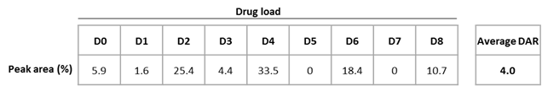Individual DAR contributions for each drug loaded species (e.g., DAR 0 to 8) was calculated by multiplying the peak area percentage by the corresponding drug load (weighted peak areas). Then, the average DAR has been obtained by summing the weighted peak area percentages and dividing their sum by 100:

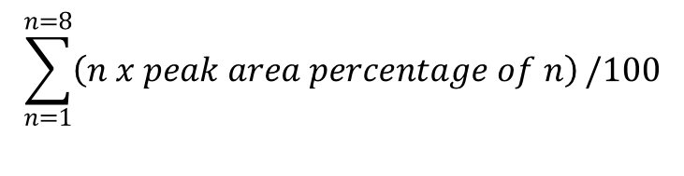

**Supplementary Table S4.** Cell cycle.

|  |  |  |  |  |
| --- | --- | --- | --- | --- |
| **Incubation medium** | **Cell cycle phase** | **Percentage of cells, mean (SD)** | | |
| **24 hours** | **48 hours** | **72 hours** |
| PBS | G0/GI | 56 (9) | 56 (3) | 64 (2) |
| G2 | 17 (7) | 18 (4) | 8 (4) |
| S | 27 (4) | 25 (4) | 28 (5) |
| Isotype control | G0/GI | 53 (5) | 56 (4) | 60 (1) |
| G2 | 19 (6) | 19 (4) | 7 (5) |
| S | 28 (2) | 25 (3) | 33 (6) |
| hz208F2-4 | G0/GI | 64 (9) | 62 (7) | 65 (10) |
| G2 | 16 (6) | 16 (4) | 10 (4) |
| S | 20 (3) | 22 (4) | 25 (13) |
| Isotype control ADC | G0/GI | 50 (6) | 57 (4) | 69 (1)* |
| G2 | 22 (8) | 19 (1) | 11 (2) |
| S | 28 (3) | 25 (5) | 20 (3)* |
| W0101 | G0/GI | 38 (3)** | 32 (3)** | 24 (3)** |
| G2 | 42 (1)** | 38 (4)** | 47 (5)** |
| S | 20 (2) | 30 (2)** | 29 (4) |
| MMAE | G0/GI | 19 (3)** | 18 (4)** | 15 (3)** |
| G2 | 72 (4)** | 72 (6)** | 74 (6)** |
| S | 9 (2)** | 10 (3)** | 11 (4)** |

MCF-7 cells were incubated with naked antibodies, ADCs, or with MMAE. Cells were incubated for 24, 48, or 72 hours with 10 µg/mL of antibodies or equivalent free drug. The cell cycle was analyzed using Modfit software version 4.0.5. G1/G0, S, and G2/M phases were quantified. The results represent the mean (SD) percentage of cells in each phase of the cell cycle from 3 independent experiments.

Abbreviations: ADC, antibody–drug conjugate; MMAE, monomethyl auristatin E. Statistical analysis was performed using a student paired t-test. * and ** indicate *p <0.05*. * indicate a significant difference versus isotype control condition. ** indicate a significant difference versus isotype control ADC condition.

**Supplementary Figure S1.** Flowchart showing the selection of antibodies targeting IGF-1R. Mice were immunized with rhIGF-1R and 578 murine antibodies were evaluated. Internalization of murine antibodies was performed by flow cytometry on MCF-7 cells. The best internalizing antibodies (*n* = 20) were then selected based on the absence of IR recognition, binding affinity, and cross reactivity on monkey IGF-1R. After this second selection criteria, 5 antibodies were selected and evaluated for their capacity to compete with IGF-1 binding, the absence of any agonistic activity, their capacity to induce cell cytotoxicity after their conjugation with the auristatin derivative, and their potential for humanizing and development. At the end of the selection process, the most potent antibody, 208F2, was retained. IGF-1R, insulin-like growth factor type 1 receptor; IR, insulin receptor; rhIGF-1R, recombinant human IGF-1R.

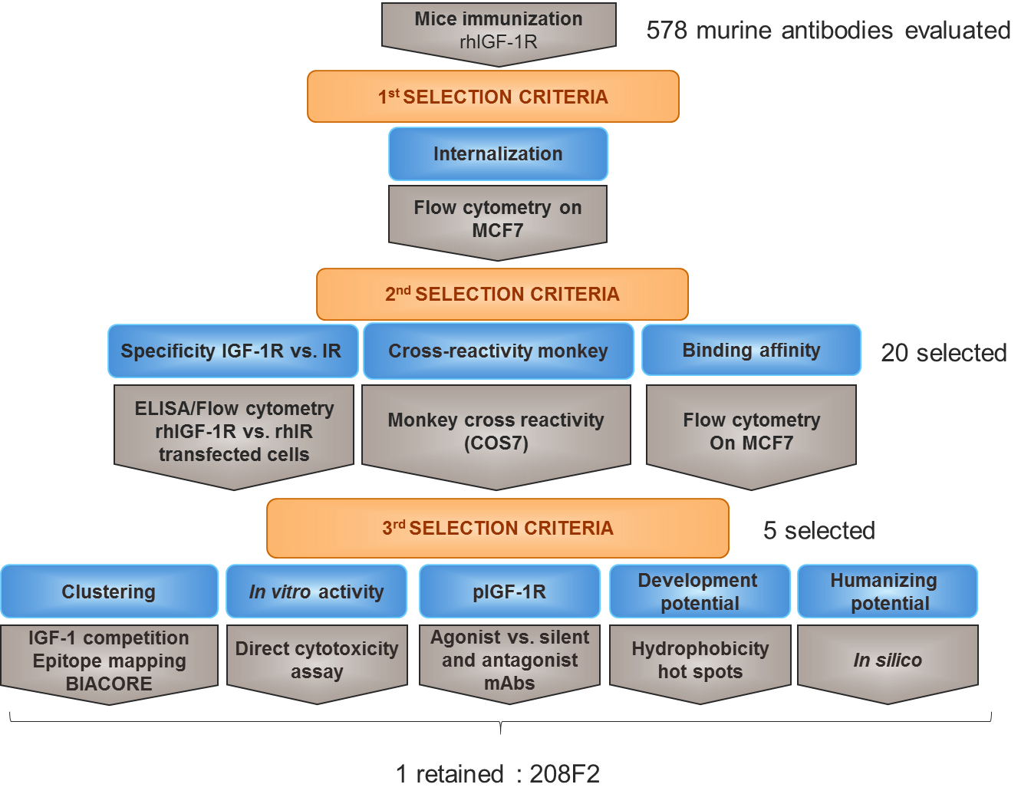

**Supplementary Figure S2.** Internalization kinetics of 5 murine anti-IGF-1R antibodies. **A,** Cells were incubated at 37°C with 10 µg/ml murine antibody and remaining antibody on the cell surface was determined by flow cytometry. The percentage of remaining antibody for each murine antibody was calculated. **B,** The t1/2 (time at which half maximum internalization occurs) was determined for each murine antibody using prism software.

**A**

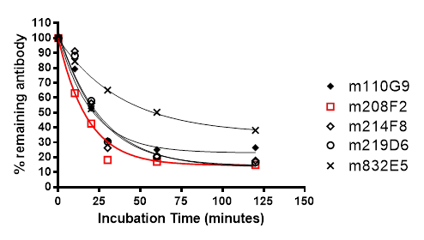

**B**

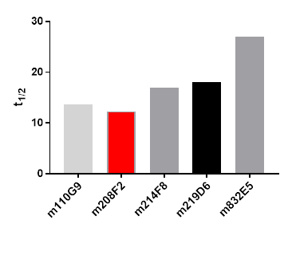

**Supplementary Figure S3.** Inhibition of binding and phosphorylation. **A**, The plate was coated using rh-IGF1R (R&D) overnight at 4°C. Radiolabeled 125I-IGF1 (1µM), was co-incubated with either IGF-1 (1µM) or murine anti-hIGF-1R Abs (1µM) at room temperature for 5 hours. The plate was read using the TopCount Reader.

The effect of the murine anti-hIGF-1R Abs was express as percentage of the binding of 125I-IGF1 on rh-IGF1R. **B**, MCF-7 cells were incubated in serum-free medium overnight. Then, cells were incubated for 5 minutes with murine anti-hIGF-1R Abs before addition of IGF-1 for 2 minutes at 37°C. Medium was discarded and cells were scraped in a lysis buffer (pH 7.5) containing 10 mM Tris HCl buffer (pH 7.5), 15% NaCl (1 M), 10% detergent mix (10 mM Tris-HCl, 10% Igepal lysis buffer) (Sigma Chemical Co.), 5% sodium deoxycholate (Sigma Chemical Co.), 1 protease inhibitor cocktail complete TM tablet (Roche), 1% phosphatase inhibitor Cocktail Set II (Calbiochem), for 90 min at 4°C. The lysates were clarified by centrifugation at 4°C, heated for 5 min at 100°C and kept at -20°C or directly loaded on 4–12% SDS-PAGE gels. Incubation of the primary antibody was performed for 2 hr at room temperature and then incubation with HRP-linked secondary antibodies was performed for 1 hr at room temperature. Membranes were washed in TBST prior to visualization of proteins with ECL. Blots were quantified using Image J software. Phospho- protein values were normalized with GAPDH. Phosphorylation of hIGF-1R in response to IGF-1 was considered as 100 % of stimulation. The effect of murine anti-hIGF-1R Abs on the phosphorylation of hIGF-1R was determined as % of phosphorylation induced by IGF-1.

**A**

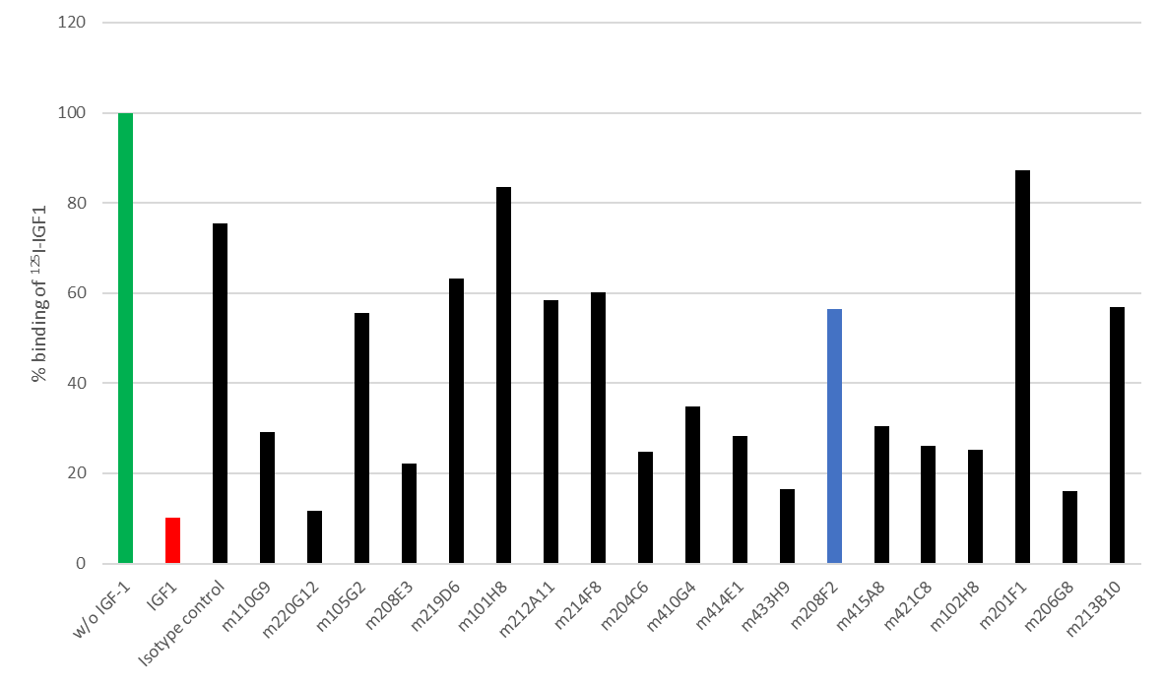

**B**

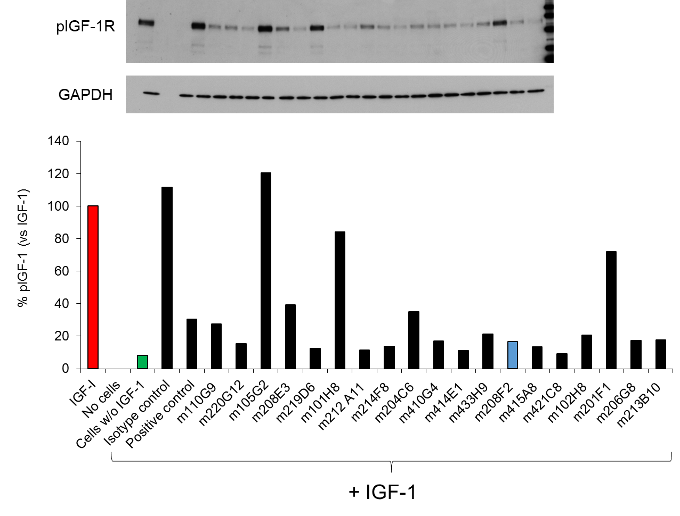

**Supplementary Figure S4.** Binding and internalization of W0101. **A,** MCF-7 cells were incubated with increasing concentrations of the naked humanized anti-IGF-1R antibody 208F2 (hz208F2-4) or its corresponding ADC, W0101. The binding capacity of both antibodies was determined by flow cytometry. The binding capacity of the naked humanized anti-IGF-1R 208F2 (hz208F2-4) and its corresponding ADC, W0101, was performed in MCF-7 cells. **B,** Loss of antibodies on the MCF-7 cell surface was determined after cell incubation at 4°C or 37°C for 4 hours. Cells were incubated with increasing concentrations of either hz208F2-4 or W0101. The remaining bound antibody was determined by flow cytometry. Data represent the percentage of antibody internalization. The percentage internalization was calculated as follows: 100 – (signal at 37°C/signal at 4°C) x 100. Representative results from at least 3 independent experiments are shown. ADC, antibody–drug conjugate; IGF-1R, insulin-like growth factor type 1 receptor.

**A**



**B**



**Supplementary Figure S5.** Effect of W0101 on **A,** the cell cycle and **B,** apoptosis. MCF-7 cells were incubated with naked antibodies, ADCs (10 µg/mL), or MMAE (equivalent dose). Cells were incubated for 24, 48, or 72 hours with 10 µg/mL of antibodies or equivalent free drug. Cell cycle analysis was evaluated after incubation in the presence of propidium iodide. Cells debris was excluded. The cell cycle was analyzed using Modfit software version 4.0.5. Representative results from 3 independent experiments are shown. Apoptosis was determined using annexin V binding after 72 hours of incubation in the presence of the ADC. The results represent the mean of 3 independent experiments ± SD. *, *P* < 0.05 compared to the isotype control ADC. ADC, antibody–drug conjugate; MMAE, monomethyl auristatin E.

**A**

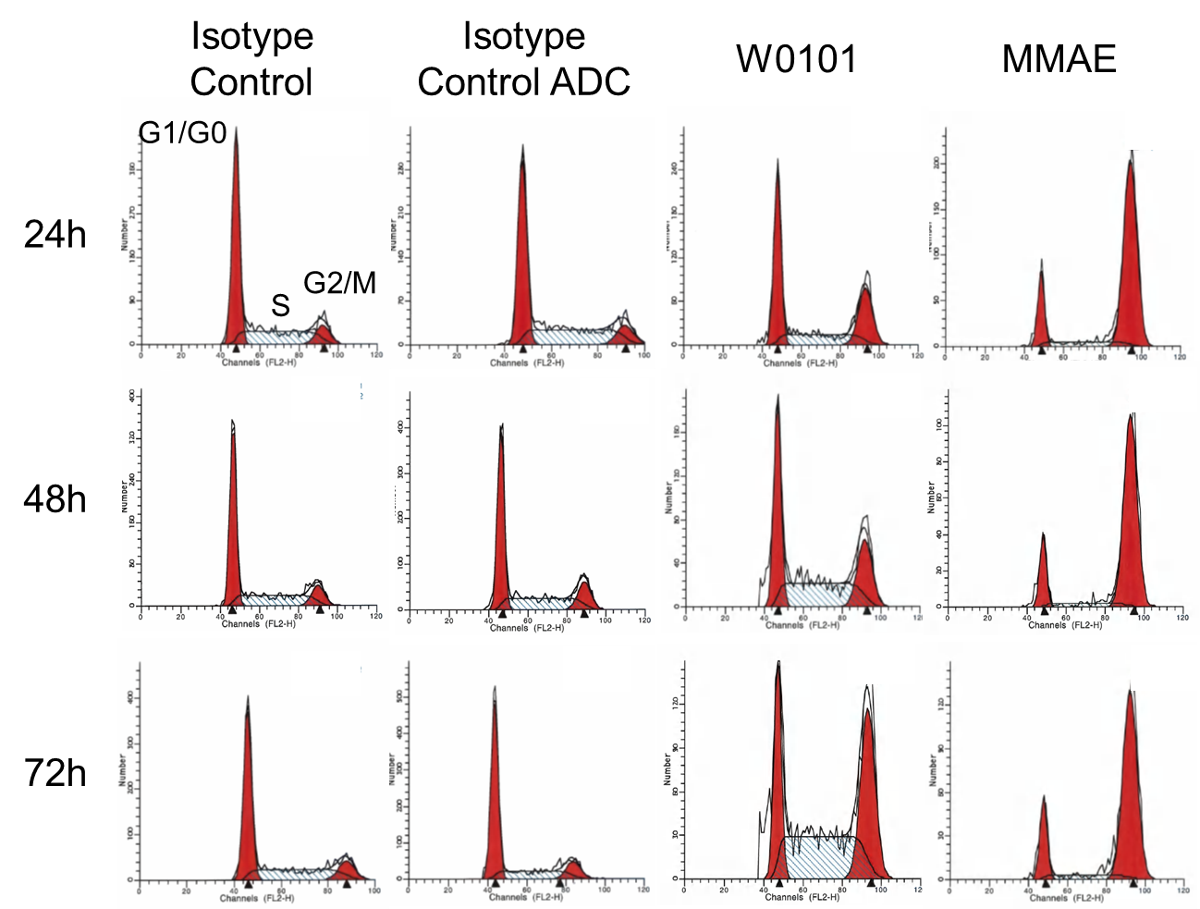

**B**

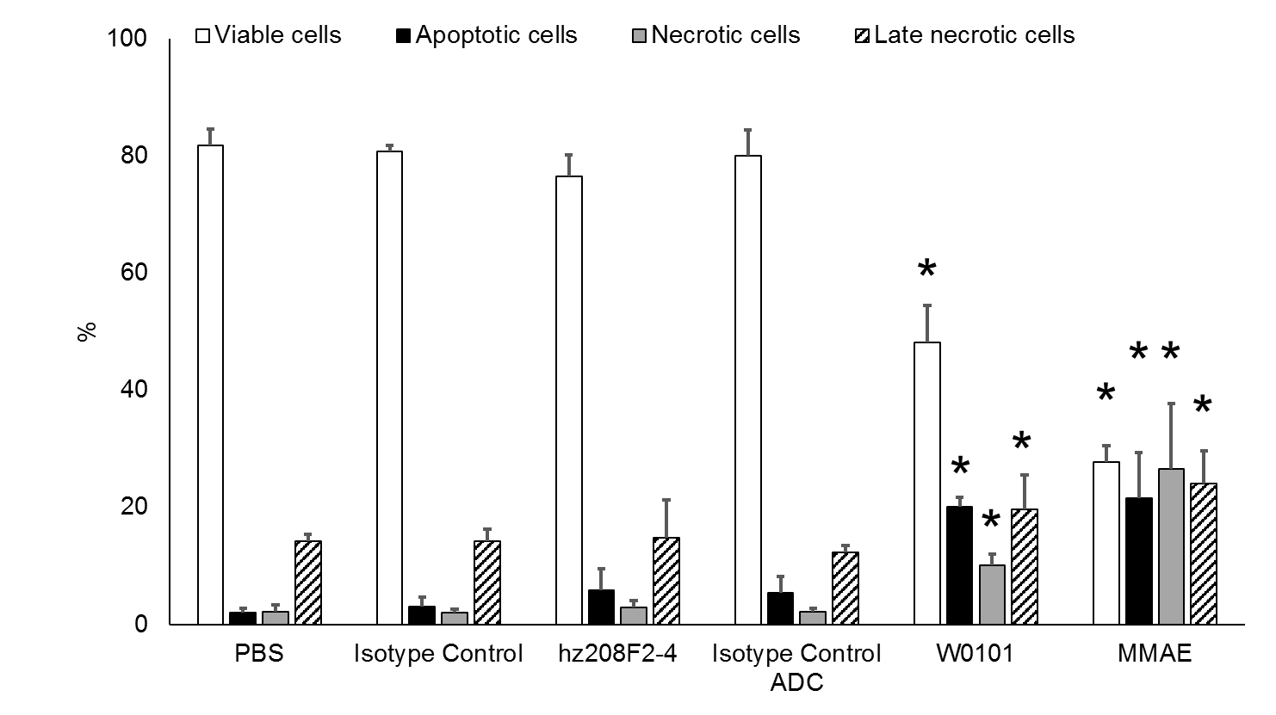

**Supplementary Figure S6.** The naked antibody hz208F2-4 did not induce tumor growth inhibition in several xenograft models. **A**, MCF-7 model treated with 208F2 7 mg/kg once a week for 2 cycles. **B,** NCI-H2122 model treated with hz208F2-4 3 mg/kg twice a week for 2 cycles.

**A**



**B**



**Supplementary Figure S7.** Bystander activities of W0101. Evaluation of the bystander effect was performed as previously described with minor modifications (1). Co-culture experiments included MCF-7 (IGF-1R+) and Hs746t (IGF-1R–) cells. Briefly, MCF-7 and Hs746 t were cultured alone (Alone) or co-cultured (Coculture) with increasing concentrations of W0101. After 6 days of incubation at 37°C, cells were incubated with an anti-cMet antibody to identify MCF-7 cells (c-Met–) and Hs746t (c-Met++). The viable cell count was assessed by flow cytometry using beads (Molecular Probes™ # C36950, Fisher Scientific) to enable the determination of the number of surviving MCF-7 and Hs746t tumor cells. **A**, viable MCF-7 cell count after 6 days of incubation alone or in coculture with Hs746t. **B**, viable Hs746t cell count after 6 days of incubation alone or in coculture with MCF-7.

**A**

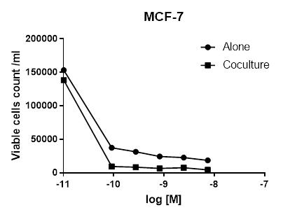

**B**

