Supplementary figures:

Supplementary Figure S1
(A) Immunoblot analysis of whole cell lysates of OVCAR4 and OVCAR8 cells treated with vehicle (DMSO) and verticillin A (50 nM) and probed for apoptotic marker (Bax). Actin was used as a loading control. (B) OVCAR8 cells were treated with vehicle control (DMSO) and verticillin A (50 nM) for 24 hrs and 1x10⁶ cells were used for histone extraction. Graph represents differential expression mass spectrometry analysis of histone post-translational modifications. Error bars represent standard deviation obtained from 3 technical replicates of each sample. (C) qRT-PCR validation of genes in apoptosis signaling (NFKB2, RELB) and oxidative stress response pathway (TXN, DUSP6 and TXNRD1) for OVCAR8 cells treated with vehicle control (DMSO) and verticillin A (50 nM) for 24 hrs. Data represent mean ± SEM. Significance tested by Student’s t-test in comparison to vehicle control.

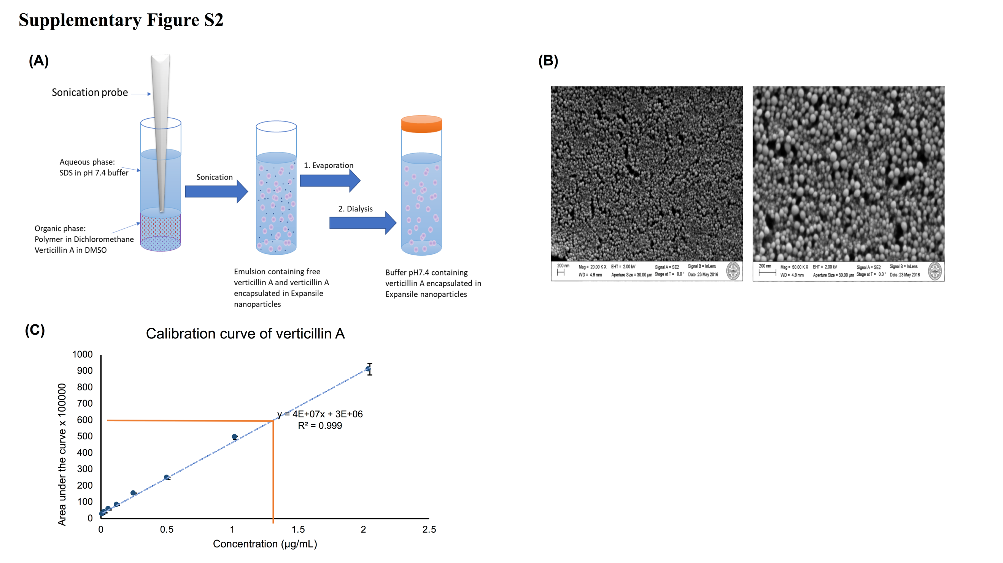

Supplementary Figure S2
(A)Verticillin A-eNP synthesis followed a modified procedure developed by Colby et al (17,18). The aqueous phase contains surfactant while the organic phase contains the pre-polymerized eNP polymer and verticillin A. This solution was emulsified with a probe sonicator to create a suspension of organic phase droplets in the aqueous phase. The organic solvent was evaporated, leaving behind verticillin A encapsulated inside eNPs. Finally, a last step of dialysis was done on the solution to eliminate the verticillin A molecules that escaped encapsulation during the sonication process. (B) Scanning electron micrograph of verticillin A expansile nanoparticles showing spherical particles of approximately 100 nm at pH 7.4. The right picture is a zoom in of a spot shown on the left picture. Scale bar: 200 nm. (C) Calibration curve for verticillin A, as measured via UPLC-HRMS, using a Waters Acquity UPLC system coupled with a Thermo Q-Exactive Plus mass spectrometer. The instrument was operated under positive mode using selected ion monitoring (SIM) of verticillin A [(M+H)⁺, m/z of 697.10]. To build the calibration curve, 3 µl of each concentration was analyzed in triplicates. These data represent mean ± SD, and the orange line represents the amount of verticillin A in the diluted solution (1.29 µg/ml). In sum total, there was 0.91 mg of verticillin A per ml of eNP solution, representing an encapsulation efficiency of 76.9%.

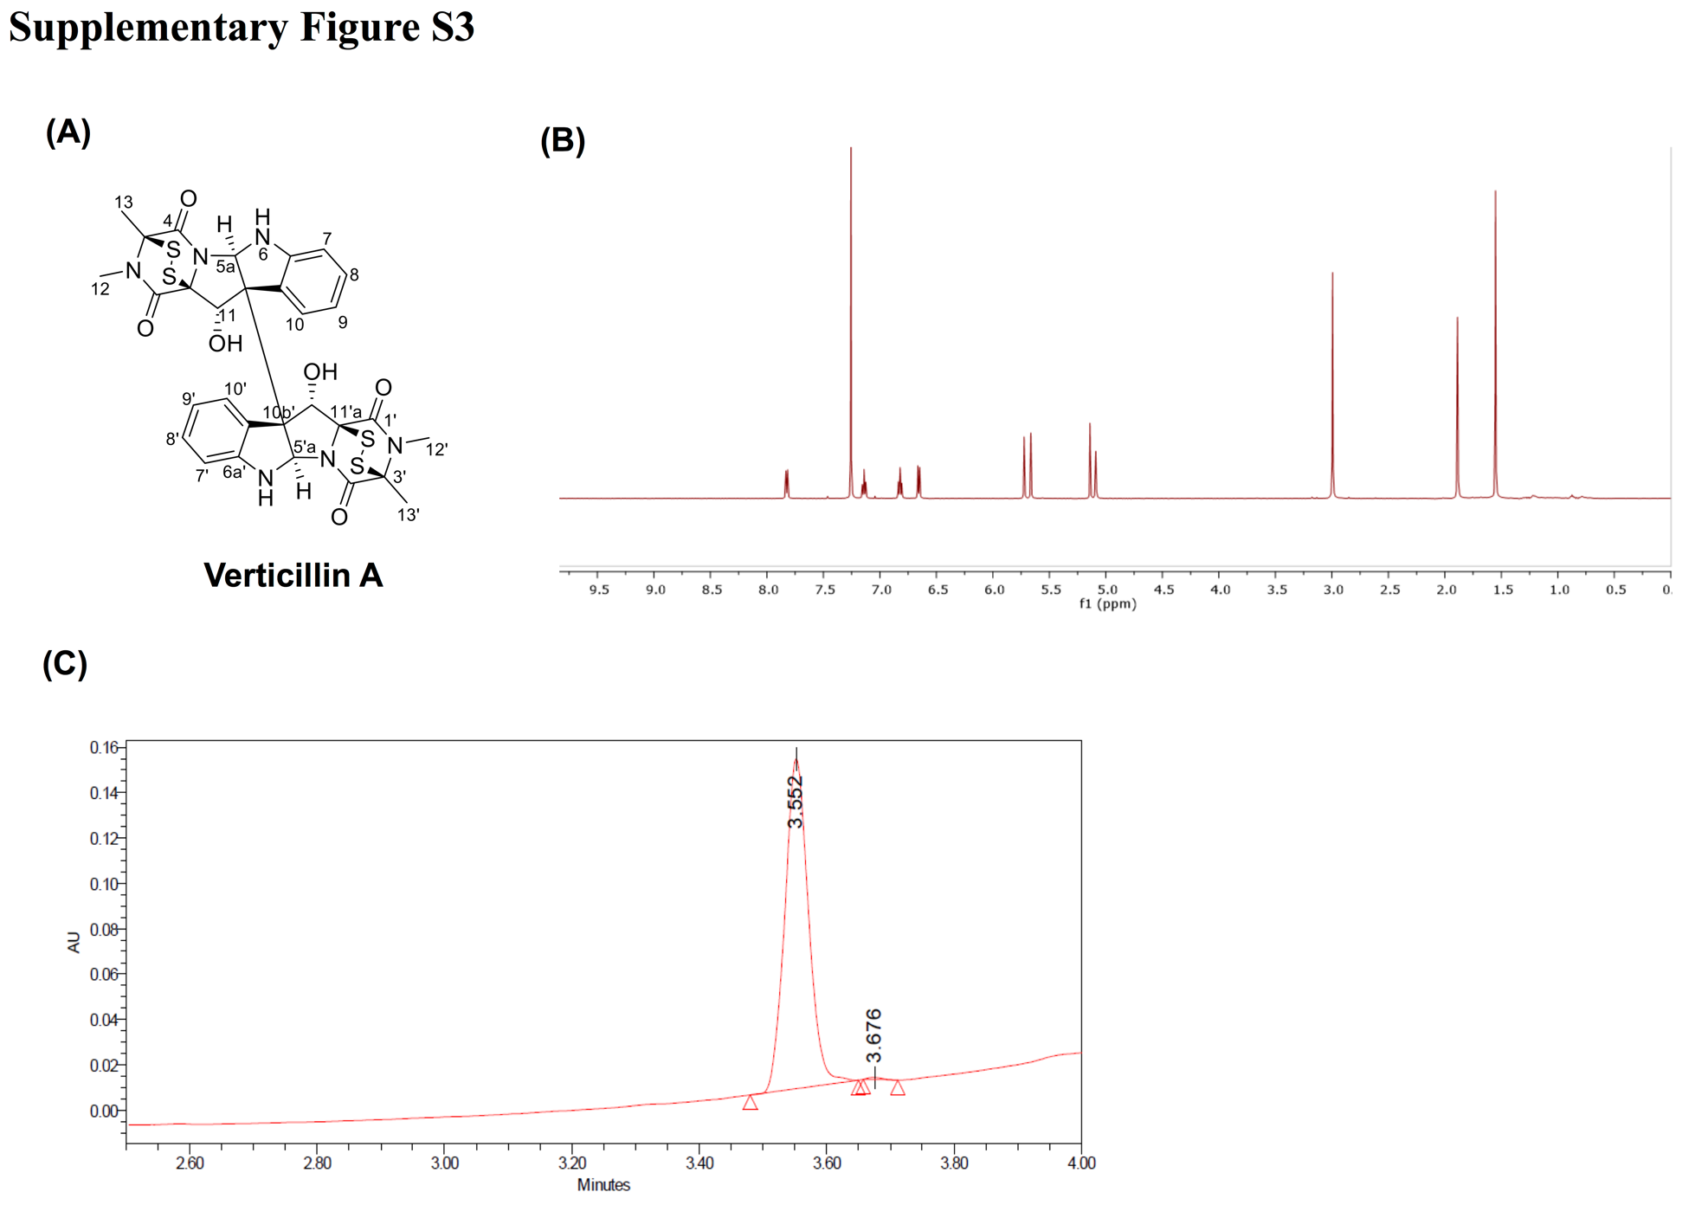

Supplementary Figure S3
(A) Structure of verticillin A. (B) ¹H-NMR data of verticillin A analyzed in CDCl₃ (δ_{H} 7.26 ppm) using a JOEL 500 MHz instrument. (C) A Waters Acquity UPLC system was used to analyze the verticillin A used in the encapsulation process to synthesize eNPs loaded with 5% of the compound. Verticillin A eluted at 3.55 min when analyzed using a gradient UPLC system that initiated with 40:60 MeOH:H₂O with 0.1% formic acid on a HSS PFP column (1.8 µm, 2.1 x 100), then increased linearly to 60:40 MeOH:H₂O with 0.1% formic acid over 4.00 min. Both figures indicate that the purity of verticillin A was greater than 95%.

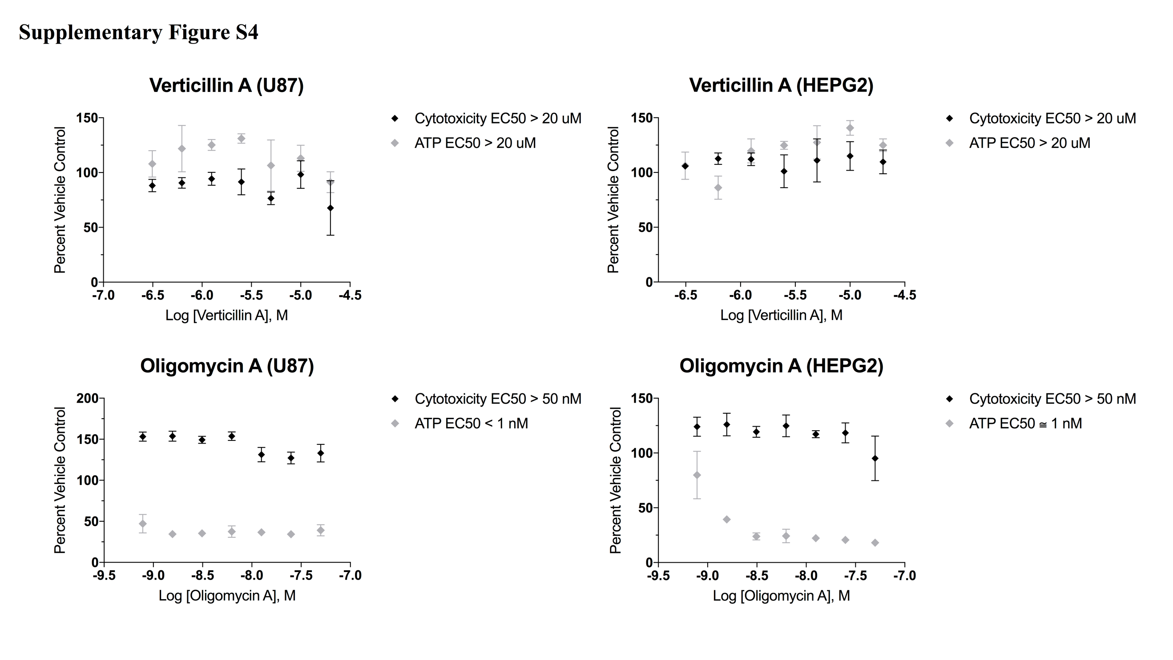

Supplementary Figure S4
Mitochondrial toxicity assay was performed in U87 and HEPG2 cells using Mitochondrial ToxGloTM kit. Cell membrane integrity and ATP levels were measured using fluorescent and luminescent substrate respectively. Verticillin A treatment showed no changes in ATP levels or membrane integrity indicating no mitochondrial toxicity. Oligomycin was used as a positive control and showed mitochondrial toxicity.

