Uitdehaag et al. (2018) Supplementary Figure S6. A, Waterfall plots of the VEGFR inhibitors. Geometrically averaged panel IC₅₀s are 12.6 µM for lenvatinib, 3.2 µM for nintedanib and 17.9 µM for tivozanib. B, Waterfall plot of midostaurin (IC_{50,average} = 1.1 µM).

A
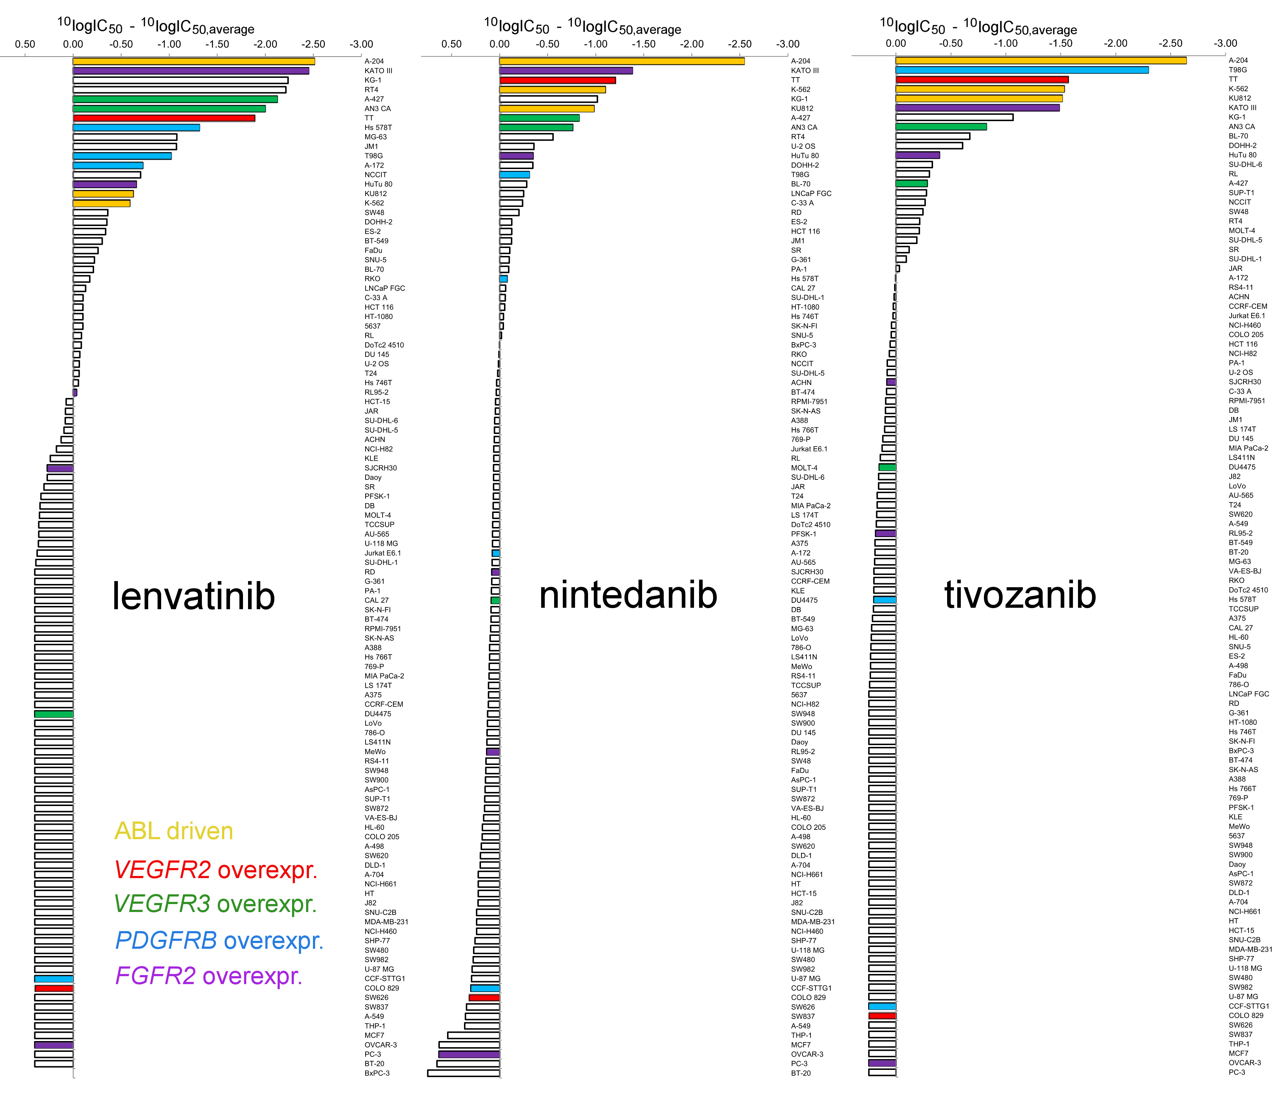

B
