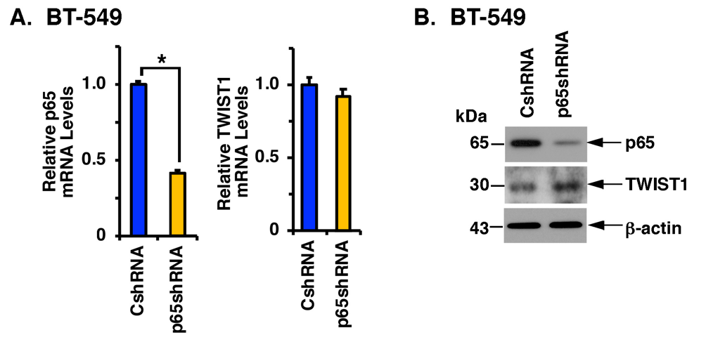

Supplemental Figure S1. Targeting NF-κB p65 has little effect on TWIST1 expression. A and B. BT-549 cells expressing a CshRNA or p65shRNA were analyzed for p65 and TWIST1 mRNA levels by qRT-PCR using primers listed in Supplemental Table S1. The results (mean±SD) are expressed as relative mRNA levels compared to that obtained for control cells (assigned a value of 1) (A). Lysates were immunoblotted with antibodies against the indicated proteins (B).

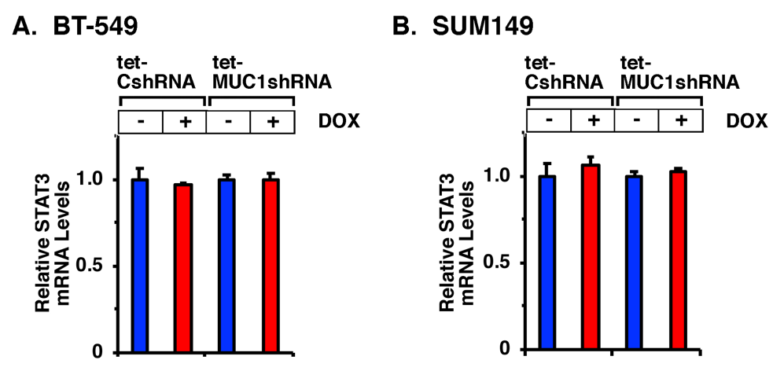

Supplemental Figure S2. Targeting MUC1-C is not associated with regulation of STAT3 mRNA levels. A and B. BT-549 (A) and SUM149 (B) cells expressing a tet-CshRNA or tet-MUC1shRNA were left untreated or treated with 500 ng/ml DOX for 7 days. Cells were analyzed for STAT3 mRNA levels by qRT-PCR. The results (mean±SD) are expressed as relative mRNA levels compared to that obtained for control untreated cells (assigned a value of 1).

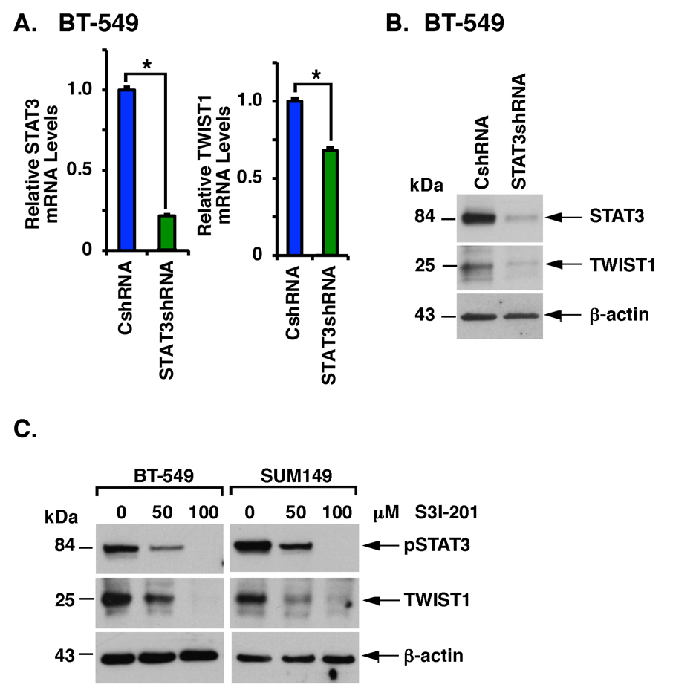

Supplemental Figure S3. Targeting STAT3 genetically or pharmacologically decreases TWIST1 expression. A and B. BT-549 cells expressing a CshRNA or STAT3shRNA were analyzed for STAT3 and TWIST1 mRNA levels by qRT-PCR. The results (mean±SD) are expressed as relative mRNA levels compared to that obtained for control cells (assigned a value of 1) (A). Lysates were immunoblotted with antibodies against the indicated proteins (B). C. BT-549 and SUM149 cells were treated with 0, 50 or 100 μM S3I-201 for 48 h. Lysates were immunoblotted with antibodies against the indicated proteins.

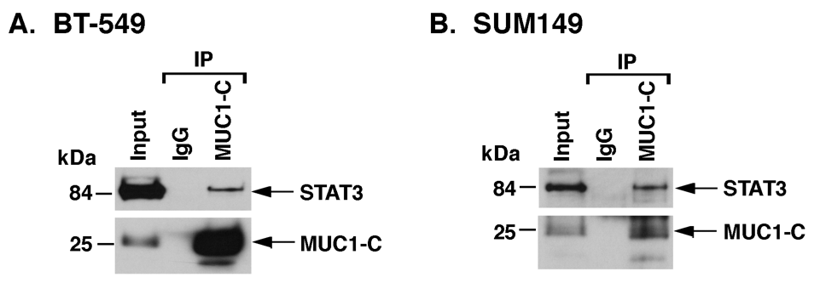

Supplemental Figure S4. MUC1-C and STAT3 form a nuclear complex. A and B. Nuclear lysates from BT-549 (A) and SUM149 (B) cells were incubated with anti-MUC1-C or a control IgG. The precipitates were immunoblotted with antibodies against STAT3 and MUC1-C.

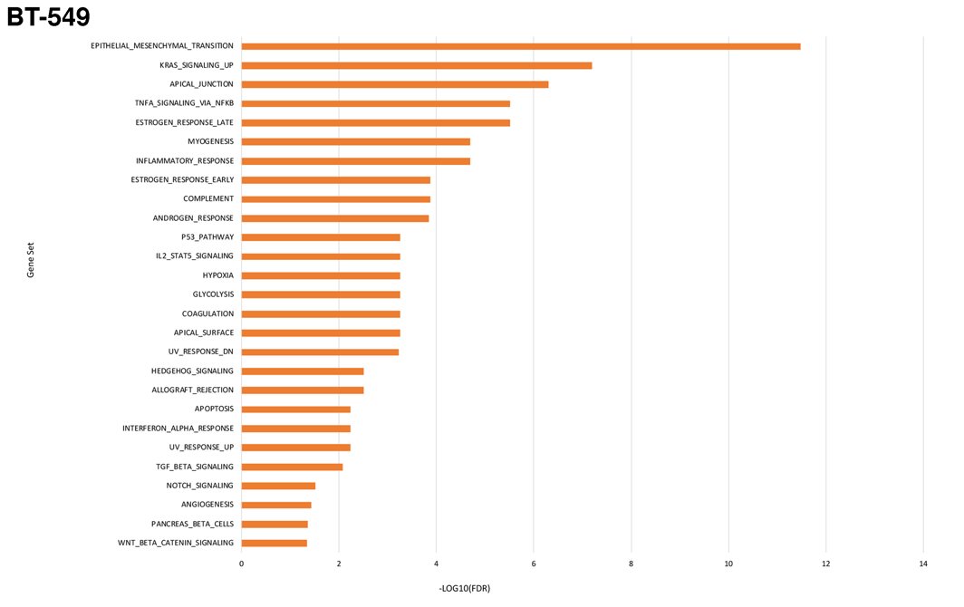

Supplemental Figure S5. Hallmark pathway analysis for BT-549 cells. RNA-seq was performed in triplicate on BT-549/CshRNA and BT-549/MUC1shRNA cells. The datasets were analyzed using the Hallmark gene signature collection. Results are shown for the 20 most significant pathways.

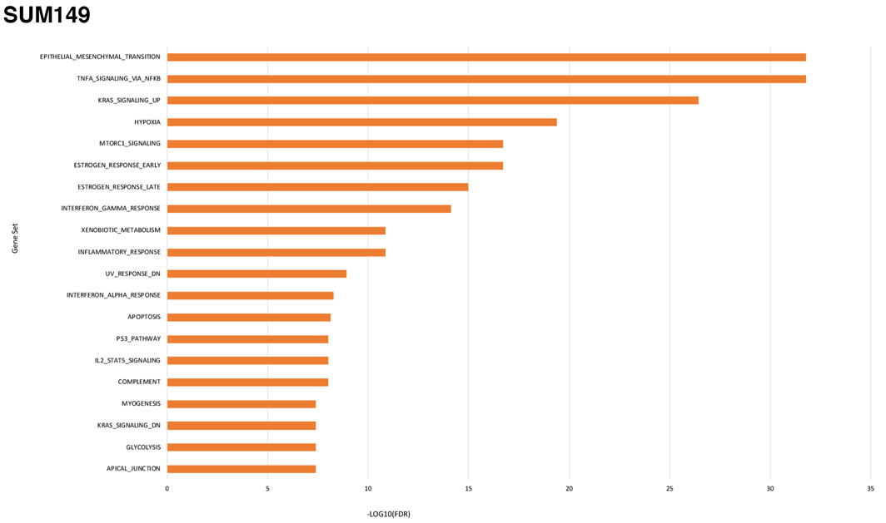

Supplemental Figure 6. Hallmark pathway analysis for SUM149 cells. RNA-seq was performed in triplicate on SUM149/CshRNA and SUM149/MUC1shRNA cells. The datasets were analyzed using the Hallmark gene signature collection. Results are shown for the 20 most significant pathways.

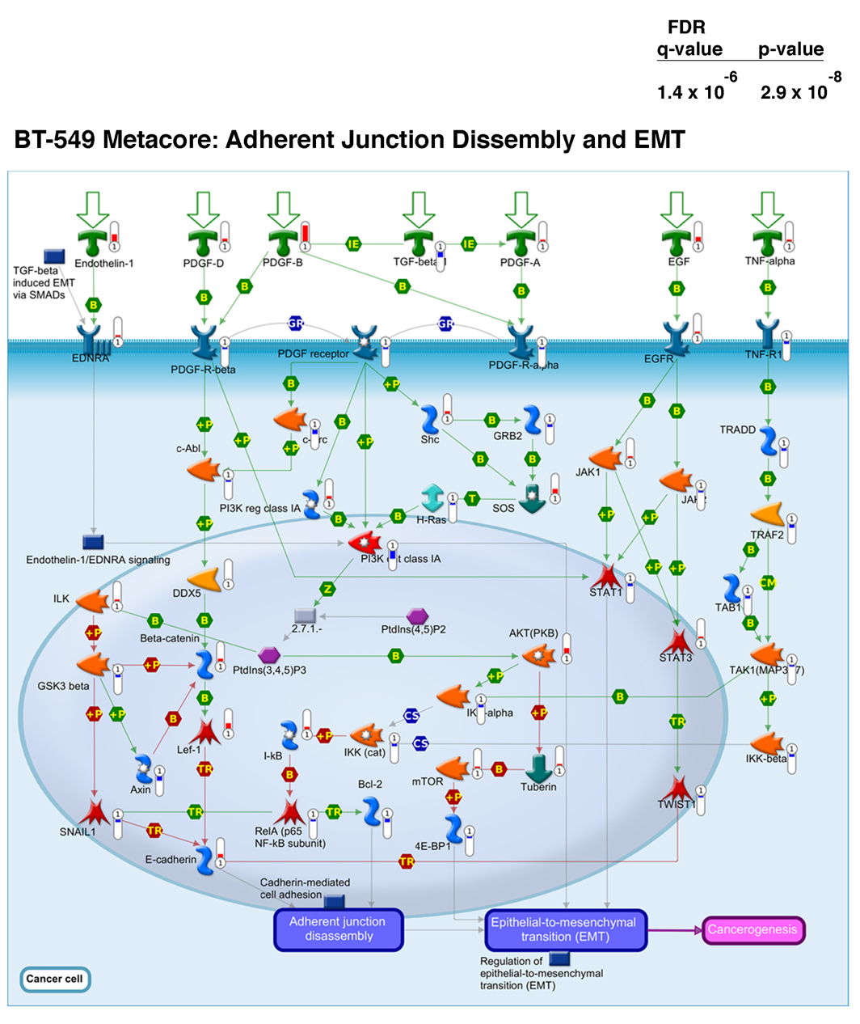
Supplemental Figure S7. Metacore adherens junction disassembly and EMT pathway analysis for BT-549 cells. RNA-seq data from BT-549/CshRNA and BT-549/MUC1shRNA cells was analyzed using Metacore for enrichment.
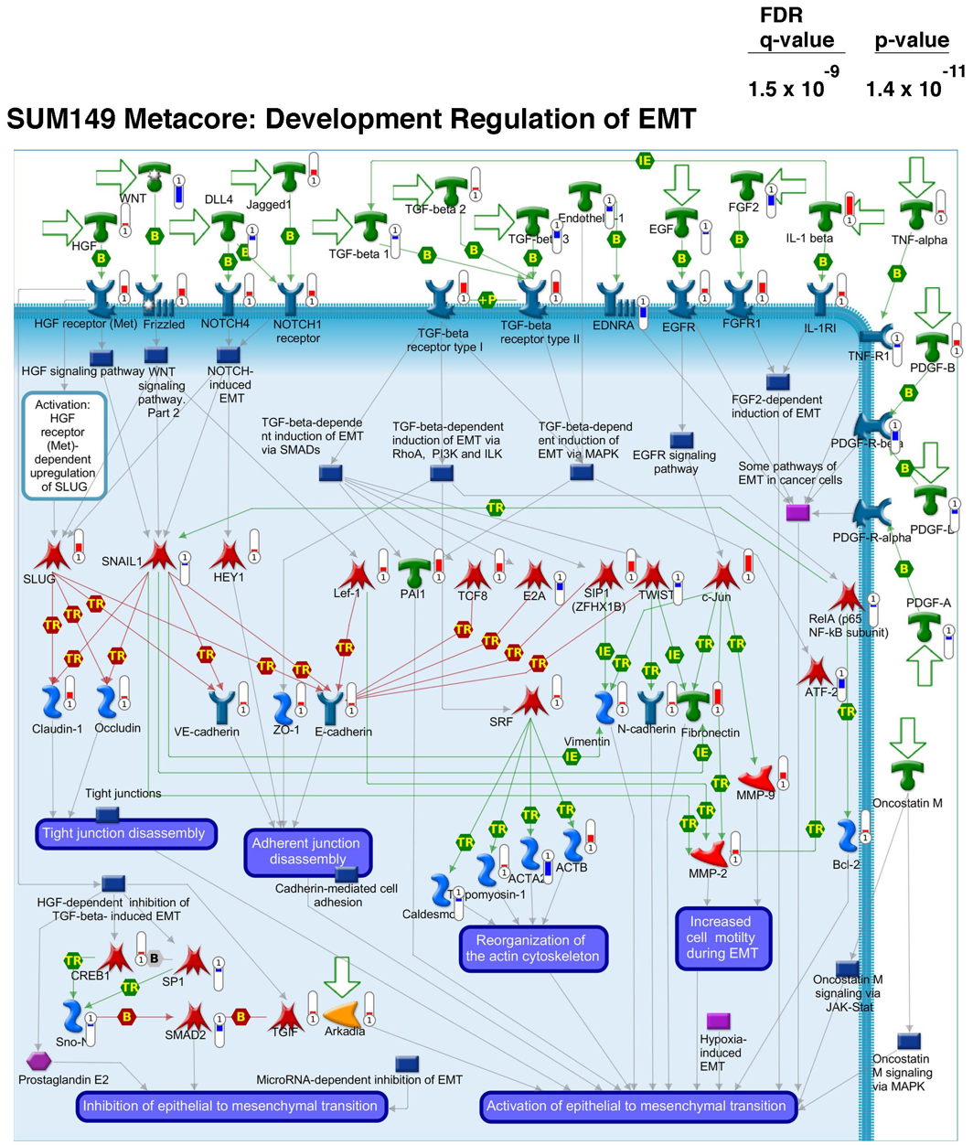
Supplemental Figure S8. Metacore EMT pathway analysis for SUM149 cells. RNA-seq data from SUM149/CshRNA and SUM149/MUC1shRNA cells was analyzed using Metacore for enrichment.
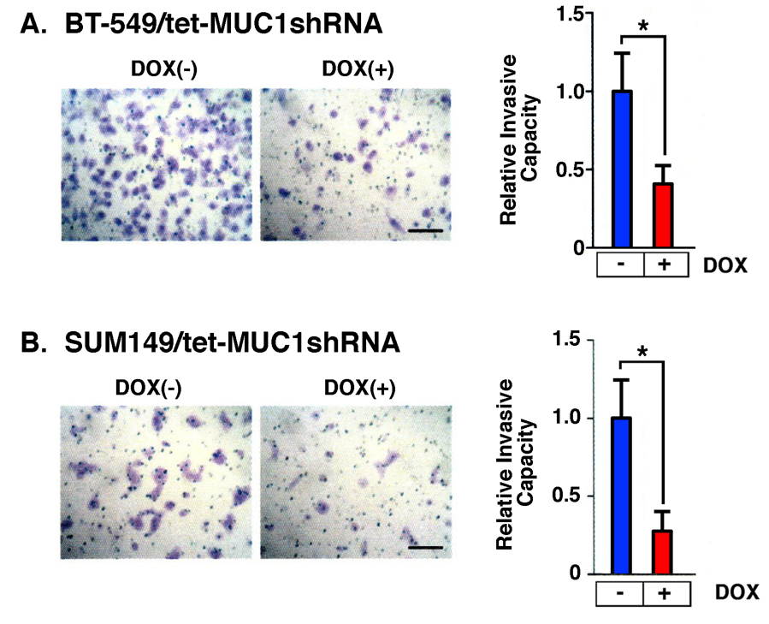

Supplemental Figure S9. Silencing MUC1-C inhibits cell invasive capacity. A and B. BT-549/tet-MUC1shRNA (A) and SUM149/tet-MUC1shRNA (B) cells left untreated or treated with 500 ng/ml DOX for 7 days were evaluated for invasive capacity in matrigel coated transwell chambers (left). Results are expressed as the relative invasive capacity compared to that obtained with the untreated cells (assigned a value of 1).

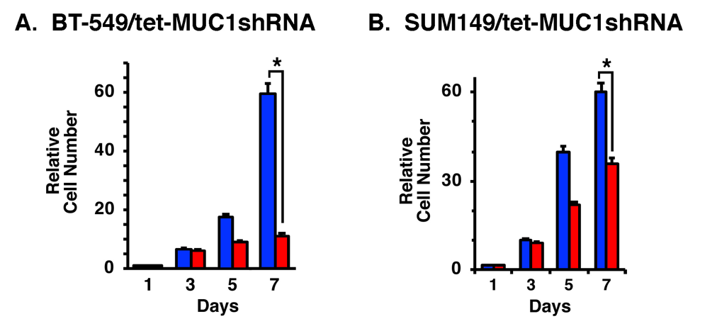

Supplemental Figure S10. Silencing MUC1-C inhibits growth of BT-549 and SUM149 cells. A and B. BT-549/tet-MUC1shRNA (A) and SUM149/tet-MUC1shRNA (B) cells were left untreated (red bars) or treated with 500 ng/ml DOX (blue bars) for the indicated number of days. The results are expressed as relative cell numbers (mean±SD) compared to that obtained on Day 1 (assigned a value of 1).

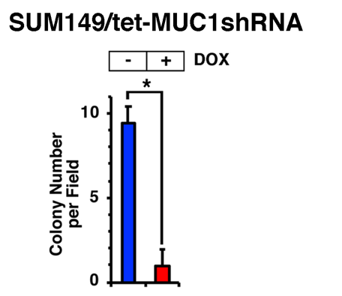

Supplemental Figure S11. Silencing MUC1-C inhibits colony formation of SUM149 cells. SUM149/tet-MUC1shRNA cells left untreated (blue bars) or treated with 500 ng/ml DOX (red bars) for 7 days were analyzed for colony formation. The results (mean±SD of at least three determinations) are expressed as the number of colonies/field.

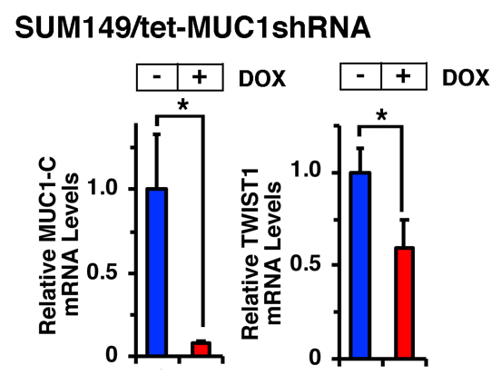

Supplemental Figure S12. Downregulation of MUC1-C and TWIST1 expression in vivo. Mice bearing SUM149/tet-MUC1shRNA tumors were fed without and with DOX. Tumors harvested on day 21 were analyzed for MUC1-C and TWIST1 mRNA levels. The results (mean±SD) are expressed as relative mRNA levels compared to that obtained for control cells (assigned a value of 1).

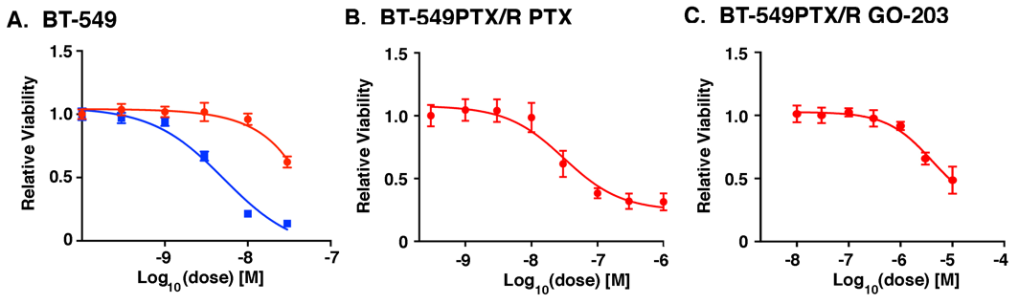

Supplemental Figure S13. Selection of BT-549 cells for PTX resistance. A. BT-549 (blue squares) and BT-549/PTX-R (red circles) cells were treated with the indicated PTX concentrations and analyzed for cell viability. B and C. BT-549/PTX-R cells treated with the indicated concentrations of PTX (B) or GO-203 (C) were analyzed for cell viability.

Supplemental Table S1: Primers sequences for qRT-PCR.

Primer | FWD | REV
GAPDH | CCATGGAGAAGGCTGGGG | CAAAGTTGTCATGGATGACC
MUC1 | TACCGATCGTAGCCCCTATG | CTCACCAGCCCAAACAGG
TWIST1 | CGGGAGTCCGCAGTCTTA | GCTTGAGGGTCTGAATCTTG
STAT3 | CAGCAGCTTGACACACGGTA | AAACACCAAAGTGGCATGTGA
ESR1 | GACAGGGAGCTGGTTCACAT | AGGATCTCTAGCCAGGCACA
GATA3 | AGCCAGGAGAGCAGGGACG | CTGTTAATATTGTGAAGCTTGTAGTAGAG
ZEB1 | ACCCTTGAAAGTGATCCAGC | CATTCCATTTTCTGTCTTCCGC
SNAIL | CGGAAGCCTAACTACAGCGA | GGACAGAGTCCCAGATGAGC
NF-κB p65 | CTGCAGTTTGATGATGAAGA | TAGGCGAGTTATAGCCTCAG

Supplemental Table S2: Primers used in ChIP assays.

Primer | FWD | REV
TWIST1 | GCCAGGTCGTTTTTGAATGGT | CGTGAGGAGGAGGGACTTTTC
MUC1 | TAGTCAGGGGGTTGAGCGAT | AGCAGGTGACAGGTGACAAAA

Supplemental Table S3: Combination FA and CI values.

Combination | GO-203(μM) | PTX(nM) | FA | CI
1 | 0.1 | 1 | 0.470 | 0.057
2 | 0.1 | 3 | 0.488 | 0.122
3 | 0.1 | 10 | 0.484 | 0.348
4 | 0.3 | 1 | 0.560 | 0.107
5 | 0.3 | 3 | 0.556 | 0.172
6 | 0.3 | 10 | 0.595 | 0.398
7 | 1 | 1 | 0.627 | 0.281
8 | 1 | 3 | 0.624 | 0.346
9 | 1 | 10 | 0.661 | 0.572

