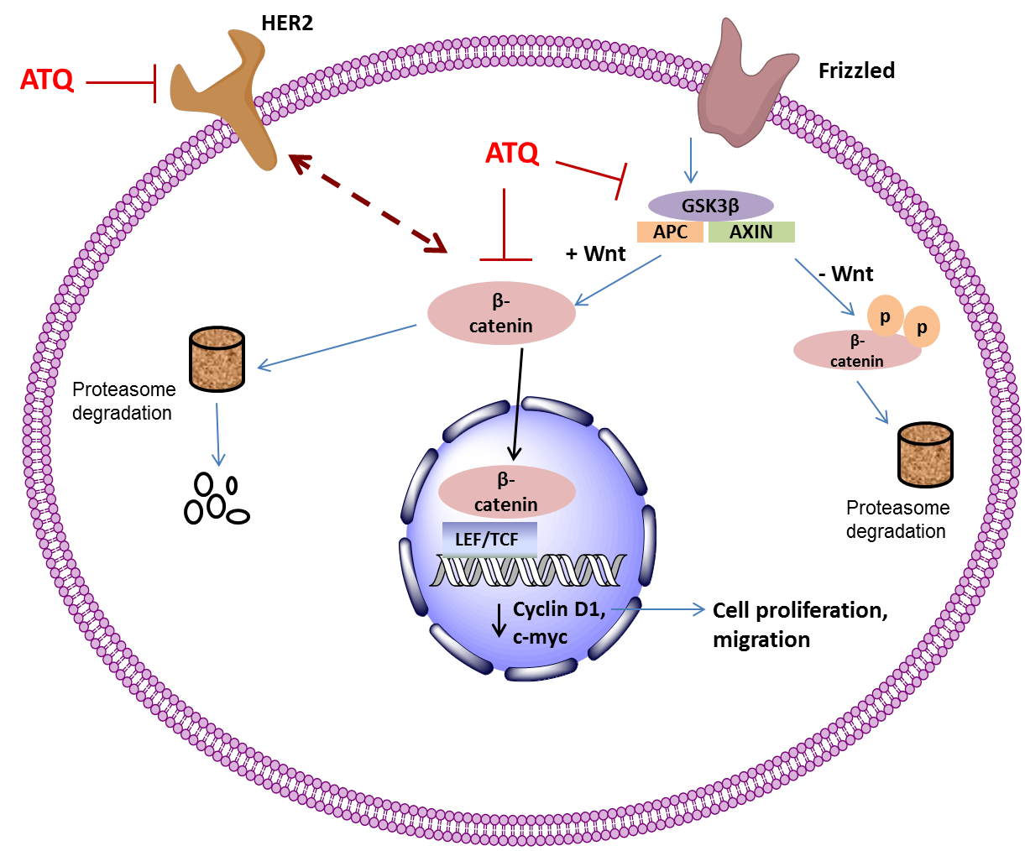

Supplementary Figure S4: Schematic diagram depicting mechanism of atovaquone (ATQ) in breast cancer cells. Atovaquone inhibits HER2 mediated β-catenin signaling and its downstream c-Myc, cyclinD1. Atovaquone promotes proteasome mediated degradation of β-catenin in cytoplasm resulting in reduced translocation into nucleus.

