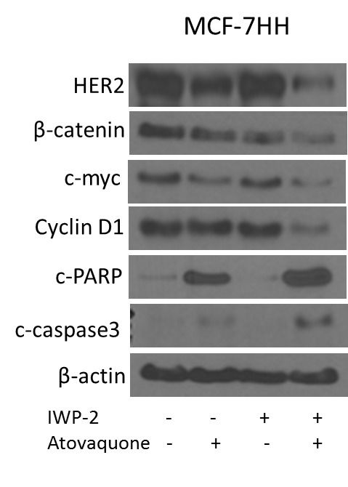

Supplementary Figure S3: (A) MCF-7HH cells were treated with β-catenin inhibitor, IWP-2 (20μM) and atovaquone (20μM) alone and in combination for 72 hours. Western blotting was performed using the cell lysates.

