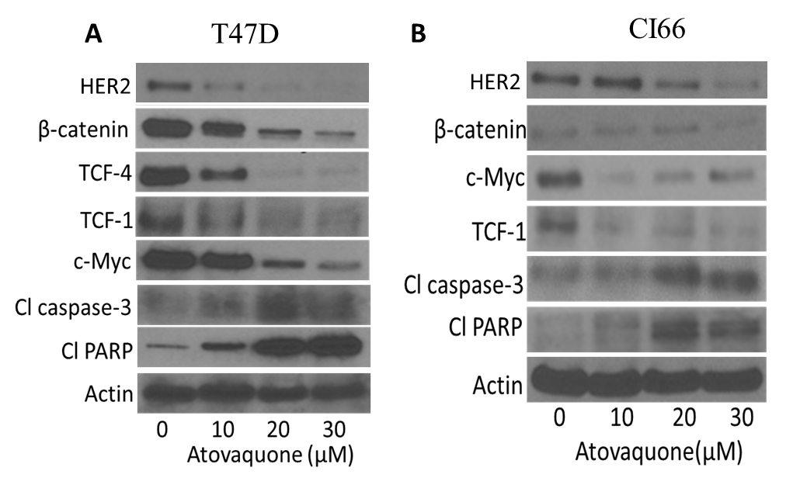

Supplementary Figure S2: Western blot showing reduction in expression of HER2, β-catenin, TCF-4, TCF-1, c-Myc and increase in C-caspase3 and C-PARP levels after treatment with atovaquone at indicated concentrations at 72 hours in (A) T47D cells and (B) CI66 cells.

