Supplementary Table 1

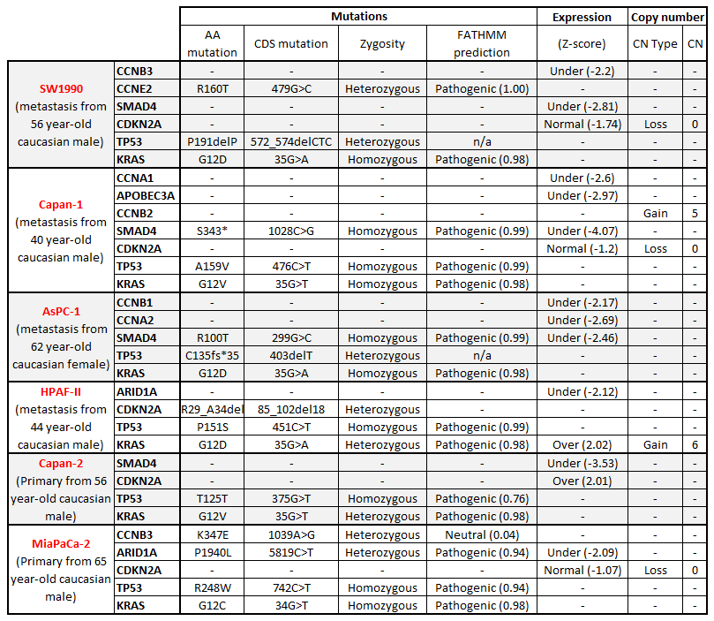
Supplementary Table 1. Genetic alterations likely to sensitize to ATR inhibition in the human PDAC cell lines
Genetic alterations in the human PDAC cell lines, for all the genes in Fig. 1A (COSMIC, http://cancer.sanger.ac.uk/cosmic). Note that no sequencing data was available for Panc-1.

