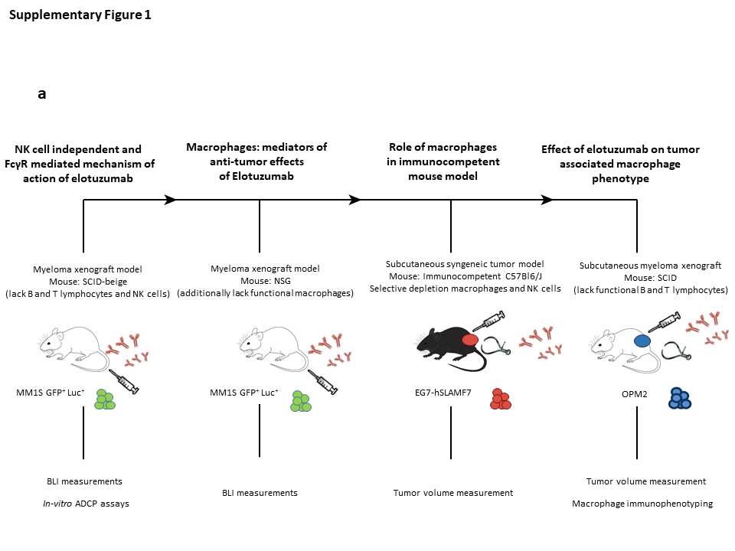
Supplementary Figure 1. In-vivo mouse models schema.
(a) Schematic representation of the in-vivo mouse models (outlined in methods section) used in studying the involvement of macrophages and role of FcγR stimulation in mediating the anti-tumor properties of elotuzumab.

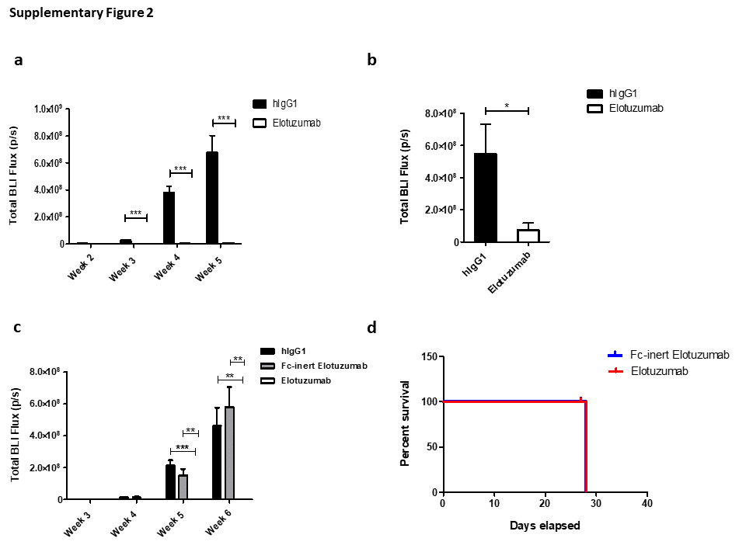Supplementary Figure 2. Total BLI Flux of SCID.beige myeloma xenograft model and Kaplan-Meier survival analysis of the NSG xenograft model.
(a) Total BLI flux (mean p/s ± S.D.) of elotuzumab treated mice 48 hrs after myeloma cell injection demonstrated a statistically significant reduction in BLI intensity among elotuzumab treated mice. (b) Total BLI flux of elotuzumab also significantly reduced compared to isotype control mice in the later tumor model where treatment was initiated after tumor engraftment as evidenced by early positive BLI signals. (c) Total BLI flux (mean p/s ± S.D.) of mice treated with hIgG1, Fc-inert elotuzumab, or elotuzumab 48 hrs after myeloma cell injection. Similar to hIgG1 control, lack of Fc-FcγR interaction upon Fc-inert elotuzumab treatment significantly abrogated elotuzumab induced reduction in tumor burden. *P<0.05, **P<0.01, ***P<0.001 by two-tailed unpaired t-test. (d) Early xenograft model Kaplan-Meier survival analysis of NSG mice injected with MM1S GFP⁺ Luc⁺ cells (corresponding to Fig. 2C) showing no difference in survival among elotuzumab treated NSG mice compared to Fc-inert treated group (mean survival in both groups= 28.67 days) (n=3 mice per group).
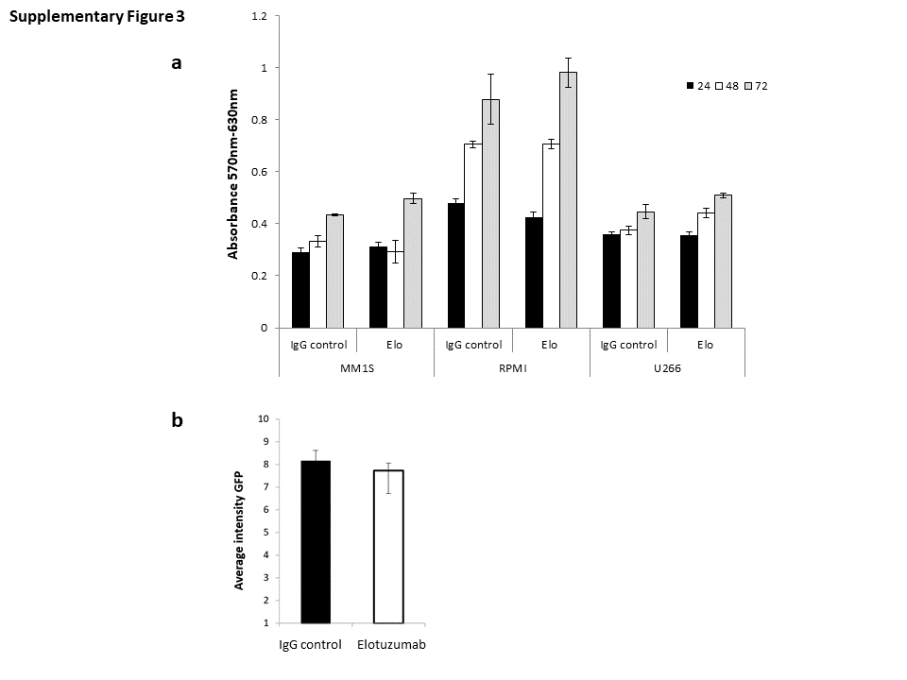
Supplementary Figure 3. Elotuzumab does not affect myeloma cell proliferation and homing to the bone marrow.
(a) MTT assay conducted on myeloma cell lines (MM1S, RPMI and U266) upon in-vitro exposure to 100µg/ml of hIgG1 or elotuzumab for 24, 48, or 72 hrs. No difference in cellular proliferation across the tested cell lines was detected with treatment of elotuzumab compared to hIgG1. Data is representative of two independent experiments with each condition done in triplicate. (b) Quantification of MM1S GFP+ Luc+ homing to the bone marrow through in vivo confocal imaging 18 hours after i.v. injection of MM1S GFP+ Luc+ and i.p treatment with elotuzumab or hIgG1 control. Elotuzumab does not reduce homing of the myeloma cells compared to mice treated with hIgG1 control (n=3 per group).

