**Title: Analysis of HSP27 and the autophagy marker LC3B+ puncta following preoperative chemotherapy identifies high-risk osteosarcoma patients**

**Supplemental Tables and Figures**

**Table S1.** Univariate analysis for factors associated with overall survival in patients with metastatic osteosarcoma

|  |  |  |  |  |
| --- | --- | --- | --- | --- |
| **Factor** | **No. of deaths** | **Total no. of patients** | **HR (95% CI)** | ***P*** |
| Age at diagnosis | 32 | 45 | 1.01 (0.99, 1.03) | 0.496 |
| Sex |  |  |  |  |
| Male | 19 | 27 | Ref |  |
| Female | 13 | 18 | 1.21 (0.60, 2.46) | 0.596 |
| Histologic subtype |  |  |  |  |
| Others | 17 | 26 | Ref |  |
| Osteoblastic | 15 | 19 | 1.17 (0.57, 2.37) | 0.669 |
| Primary site |  |  |  |  |
| Others | 11 | 17 | Ref |  |
| Femur | 21 | 28 | 1.33 (0.64, 2.77) | 0.445 |
| Preoperative chemotherapy |  |  |  |  |
| Yes | 25 | 38 | Ref |  |
| No | 2 | 2 | 6.82 (1.47, 31.7) | 0.014 |
| Pathologic Responsea |  |  |  |  |
| Good | 10 | 16 | Ref |  |
| Poor | 14 | 21 | 1.28 (0.57, 2.89) | 0.555 |
| Pre-treatment biomarkers |  |  |  |  |
| LC3B+ |  |  |  |  |
| <10% | 1 | 4 | Ref |  |
| ≥10% | 3 | 4 | 4.31 (0.44, 42.0) | 0.209 |
| LC3B percent |  |  |  |  |
| ≤Median | 1 | 4 | Ref |  |
| >Median | 3 | 4 | 4.31 (0.44, 42.0) | 0.209 |
| HSP27+ |  |  |  |  |
| ≥10% | 6 | 8 | Ref |  |
| <10% | 1 | 1 | 24 (0.26, 2210) | 0.997 |
| Resection biomarkers |  |  |  |  |
| LC3B+ (10%) |  |  |  |  |
| <10% | 8 | 11 | Ref |  |
| ≥10% | 11 | 13 | 1.89 (0.73, 4.94) | 0.192 |
| LC3B percent |  |  |  |  |
| ≤Median | 10 | 13 | Ref |  |
| >Median | 9 | 11 | 1.99 (0.77, 5.11) | 0.153 |
| HSP27+ |  |  |  |  |
| <10% | 7 | 11 | Ref |  |
| ≥10% | 10 | 11 | 1.37 (0.51, 3.70) | 0.53 |

Abbreviations: HR, hazard ratio; CI, confidence interval.

aLandmark analysis method.

**Table S2.** LC3B+ puncta in paired patient specimensa

|  |  |  |  |
| --- | --- | --- | --- |
| LC3B+ puncta in paired biopsy and primary tumor resection specimens | | | |
|  | Primary tumor resection | | *P*b |
| Biopsy | <10% | ≥10% | 0.103 |
| <10% | 4 | 5 |  |
| ≥10% | 1 | 8 |  |
| LC3B+ puncta in paired biopsy and metastasis resection specimens | | | |
|  | Metastasis resection | | *P*b |
| Biopsy | <10% | ≥10% | 0.083 |
| <10% | 3 | 3 |  |
| ≥10% | 0 | 2 |  |
| LC3B+ puncta in paired primary tumor and metastasis resection specimens | | | |
|  | Metastasis resection | | *P*b |
| Primary tumor resection | <10% | ≥10% | 0.166 |
| <10% | 4 | 9 |  |
| ≥10% | 4 | 9 |  |

aSpecimens were positive for LC3B+ puncta if ≥10% of their tumor cells stained positive for the protein.

bMcNemar’s test.

**Table S3.** HMGB1 and SQSTM1 expression in osteosarcoma specimens

|  |  |  |  |  |
| --- | --- | --- | --- | --- |
|  | **No. of specimens (%)** | | | |
| **Factor** | **All** | **Biopsy** | **Primary tumor resection** | **Metastasis resection** |
| HMGB1 nuclear intensity |  |  |  |  |
| None | 83 (37) | 12 (52) | 55 (41) | 16 (25) |
| Weak | 47 (21) | 2 (9) | 25 (19) | 20 (31) |
| Moderate | 75 (34) | 7 (30) | 46 (34) | 22 (34) |
| Strong | 17 (8) | 2 (9) | 8 (6) | 7 (11) |
| HMGB1 cytoplasmic intensity |  |  |  |  |
| None | 195 (88) | 23 (100) | 124 (93) | 48 (75) |
| Weak | 14 (6) |  | 4 (3) | 10 (16) |
| Moderate | 11 (5) |  | 5 (4) | 6 (9) |
| Strong | 1 (0) |  | 1 (1) |  |
| HMGB1 nuclear percent >50% |  |  |  |  |
| Negative | 99 (45) | 13 (57) | 64 (48) | 22 (34) |
| Positive | 123 (55) | 10 (43) | 70 (52) | 43 (66) |
| SQSTM1 nuclear intensity |  |  |  |  |
| None | 158 (66) | 41 (95) | 81 (60) | 36 (61) |
| Weak | 20 (8) |  | 14 (10) | 6 (10) |
| Moderate | 49 (21) | 2 (5) | 34 (25) | 13 (22) |
| Strong | 11 (5) |  | 7 (5) | 4 (7) |
| SQSTM1 cytoplasmic intensity |  |  |  |  |
| None | 157 (68) | 43 (100) | 97 (71) | 17 (32) |
| Weak | 31 (13) |  | 15 (11) | 16 (30) |
| Moderate | 38 (16) |  | 22 (16) | 16 (30) |
| Strong | 6 (3) |  | 2 (1) | 4 (8) |

**Table S4.** Association between pre-treatment biomarker expression status and pathologic response to preoperative chemotherapy

|  |  |  |  |  |  |  |
| --- | --- | --- | --- | --- | --- | --- |
| **Factor** | **No. of patients with poor response (column %)** | **No. of patients with good responsea (column %)** |  | **No. of patients with poor response (row %)** | **No. of patients with good responsea (row %)** | ***P*** |
| HSP27 percent |  |  |  |  |  | 1b |
| <10% | 3 (14) | 4 (13) |  | 3 (43) | 4 (57) |  |
| ≥10% | 19 (86) | 27 (87) |  | 19 (41) | 27 (59) |  |
| LC3B intensity |  |  |  |  |  | 0.391c |
| None | 16 (62) | 21 (72) |  | 16 (43) | 21 (57) |  |
| Weak/moderate/strong | 10 (38) | 8 (28) |  | 10 (56) | 8 (44) |  |
| LC3B percent |  |  |  |  |  | 0.391c |
| ≤Median | 16 (62) | 21 (72) |  | 16 (43) | 21 (57) |  |
| >Median | 10 (38) | 8 (28) |  | 10 (56) | 8 (44) |  |
| LC3B percent |  |  |  |  |  | 0.391c |
| <10% | 16 (62) | 21 (72) |  | 16 (43) | 21 (57) |  |
| ≥10% | 10 (38) | 8 (28) |  | 10 (56) | 8 (44) |  |

aGood pathologic response was defined as ≥90% tumor necrosis at the time of resection.

bFisher’s exact test.

cChi-squared test.

**Table S5.** Phosphorylated HSP27 expression in osteosarcoma patient samples

|  |  |  |  |  |
| --- | --- | --- | --- | --- |
|  | **No. of specimens (%)** | | | |
| **Factor** | **All** | **Biopsy** | **Primary tumor resection** | **Metastasis resection** |
| pHSP27 intensity |  |  |  |  |
| None | 241 (84) | 44 (77) | 133 (88) | 64 (82) |
| Weak | 39 (14) | 11 (19) | 16 (11) | 12 (15) |
| Moderate | 4 (1) | 2 (4) | 2 (1) |  |
| Strong | 3 (1) |  | 1 (1) | 2 (3) |
| pHSP27 percent |  |  |  |  |
| <10% | 264 (92) | 44 (77) | 143 (94) | 77 (99) |
| ≥10% | 23 (8) | 13 (23) | 9 (6) | 1 (1) |

**Supplemental Figure Legends**

**Figure S1.** Representative SQSTM1 and HMGB1 staining. A. Cytoplasmic SQSTM1 staining. B. Cytoplasmic and nuclear SQSTM1 staining. C. Nuclear and cytoplasmic HMGB1 staining. (Magnification 40x.)

**Figure S2.** Relapse-free survival of patients with localized osteosarcoma stratified by cytoplasmic LC3B+ puncta status (≥10% [positive] vs < 10% [negative]) at resection.

**Figure S3.** Relapse-free survival of patients with localized osteosarcoma stratified by HSP27 expression status (≥10% [positive] vs <10% [negative]) at resection.

**Figure S4.** Overall survival of patients with localized osteosarcoma who had a poor pathologic response to preoperative chemotherapy stratified according to LC3B+ puncta status at resection. Among poor responders, the presence of LC3B+ puncta was associated with a trend towards better OS.

**Figure S5.** Representative phosphorylated HSP27 staining in osteosarcoma.

**Figure S1.**



**Figure S2.**

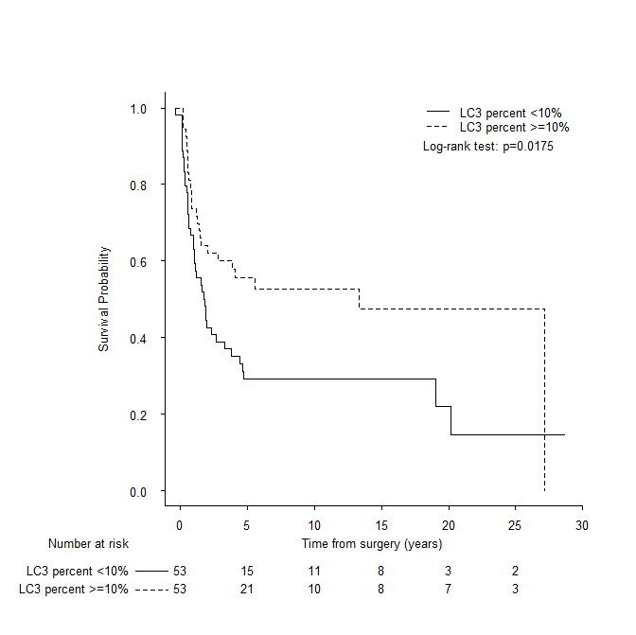

**Figure S3.**

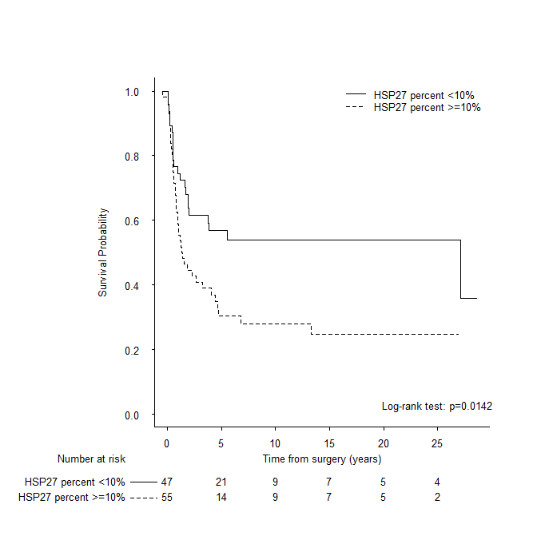

**Figure S4.**

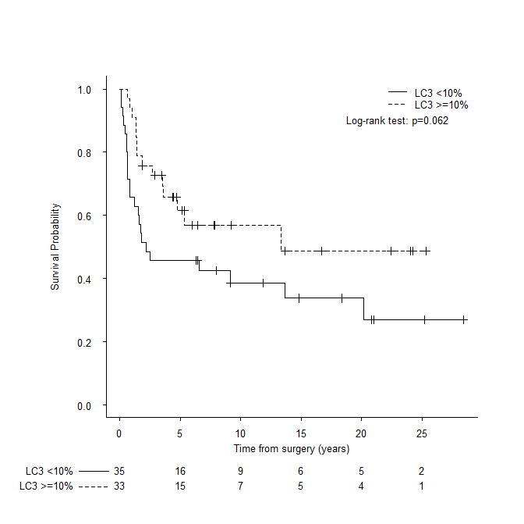

**Figure S5**

