Supplementary Materials

Supplementary Figure 1. Effect of PIP3 on TNF-α induced IL6 and IL8 expression. (a and b) A549 cells were treated with different concentrations of PIP2 or PIP3. After 72 h of treatment, cells were incubated with 10 ng/ml TNF-α for additional 12 h, and then harvested for IL6 (a) and IL8 (b) qRT-PCR analysis.

Supplementary Figure 2. PIP3 but not Hoechst 33258 shows Plk1 suppression ability. (a) Comparison of the cellular uptake of PIP3 and Hoechst 33258. Hela cells were incubated with different concentrations of PIP3 or Hoechst 33258 for 24 hours. Fluorescent microscopy images were acquired and as shown. (b) PIP3 but not Hoechst 33258 shows Plk1 suppression ability. Hela cells were treated with different concentrations of PIP3 or Hoechst 33258 for 72 hours and then collected for western blotting analysis to examine the Plk1 expression. (c) Evaluation of PIP3 stability in vitro. Hela cells were treated with 10 μM PIP3 for 72 hours, then cells were collected and lysed. Released PIP3 was monitored by RP-HPLC analysis. PIP3 dissolved in water was served as control.

Supplementary Figure 3. Time-dependent cellular uptake of PIP3. (a) Hela cells or (b) A549 cells stably expressing histone H2B-RFP were incubated with 10 μM of PIP3. At different time points, cells were harvested, stained, and imaged. Scale bar, 50 μm. (c) Nuclear localization of PIP3 in A549 cells. Scale bar, 10 μm.

Supplementary Figure 4. Cellular uptake and nuclear localization of PIPs. Hela cells or A549 cells stably expressing histone H2B-RFP were incubated with 10 μM of different PIPs for 24 h. Cells were then subjected to live-imaging using confocal microscopy. Scale bar, 10 μm.

Supplementary Figure 5. Flow cytometry analysis of apoptosis upon PIP3 treatment. Hela cells were treated with or without 10 μM PIP3 for 72 hours and then labeled by Propidium iodide and Annexin V-FITC for detecting early and late apoptotic signal.

Supplementary Figure 6. Correlation between Plk1 expression level and PIP3 sensitivity. (a and b) Plk1 mRNA levels (a) and Plk1 protein levels (b) in various cell lines. (c-e) Pearson correlation co-efficiency was calculated between Plk1 mRNA level, Plk1 protein expression level, and PIP3 sensitivity (represented by IC50 value).

Supplementary Figure 7. PIP3 treatment does not affect mitotic progression in nontransformed cells. (a and b) The hTERT-RPE1 cells and HUVEC cells were synchronized, PIP3 treated, and analyzed as in Figure 4a and 4b. Plk1 inhibition efficiency examined by western blotting was shown in the top. (c and d) Percentages of mitotic cells at different phases were quantified in these treated cells (n.s, not significant; n=3). (e) Time-lapse microscopy of nontransformed cells with or without PIP3 treatment. hTERT-RPE1 cells and HUVEC cells stably expressing histone H2B-RFP were treated with 0.1% DMSO or 20 μM of PIP3 for 72 h and analyzed by time-lapse imaging. (f and g) The duration of total mitosis (f) and time spent in each sub-stage of mitosis (g) were further quantified (n.s, not significant; n≥25).

Supplementary Figure 8. In vivo antitumor activity of PIP3. (a) Representative images of mice from vehicle group and PIP3-treated group on the sacrifice day. Yellow arrows indicate tumor locations. (b) Images of isolated tumors from vehicle group or PIP3-treated group. (c) In vivo cellular localization of PIP3. Frozen sections of tumors from PIP3-treated group were imaged under microscopy to visualize the cellular uptake of PIP3 in vivo. The nuclei were stained by Topro3. Scale bar, 100 μm.

Supplementary Movie 1-6. Live imaging of mitotic progression in control and PIP3 treated cells. Hela, A549, hTERT-RPE1 and HUVEC cells stably expressing histone H2B-RFP were incubated in medium with 0.1% DMSO or 20 μM PIP3. After 72 h of incubation, cells were subjected to live imaging at Olympus live cell workstation. Images were taken every 2 min to cover the whole mitotic process. Movies, S1-S4, are related to the panels in Figure 4f from top to bottom. Movies, S5-S8, are related to the panels in Figure 6e from top to bottom.

Supplementary Text
Polyamides synthesis
- Synthesis of Ht-1 and Ht-2
Ht-1: This compound was prepared according to the literature method¹.
Ht-2-A was prepared according to the literature method². Ht-2-B was prepared as follows. Hydrogen chloride gas was slowly bubbled into a solution of ethyl 3-cyanobenzoate (35 g, 0.2 mol) in absolute ethanol (40 ml) maintained at 0 ºC in an ice-water bath. After 3 h, the addition tube was removed and the mixture was stirred at room temperature overnight. Then the solvent was removed under reduced pressure and the residue was treated with diethyl ether (200 ml). After stirring overnight, the resulting precipitate was filtered, washed with ether and dried in vacuo. The product was used directly without further purification.
Ht-2: A mixture of Ht-2-A (10 g, 31.0 mmol) and Ht-2-B (11.4 g, 44.2 mmol) in acetic acid (100 mL) was refluxed for 4 h. Then the solvent was removed under reduced pressure and the residue was purified by column chromatography. The product was dissolved in methanol (100 ml) and cooled to 0 oC, a solution of NaOH (3.1g, 77.5 mmol) in H2O (50 ml) was added dropwise. After addition, the mixture was stirred at room temperature for 8 h. Then the reaction mixture was concentrated and precipitated upon addition of a dilute solution of hydrogen chloride. After filtration and desiccation, Ht-2 was obtained as a yellow powder (9.7 g, 69%). 1H NMR (DMSO-d6，400 MHz)：2.84 (s, 3H), 3.27 (m, 4H), 3.54 (d, J = 8.8 Hz, 2H), 3.89 (d, J = 9.6 Hz, 2H), 7.23 (s, 1H), 7.37 (d, J = 8.8 Hz, 1H), 7.74 (d, J = 8.8 Hz, 1H), 7.81 (t, J = 8.0 Hz, 1H), 8.03 (d, J = 8.8 Hz, 1H), 8.20 (d, J = 7.6 Hz, 1H), 8.47 (d, J = 8.4 Hz, 1H), 8.69 (d, J = 7.6 Hz, 1H), 8.88 (s, 1H), 8.93 (s, 1H), 11.44 (br s, 1H) ppm; ¹³C NMR (DMSO-d₆，100 MHz)：42.3, 46.6, 52.5, 99.3, 114.8, 115.4, 116.2, 117.8, 119.3, 124.4, 126.4, 126.9, 129.0, 130.3, 132.4, 132.5, 133.2, 133.4, 148.1, 149.2, 152.5, 166.9; MS (ES): m/z: 453.2 [M+H]⁺。
- Automated synthesis of PIP Resin A
Synthesis of PIP Resin A: (i) TFA/phenol/H₂O; (ii) Boc-Py-OH, BTC, collidine, DIEA; (iii) TFA/phenol/H₂O; (iv) Boc-Py-OH, BTC, collidine, DIEA; (v) TFA/phenol/H₂O; (vi) Boc-Py-OH, BTC, collidine, DIEA; (vii) TFA/phenol/H₂O; (viii) Fmoc-D-Dab(Boc)-OH, BTC, collidine, DIEA, HOAt; (ix) TFA/phenol/H₂O; (x) Boc-Py-OH, BTC, collidine, DIEA; (xi) TFA/phenol/H₂O; (xii) Boc-Py-OH, BTC, collidine, DIEA; (xiii) TFA/phenol/H₂O; (xiv) Boc-Im-OH, BTC, collidine, DIEA, HOAt; (xv) TFA/phenol/H₂O; (xvi) Im-OH, PyBOP, DIEA.
The automated synthesis of resin bound Py-Im polyamide (PIP Resin A) was performed on a CS336X peptide synthesizer. It was carried out on a 0.06 mmol scale (400 mg of the resin; 0.15 mmol/g) by solid-phase Boc-chemistry according to the literature procedure³.
- Synthesis of polyamide sequence PIP1
Dimethylaminopropylamine (100 μL) in DMF (1 mL) was added to PIP Resin A (100 mg, 0.015 mmol) and the mixture was shaken at 90°C for 1 h. After cooling to room temperature, the resin was removed by filtration through a disposable propylene filter and washed with MeOH (2 mL). The mixture was concentrated under reduced pressure and the residue was dissolved in 10% MeCN/0.1%TFA-H₂O and purified by semi-preparative RP-HPLC. After lyophilization, polyamide PIP1 was obtained as a pale yellow powder (4 mg, 23% with respect to the first loading of the resin). HRMS (ESI-TOF) m/z: calcd for C₅₅H₆₈N₂₁O₉ [M+H]⁺ 1166.5503, found 1166.5508.
- Synthesis of polyamide sequences PIP2 and PIP4
PIP8: The Fmoc group of PIP Resin A (400 mg, 0.06 mmol) was removed with 20% piperidine/DMF. After washing with DMF (4 x 2 mL), the resin was treated with a mixture of Boc₂O (55 μL, 0.24 mmol) and DIEA (100 μL, 0.6 mmol) in dry DMF (2 mL) for 30 min, drained and washed with DMF (4 x 2 mL). 3,3'-Diamino-N-methyl-dipropylamine (400 μL) in DMF (2 mL) was then added to the resin and the mixture was shaken at 90 °C for 1 h. After cooling to room temperature, the resin was removed by filtration through a disposable propylene filter and washed with MeOH (8 mL). The mixture was concentrated under reduced pressure and the residue was dissolved in 10% MeCN/0.1%TFA-H₂O and purified by semi-preparative RP-HPLC. After lyophilization, polyamide PIP8 was obtained as a pale yellow powder (16 mg, 20% with respect to the first loading of the resin). HRMS (ESI-TOF) m/z: calcd for C₆₂H₈₁N₂₂O₁₁ [M+H]⁺ 1309.6450, found 1309.6444.
PIP2: A solution of isophthalic acid (3.3 mg，20 μmol), PyBOP (10.4 mg，20 μmol) and DIEA (50 μL，300 μmol) in dry DMF (0.5 mL) was shaken for 10 min at room temperature. Then PIP8 (2.6 mg, 2 μmol) was added and the resulting mixture was shaken for 2 h at room temperature. After purification by semi-preparative RP-HPLC and lyophilization, the product was dissolved in CH₂Cl₂ (1 mL) and cooled in an ice-water bath. TFA/phenol/H₂O (92.5:5:2.5, 0.4 ml) was added and the mixture was stirred at the same temperature for 1 h. The solvent was removed under reduced pressure and the residue was dissolved in 10% MeCN/0.1%TFA-H₂O and purified by semi-preparative RP-HPLC. After lyophilization, polyamide PIP2 was obtained as a pale yellow powder (1.7 mg, 64%). HRMS (ESI-TOF) m/z: calcd for C₆₅H₇₇N₂₂O₁₂ [M+H] ⁺ 1357.6086, found 1357.6089.
PIP4: A solution of Ht-2 (2.7 mg，6 μmol), PyBOP (3.1 mg，6 μmol) and DIEA (5 μL，30 μmol) in DMF (0.5 mL) was shaken for 10 min at room temperature. Then PIP8 (2.6 mg, 2 μmol) was added and the resulting mixture was shaken for 2 h at room temperature. After purification by semi-preparative RP-HPLC and lyophilization, the product was dissolved in CH₂Cl₂ (1 mL) and cooled in an ice-water bath. TFA/phenol/H₂O (92.5:5:2.5, 0.4 ml) was added and the mixture was stirred at the same temperature for 1 h. The solvent was removed under reduced pressure and the residue was dissolved in 10% MeCN/0.1%TFA-H₂O and purified by semi-preparative RP-HPLC. After lyophilization, polyamide PIP4 was obtained as a yellow powder (2.8 mg, 86%). HRMS (ESI-TOF) m/z: calcd for C₈₃H₉₅N₂₈O₁₀ [M+2H]²⁺ 822.3926, found 822.3934.
- Synthesis of polyamide sequence PIP3
PIP Resin B: The Fmoc group of PIP Resin A (400 mg, 0.06 mmol) was removed using a mixture of 20% piperidine/DMF. After washing with DMF (4 x 2 mL) and dry DMF (2 mL), the resin was treated with a mixture of Ht-1 (123 mg, 0.24 mmol), PyBOP (125 mg, 0.24 mmol), DIEA (350 μL, 2.112 mmol) and DMF (2 mL) for 1 h. The reaction mixture was drained and the resin was rinsed with DMF (4 x 2 mL). The resulting PIP Resin B was decided in two parts.
PIP3: dimethylaminopropylamine (100 μL), Cu(OAc)₂ and DMF (1 mL) were added to PIP Resin B (200 mg, 0.03 mmol). The reaction mixture was shaken at room temperature under air for 24 h. The crude peptide was collected by centrifugation and the blue solution was diluted with 10% MeCN/0.1%TFA-H2O and purified by semi-preparative RP-HPLC. After lyophilization, polyamide PIP3 was obtained as a yellow powder (9 mg, 18%). HRMS (ESI-TOF) m/z: calcd for C₈₄H₉₇N₂₇O₁₁ [M+H]⁺ 1658.7777, found 1658.7774.
- Synthesis of polyamide sequences PIP5 and PIP6

PIP9: 3,3'-Diamino-N-methyl-dipropylamine (100 μL), Cu(OAc)₂, and DMF (1 mL) were added to PIP Resin B (200 mg, 0.03 mmol). The reaction mixture was shaken at room temperature for 24 h. The crude peptide was collected by centrifugation and the blue solution was diluted with 10% MeCN/0.1%TFA-H2O and purified by semi-preparative RP-HPLC. After lyophilization, polyamide PIP9 was obtained as a yellow powder (10 mg, 20%). HRMS (ESI-TOF) m/z: calcd for C₈₆H₁₀₁N₂₈O₁₁ [M+H]⁺ 1701.8199, found 1701.8141.
PIP5: A solution of isophthalic acid (3.3 mg，20 μmol), PyBOP (10.4 mg，20 μmol) and DIEA (50 μL，300 μmol) in dry DMF (0.5 mL) was shaken for 10 min at room temperature. Then PIP9 (3.4 mg, 2 μmol) was added and the resulting mixture was shaken for 2 h at room temperature. After purification by semi-preparative RP-HPLC and lyophilization, polyamide PIP5 was obtained as a yellow powder (2.8 mg, 75%). HRMS (ESI-TOF) m/z: calcd for C₉₄H₁₀₆N₂₈O₁₄ [M+2H]²⁺ 925.4216, found 925.4209.
PIP6: A solution of Ht-2 (2.7 mg，6 μmol), PyBOP (3.1 mg，6 μmol) and DIEA (5 μL，30 μmol) in DMF (0.5 mL) was shaken for 10 min at room temperature. Then PIP9 (4 mg, 3 μmol) was added and the resulting mixture was shaken for 2 h at room temperature. After purification by semi-preparative RP-HPLC and lyophilization, polyamide PIP6 was obtained as a yellow powder (5.6 mg, 87%). HRMS (ESI-TOF) m/z: calcd for C₁₁₂H₁₂₄N₃₄O₁₂ [M+2H]²⁺ 1068.5064, found 1068.5052.
- Synthesis of polyamide sequences PIP7
PIP7 was obtained following the same experimental procedure used to prepare PIP3. HRMS (ESI-TOF) m/z: calcd for C₈₂H₉₄N₂₉O₁₁ [M+H]⁺ 1660.7682, found 1660.7652.

Copies of NMR Spectrums
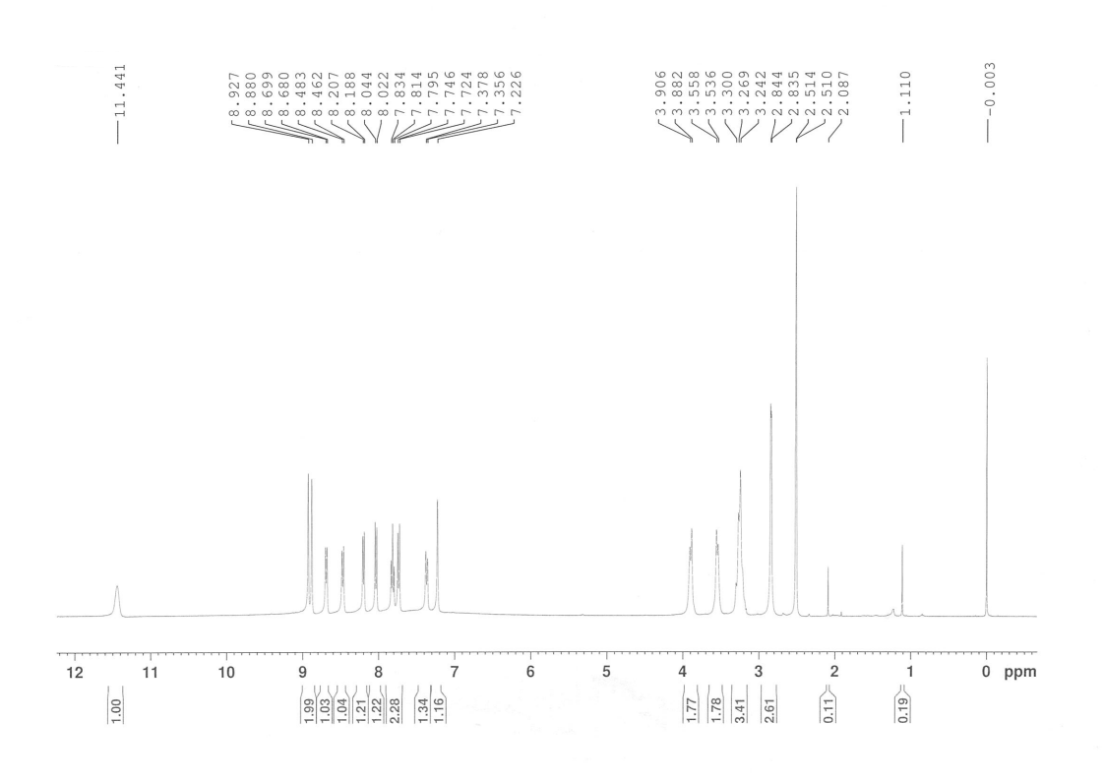
¹H NMR spectra of Ht-2
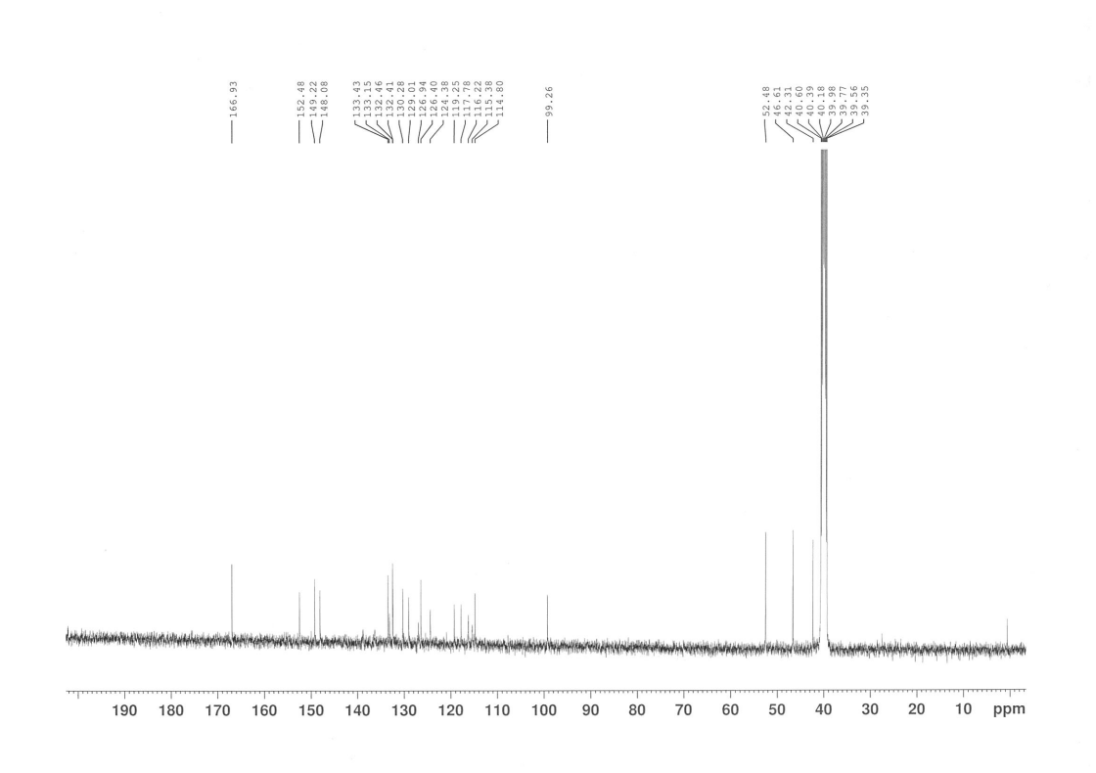
¹³C NMR spectra of Ht-2
Copies of HRMS Spectrums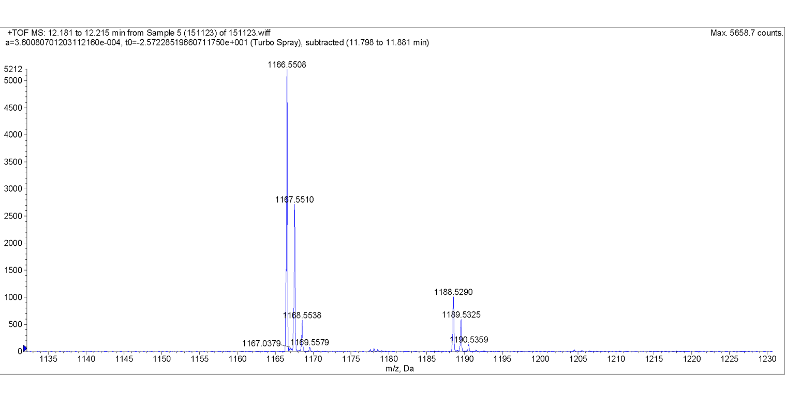
HRMS spectra of PIP1

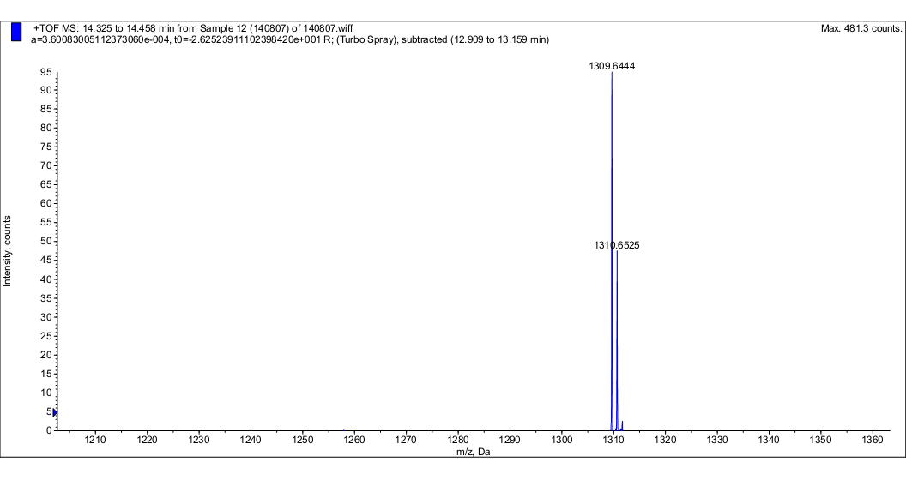
HRMS spectra of PIP8

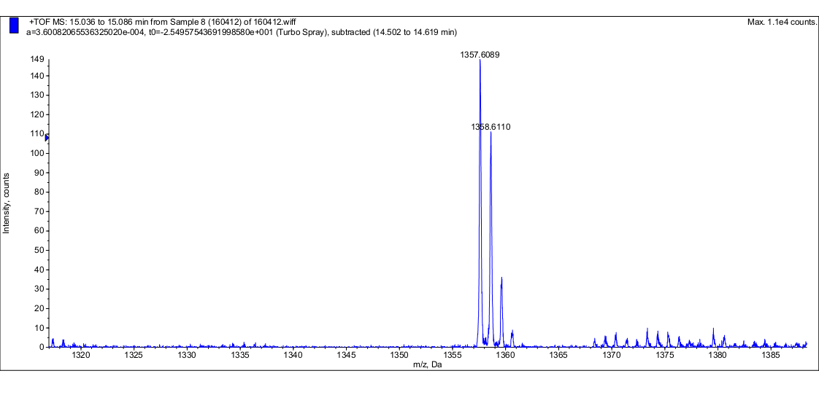
HRMS spectra of PIP2

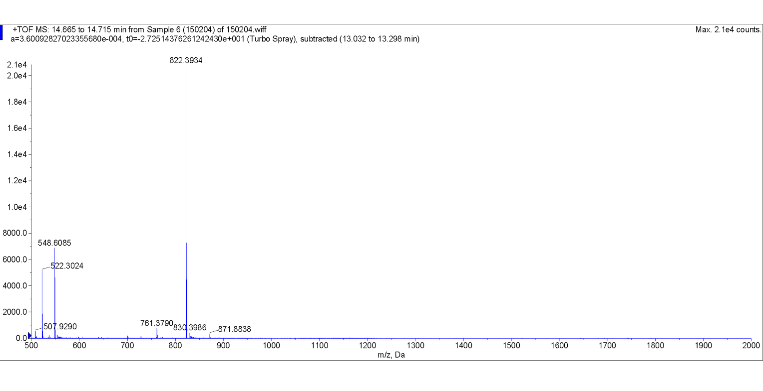
HRMS spectra of PIP4

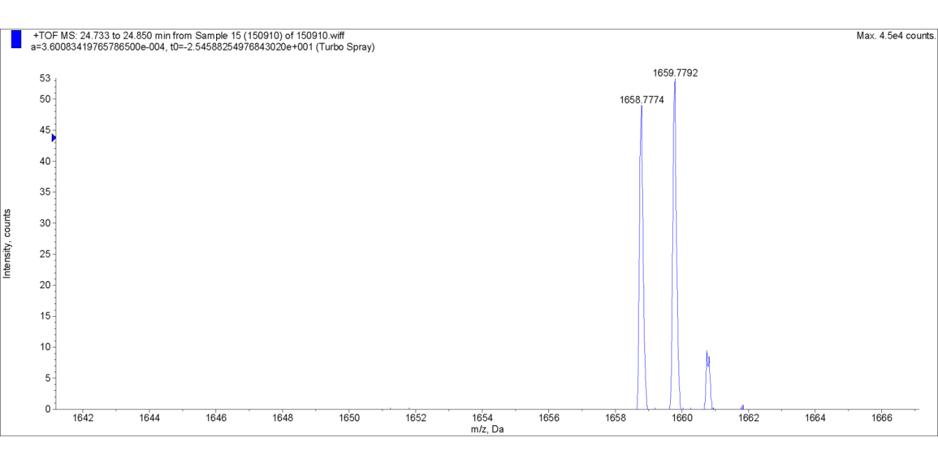
HRMS spectra of PIP3

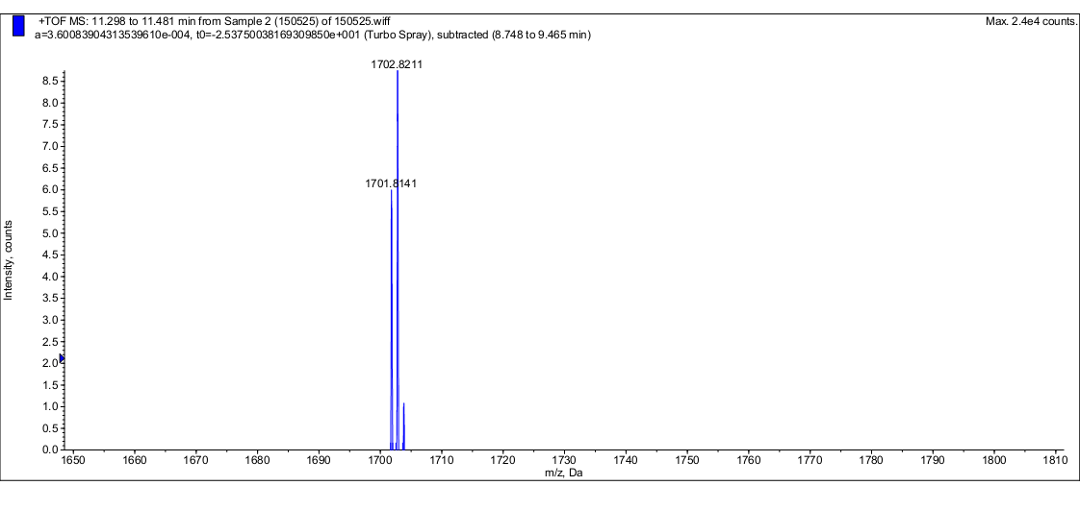
HRMS spectra of PIP9

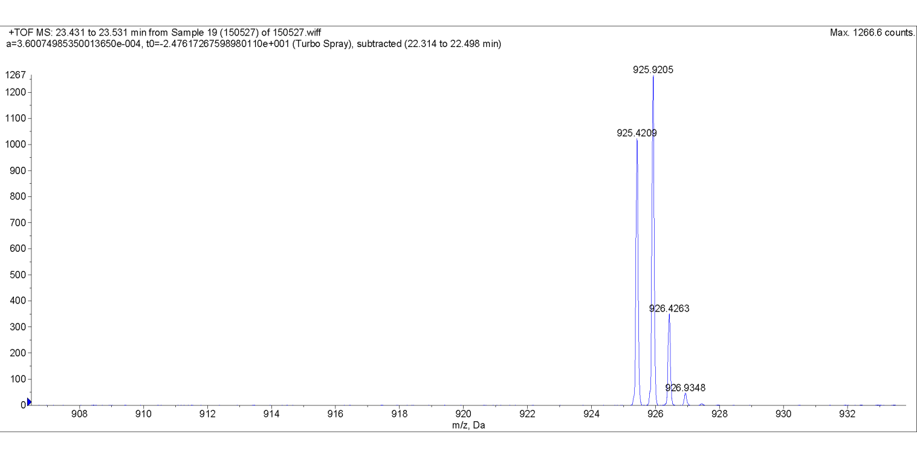
HRMS spectra of PIP5

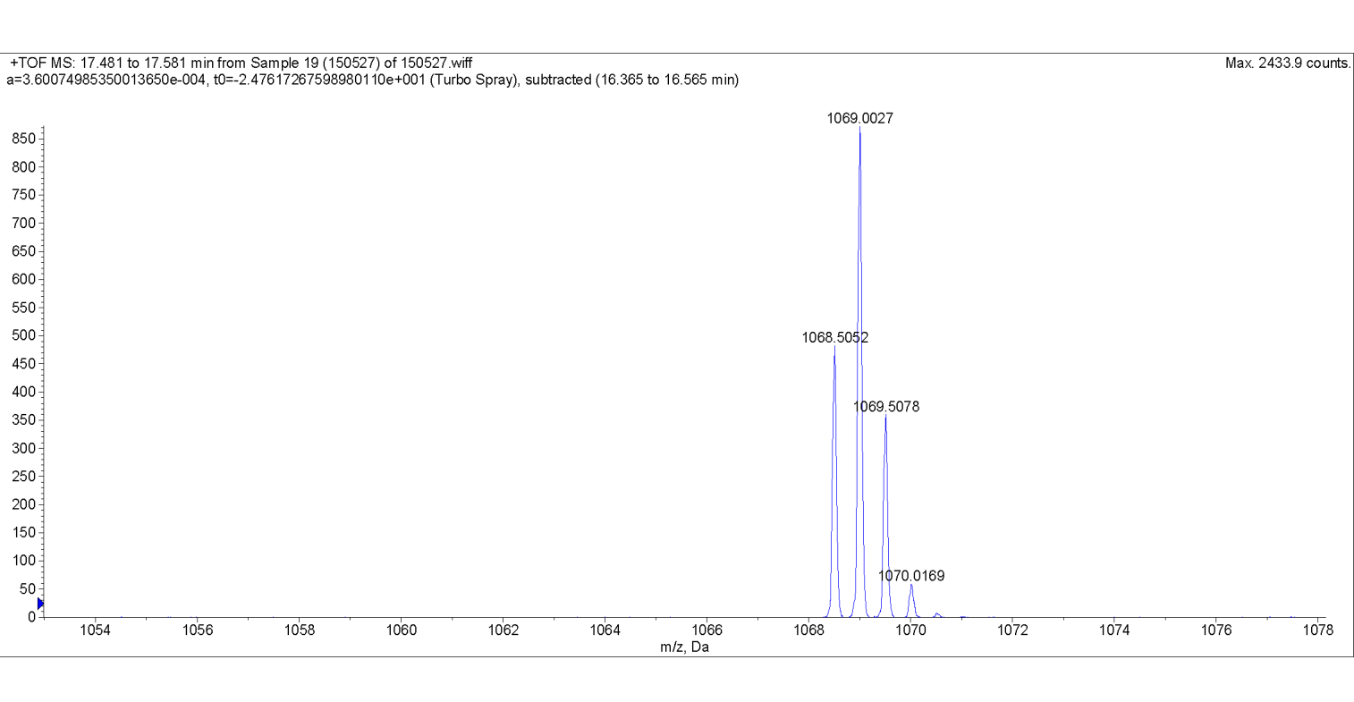
HRMS spectra of PIP6

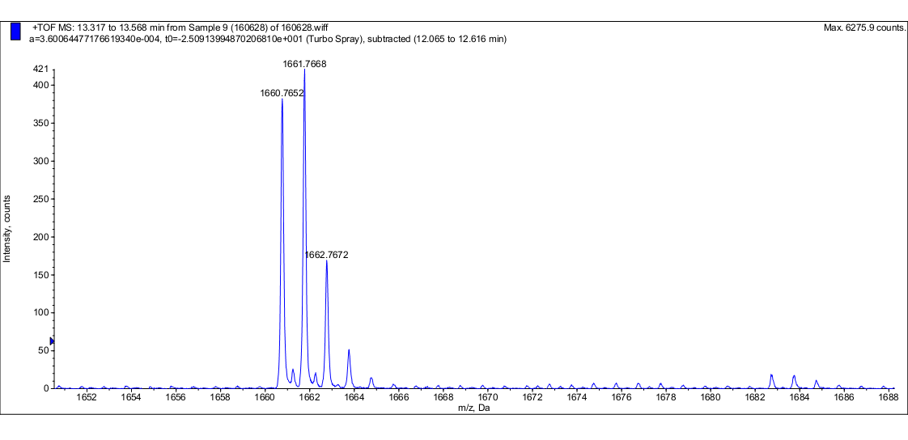
HRMS spectra of PIP7

HPLC of PIP compounds

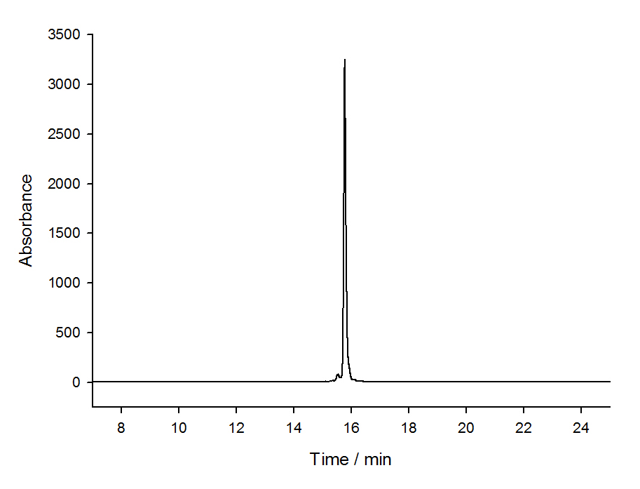
HPLC of PIP1

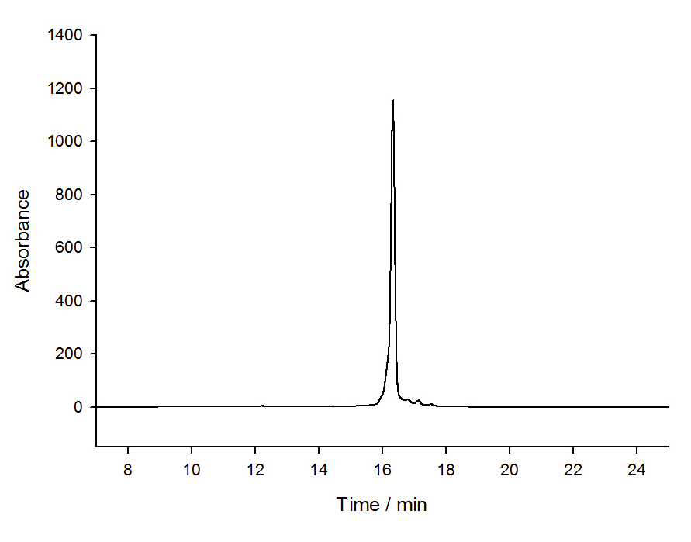
HPLC of PIP2

HPLC of PIP3

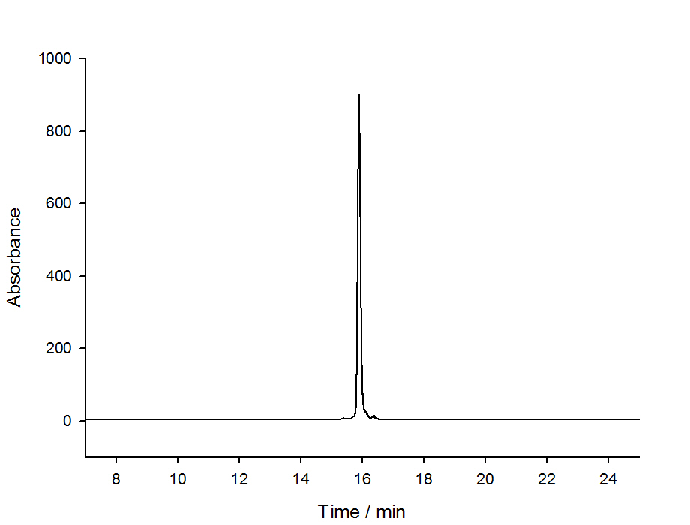

HPLC of PIP4

HPLC of PIP5

HPLC of PIP6

HPLC of PIP7

Supplementary References:

1. Reddy PM, Bruice TC. Solid-phase synthesis of positively charged deoxynucleic guanidine (DNG) tethering a Hoechst 33258 analogue: Triplex and duplex stabilization by simultaneous minor groove binding. Journal of the American Chemical Society 2004;126:3736-47
2. Argentini M, Dos Santos DF, Weinreich R, Hansen H-J. Synthesis of an o-Carboranyl Derivative of 4-[5-(4-Methyl-1-piperazinyl)-2, 5 ‘-bi-1 H-benzimidazol-2 ‘-yl] phenol. Inorganic chemistry 1998;37:6018-22
3. Fang L, Yao G, Pan Z, Wu C, Wang H-S, Burley GA, et al. Fully automated synthesis of DNA-binding Py-Im polyamides using a triphosgene coupling strategy. Organic letters 2014;17:158-61

