**Supplementary Materials**

**Scavenger Receptor Type B1 and Lipoprotein Nanoparticle Inhibit Myeloid Derived Suppressor Cells**

**Authors:**

Michael P. Plebanek1,2,*, Debayan Bhaumik1,*, Paul J. Bryce3, C. Shad Thaxton1,4,5,6,§

**Affiliations:**

1Northwestern University, Feinberg School of Medicine, Department of Urology, Tarry 16-703, Chicago, IL 60611

2Northwestern University, Driskill Graduate Program in the Life Sciences, 303 E. Chicago, Chicago, IL 60611

3Northwestern University, Feinberg School of Medicine, Division of Allergy-Immunology, Department of Medicine, Chicago, IL, USA, 60611

4Northwestern University, Simpson Querrey Institute for BioNanotechnology, 303 E. Superior, 11th Floor, Chicago, IL 60611

5Northwestern University, International Institute for Nanotechnology, 2145 Sheridan Road, Chicago, IL 60208

6Northwestern University, Robert H. Lurie Comprehensive Cancer Center, 303 E. Superior, Chicago, IL 60611

*These authors contributed equally to this work.

§To whom correspondence should be addressed: C. Shad Thaxton, MD, PhD (cthaxton003@northwestern.edu)

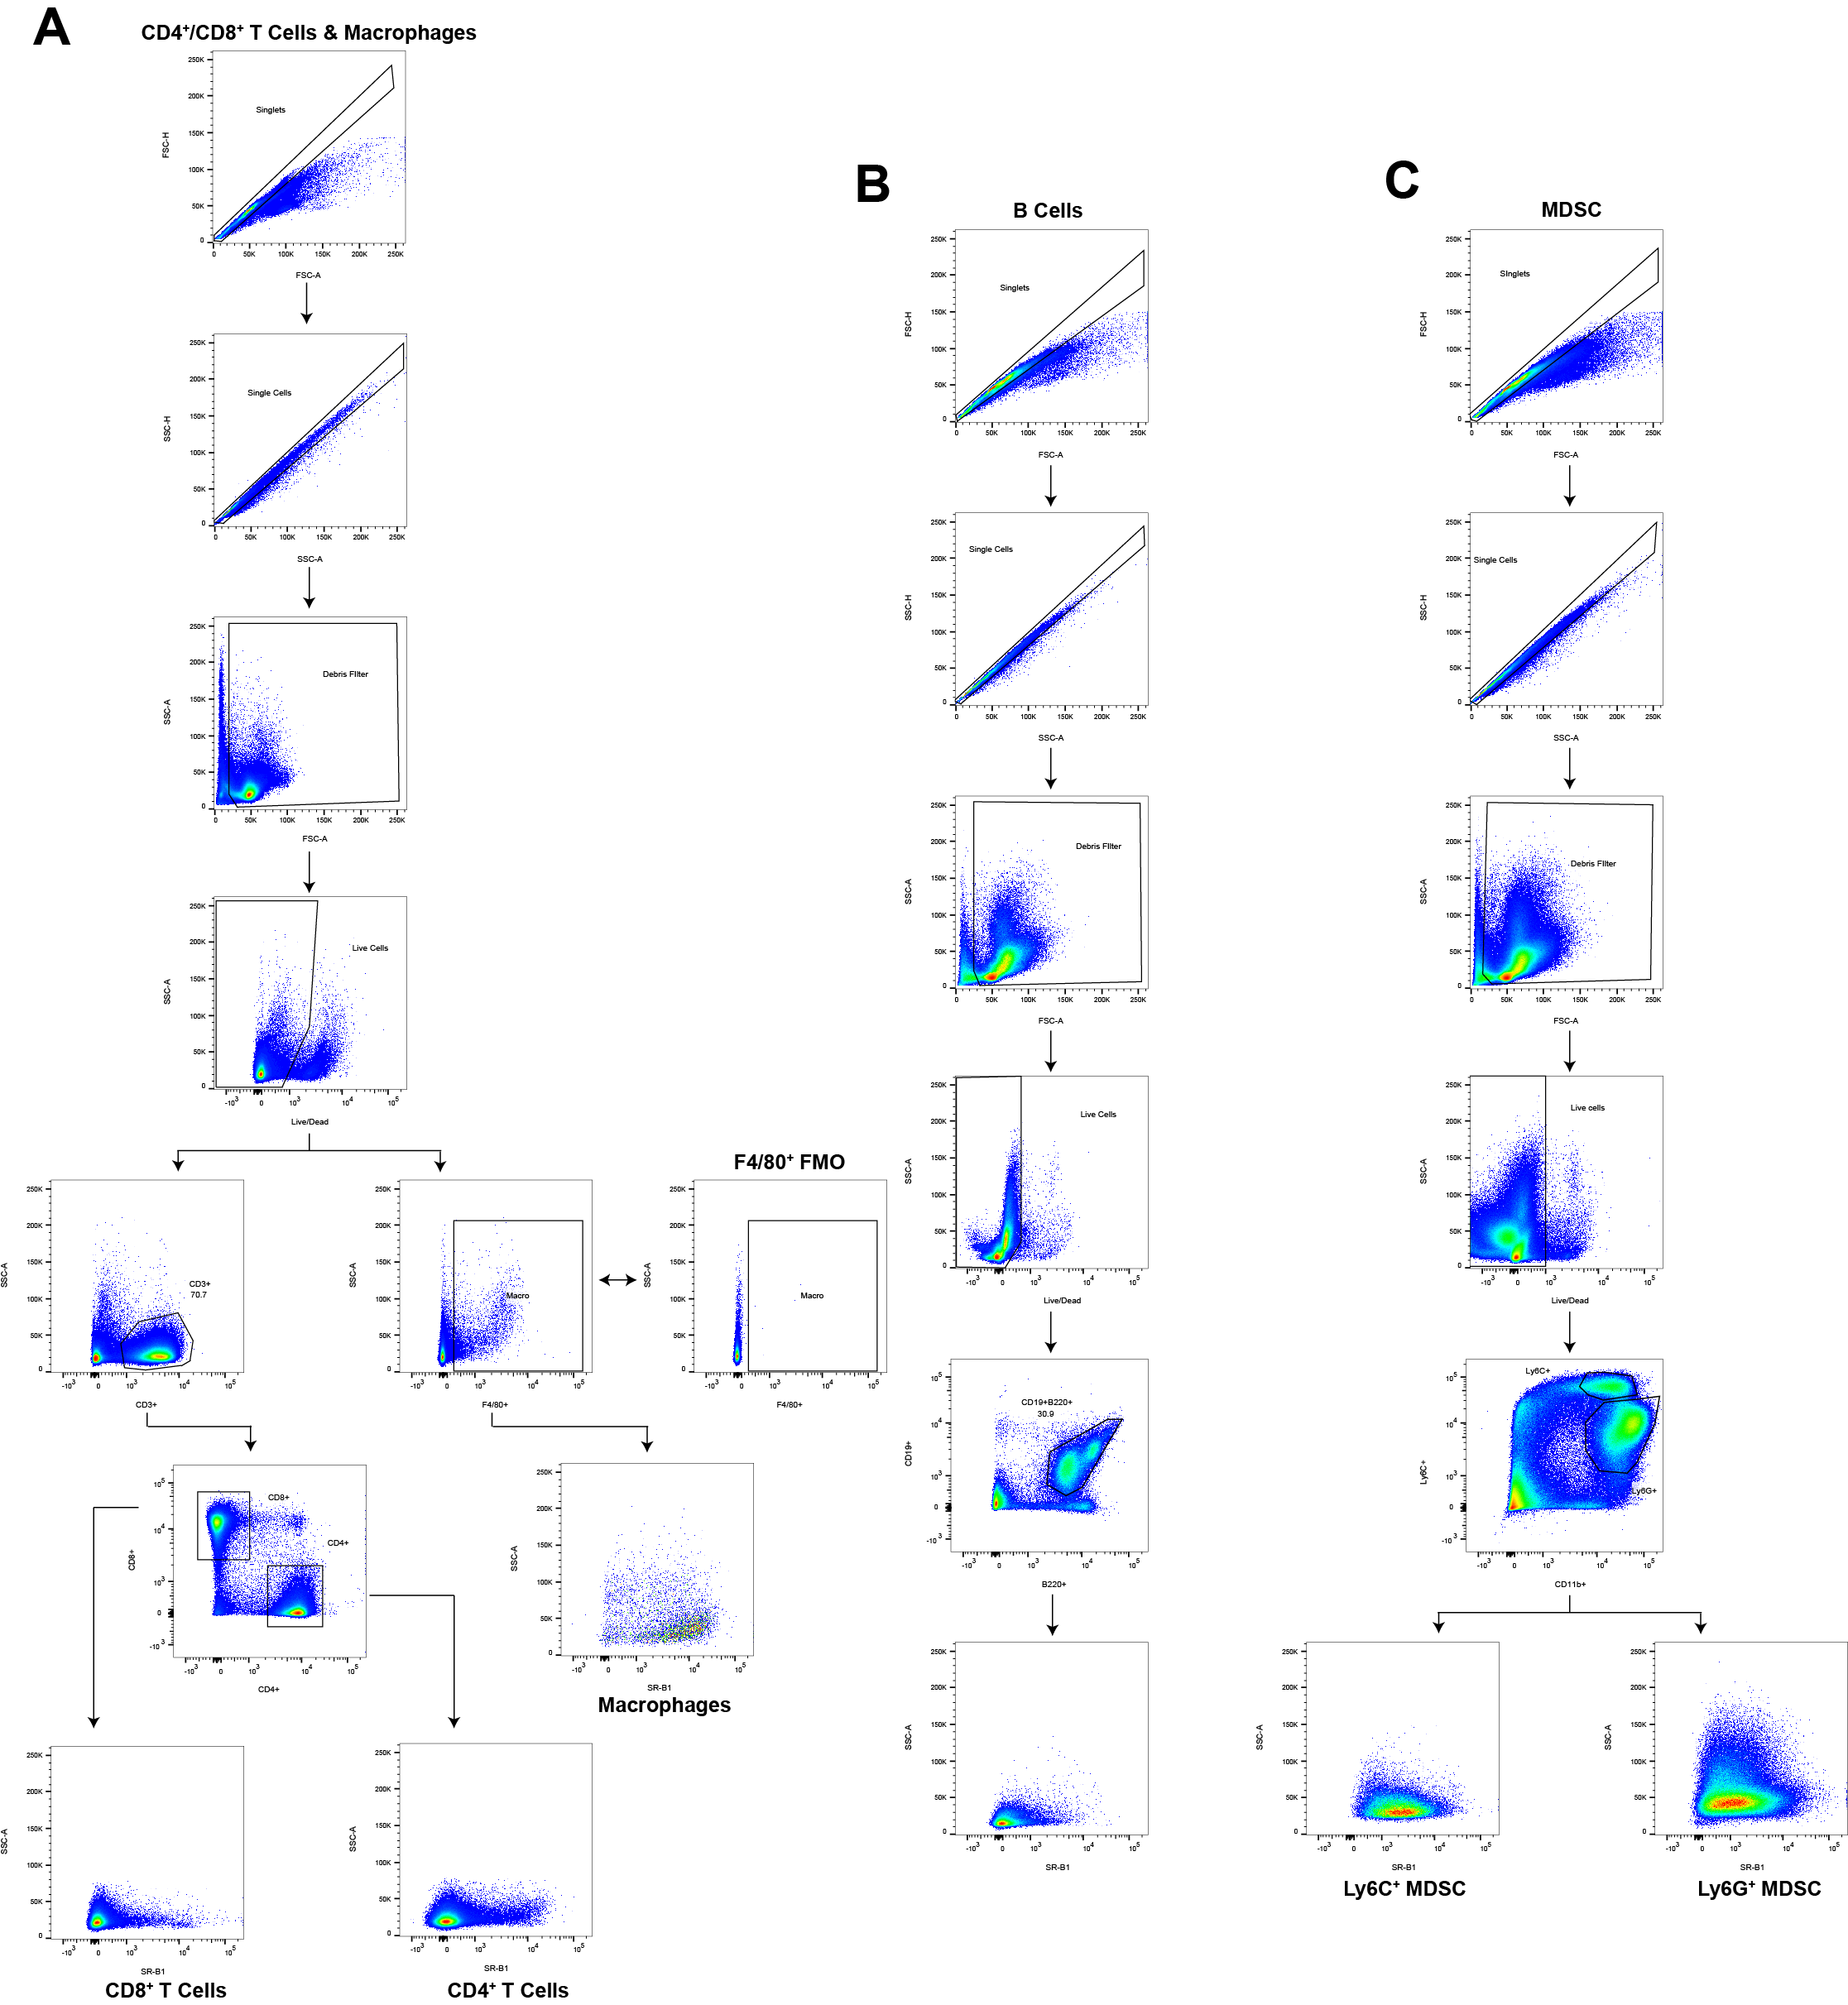**Supplementary Figures**

**Supplementary Figure S1.** Flow cytometry gating schema to analyze immune cell SCARB1 expression.C57Bl/6 mice were sacrificed and bone marrow, lymph node, and spleen cell isolates were harvested after which adaptive and innate immune cells were analyzed by flow cytometry to determine their SCARB1 expression. **A,** Gating to isolate CD4+ T cells, CD8+ T cells, and Macrophages (F4/80+) used in lymph node and spleen isolates. **B,** Gating to isolate B cells (CD19+B220+) used in lymph node, spleen, and bone marrow. **C,** Gating to isolate Ly6C+ MDSC (M-MDSC) and Ly6G+ MDSC (PMN-MDSC) used in lymph node, spleen, and bone marrow.

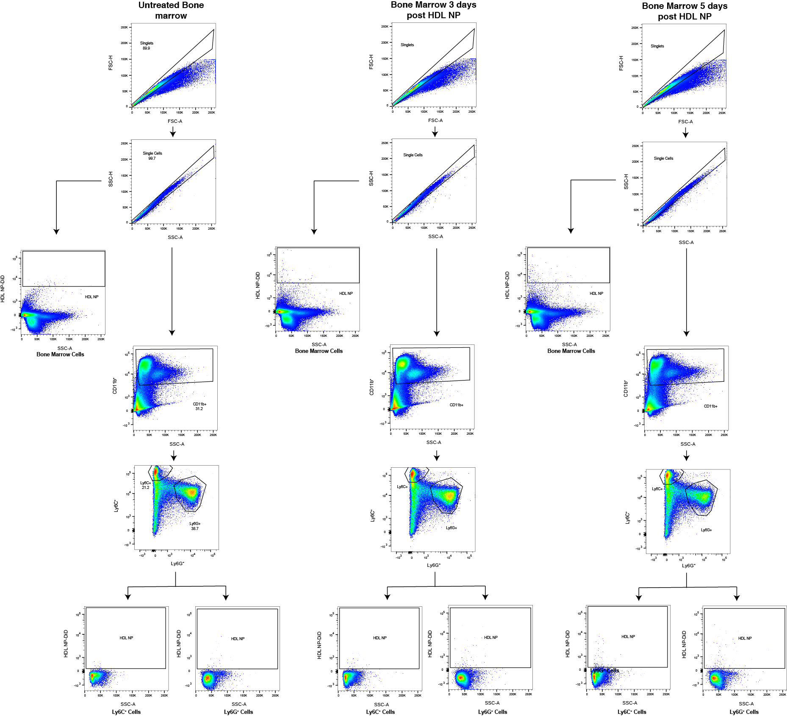

**Supplementary Figure S2.** HDL NP targeting of bone marrow CD11b+ cells.Flow plots showing the presence of DiD-labeled HDL NPs in the bone marrow 3 and 5 days after intravenous injection (100 µl, 1 µM HDL). Bone marrow cells were isolated and stained for CD11b, Ly6G, and Ly6C. Data show limited HDL NP-DiD presence in total bone marrow cells, as is apparent by comparison to the untreated. There is also almost no HDL NP-DiD signal looking specifically at CD11b+, Ly6G+ or Ly6C+ cells.

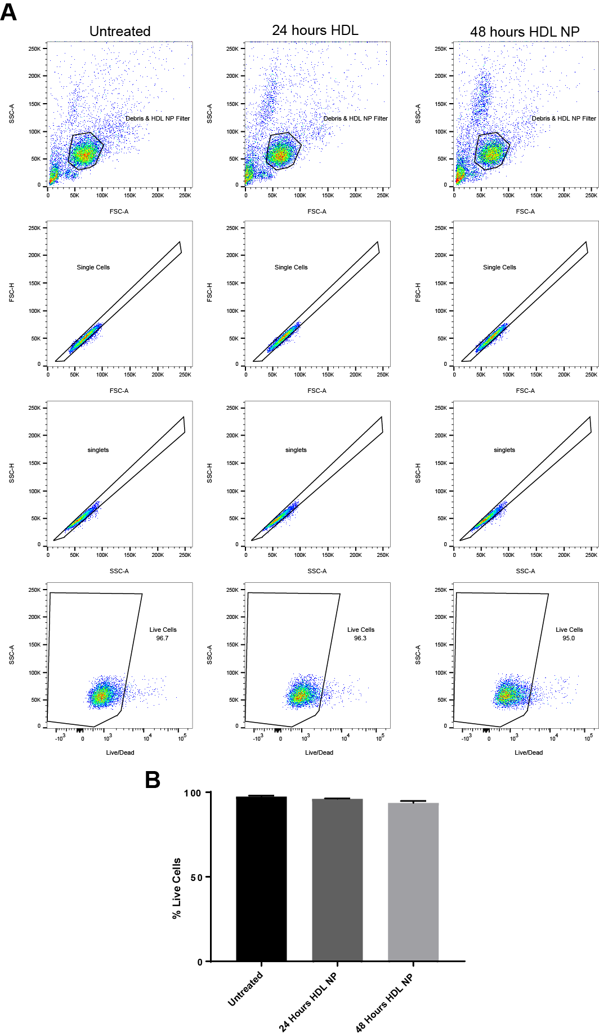

**Supplementary Figure S3.** HDL NP cytotoxicity towards CD11b+Ly6G+ and CD11b+Ly6C+ cells.CD11b+Ly6G+ and CD11b+Ly6C+ cells were harvested and analyzed by flow cytometry to determine cytotoxicity after treatment with HDL NP. **A,** Flow plots demonstrating the gating of CD11b+Ly6G+ and CD11b+Ly6C+ cells to determine live cell contents after treatment. **B,** Average percent live cells for each treatment group demonstrating no substantial difference in cell death.

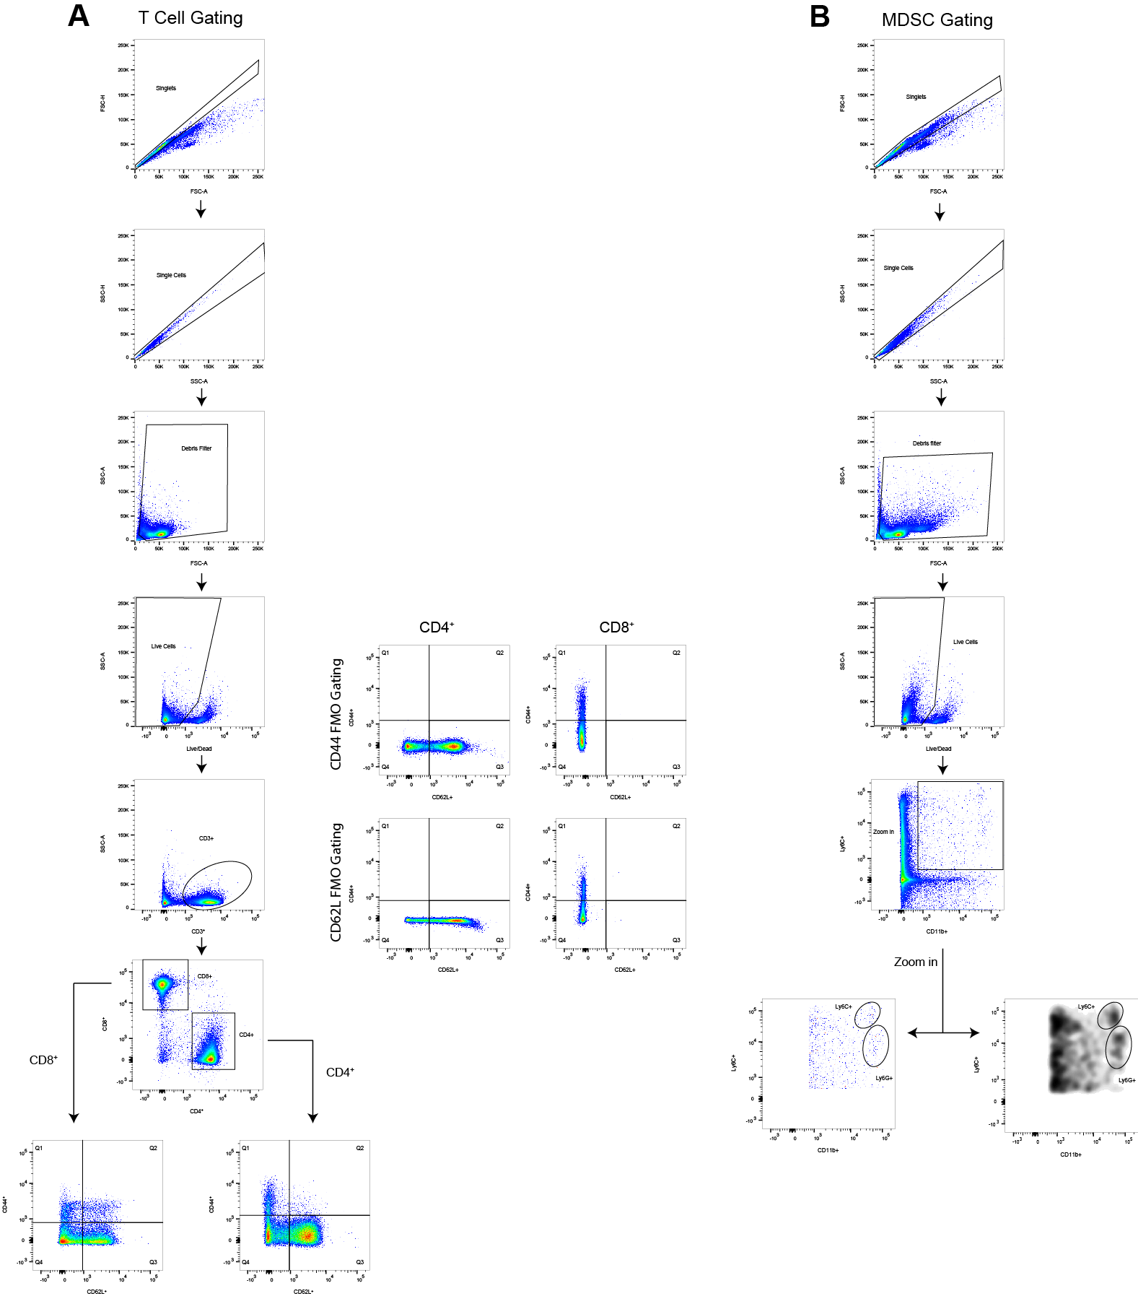

**Supplementary Figure S4.** Flow cytometry gating schema for lymph node analysis of T cell and MDSC modulation with HDL NP treatment.After treating WT mice with either PBS (n=7) or HDL NP (n=7) 3X/ week for 1 week, immune cell distributions in lymph nodes were analyzed by flow cytometry to quantify CD4+ and CD8+ T cells as well as MDSCs. **A,** Gating to isolate CD4+ and CD8+ T cells and phenotype activation subset. **B,** Gating to isolate M-MDSC (CD11b+Ly6Chi) and PMN-MDSC (CD11b+Ly6Clo) for quantification.

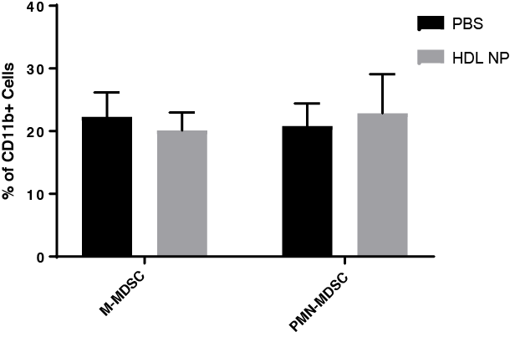

**Supplementary Figure S5.** HDL NP pre-treatment and MDSC distribution in the lymph nodes. After treating WT mice with either PBS (n=7) or HDL NP (n=7) 3X/ week for 1 week, MDSC presence was analyzed in lymph node isolates by flow cytometry. Data demonstrate no significant difference in the number of either M-MDSCs or PMN-MDSCs in the lymph nodes.

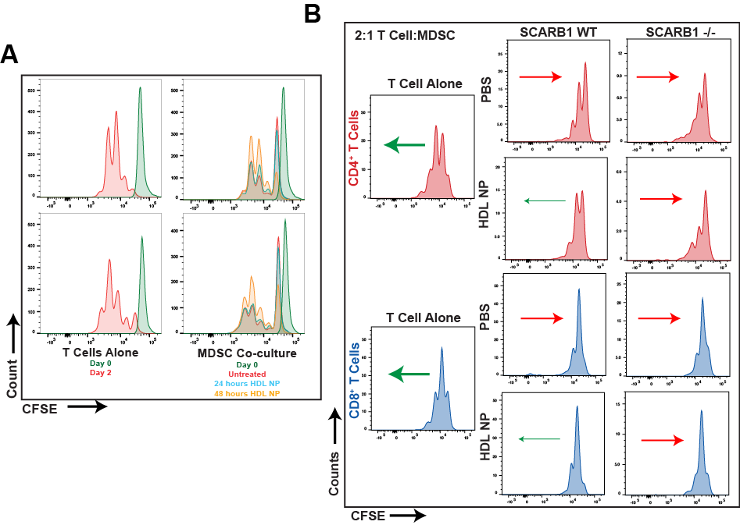

**Supplementary Figure S6.** HDL NPs inhibit T cell suppression by MDSCs.Bone marrow MDSCs were isolated and treated with HDL NPs (50 nM) for 48 hours upon which point they were co-cultured with CFSE-labeled T cells in the presence of anti-CD3/CD28 conjugated activation beads. T cells were allowed to incubate for 48 hours and T cell proliferation was analyzed by flow cytometry. **A,** The effect of HDL NPs on MDSC mediated T cell suppression where the MDSCs were matured *in vitro*. Cells were cultured in a 2:1 T cell:MDSC ratio and treated with 50 nM HDL NP. **B,** CFSE flow plots showing the effect of HDL NP treatment on T cell suppression by MDSCs (2:1) from B16F10 tumor bearing wild-type and SCARB1 -/- mice. Arrows represent the general shift (red = less proliferation and green = more proliferation) in the CFSE signal of the cell population relative to its PBS or HDL NP treated counterpart.

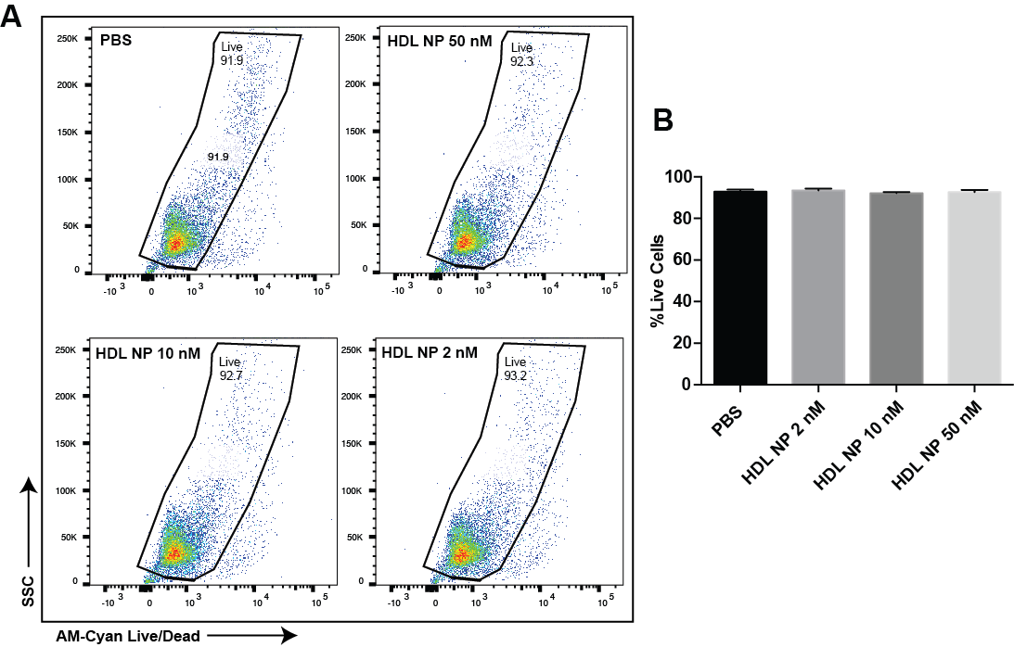

**Supplementary Figure S7.** HDL NP treatment of MDSCs. **A,** MDSCs were incubated with HDL NPs (50 nM, 10 nM, and 2 nM) for 48 hours. Cell viability was assessed using flow cytometry after staining with LIVE/DEAD Fixable Aqua Dead Cell Stain and compared to PBS treated controls. **B,** Quantification of the percent of live cells in **A**.

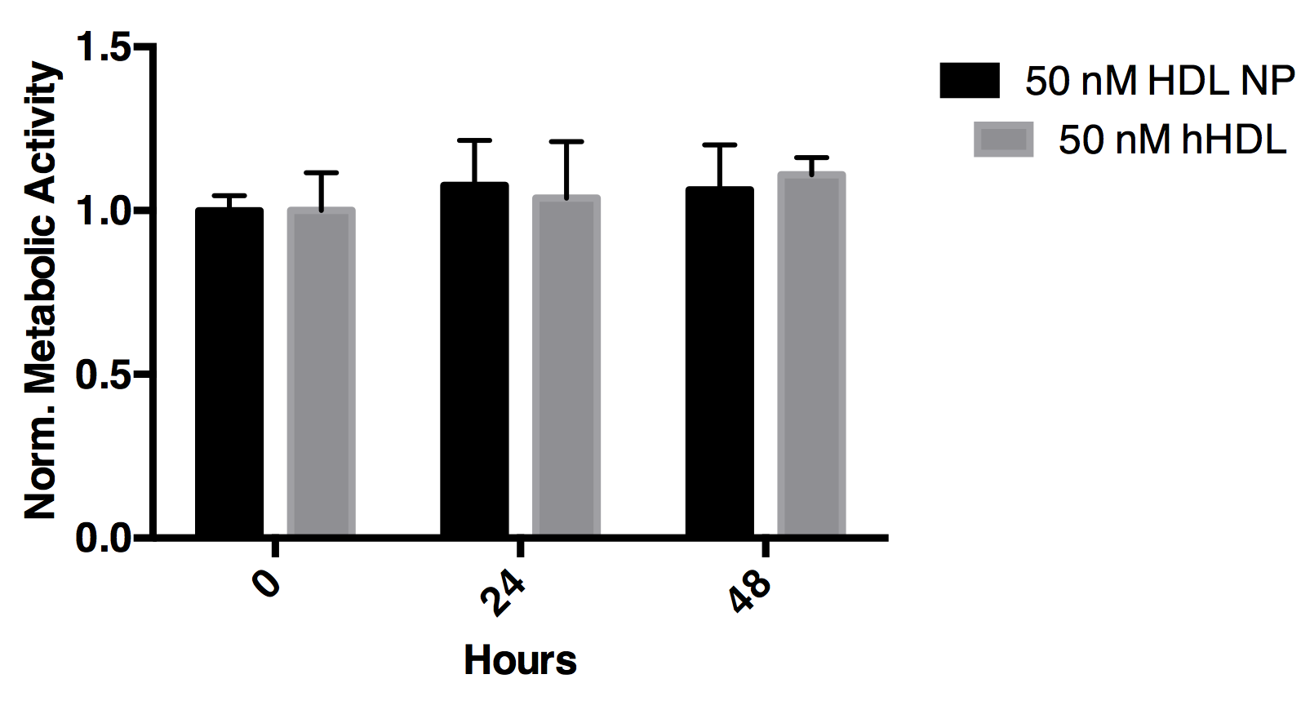

**Supplementary Figure S8.** HDL NP treatment of B16F10 melanoma cells.B16F10 cells were incubated with HDL NPs (50 nM) or human HDL (hHDL) for up to 48 hours. MTS assay shows no reduction in viability after treatment with HDL NP or hHDL when compared to untreated (0 hour time point).



**Supplementary Figure S9.** Survival ofmice with orthotopic B16F10 tumors after treatment with HDL NPs. B16F10 cells were injected intradermally into C57Bl/6 mice and subsequently treated with HDL NPs via the tail-vein. HDL NP treatment led to a significant increase in survival as compared to PBS treated controls.

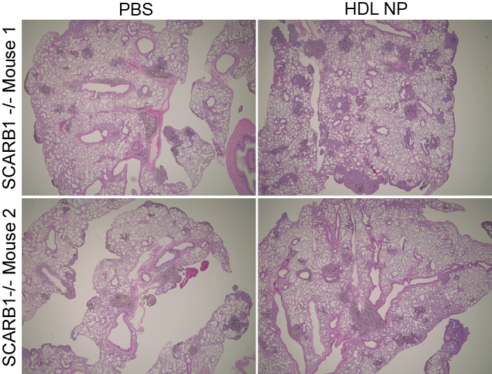

**Supplementary Figure S10.** SCARB1 -/- mice and the inhibition of metastasis by HDL NPs.SCARB1 -/- mice were pretreated with HDL NPs (3x per week, 100 µl, 1 µM) then inoculated with 1 x 105 B16F10 melanoma cells. Mice were sacrificed, lungs were stained using H&E and then imaged using light microscopy. (n=3 mice per condition)

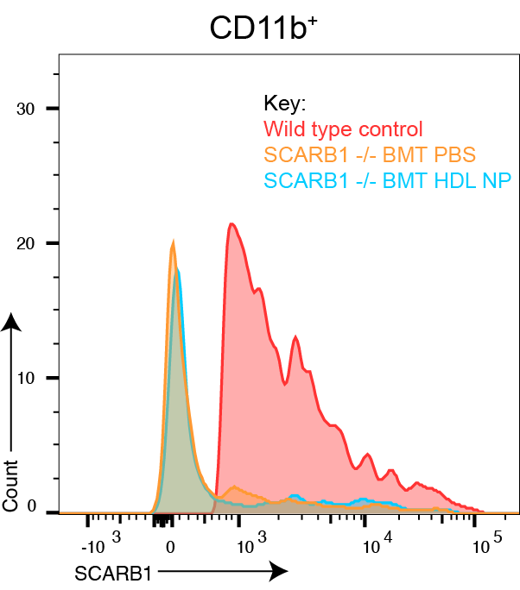

**Supplementary Figure S11.** SCARB1 expression in CD11b+ myeloid cells obtained from wild-type mice after lethal irradiation and transplant of bone marrow harvested from SCARB1 -/- donor mice. Flow cytometry data demonstrate the lack of SCARB1 expression in CD11b+ cells obtained from the bone marrow of wild-type mice following bone marrow transplant (BMT) using cells from SCARB1 -/- mice. Bone marrow from PBS and HDL NP treated BMT mice are included.

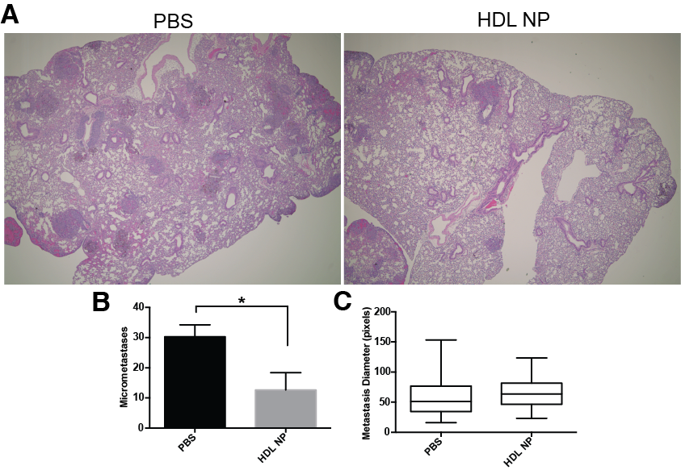

**Supplementary Figure S12.** HDL NP treatment and metastatic burden in established melanoma model.C57Bl/6 mice were inoculated with 1 x 105 B16F10 melanoma cells and allowed to develop for 5 days, at which point mice were treated with HDL NPs according to the dosing scheme in Fig. 4C or treated with control PBS. **A,** Mice were sacrificed, lungs were stained using H&E and tumor burden was assessed. **B,** The number of micrometastases per lung in **A** were quantified and HDL NP (N=5) treatment was compared to PBS control (n=4). **C,** The size of the metastatic lesions from **A** was measured revealing no appreciable difference. \**P* < 0.05 by two-tailed Ttest

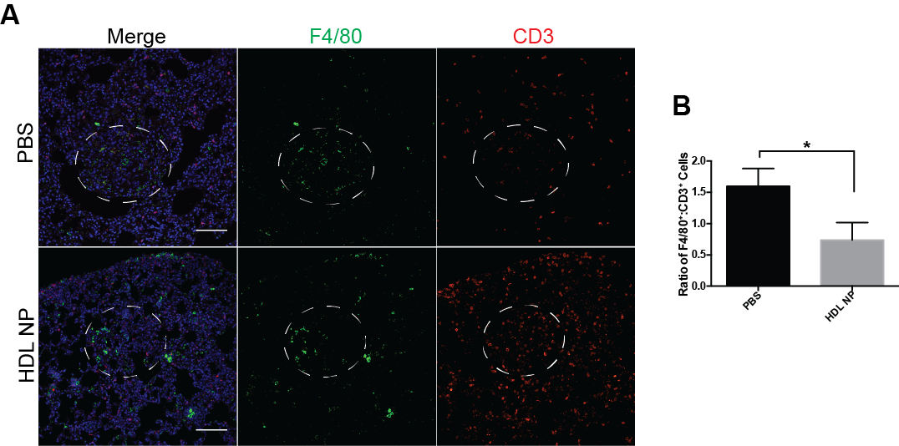

**Supplementary Figure S13.** HDL NPs reshape the immune microenvironment in established melanoma metastasis.1 x 105 B16F10 melanoma cells were injected I.V. into C57Bl/6 mice and allowed to develop for 5 days, at which point mice were treated with HDL NPs according to the dosing scheme in Fig. 4C or treated with control PBS. **A,** Lungs were dissected and macrophages (F4/80) and T cells (CD3) were analyzed by IHC. Metastatic tumor outline by dotted white line. Scale bar = 100 µm **B,** The ratio of tumor-associated macrophages (F4/80) to tumor infiltrating T cells from **A** was quantified (n=5).

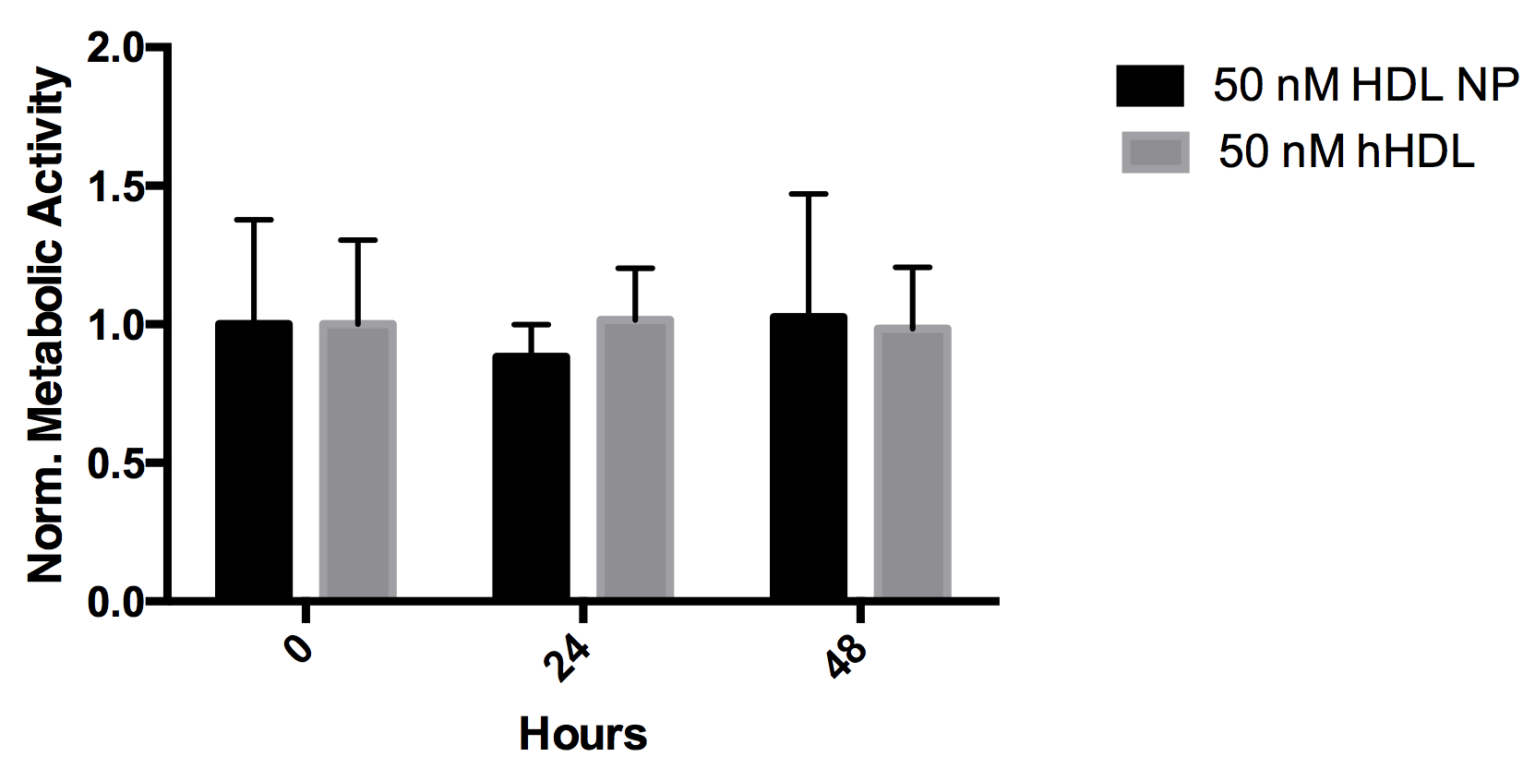

**Supplementary Figure S14.** HDL NP treatment of LLC cells.LLC cells were incubated with HDL NPs (50 nM) or human HDL (hHDL) for up to 48 hours. MTS assay shows no reduction in viability after treatment with HDL NP or hHDL when compared to untreated (0 hour time point).

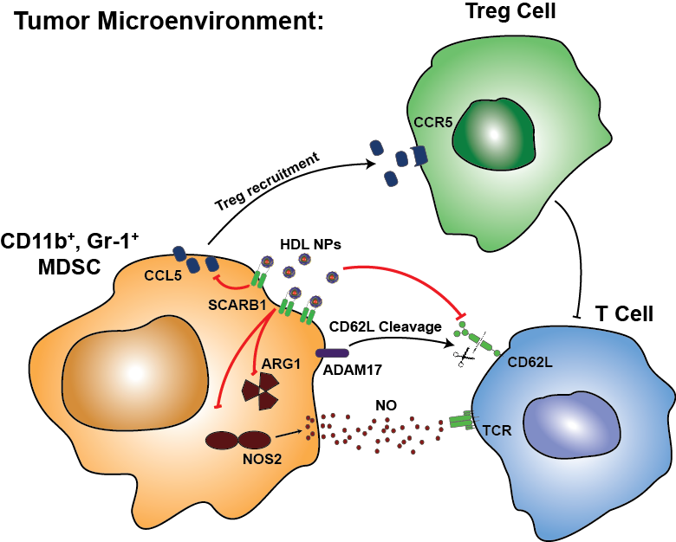

**Supplementary Figure S15.** Summary of HDL NP effects on MDSCs. This diagram shows the molecular mechanisms through which HDL NP binding to SCARB1 inhibits MDSCs and activates T cells in the tumor microenvironment.

**Supplementary Table S1:**

|  |  |  |  |  |
| --- | --- | --- | --- | --- |
| **Protein** | **Clone** | **Use** | **Dilution** | **Company** |
| **SCARB1** | NB400-104A | FC | 3:100 | Novus |
| **CD11b** | M1/70 | FC | 1:100 | BD Pharmingen |
| **F4/80** | BM8 | FC, IHC | 1:100, 1:400 | Biolegend, eBiosciences |
| **Ly6C** | HK1.4 | FC | 1:200 | Biolegend |
| **Ly6G** | 1A8 | FC | 1:100 | Biolgend |
| **CD3** | 145-2 C11, 17A2, SP7 | FC, IHC | 1:100, 1:500 | Biolegend, Abcam |
| **CD4** | RM4-4, | FC | 1:100 |  |
| **CD8** | 53-6.7, Polyclonal | FC, IHC | 1:100, 1:400 | Biolegend, Abcam |
| **CD19** | eBio1D3 | FC | 1:100 | eBiosciences |
| **B220** | RA3-6B2 | FC | 1:100 | Biolegend |
| **CD44** | IM7 | FC | 1:100 | Biolegend |
| **CD62L** | MEL-14 | FC | 1:100 | BD Biosciences |
| **Gr-1** | RB6-865 | IHC | 1:100 | R&D Systems |
| **FOXP3** | Polyclonal | IHC | 1:200 | Abcam |
| **Anti-Rat IgG** | Polyclonal | IHC secondary-488 | 1:100 | Jackson Immunoresearch |
| **Anti-Rabbit IgG** | Polyclonal | FC, IHC secondary-Cy5 | 1:100 | Novus, Jackson Immunoresearch |

**Supplementary Table S2:**

|  |  |
| --- | --- |
| **Gene** | **Primer** |
| **Actb** | Fwd: 5’-aagtcagtgtacaggtaagcc-3’ |
| Rev: 5’-gtcccccaacttgagatgtatg-3’ |
| **S100A9** | Fwd: 5’-gaagaaagagaagagaaatgaagcc-3’ |
| Rev: 5’-ctttgccatcagcatcatacactcc-3’ |
| **Nos2** | Fwd: 5’-cacttctgctccaaatccaac-3’ |
| Rev: 5’-gactgagctgttagagacactt3’ |
| **Arg1** | IDT Assay ID: Mm.PT.58.8651372 |
| **CCL5** | IDT Assay ID: Mm.PT.58.43548565 |
| **TNF** | Fwd: 5’-ctgagttctgcaaagggagag-3’ |
| Rev: 5’-cctcagggaagaatctggaaag-3’ |
| **SCARB1**  **(Genotyping)** | Oimr 7768 5’-atctcagccttaggccctgt-3’ |
| Oimr 7769 5’-tcaaaccctgtgacaacagc-3’ |
| Oimr 7770 5’-atagattcgcccttgtgtcc-3’ |