|  |  |  |  |  |  |  |  |
| --- | --- | --- | --- | --- | --- | --- | --- |
| **Compound** | **Dose (mg/kg)** | **Cmax  (ng/mL)/(µM)** | | **Cmax ratio** | **AUClast  (hr·ng/mL)/(hr·µM)** | | **AUC ratio** |
|  | | Plasma | Tumor |  | Plasma | Tumor |  |
| ARQ 197 (MW=369) | 240 | 877/2.37 | 3683/9.98 | 4.1 | 4829/13.1 | 21997/59.6 | 4.5 |
| EMD1214063 (MW=493) | 30 | 573/1.16 | 9406/19.1 | 16.4 | 2692/5.46 | 89684/182 | 34.5 |
| XL184 (MW=502) | 33 | 6550/13.0 | 6900/13.7 | 1.1 | 27996/55.8 | 66000/131 | 2.35 |
| XL880 (MW=633) | 83 | 3420/5.40 | 22000/34.7 | 6.5 | 26173/41.3 | 171300/271 | 6.54 |

**Supplementary Table S1.**  Levels of each MET inhibitor measured in selected plasma and tumor samples collected for the highest dose of each agent in the single-dose studies; units as shown (*n* = 3 animals per group).

|  |  |  |  |
| --- | --- | --- | --- |
| **Compound** | **Dose (mg/kg)** | **tmax, tumor (hr)** | **tmax, plasma (hr)** |
| ARQ 197 | 240 | 2 | 1 |
| EMD1214063 | 30 | 2 | 1 |
| XL184 | 33 | 4 | 1 |
| XL880 | 83 | 4 | 0.5 |

**Supplementary Table S2.** Time to maximum concentration (tmax) for the highest dose of each agent in the single-dose studies (*n* = 3 animals per group).

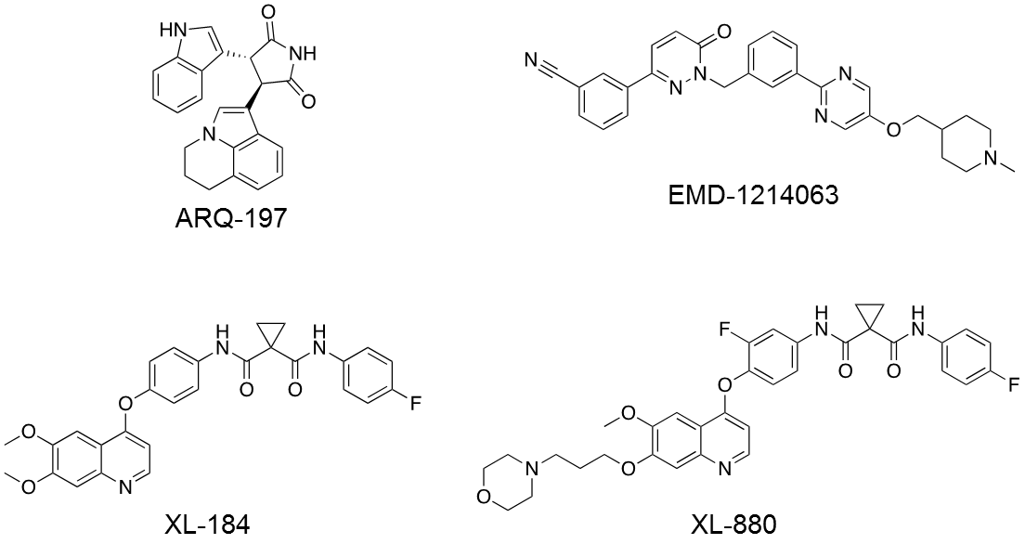

# Supplementary Figure S1: Chemical structures of MET kinase inhibitors used in this study.



A.

A.



B.

# Supplementary Figure S2: Preclinical modeling of a Phase 0 study indicates that ARQ197 does not inhibit MET TK PD biomarker response despite appreciable plasma and tumor drug concentrations. [A] pTyr1234/1235MET/MET PD biomarker data (from Figure 1) for the 4, 12, and 24 h time points following administration of a single dose of ARQ197 (at the indicated dose levels) were selected to represent clinically feasible time points for sampling in a Phase 0 study. [B] tumor and plasma pharmacokinetic data for the 1, 4, and 24 h time points (for the highest ARQ197 dose, 240 mg/kg) are also shown. Horizontal lines indicate the mean and standard deviation for each group (*n* = 3 mice per group).

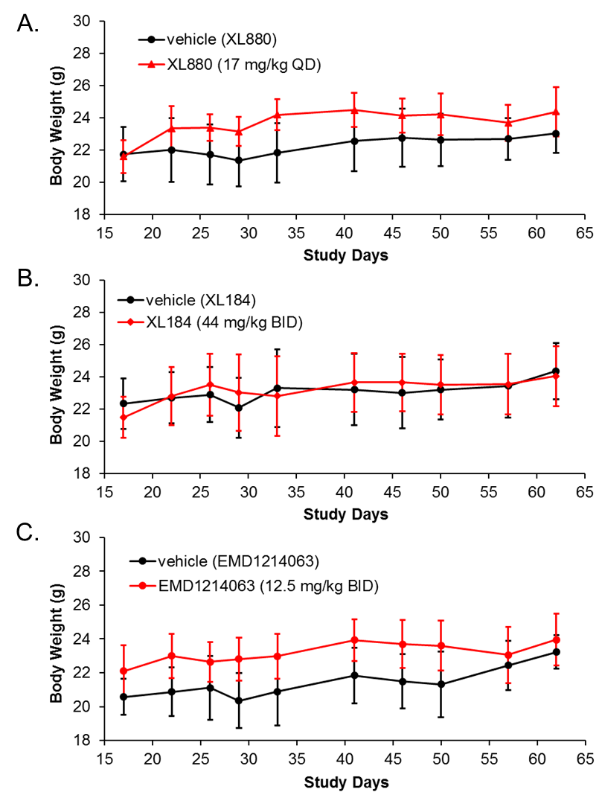

**Supplementary Figure S3:** PD biomarker−based dosage regimens for [A] XL880 (17 mg/kg once daily), [B] XL184 (44 mg/kg twice daily), or [C] EMD1214063 (12.5 mg/kg twice daily) do not result in substantial body weight loss in the SNU-5 gastric carcinoma xenograft model. Drug dosing persisted for 21 days, starting on study day 18 and continuing through day 38; mean animal body weights were calculated to day 62. Error bars represent SD (*n* = 5-16 animals per group).



B.

D.

A.

C.

# Supplementary Figure S4. Total full-length MET levels in tumor biopsies after single doses of [A] ARQ197, [B] EMD1214063, [C] XL184, or [D] XL880. Asterisks (*) indicate significant reductions in total full-length MET level (*P*< 0.05) at a given dose and collection time point (*n* = 3 animals per group) compared to the all-vehicle mean (*n* = 27 animals per group). Total full-length MET levels were significantly reduced from 4 through 24 hr for the highest doses of EMD1214063 and from 24 through 48 hr for the highest doses of XL880. ARQ197 and XL184 did not yield significant changes in total full-length MET levels at any concentration or time point. The *x*‑axis refers to time after the single dose at the dose levels indicated in the legend of each graph.



C.

A.

B.

# Supplementary Figure S5. Total full-length MET levels in tumor biopsy specimens after single or multiple doses of [A] XL880 (17 mg/kg once daily), [B] XL184 (44 mg/kg twice daily), and [C] EMD1214063 (12.5 mg/kg twice daily) (*n* = 6), or matched vehicle (*n*= 16-18). Mean levels of total full-length MET are shown at the indicated time points after dose 1 on treatment day 1 (grey) and either dose 8 for XL880 or dose 15 for XL184 and EMD1214063 on treatment day 8 (red).

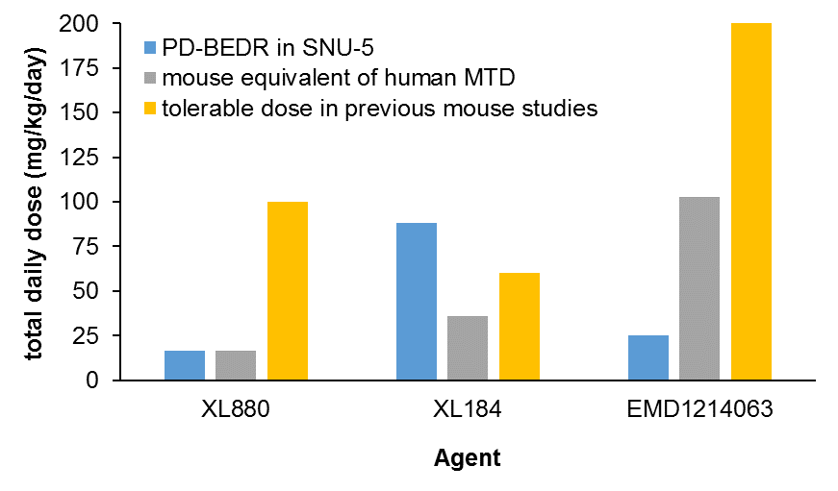

# Supplementary Figure S6. Total daily doses of XL880, XL184, and EMD1214063 in PD-guided biologically effective dosage regimens (PD-BEDRs) compared to predicted MTDs and empirically determined tolerable doses in mice. The total daily dose corresponding to the PD-BEDR for each agent in the SNU-5 model is shown (blue), along with the mouse equivalent of the human MTD (gray), calculateda using the clinical MTDs for each agentb,c,d. In the case of EMD1214063, an MTD was not determined in the phase I study; instead, the recommended phase II dosed was used for calculating the mouse equivalent of the human MTD. Shown in yellow are the highest doses of each agent shown to be tolerable in mouse xenograft multi-dose efficacy studiese,f,g (note: actual mouse MTDs were not determined in these studies).

a Nair AB, Jacob S. A simple practice guide for dose conversion between animals and human. Journal of Basic and Clinical Pharmacy 2016;7:27-31.

b Shapiro GI, McCallum S, Adams LM, Sherman L, Weller S, Swann S*, et al.* A Phase 1 dose-escalation study of the safety and pharmacokinetics of once-daily oral foretinib, a multi-kinase inhibitor, in patients with solid tumors. Invest New Drugs 2013;**31**:742-50.

c Kurzrock R, Sherman SI, Ball DW, Forastiere AA, Cohen RB, Mehra R*, et al.* Activity of XL184 (Cabozantinib), an oral tyrosine kinase inhibitor, in patients with medullary thyroid cancer. J Clin Oncol 2011;**29**:2660-6.

d Falchook GS, Kurzrock R, Amin HM, Fu S, Piha-Paul SA, Janku F, et al. Efficacy, safety, biomarkers, and phase II dose modeling in a phase I trial of the oral selective c-Met inhibitor tepotinib (MSC2156119J). J Clin Oncol 2015;**33**:2591.

e Qian F, Engst S, Yamaguchi K, Yu P, Won KA, Mock L*, et al.* Inhibition of tumor cell growth, invasion, and metastasis by EXEL-2880 (XL880, GSK1363089), a novel inhibitor of HGF and VEGF receptor tyrosine kinases. Cancer Res 2009;**69**:8009-16.

f Yakes FM, Chen J, Tan J, Yamaguchi K, Shi Y, Yu P*, et al.* Cabozantinib (XL184), a Novel MET and VEGFR2 Inhibitor, Simultaneously Suppresses Metastasis, Angiogenesis, and Tumor Growth. Mol Cancer Ther 2011;**10**:2298-308.

g Bladt F, Faden B, Friese-Hamim M, Knuehl C, Wilm C, Fittschen C*, et al.* EMD 1214063 and EMD 1204831 Constitute a New Class of Potent and Highly Selective c-Met Inhibitors. Clin Cancer Res 2013;**19**:2941-51.