Inhibition of BMI1, a therapeutic approach in endometrial cancer.
Megan Buechel ¹*, Anindya Dey¹*, Shailendra Kumar Dhar Dwivedi¹, Aleia Crim¹, Kai Ding², Roy Zhang³, Priyabrata Mukherjee³, Kathleen N. Moore¹, Liangxian Cao⁴, Arthur Branstrom⁴, Marla Weetall⁴, John Baird⁴ and Resham Bhattacharya^{1,5 #}
1. Department of Obstetrics and Gynecology, Stephenson Cancer Center, University of Oklahoma Health Science Center, Oklahoma City, Oklahoma, USA
2. Department of Biostatistics and Epidemiology, University of Oklahoma Health Science Center, Oklahoma City, Oklahoma, USA
3. Department of Pathology, University of Oklahoma Health Science Center, Oklahoma City, Oklahoma, USA
4. PTC Therapeutics, South Plainfield, New Jersey, USA
5. Department of Cell Biology, University of Oklahoma College of Medicine, Oklahoma City, Oklahoma, USA
* Authors contributed equally to this work.
# Corresponding Author: Resham Bhattacharya Ph.D., Associate Professor
Peggy and Charles Stephenson Cancer Center, OUHSC. 975 NE 10th Street, BRC-1409B, Oklahoma City, OK 73104.
Email: Resham-Bhattacharya@ouhsc.edu
Supplementary Figures:

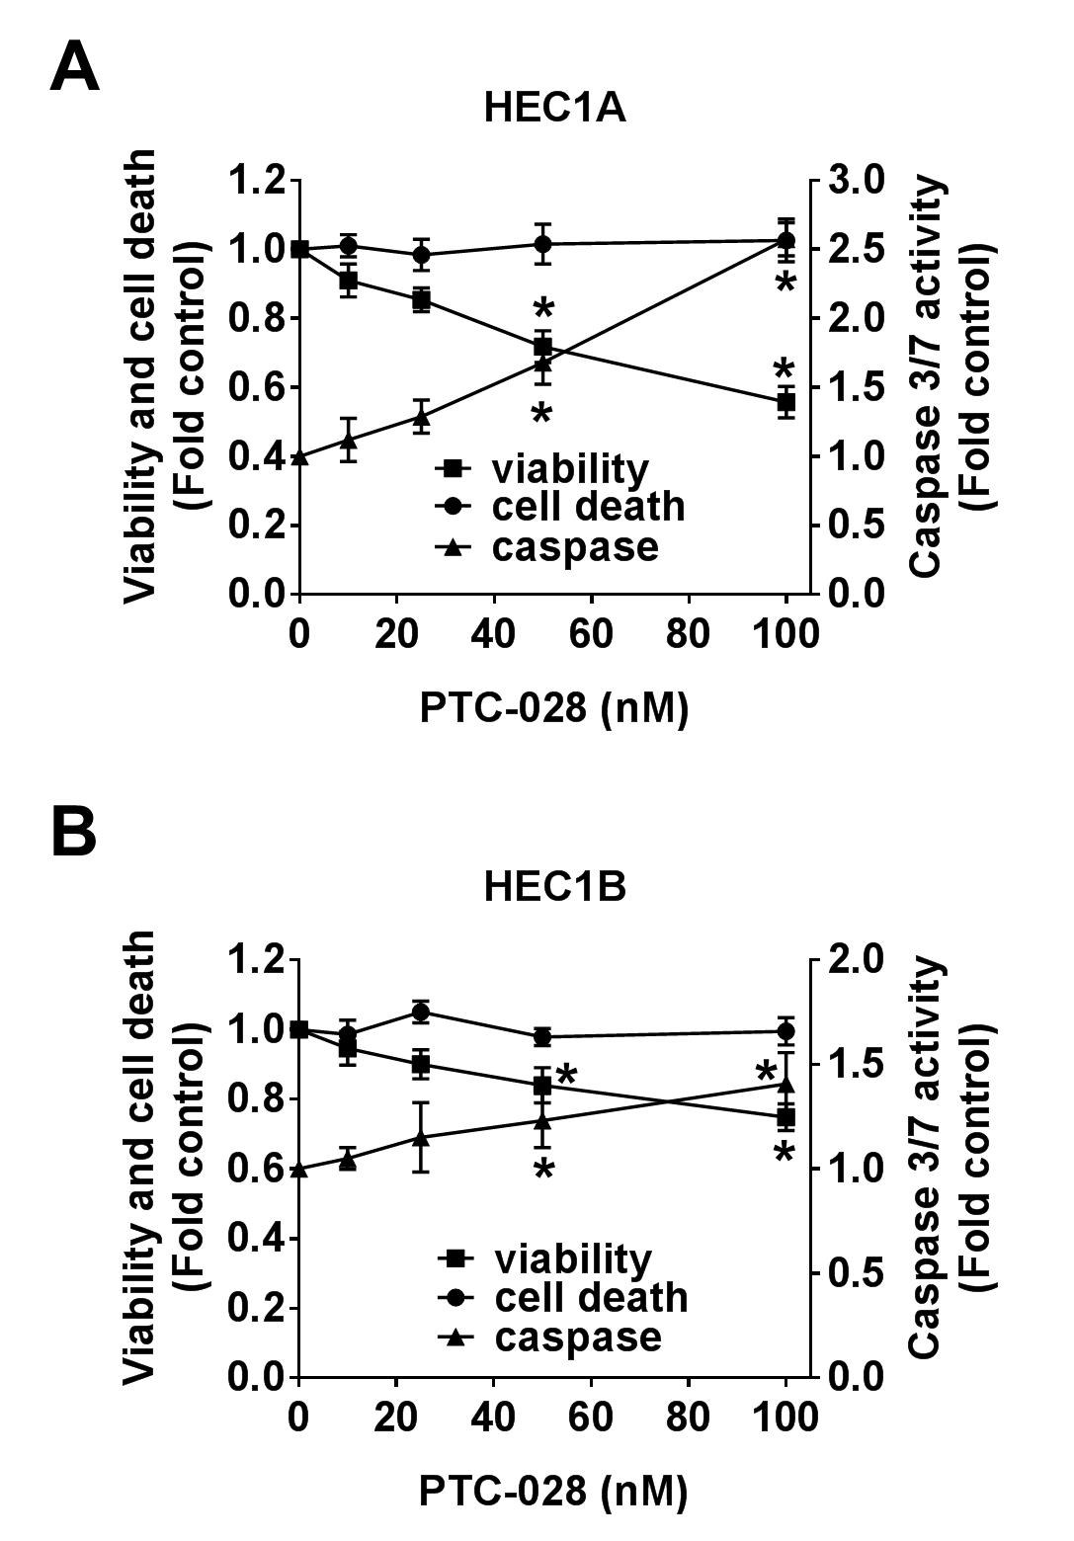

Figure S1: PTC-028 inhibits endometrial cancer cell viability. (A) HEC1A and (B) HEC1B cells were treated with increasing concentrations of PTC-028 for 48h and cell viability, cytotoxic cell death and caspase 3/7 activity was evaluated using the ApoTox-Glo Triplex assay. Data are mean ± S.D. of three independent experiments performed in triplicate. *P<0.05 when comparing with respective vehicle treated control by two-way ANOVA.

