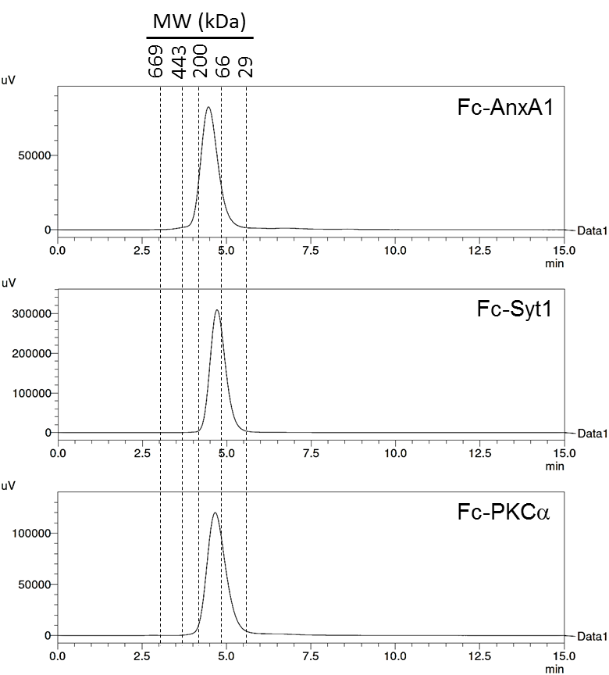

**Figure S1.** Gel filtration chromatography analyses of purified PS-specific Fc fusions with elution times of molecular weight (MW) standards indicated by dotted black lines.

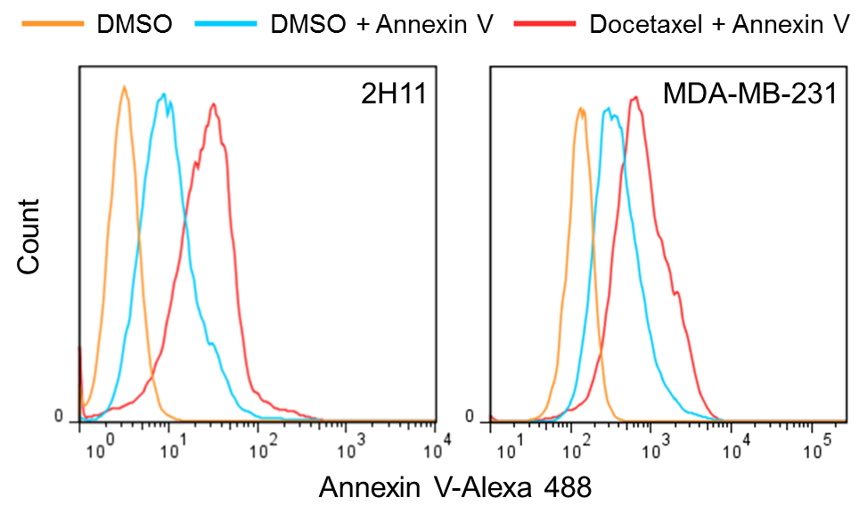

**Figure S2.** The tumor endothelial cell line 2H11 and breast cancer cell line MDA-MB-231 expose PS. Cells were treated with vehicle (DMSO) or 50 nM docetaxel for 72 hours. Cells were then incubated with Alexa 488-labeled Annexin V followed by flow cytometry analyses.

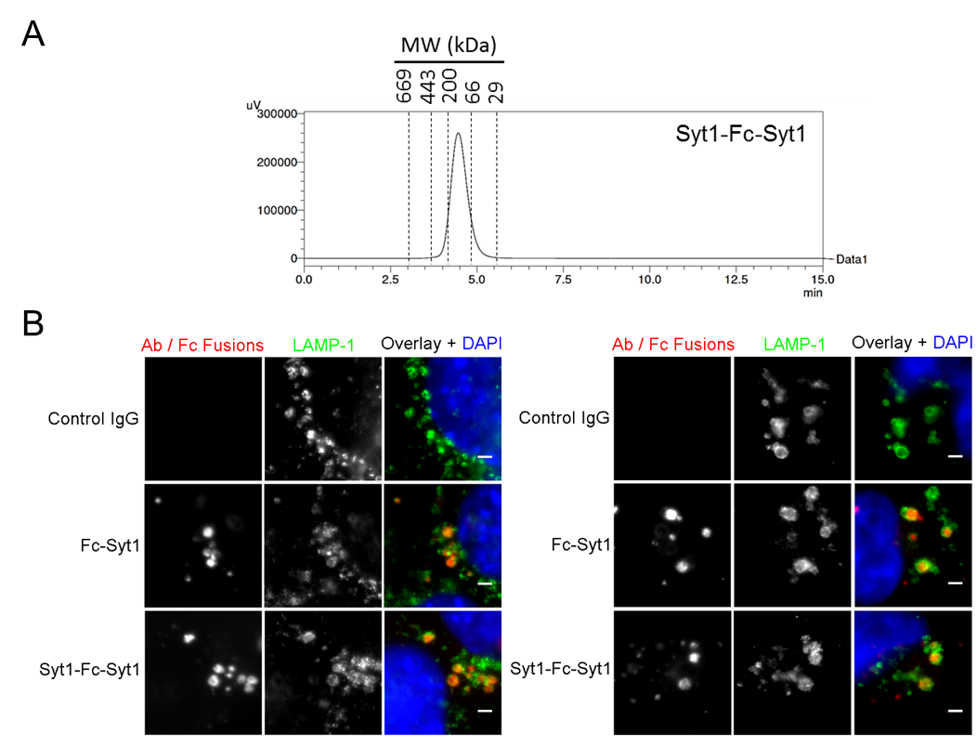

**Figure S3. A,** gel filtration chromatography analyses of purified, tetravalent Syt1-Fc-Syt1 with elution times of molecular weight (MW) standards indicated by dotted black lines. **B,** 2H11 (left) or MDA-MB-231 (right) cells were incubated with 100 nM control IgG or PS-specific Fc fusions at 37°C for 30 minutes. Cells were fixed, stained with Cy3/Alexa 555-labeled anti-human IgG (H+L) and LAMP-1-specific antibodies followed by Alexa 488-labeled secondary antibody for detecting LAMP-1. Fluorescence images were acquired and Cy3/Alexa 555, Alexa 488 and DAPI are pseudo-colored red, green and blue, respectively, in the overlays. Scale bars: 2 µm.

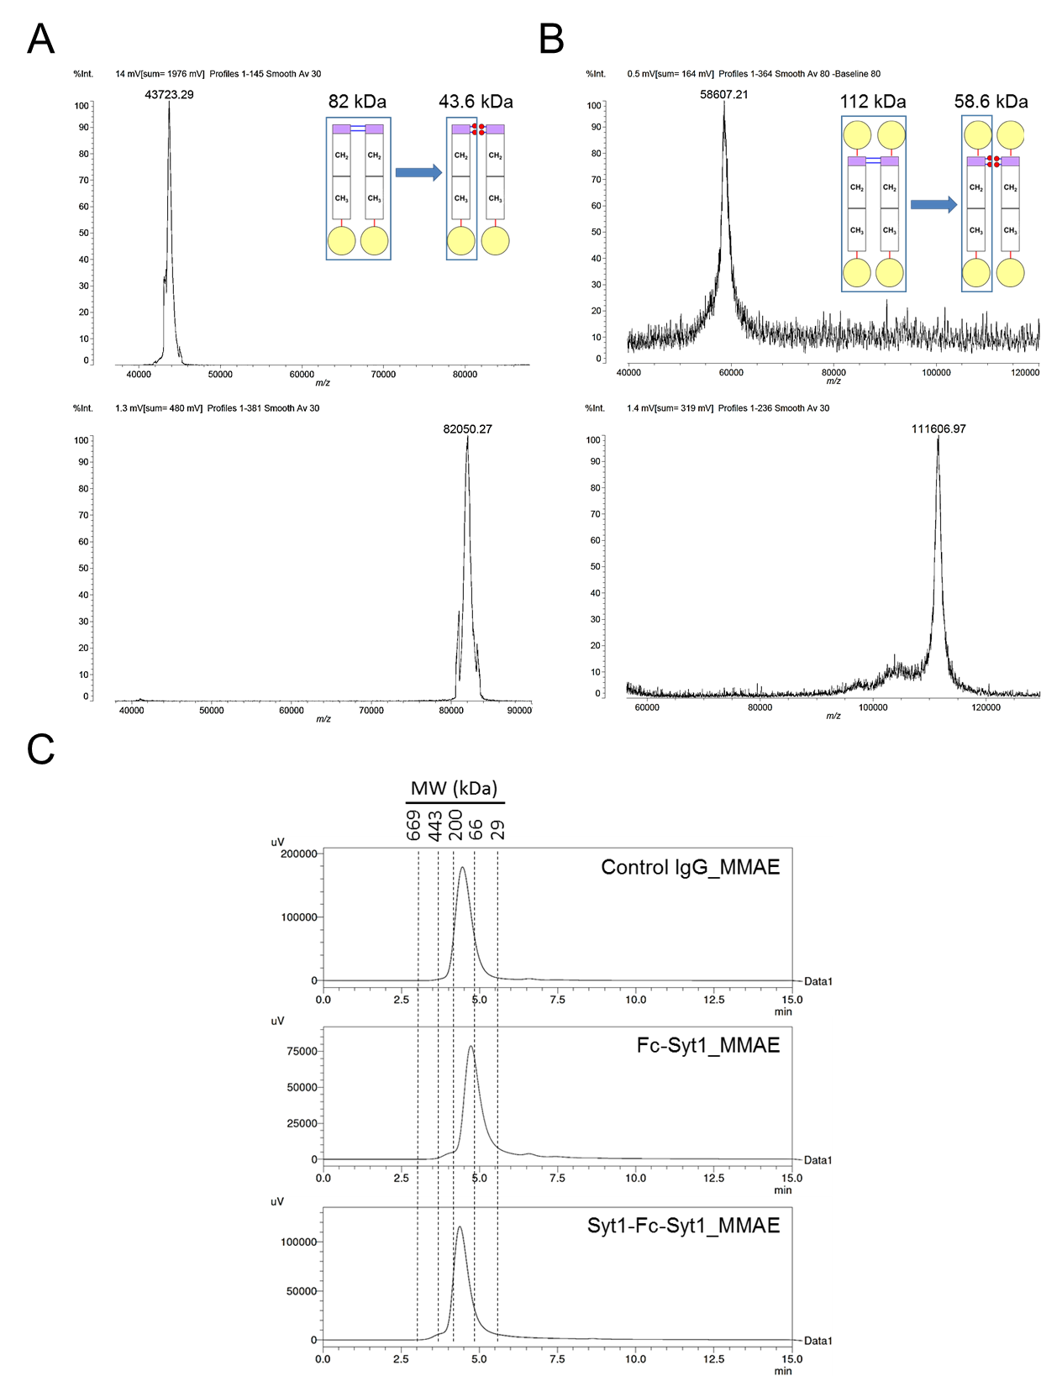

**Figure S4.** Analyses of MMAE-conjugated PS-targeting Fc fusions or control IgG. **A** and **B,** MALDI-TOF analyses of MMAE-conjugated (upper panels) or unconjugated (lower panels) Fc-Syt1 (**A**) and Syt1-Fc-Syt1 (**B**). The unconjugated proteins have molecular weights of 82 and 112 kDa, respectively, whereas conjugation to MMAE results in molecular weights of approximately 43.6 and 58.6 kDa, respectively, due to the disruption of disulfide bonds in the hinge region. **C,** gel filtration chromatography analyses of MMAE-conjugated proteins with elution times of molecular weight (MW) standards indicated by dotted black lines.

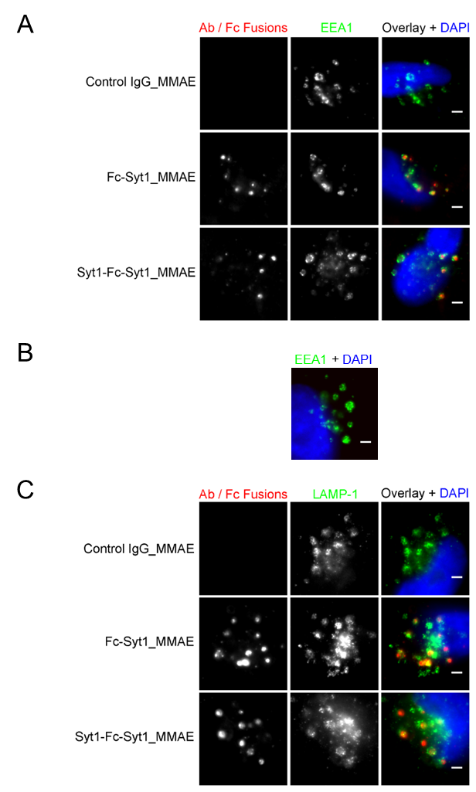

**Figure S5. A,** MDA-MB-231 cells were incubated with 100 nM PS-specific PDCs or MMAE-conjugated control IgG for 15 minutes. Cells were fixed and stained with Alexa 555-labeled anti-human IgG (H+L) and EEA1-specific antibody followed by Alexa 488-labeled secondary antibody for detecting EEA1. Fluorescence images were acquired and Alexa 555, Alexa 488 and DAPI are pseudo-colored red, green and blue, respectively, in the overlays. Scale bars: 2 µm. **B,** untreated MDA-MB-231 cells were fixed and stained with EEA1-specific antibody followed by Alexa 488-labeled secondary antibody for detecting EEA1. Fluorescence images were acquired and Alexa 488 and DAPI are pseudo-colored green and blue, respectively, in the overlay. Scale bar: 2 µm. **C,** MDA-MB-231 cells were incubated with 100 nM PS-specific PDCs or MMAE-conjugated control IgG for 30 minutes. Cells were fixed and stained with Alexa 555-labeled anti-human IgG (H+L) and LAMP-1-specific antibody followed by Alexa 488-labeled secondary antibody for detecting LAMP-1. Fluorescence images were acquired and Alexa 555, Alexa 488 and DAPI are pseudo-colored red, green and blue, respectively, in the overlays. Scale bars: 2 µm.

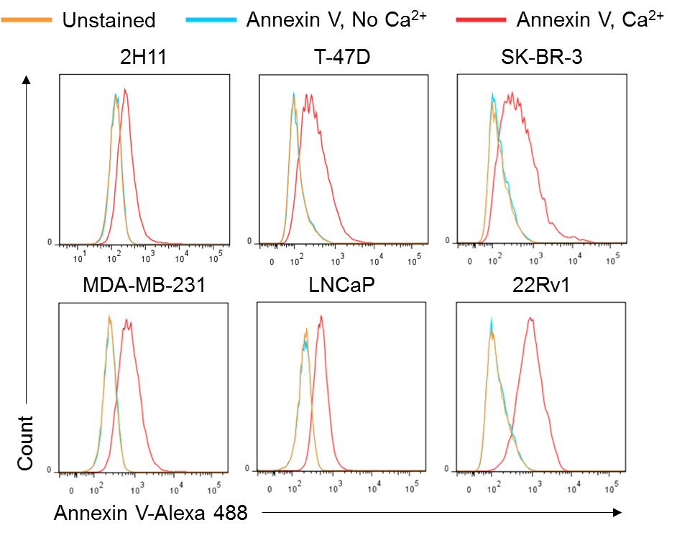

A

B

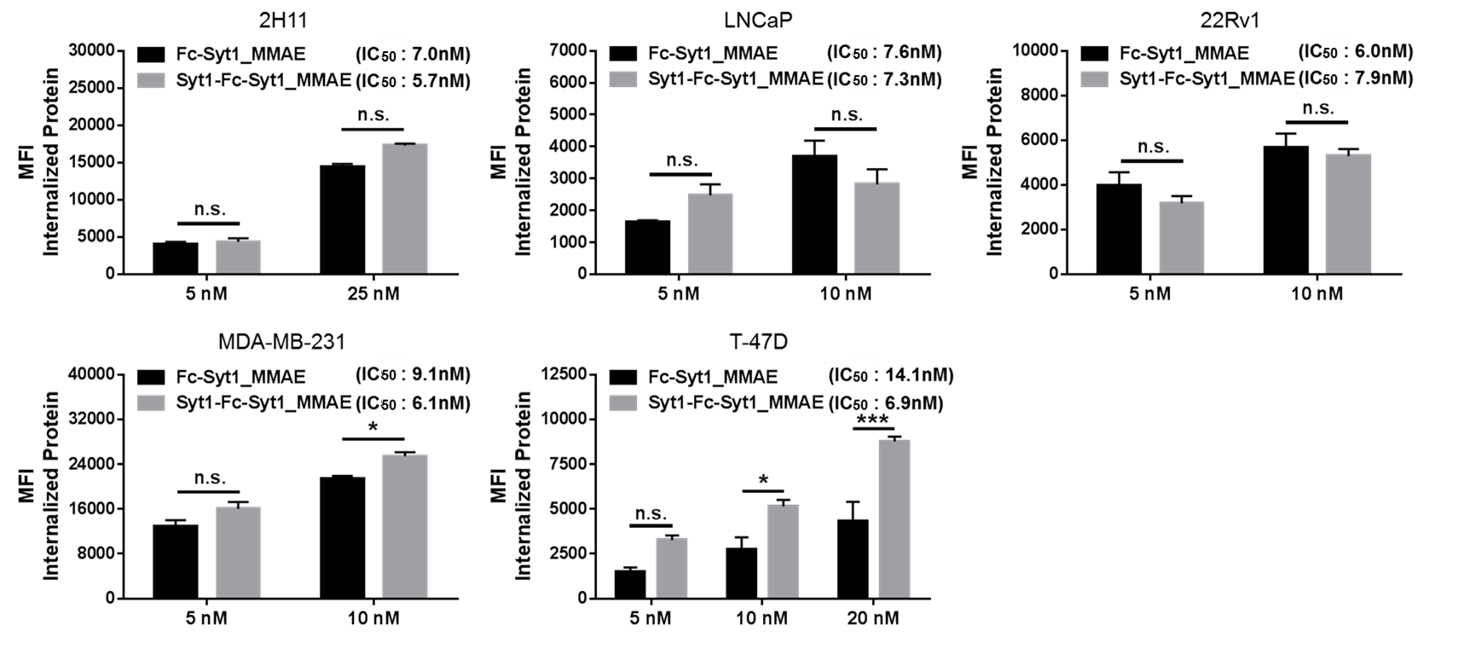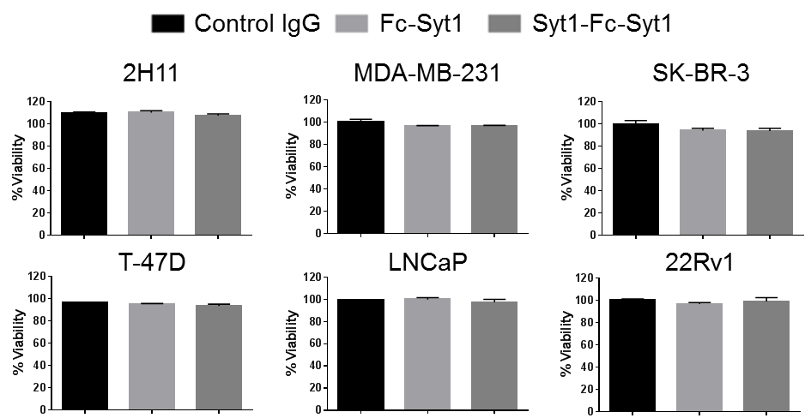

C

**Figure S6. A,** PS exposure on the indicated cells were determined by incubation with Alexa 488-labeled Annexin V in the absence or presence of Ca2+, followed by flow cytometry analyses. **B,** cell lines were treated with PS-specific PDCs at the indicated concentrations around the IC50s (shown in Fig. 4B) for 2 hours at 37°C. Cells were then washed, trypsinized and fixed with 4% PFA. Surface bound and total cell-associated proteins were detected by incubating cells with Alexa 647-labeled goat anti-human IgG (H+L) antibodyin the absence or presence of 0.1% saponin, respectively, followed by flow cytometry analyses. Levels of internalized protein were calculated by subtracting the value of surface bound protein from that of total cell-associated protein. Statistically significant differences were analyzed using two-way ANOVA followed by Bonferroni *post hoc* test. n.s., no significant difference; *, *P* < 0.05; ***, *P* < 0.001. Error bars represent SEM. **C,** unconjugated Fc-Syt1 and Syt1-Fc-Syt1 have no effect on tumor cell viability. Tumorcells were treated with 1 µM control IgG or PS-specific Fc fusions for 96 hours, and cell viability was determined using the MTS reagent. Error bars represent SEM.



**Figure S7.** BALB/c SCID mice were implanted with LNCaP tumors. Mice (n = 5-6 mice/group) were treated (day 27-59) with either unconjugated or MMAE-conjugated Fc fusions at a dose of 1 nmole/mouse (4.1 mg/Kg for Fc-Syt1 or Fc-Syt1_MMAE, 5.6 mg/Kg for Syt1-Fc-Syt1_MMAE) twice per week. PBS was delivered as vehicle control. Body weights were measured twice per week.

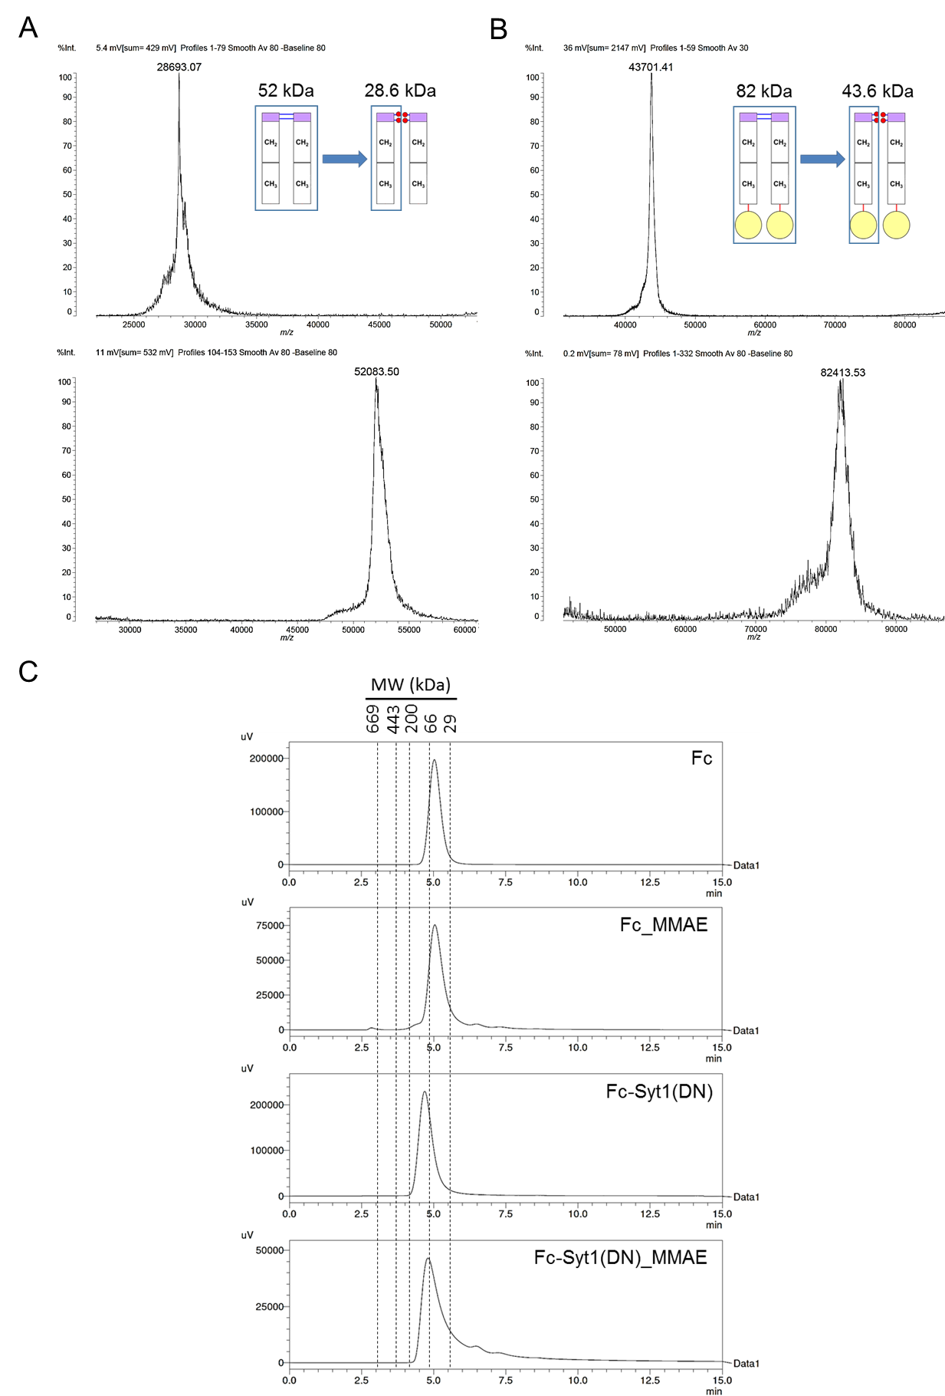

**Figure S8.** Analyses of MMAE-conjugated Fc and the PS-targeting deficient Fc-Syt1(DN) mutant. **A** and **B,** MALDI-TOF analyses of MMAE-conjugated (upper panels) and unconjugated (lower panels) Fc (**A**) and Fc-Syt1(DN) (**B**). Unconjugated Fc and Fc-Syt1(DN) have molecular weights of 52 and 82 kDa, respectively, whereas conjugation to MMAE results in molecular weights of approximately 28.6 and 43.6 kDa, respectively, due to the disruption of disulfide bonds in the hinge region. **C,** gel filtration chromatography analyses of unconjugated Fc or Fc-Syt1(DN) and their MMAE-conjugated derivatives, with elution times of molecular weight (MW) standards indicated by dotted black lines.