Supplemental Data for

MET Tyrosine Kinase Inhibition Enhances the Antitumor Efficacy of an HGF Antibody

Pamela J. Farrell¹, Jennifer Matuszkiewicz¹, Deepika Balakrishna¹, Shweta Pandya^{1,6}, Mark S. Hixon¹, Ruhi Kamran¹, Shaosong Chu², J. David Lawson³, Kengo Okada⁴, Akira Hori⁴, Akio Mizutani⁴, Hidehisa Iwata⁴, Ron de Jong¹, Barb Hibner⁵ and Patrick Vincent¹

Departments of ¹Biological Sciences, ²Chemistry, ³Computational Sciences and Crystallography Takeda California, San Diego, CA 92121; ⁴Pharmaceutical Research Division, Takeda Pharmaceutical Companies Ltd, Japan; ⁵Oncology Biology, Takeda Boston, Cambridge, MA 02139; ⁶Currently at Illumina, Inc., San Diego, CA.

Supporting Information

Coordinates for the crystal structures of MET complexed with Compound 1, Compound 2 and Compound 3 have been deposited in the PDB with accession codes 5UAF, 5UAB and 5UAD.

Supplemental Table and Figure Legends
Supplemental Table 1. Activity of MET TKIs in enzyme and cellular assessments. Imidazopyridazine series Compound 1, 2 and 3 were evaluated versus two known MET TKIs, PF04217903 and crizotinib. Enzyme assays were performed with (pY-MET) and without MET pre-activation. Cellular assays included mechanism-based (pY1349-MET), end point biology (viability) and selectivity for MET (ATP levels in BaF3 cells expressing the indicated kinase).

Supplemental Table 2. Activity of Compound 1 against approximately 130 additional protein kinases was determined by screening at 1 μM and 10 μM using the kinase profiling services at Millipore (Billerica, MA) and Invitrogen (Carlsbad, CA). Assay details and conditions are described by these providers. For kinases exhibiting estimated IC₅₀ < 250 nM, additional screening was performed to obtain 11-point dose response curves. As indicated, some kinases were evaluated by Takeda (11-point dose response curves) using assay conditions according to the manufacturer’s instructions for each kinase and ATP concentration at or below the K_{m} for each kinase. The cellular IC₅₀ in this table is the same as that in supplemental table 1 and is provided here for comparison to enzyme IC_{50.} (nd = not determined)

Figure S1. Binding modes of selective MET TKIs. The x-ray diffraction crystal structures of MET in complex with Compound 1, Compound 2, and Compound 3 and a model of PF04217903 are shown. Note that the area occupied by the difluoro moiety of Compound 1 is not filled by the other compounds and there is no isostere of the Compound 1 difluoro moiety in the other compounds.

Figure S2. Compound 1 at various doses enhances the antitumor effect of TAK-701 (A). Additionally, TAK-701 at various doses enhances the antitumor effect of Compound 1 in U-87MG glioblastomas (B). Figure S2A is the same as Figure 5B and is provided for side-by-side comparison. Tumor volumes (mean ± SEM) were measured over time for the indicated dose regimen. See Materials and Methods for further description of procedures involving U-87MG xenograft models. TTE was determined to be significant with Logrank test. Kaplan-Meier survival plots showing survival over time illustrated in (C).

Figure S3. Kaplan-Meier plots for the U-87MG study shown in Figure 6. Plots show the percentage of animals remaining in the study versus time for the indicated dose regimen.

Figure S4. Inhibition of MET pathway signaling by Compound 1, TAK-701 and combination of Compound 1 + TAK-701, in U-87MG xenografts following 5 days of treatment. Western blot biomarker analysis was performed on xenografts collected on day 5 at 2 hours post dose (n = 3 mice per group for each group: 100 mg/kg Compound 1, 10 mg/kg TAK-701 and 100 mg/kg Compound 1 + 10mg/kg TAK-701). See Figure 6A for evaluation of phosphorylated tyrosine 1349 (phosY1349) MET and total MET by quantitative immunoassay. The following proteins were not detected at sufficient levels to allow for evaluation: HER2, phosY1221/2-HER2, phosY1068-EGFR, phosY1289-HER3, HER2, phosY576-FAK and phosY307-GAB1.

Figure S5. Compound 1 enhances the effect of a MEK inhibitor (TAK-733) or a PI3K inhibitor (Pictilisib) resulting in enhanced effect on MKN45 cell viability. Enhanced effect is observed when a MEK inhibitor, TAK-733, is added to cells treated with dose response of Compound 1. For the combination dose response curves, each point of the Compound 1 dose response curve contains a constant concentration of TAK-733. Example of synergy is highlighted: blue circles (single agent viability) and red circle (combination, which uses the same concentration of the blue circled single agents).

Supplemental Table 1

 | IC₅₀, nM
Assay: | Compound 1 | Compound 2 | Compound 3 | PF04217903 | Crizotinib
MET, Enzyme | < 1 | 5 | 5 | 3 | 4
phos-MET, Enzyme | 12 | 166 | 44 | 23 | 20
phos-MET, SNU-5 Cells | 7 | 180 | 11 | 12 | 14
Viability, EBC-1 Cells | 5 | 89 | 15 | 18 | 25
Viability, MKN45 Cells | 9 | 182 | 27 | 28 | 49
Viability, A549 Cells | >50,000 | >50,000 | >50,000 | >50,000 | 2,384
Viability, MET-BaF3 Cells | 5 | 117 | 12 | 19 | 48
Viability, FMS-BaF3 Cells | >10,000 | >10,000 | >10,000 | >10,000 | 458
Viability, SYK-BaF3 Cells | >10,000 | >10,000 | >10,000 | >10,000 | 1,198
Viability, TRKA-BaF3 Cells | 1,994 | 7,906 | 2,404 | >10,000 | 209
Viability, TRKB-BaF3 Cells | 2,146 | 6,101 | 2,342 | >10,000 | 104
Viability, TRKC-BaF3 Cells | 1,796 | >10,000 | 2,372 | >10,000 | 213

Supplemental Table 2

 | Enzyme | Enzyme Assay | Cell | Cellular Assay
Human Kinase | IC₅₀ (nM) | Provider | IC₅₀ (nM) | Provider
MET | < 1 | Millipore | 5 | Advanced Cellular Dynamics
 | 2.2 | Takeda
phosphorylated MET | 5 | Invitrogen
 | 12 | Takeda
FMS | 32 | Invitrogen | > 10,000 | Advanced Cellular Dynamics
TRKC | 39 | Invitrogen | 1,796 | Advanced Cellular Dynamics
TRKB | 219 | Invitrogen | 2,146 | Advanced Cellular Dynamics
TRKA | 240 | Invitrogen | 1,994 | Advanced Cellular Dynamics
ROS1 | 275 | Invitrogen | nd | nd
Axl | 490 | Takeda | nd | nd
Abl1 | 661 | Invitrogen | nd | nd
GSK-3 beta | 708 | Takeda | nd | nd
MUSK | 1,072 | Invitrogen | nd | nd
Lck | 1,175 | Invitrogen | nd | nd
RON | 1,318 | Invitrogen | nd | nd
FGR | 1,905 | Invitrogen | nd | nd
cMER | 2,692 | Invitrogen | nd | nd
EphA1 | 3,631 | Invitrogen | nd | nd
Yes | 3,981 | Invitrogen | nd | nd
Aurora A | 4,266 | Takeda | nd | nd
Flt3 | 4,467 | Takeda | nd | nd
Ret | 4,467 | Invitrogen | nd | nd
CLK2 | 4,677 | Invitrogen | nd | nd
ITK | 4,786 | Invitrogen | nd | nd
EphB2 | 5,248 | Invitrogen | nd | nd
Aurora B | 5,548 | Takeda | nd | nd
SRC | 5,623 | Takeda | nd | nd
EphB1 | 8,128 | Invitrogen | nd | nd
Abl2 | 8,511 | Invitrogen | nd | nd
c-RAF_Y340D_Y341D | 9,333 | Invitrogen | nd | nd
HCK | 9,772 | Invitrogen | nd | nd
ALK | 11,220 | Invitrogen | nd | nd
BTK | 11,220 | Invitrogen | nd | nd
FGFR2 | 12,023 | Invitrogen | nd | nd
FGFR3 | 12,882 | Invitrogen | nd | nd
DAPK1 | 13,490 | Invitrogen | nd | nd
HER4 | 13,490 | Invitrogen | nd | nd
INSRR | 13,490 | Invitrogen | nd | nd
EphA4 | 17,783 | Invitrogen | nd | nd
FAK2 | 19,953 | Invitrogen | nd | nd
VEGFR2 | 19,953 | Takeda | nd | nd
Flt4 | 20,417 | Invitrogen | nd | nd
LynA | 21,878 | Invitrogen | nd | nd
EphB4 | 24,547 | Invitrogen | nd | nd
Blk | 26,915 | Invitrogen | nd | nd
EphA2 | 28,184 | Invitrogen | nd | nd
CDK9/cyclinT1 | 28,840 | Invitrogen | nd | nd
Fyn | 34,674 | Invitrogen | nd | nd
FRK | 36,308 | Invitrogen | nd | nd
MELK | 36,308 | Invitrogen | nd | nd
JAK2 | 37,154 | Invitrogen | nd | nd
MYLK2 | 37,154 | Invitrogen | nd | nd
CDK2 | 39,811 | Takeda | nd | nd
c-Kit | 39,811 | Takeda | nd | nd
EGFR | 39,811 | Takeda | nd | nd
HER2 | 39,811 | Takeda | nd | nd
Insulin Receptor | 39,811 | Takeda | nd | nd
MAP3K5 | 39,811 | Takeda | nd | nd
PKACA | 39,811 | Takeda | nd | nd
EphB3 | 41,687 | Invitrogen | nd | nd
BMX | 42,658 | Invitrogen | nd | nd
MATK | 42,658 | Invitrogen | nd | nd
IGF1R | 43,652 | Invitrogen | nd | nd
TYRO3 | 45,709 | Invitrogen | nd | nd
Flt1 | 53,703 | Invitrogen | nd | nd
p38gamma | 53,703 | Invitrogen | nd | nd
MKK6 | 54,954 | Invitrogen | nd | nd
LTK | 79,433 | Invitrogen | nd | nd
AKT2 | > 10,000 | Invitrogen | nd | nd
AMPKalpha1 | > 10,000 | Invitrogen | nd | nd
AMPKalpha2 | > 10,000 | Invitrogen | nd | nd
CamK1 | > 10,000 | Invitrogen | nd | nd
CamK2alpha | > 10,000 | Invitrogen | nd | nd
CamK4 | > 10,000 | Invitrogen | nd | nd
Chk1 | > 10,000 | Invitrogen | nd | nd
Chk2 | > 10,000 | Invitrogen | nd | nd
CK1delta | > 10,000 | Invitrogen | nd | nd
CK1gamma1 | > 10,000 | Invitrogen | nd | nd
CK2alpha1 | > 10,000 | Invitrogen | nd | nd
EGFR_T790M | > 10,000 | Invitrogen | nd | nd
ERK2 | > 10,000 | Invitrogen | nd | nd
FES | > 10,000 | Invitrogen | nd | nd
FGFR4 | > 10,000 | Invitrogen | nd | nd
FRAP1 (mTOR) | > 10,000 | Invitrogen | nd | nd
GRK5 | > 10,000 | Invitrogen | nd | nd
IRAK4 | > 10,000 | Invitrogen | nd | nd
JAK1 | > 10,000 | Invitrogen | nd | nd
JAK3 | > 10,000 | Invitrogen | nd | nd
JNK2 | > 10,000 | Invitrogen | nd | nd
JNK3 | > 10,000 | Invitrogen | nd | nd
MAPKAPK2 | > 10,000 | Invitrogen | nd | nd
MEK1 | > 10,000 | Invitrogen | nd | nd
MKNK1 | > 10,000 | Invitrogen | nd | nd
Msk1 | > 10,000 | Invitrogen | nd | nd
Msk2 | > 10,000 | Invitrogen | nd | nd
MST1 | > 10,000 | Invitrogen | nd | nd
NEK2 | > 10,000 | Invitrogen | nd | nd
NEK6 | > 10,000 | Invitrogen | nd | nd
P70S6K | > 10,000 | Invitrogen | nd | nd
PAK3 | > 10,000 | Invitrogen | nd | nd
PDGFRalpha | > 10,000 | Invitrogen | nd | nd
PDGFRbeta | > 10,000 | Invitrogen | nd | nd
PDK1 | > 10,000 | Invitrogen | nd | nd
PIK3CG | > 10,000 | Invitrogen | nd | nd
PIM1 | > 10,000 | Invitrogen | nd | nd
PKCeta | > 10,000 | Invitrogen | nd | nd
PKCgamma | > 10,000 | Invitrogen | nd | nd
PKCtheta | > 10,000 | Invitrogen | nd | nd
PRKG1 | > 10,000 | Invitrogen | nd | nd
ROCK-I | > 10,000 | Invitrogen | nd | nd
ROCK-II | > 10,000 | Invitrogen | nd | nd
Rsk1 | > 10,000 | Invitrogen | nd | nd
Rsk2 | > 10,000 | Invitrogen | nd | nd
SGK1 | > 10,000 | Invitrogen | nd | nd
SRMS | > 10,000 | Invitrogen | nd | nd
SYK | > 10,000 | Invitrogen | nd | nd
TBK1 | > 10,000 | Invitrogen | nd | nd
ZAP70 | > 10,000 | Invitrogen | nd | nd
AKT | > 10,000 | Takeda | nd | nd
ASK | > 10,000 | Takeda | nd | nd
BRAF | > 10,000 | Takeda | nd | nd
CDK1 | > 10,000 | Takeda | nd | nd
CHK1 | > 10,000 | Takeda | nd | nd
CK1 | > 10,000 | Takeda | nd | nd
CSK | > 10,000 | Takeda | nd | nd
ERK1 | > 10,000 | Takeda | nd | nd
FAK | > 10,000 | Takeda | nd | nd
FGFR1 | > 10,000 | Takeda | nd | nd
IKK | > 10,000 | Takeda | nd | nd
JNK | > 10,000 | Takeda | nd | nd
MEKK | > 10,000 | Takeda | nd | nd
MEK1 | > 10,000 | Takeda | nd | nd
MEK5 | > 10,000 | Takeda | nd | nd
p38alpha | > 10,000 | Takeda | nd | nd
PDGFRbeta | > 10,000 | Takeda | nd | nd
PKC | > 10,000 | Takeda | nd | nd
PLK1 | > 10,000 | Takeda | nd | nd
TAK1 | > 10,000 | Takeda | nd | nd
Tie2 | > 10,000 | Takeda | nd | nd
TTK | > 10,000 | Takeda | nd | nd

Figure S1. Binding mode of selective MET TKIs shows the di-flouoro- position of Compound 1 in the MET active site.

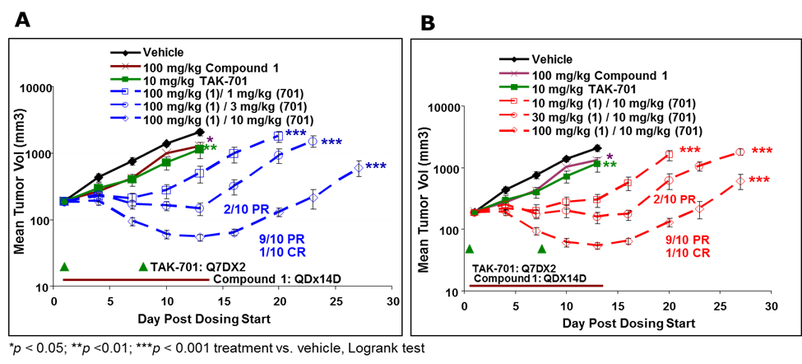
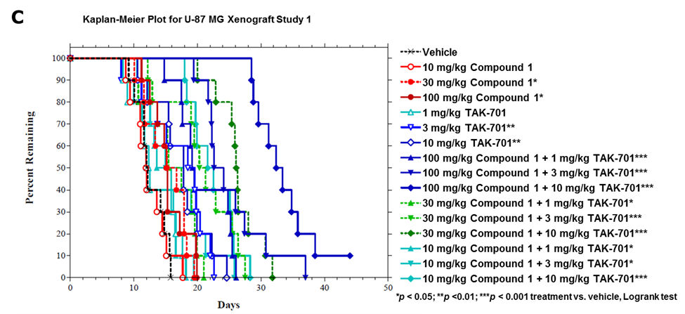
Figure S2. MET TKI, Compound 1, synergizes with in HGF antibody, TAK-701, resulting in enhanced antitumor efficacy in U-87MG glioblastomas.

Figure S3. MET TKIs synergize with in HGF antibody, TAK-701, increasing overall survival.

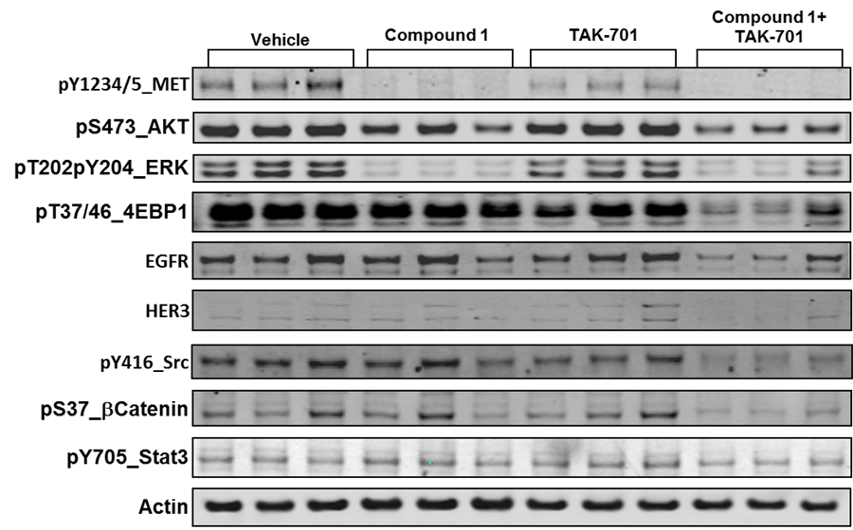

Figure S4. Inhibition of MET pathway signaling by Compound 1, TAK-701 and combination of Compound 1 + TAK-701, in U-87MG xenografts following 5 days of treatment.

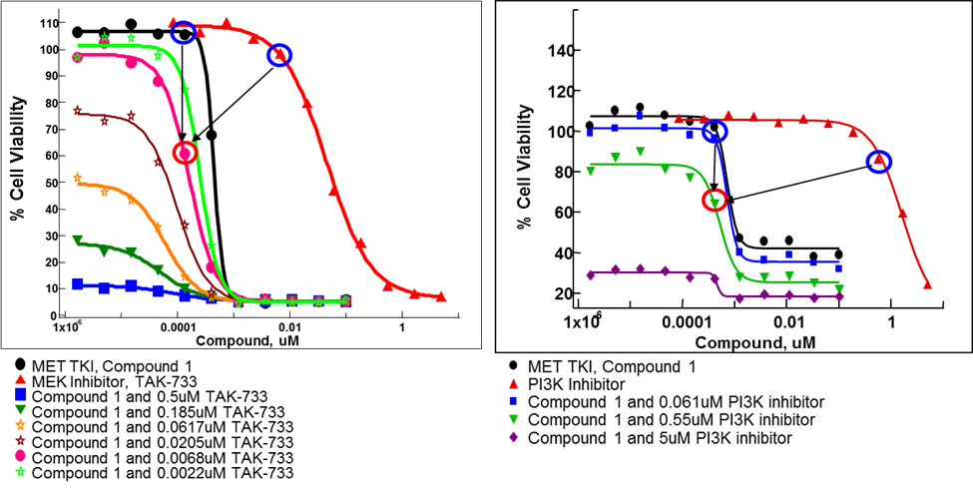
Figure S5. Compound 1 synergizes with MEK or PI3K inhibitor resulting in enhanced loss of MKN45 cell viability.

