Supplementary Material
A murine model for quantitative, real-time evaluation of convection-enhanced delivery (RT-CED) using an ¹⁸[F]-positron emitting, fluorescent derivative of dasatinib
Melinda Wang^{1§}, Harikrishna Kommidi^{2§}, Umberto Tosi¹, Hua Guo², Zhiping Zhou³, Melanie E. Schweitzer³, Linda Y. Wu¹, Ranjodh Singh¹, Shengqi Hou⁴, Benedict Law², Richard Ting^{2✉}, and Mark M. Souweidane^{3✉}

¹ Weill Cornell Medicine, New York, NY, USA.
² Molecular Imaging Innovations Institute (MI3), Department of Radiology, Weill Cornell Medicine, New York, USA.
³ Department of Neurological Surgery, Weill Cornell Medicine, New York, NY, USA.
⁴ Department of Radiation Oncology, Weill Cornell Medicine, New York, NY, USA
§ M.W. and H.K. contributed equally to this work.
✉ To whom correspondence should be addressed.
c) Co-Corresponding authors: Richard Ting, Molecular Imaging Innovations Institute (MI3), Department of Radiology, Weill Cornell Medicine, 413 East 69th Street, New York, NY 10065, USA, E-mail: rct2001@med.cornell.edu. TEL: 6469626195 FAX: 6469620577; Mark M Souweidane, Department of Neurological Surgery, Weill Cornell Medicine, 1300 York Avenue, New York, NY 10065, USA, E-mail: mmsouwei@med.cornell.edu. TEL 2127462363 FAX: 2127467729.

Contents
1. Chemistry: 4
1.1 General synthetic methods 4
1.2 Synthesis of a cationic, ¹⁹F-PET/Fluorescent, multimodality imaging probe 4
1.2.1 Synthesis and characterization of N-methyl piperazine, trimethyine cyanine dasatinib precursor, (i). 4
1.2.1.1 ¹H NMR (DMSO-d6, 500 MHz, 21 °C): 6
1.2.1.2 ¹³C NMR (DMSO-d6, 125 MHz, 21 °C): 6
1.2.1.3 UPLC: H₂O:ACN (0.05% TFA), a10-90, 1.5 min gradient, 0.6 mL/min flow, det. 350 nm 550 nm: 7
1.2.2 Synthesis of a cationic, 19F-trifluoroborate-bearing fluorescent imaging probe, (1) 7
1.2.2.1 ¹H NMR (DMSO-d₆, 500 MHz, 21 °C): 9
1.2.2.2 ¹³F NMR (DMSO-d₆, 500 MHz, 21 °C, CFCl₃ = 0.0 ppm, TFA reference = -76.4 ppm): 9
1.2.2.3 UPLC: H₂O:ACN (0.05% TFA), a10-90, 1.5 min gradient, 0.6 mL/min flow, det. 215, 280, and 550 nm: 10
1.3 Proof of structure: Chemical correlation shows that (1) is alkylated on the piperazine moiety borne by dasatinib 10
1.3.1.1 Hydrolysis of (1) - UPLC/MS: H₂O:ACN (0.05% TFA), a10-90, 1.5 min, 0.6 mL/min flow, det. 350, 550 nm: 11
1.3.1.2 Hydrolysis of (1) - UPLC/MS: (MS) det. 1.001, 1.295 min: 12
1.3.3 Identification of boronic acid (vi) following hydrolysis of (1) and week-long storage of (v) in PBS or FBS at pH 6.5. 12
1.4 Confirmation of trifluoroborate/ester stability of (1) in physiological conditions 13
1.3.1 ¹⁹F NMR (1:1 DMSO-d6:FBS, 500 MHz, 21 °C, 7 day stability study): 13
Supplementary Figure 1. Nanosyn LCK binding assay (third party verification) of nanomolar affinity of compound 1. 14
Supplementary Figure 2. Immunohistochemical (IHC) analysis of orthotopic mBSG bearing brain treated with 1 via CED 15
Supplementary Figure 3. Immunohistochemical (IHC) analysis of orthotopic mBSG bearing brain treated intravenously (tail vein) with 1 17
Supplementary Figure 4. H&E and Ki67 histology (30 days) demonstrating the safety of CED delivered of Compound 1. 19
Supplementary Figure 5. Structure of other candidate drugs for image guided drug delivery 20
Supplementary Figure 6. MTS testing of other candidate drugs for image guided drug delivery 21
Supplementary Figure 7. Dasatinib and Compound 1 have a similar effect on mBSG cell cycle in vitro 22
Supplementary Figure 8. Dasatinib and Compound 1 have similar cytotoxic and cytostatic effect on mBSG in vitro 23
Supplementary Figure 9. Dasatinib and Compound 1 both inhibit in vitro mBSG proliferation 24
Supplementary Figure 10. Western blots (AKT/pAKT/GAPDH) confirming activity of 1. 25

Supplementary Videos
Supplementary Video S1. Sagittal PET(red)/CT(blue) projection showing CED catheter placement (visible in CT) and dynamic, CED delivery of [¹⁸F]-1 by PET. Data was not quantitated due to mouse movement at 2 hours. (mouse began to wake from isoflurane anesthesia)
Supplementary Video S2. Sagittal PET(red)/ MR(grey) projection showing dynamic, CED delivery of [¹⁸F]-1 (Video of Fig.3Bi)
Supplementary Video S3. Horizontal PET(red)/CT(blue) projection showing dynamic, CED delivery of [¹⁸F]-1. PET is overexposed to emphasize gastrointestinal clearance. Exposure does not affect SUV quantitation (Video of Fig.4Aii and iii)
Supplementary Video S4. Video S3 with MR, without CT. Horizontal PET(red)/MR(grey) projection showing dynamic, CED delivery of [¹⁸F]-1. PET is overexposed to emphasize gastrointestinal clearance. Major quantities of [¹⁸F]-1 are delivered to glioma. Time on video is vs. PET scan start. CED was started 17 min into the PET scan. (Video of Fig.4Aii and iii)
Supplementary Video S5. Video S3 with MR, without CT. Horizontal PET(red)/MR(grey) projection showing dynamic, CED delivery of [¹⁸F]-1. PET is exposed to emphasize positions of largest drug concentration (i.e. gastrointestinal clearance is not visible in this window). Major quantities of [¹⁸F]-1 are delivered to glioma. (Video of Fig.4Aii and iii)
Supplementary Video S6. Horizontal PET(red)/CT(blue) projection showing dynamic, systemic (tail-vein) delivery of [¹⁸F]-1. PET is overexposed in attempts to capture drug presence in the brain volume. (Video of Fig.4Aiv and v)
Supplementary Video S7. Video S6 with MR instead of CT. Horizontal PET(red)/MR(grey) projection showing dynamic, systemic (tail-vein) delivery of [¹⁸F]-1. PET is overexposed in attempts to capture drug presence at glioma. Very minor quantities of [¹⁸F]-1 are delivered to glioma. (Video of Fig.4Aiv and v)

Chemistry:

1.1 General synthetic methods
Chemicals were purchased from Aldrich, Alfa Aesar, and Oakwood Chemicals. Cy3.18.OH fluorophore could be purchased from GE Healthcare Life Sciences or synthesized according to literature (Mujumdar et al., 1993). Dasatinib was purchased (LC laboratories, D-3307). Analytical, reverse phase HPLC were performed on a Waters Acquity H class HPLC/ SQD2 mass spectrometer and a Phenomenex Kinetex 1.7μm C18 100Å, 50 cm x 2.1 mm I.D. column (00B-4475-AN), with a 1.5 min, a10-90% H₂O: Acetonitrile (ACN) (0.05% TFA) gradient and a flow rate of 0.6 mL/min (unless stated otherwise). Preparative HPLC was performed on a Agilent 1200 Series HPLC equipped with a mass spectrometer (HPLC-MS, Agilent LC/MSD trap XCT) on a Phenomenex Luna C18(2) 100 Å, 250 cm x 21.20 mm I.D. 10 μm reverse phase column (00G-4253-P0 AX), with a 20 min, a10-90% H₂O:ACN (0.05% TFA) gradient and a flow rate of 15 mL/min. ¹H-NMR were performed on a Varian Unity Inova 500 MHz NMR spectrometer. High-resolution mass spectrometry was performed at the Nuclear Magnetic Resonance Analytical Core Facility of Memorial Sloan Kettering Cancer Center.

1.2 Synthesis of a cationic, ¹⁹F-PET/Fluorescent, multimodality imaging probe
The synthesis of a dasatinib (Sprycel, Bristol-Myers-Squibb) derivative for theranostic [18/19F]-PET/NIRF imaging is described in figure 1. The final yield of 1 is 25%.

1.2.1 Synthesis and characterization of N-methyl piperazine, trimethyine cyanine dasatinib precursor, (i).

The following reagents were added to a 5 mL rbf: Cy3 (80 mg, 0.14 mmols, synthesis adapted from (Mujumdar et al., 1993)) and Dasatinib (75 mg 0.14 mmols). The contents of the rbf were dissolved with 1.0 mL dry DMF and 9 μL of pyridine before condensation was started with N-3(-dimethylaminopropyl)-N’-ethyl carbodiimide hydrochloride (EDC.HCl) (96 mg, 0.49 mmols). The reaction proceeded for 6 hours at 27 °C, after which the product could be observed by UPLC/MS. N-methyl piperazine (18 μL, 0.1mmols, Oakwood Chemical 022134) and EDC.HCl (64 mg, 0.33 mmols Fluka 03450) were added to the rbf and the reaction was allowed to proceed for 4 hours at 28 °C. The reaction was directly loaded onto a preparative HPLC column with a 10-90% H₂O:ACN (0.05% TFA), 50 min gradient; 0 to 40 min: 10% to 70% ACN, 40 to 50 min, 60% to 90% ACN, Flow rate: 12 mL/min. The fractions containing the desired precursor were lyophilized in vacuo to yield a chemically pure N-methyl piperazine, trimethyine cyanine dasatinib conjugate (i) in 36% yield (57 mg, 0.05 mmol).

¹H NMR (DMSO-d₆, 500 MHz, 21 °C): δ 9.90 (s, 2H), 8.35 (t, 1H), 8.24 (s, 1H), 7.64 (d, 2H, J = 7.5Hz), 7.39-7.48 (m, 5H), 7.24-7.32 (m, 4H), 6.51 (dd, 2H, J = 7.5, 13.5Hz) 6.15 (s, 1H), 4.33-4.36 (bs, 5H), 4.10-4.14 (m, 6H), 3.82 (bs, 7H), 2.78-2.80 (m, 4H), 2.43 (s, 3H), 2.32-2.38 (m, 4H), 2.23 (s, 3H), 1.76-1.69 (m, 4H), 1.69 (s, 12H), 1.42-1.62 (m, 4H). ¹³C NMR (DMSO- d₆, 125 MHz, 21 °C): δ 172.4, 170.8, 165.4, 162.3, 161.9, 159.8, 158.3, 158.0, 157.2, 141.9, 141.8, 140.6, 138.7, 133.4, 132.3, 129.0, 128.6, 127.0, 125.2, 122.5, 117.5, 115.1, 111.5, 102.4, 58.2, 54.2, 52.4, 52.1, 50.8, 48.9, 43.7, 42.1, 41.8, 38.0, 33.0, 31.6, 27.4, 26.9, 26.7, 25.8, 25.5, 24.3, 23.9, 18.2. HRMS (ESI) calculated for C₆₂H₇₉ClN₁₁O₄S (M+): 1108.5720 found 1108.5706.

1.2.1.1 ¹H NMR (DMSO-d6, 500 MHz, 21 °C):
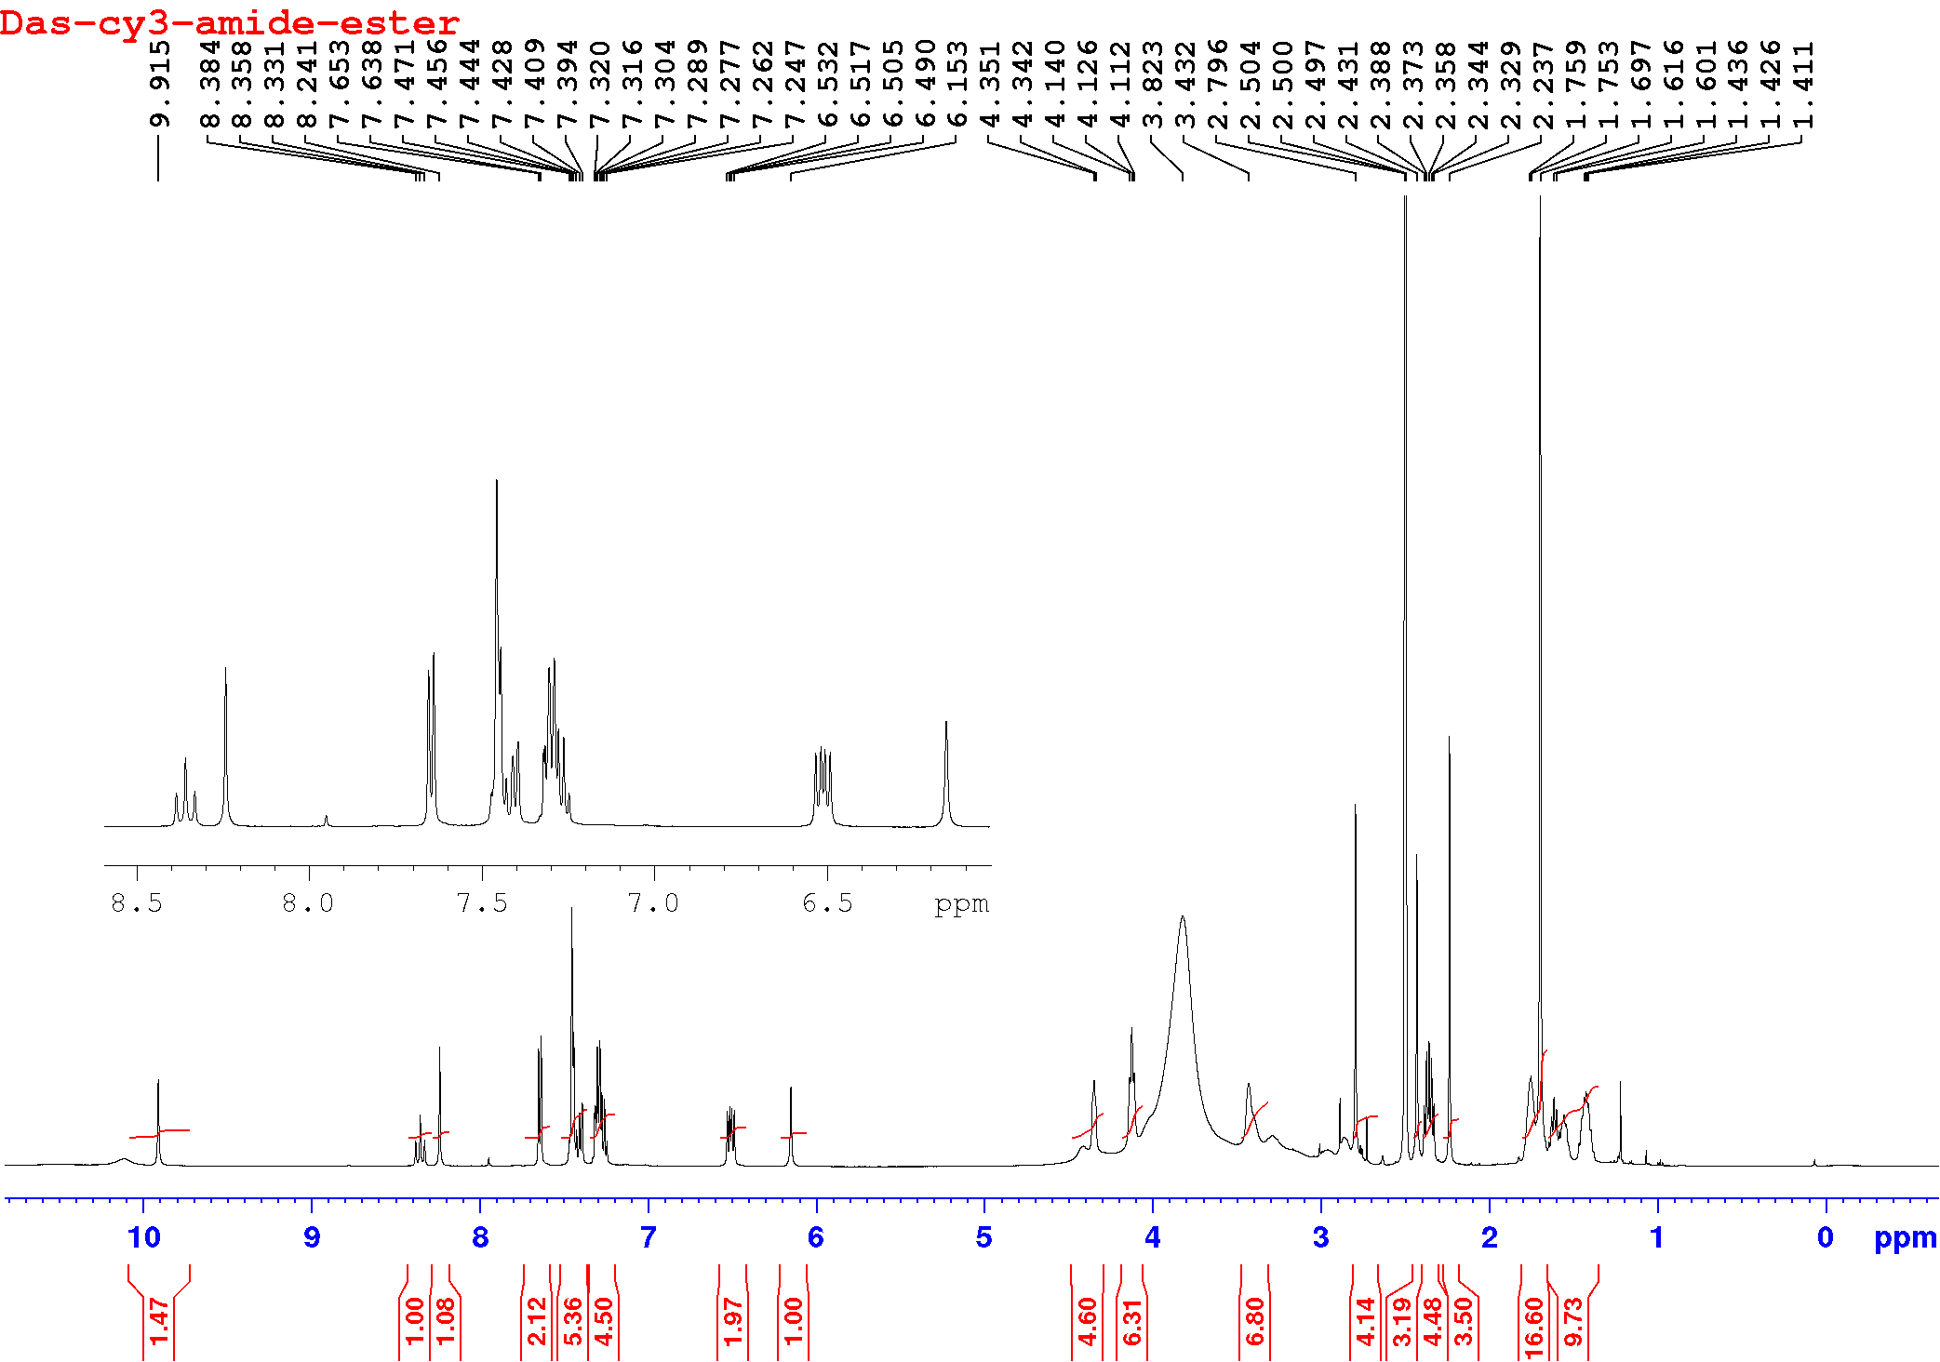

1.2.1.2 ¹³C NMR (DMSO-d6, 125 MHz, 21 °C):
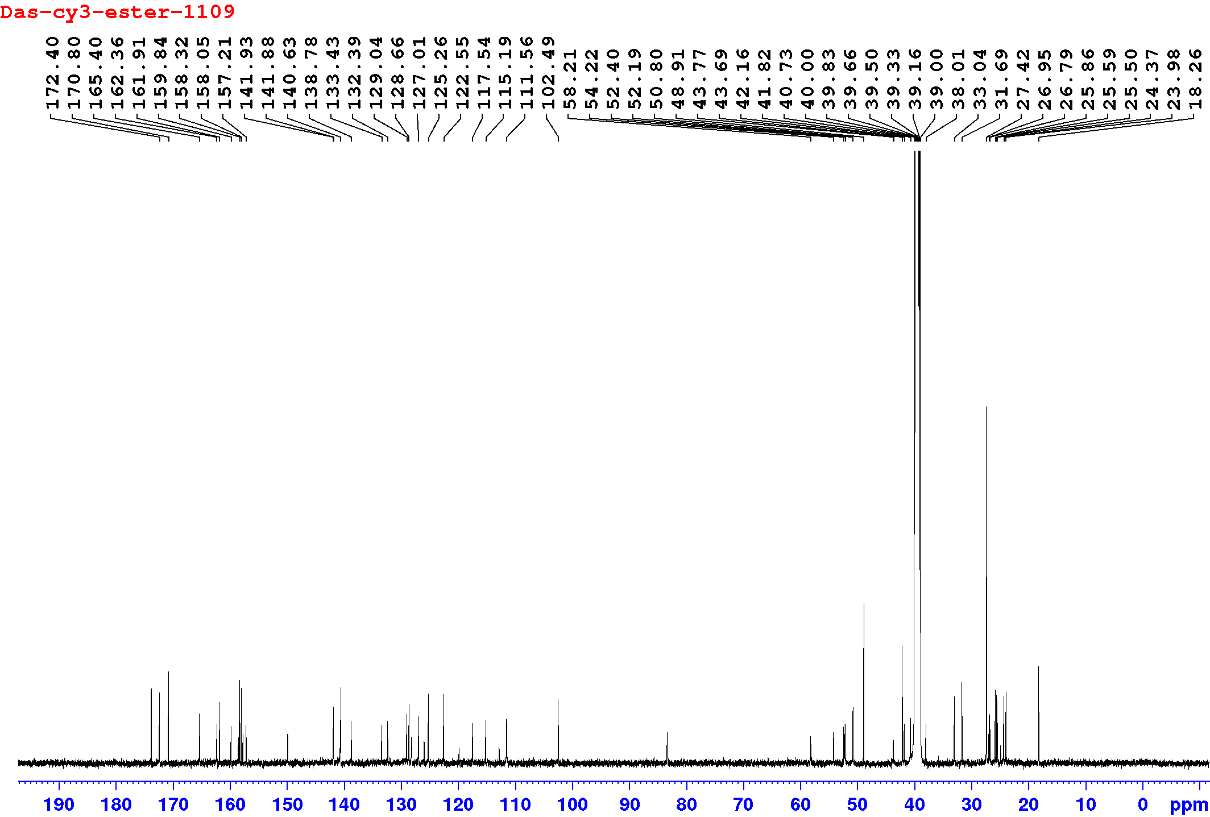

1.2.1.3 UPLC: H₂O:ACN (0.05% TFA), a10-90, 1.5 min gradient, 0.6 mL/min flow, det. 350 nm 550 nm:
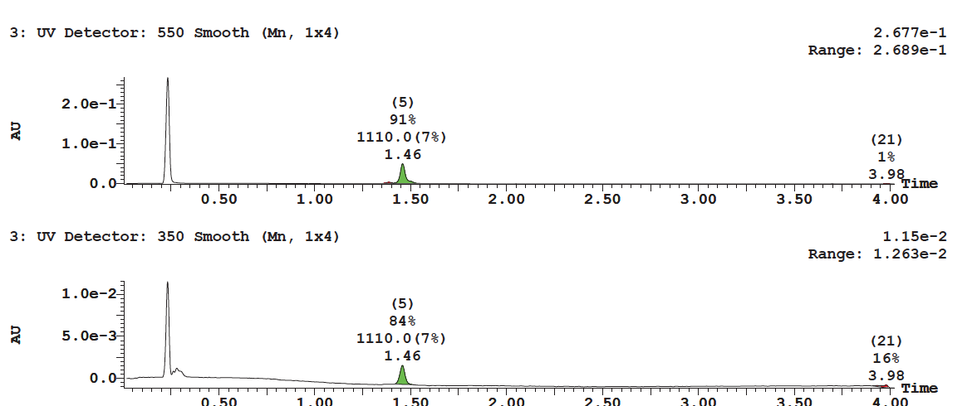

1.2.2 Synthesis of a cationic, 19F-trifluoroborate-bearing fluorescent imaging probe, (1)
To a solution of piperazine trimethyine cyanine dasatinib conjugate (i) (10 mg, 9.0 μmols) in 1.0 mL DMF, in a 5 mL round bottom flask, bromomethylboronicacid pinacol ester (2.3 mg, 10.0 μmols, Combiblocks PN-8806) and N,N-Diisopropyl ethyl amine (DIPEA) (9.0 μmols) were added. Reagents were stirred for 4h. To the reaction pot 1.0 M HF (50 μL) added and continued the stirring till starting material consumed. The obtained mixture further dissolved in DMF, filtered and purified by reverse phase preparative HPLC with a 10-90% H₂O:ACN (0.05% TFA), 50 min gradient, solvent B: MeCN; 0 to 40 min: 10% to 60% B, 40 to 50 min: 60% to 90% B, Flow rate: 12 mL/min. The fractions containing the desired precursor were lyophilized in vacuo to yield chemically pure ammonio trifluoroborate (AMBF₃), 1 (6.0 mg, 5.0 μmol) ¹H NMR (DMSO-d6, 470 MHz, 21 °C): δ 9.90 (s, 1H), 8.35 (t, 1H, J = 7.5Hz), 8.24 (s, 1H), 7.64 (d, 2H, J = 7.5Hz), 7.45-7.26 (m, 10H), 6.50 (dd, 2H, J = 9.5, 13.5Hz) 6.14 (s, 1H), 4.35 (bs, 4H), 4.12 (bs, 4H), 3.73-3.18 (m, 14H), 3.04 (s, 3H), 2.44-2.23(m, 9H), 1.75 (m, 3H), 1.69 (s, 12H), 1.64-1.54 (m, 4H), 1.43 (m, 4H). ¹⁹F NMR (DMSO-d₆, 500 MHz, 21 °C): δ -137.20 (BF₃). HRMS (ESI) calculated for C₆₃H₈₁BF₃N₁₁ClO₄S: 1190.5927 found 1190.5914.

1.2.2.1 ¹H NMR (DMSO-d₆, 500 MHz, 21 °C):
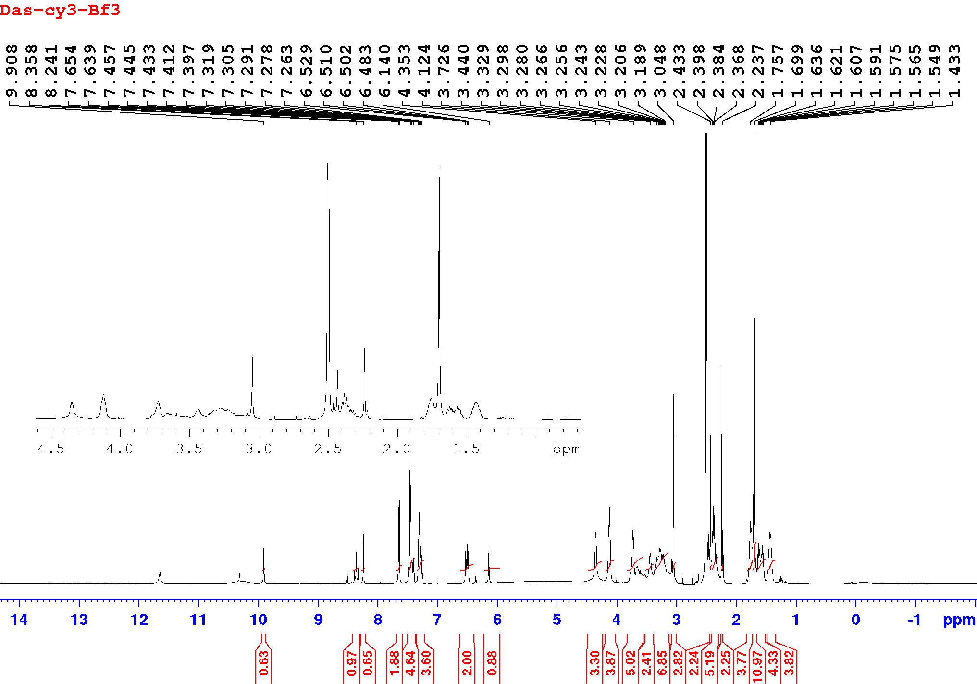

1.2.2.2 ¹³F NMR (DMSO-d₆, 500 MHz, 21 °C, CFCl₃ = 0.0 ppm, TFA reference = -76.4 ppm):
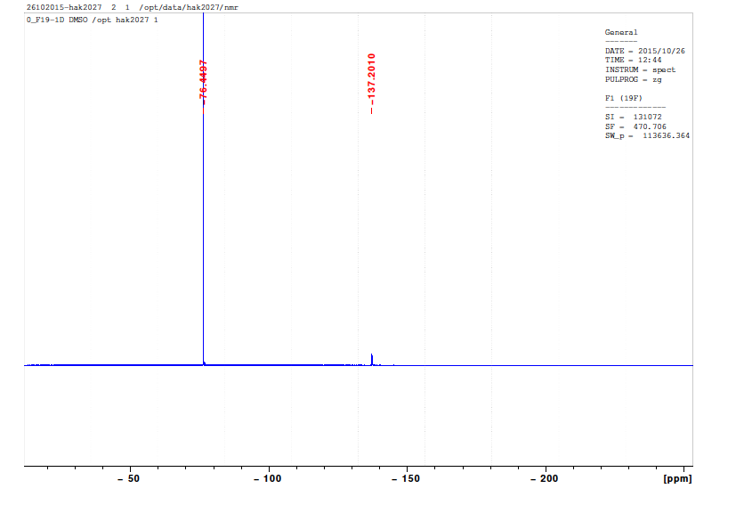

1.2.2.3 UPLC: H₂O:ACN (0.05% TFA), a10-90, 1.5 min gradient, 0.6 mL/min flow, det. 215, 280, and 550 nm:
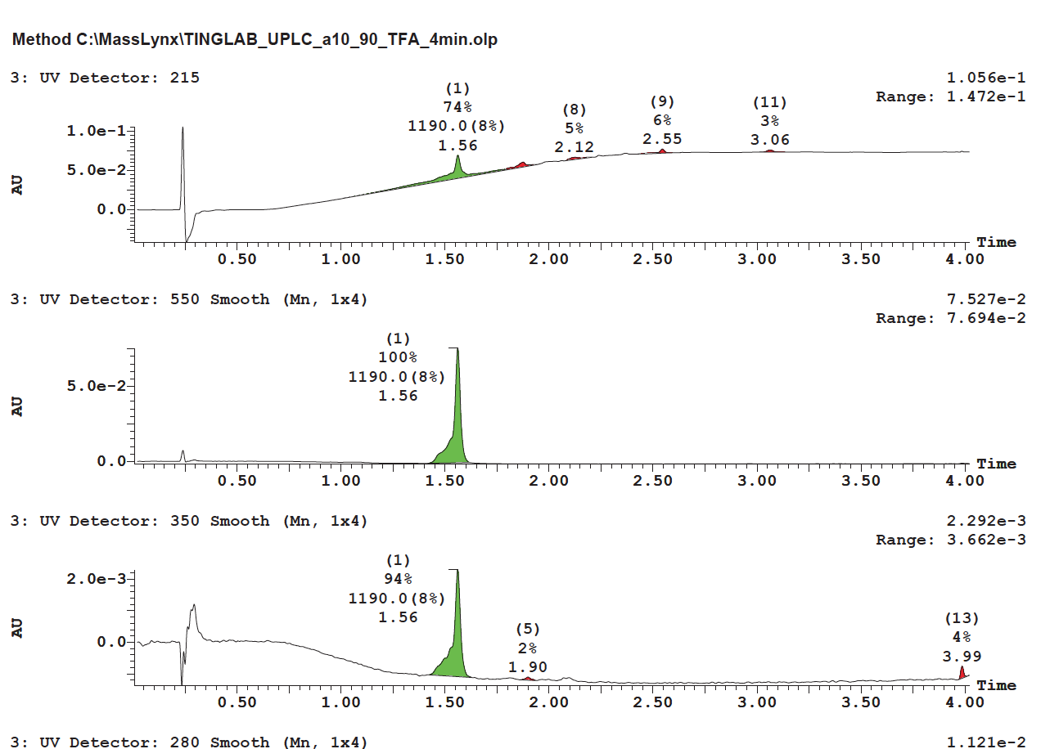

1.3 Proof of structure: Chemical correlation shows that (1) is alkylated on the piperazine moiety borne by dasatinib
Supplementary Scheme 3 Ester hydrolysis proves that ¹⁹F-trifluoroborate-bearing fluorescent imaging probe, das-1190 (1), is quantitatively alkylated at the dasatinib piperazine. The hydrolysis product (v) undergoes slow cyclization to a stable product.

Methyl trifluoroborate alkylation is on the dasatinib piperazine moiety of (1) (and not on the cyanine methyl piperazine). This was confirmed through the hydrolysis of (1) with 1.0M NaOH at room temperature for 6.0 hours. LC-MS analyses show quantitative hydrolysis of the parent compound (1) 1.56 min (550 nm) into two major new peaks corresponding the hydrolyzed products at 1.01 min (350 nm) and 1.29 min (550nm). The individual peaks correspond to cy3-piperzine amide (iv) (640 MW, 1.01 min) and Dasatinib-trifluoroborate (v) (551 MW, 1.29 min) respectively. The resulting dasatinib-(ethyl alcohol) trifluoroborate (v) is transiently stable in FBS or PBS pH 6.5. After 7 days of incubation in FBS/ PBS intramolecular cyclization of (v) gives the stable dasatinib boronic acid (vi).

1.3.1.1 Hydrolysis of (1) - UPLC/MS: H₂O:ACN (0.05% TFA), a10-90, 1.5 min, 0.6 mL/min flow, det. 350, 550 nm:
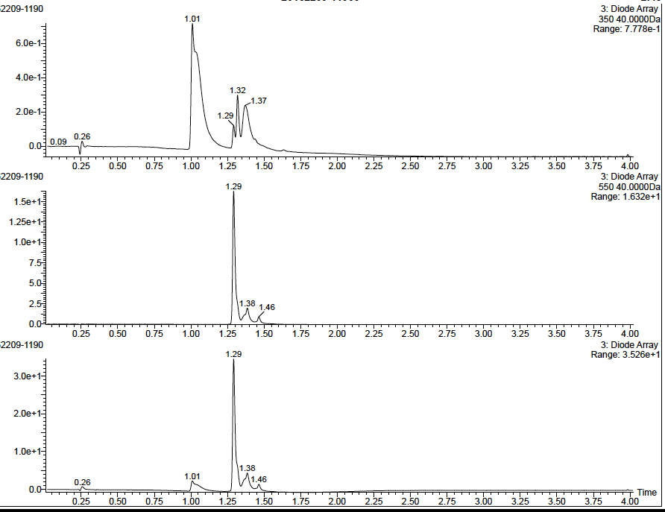
550 nm Absorbance Profile
350 nm Absorbance Profile

1.3.1.2 Hydrolysis of (1) - UPLC/MS: (MS) det. 1.001, 1.295 min:
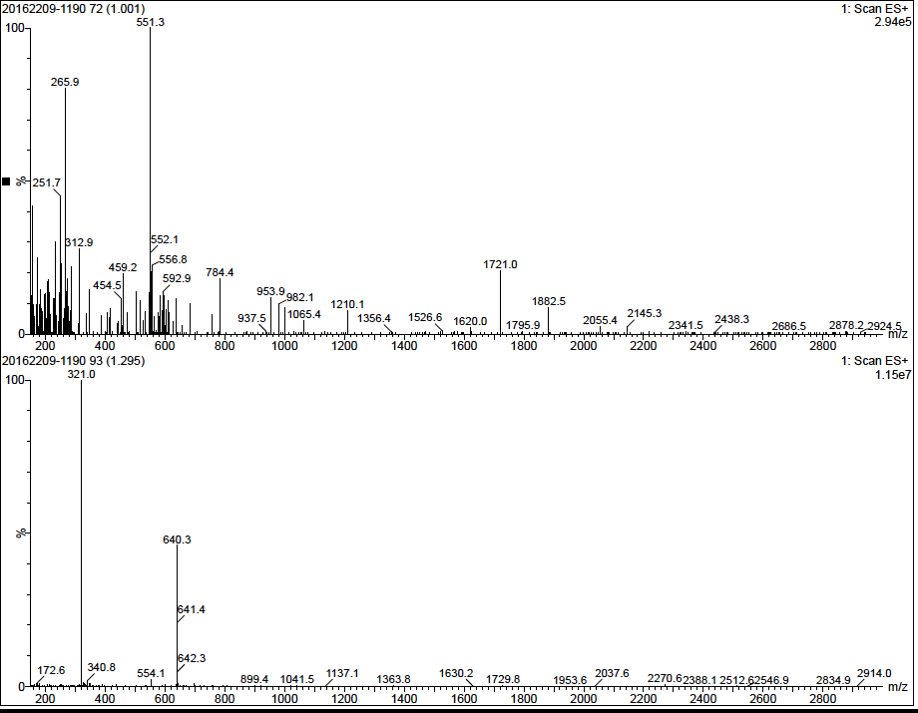
Mass spec at 1.295 min (iv)
Mass spec at 1.001 min (v)

1.3.3 Identification of boronic acid (vi) following hydrolysis of (1) and week-long storage of (v) in PBS or FBS at pH 6.5.

UPLC: H₂O:ACN (0.05% TFA), a10-90, 1.5 min gradient, 0.6 mL/min flow, det. 280 and 350 nm:
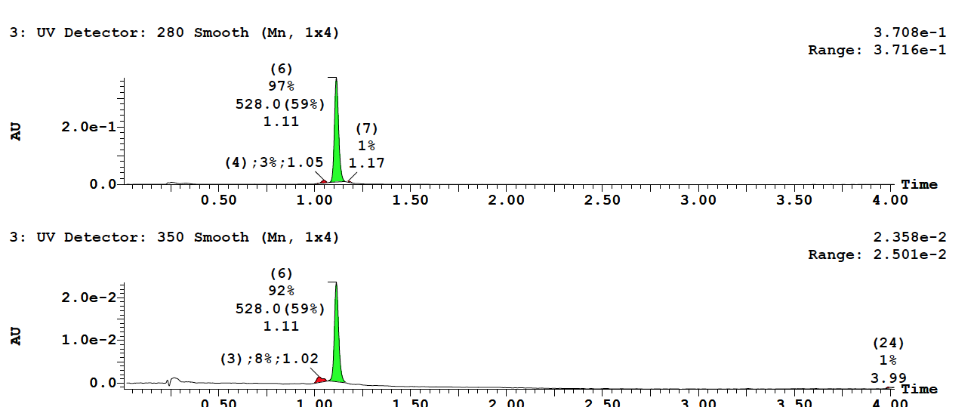

1.4 Confirmation of trifluoroborate/ester stability of (1) in physiological conditions
The following evaluation described by Perrin (Liu et al., 2015; Ting et al., 2008) is used to verify that that 1 is stable at pH 7, in PBS and FBS solution (serum).

1.3.1 ¹⁹F NMR (1:1 DMSO-d6:FBS, 500 MHz, 21 °C, 7 day stability study):

The stability of 1 was evaluated by ¹⁹F-NMR in a 50% DMSO-d₆:FBS solution (1:1) assay at pH = 7.5 (Liu et al., 2015; Ting et al., 2008). Compound 1 is stable even after 7 days of incubation at 21°C (t_{1/2} defluoridation >7 days). This is clear from the lack of change in the ¹⁹F-NMR spectra that would indicate defluoridation.
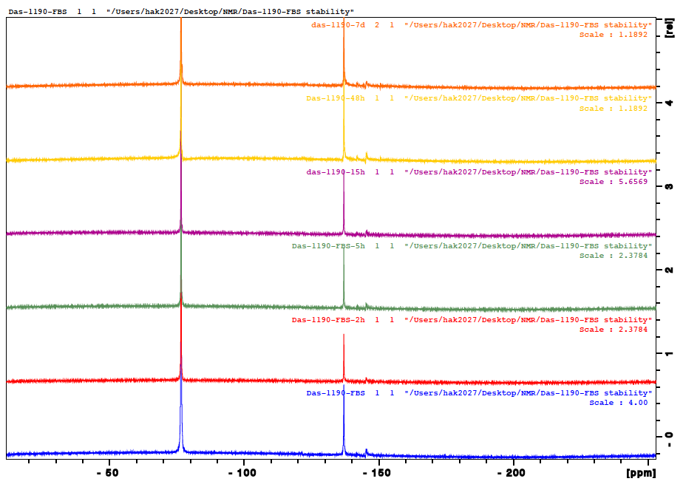

Supplementary Figure 1. Nanosyn LCK binding assay (third party verification) of nanomolar affinity of compound 1.

Supplementary Figure 2. Immunohistochemical (IHC) analysis of orthotopic mBSG bearing brain treated with 1 via CED
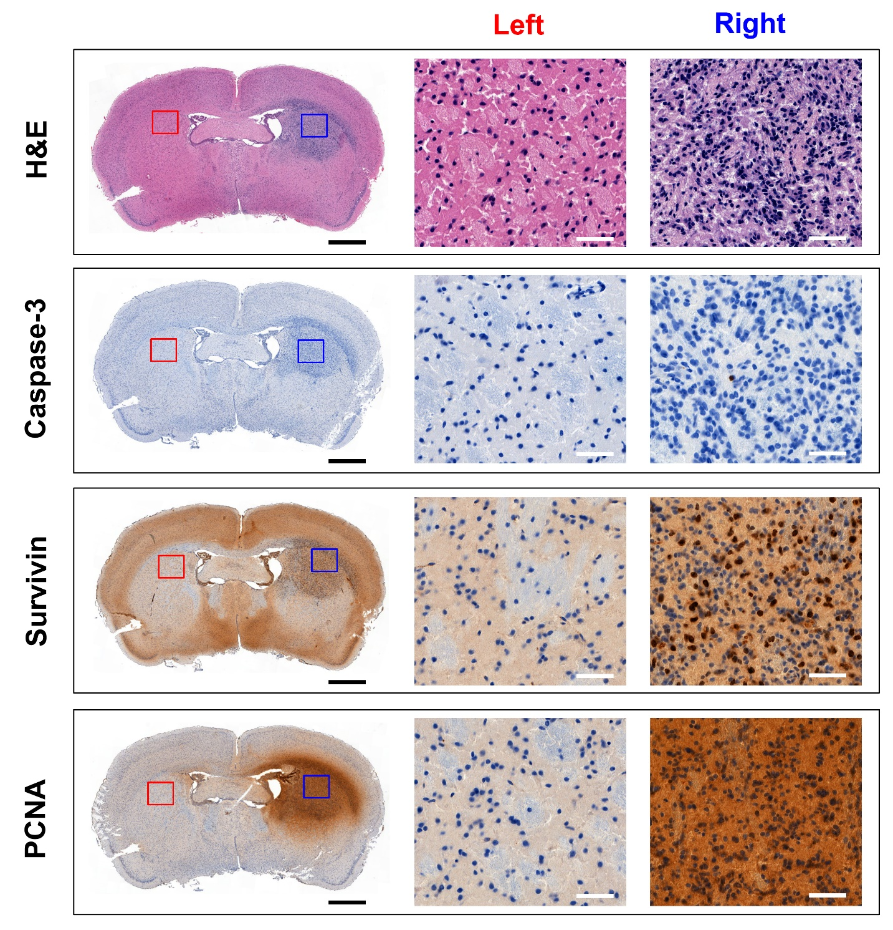
Immunohistochemical (IHC) analysis of an orthotopic glioma (right hemisphere, mBSG) bearing mouse where the glioma received a saturating dose of 1 confirmed by image guided CED. Hematoxylin and eosin (H&E, top panel), cleaved caspase-3 (2nd panel), survivin (inhibitor of apoptosis, 3rd panel), and proliferating cell nuclear antigen (PCNA) (4th panel) antibody staining are shown. A 6 µL volume, 50 µM dose of compound 1 was administrated via CED delivery and the mouse could recover for 12 h. 12 h following post-injection brains were harvested. Brain tissue was fixed with 4% PFA and embedded in paraffin. 7-µm coronal sections were obtained for antibody staining (#8109, Cell Signaling Technology, USA). Glioma in the right hemisphere (blue box and right inset) is characterized by cells containing hyperchromatic nuclei, pale and reduced cytoplasm in H&E. These data are different from control (contralateral tissue, red box and left inset) suggesting successful establishment of orthotopic glioma. Caspase 3 glioma immunohistochemistry show weak caspase 3 staining suggesting inefficient apoptosis in the tumor area. Survivin and PCNA immunohistochemistry show intense nuclear staining in the tumor area that is not present in the contralateral cerebral hemisphere control (red box and left inset). These data suggest that compound 1, delivered by CED has a slight effect in inducing tumor cell apoptosis. Black scale bar = 1 mm, white scale bar = 50 µm.

Supplementary Figure 3. Immunohistochemical (IHC) analysis of orthotopic mBSG bearing brain treated intravenously (tail vein) with 1
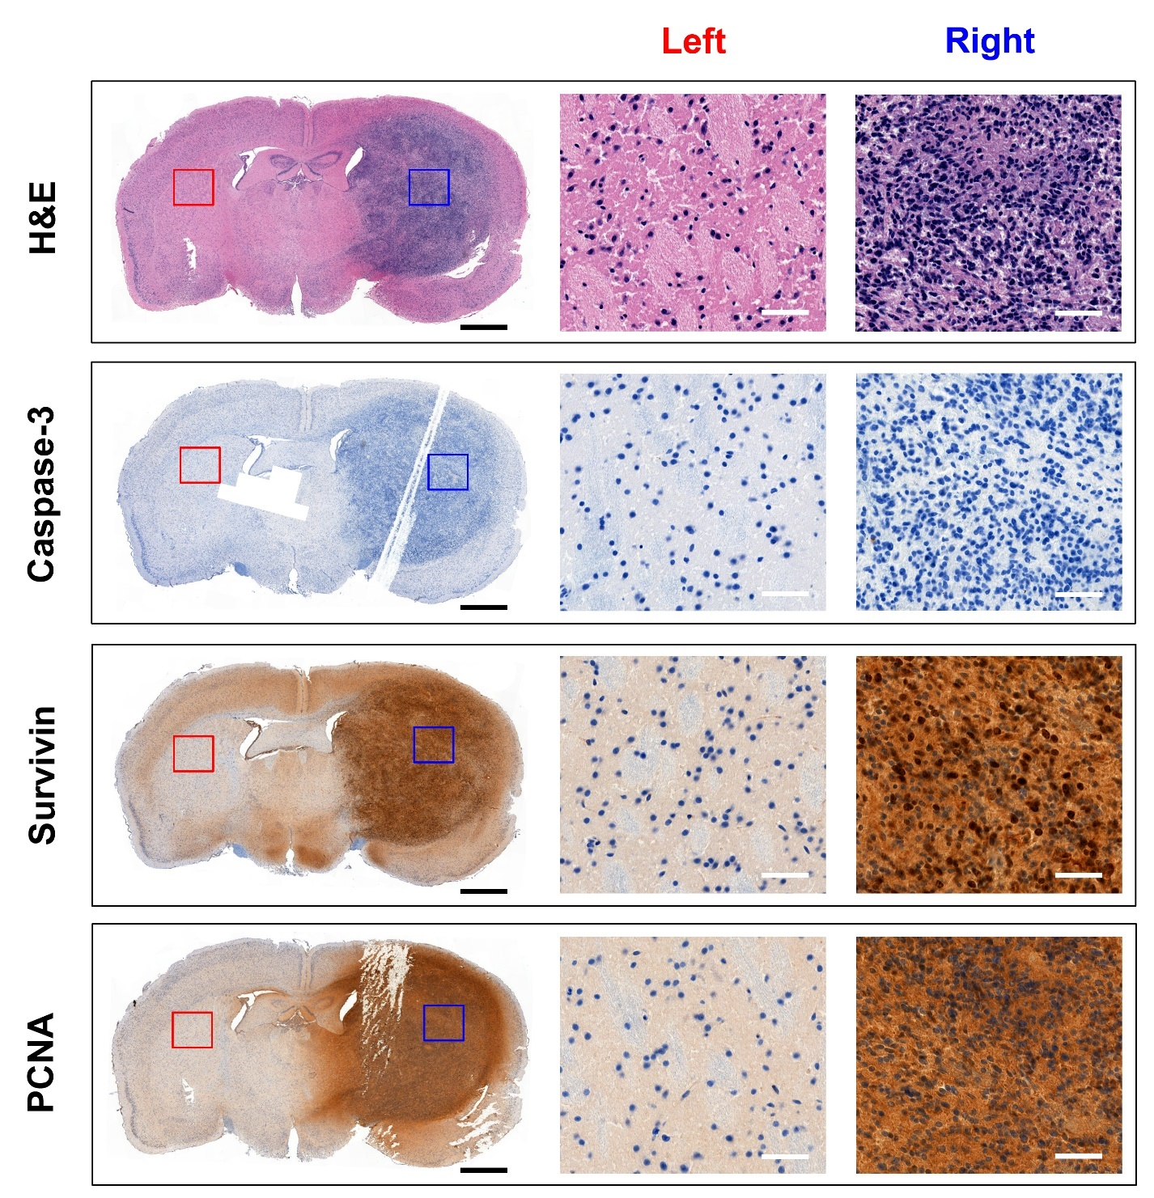
(Tail Vein Control) Immunohistochemical (IHC) analysis of an orthotopic glioma (right hemisphere, mBSG) bearing mouse where glioma was treated with 1 intravenously. Hematoxylin and eosin (H&E, top panel), cleaved caspase-3 apoptosis marker (2nd panel), survivin (inhibitor of apoptosis, 3rd panel), and proliferating cell nuclear antigen (PCNA) (4th panel) antibody staining are shown. A 6 µL volume, 50 µM compound 1 was administrated via tail vein injection. 12 h following post-injection brains were harvested. Brain tissue was fixed with 4% PFA and embedded in paraffin. 7-µm coronal sections were obtained for antibody staining (#8109, Cell Signaling Technology, USA). Glioma in the right hemisphere (blue box and right inset) is characterized by cells containing hyperchromatic nuclei, pale and reduced cytoplasm in H&E. These data are different from control (contralateral tissue, red box and left inset) suggesting successful establishment of orthotopic glioma. Caspase 3 glioma immunohistochemistry delineate apoptosis. Survivin and PCNA immunohistochemistry delineate proliferation. Black scale bar = 1 mm, white scale bar = 50 µm.

Supplementary Figure 4. H&E and Ki67 histology (30 days) demonstrating the safety of CED delivered of Compound 1.
H&E and Ki67 histology performed on brains of naïve mice that were treated with 1 via CED (1 hour delivery, 6 µL, 50 µM). Mice were allowed to recover for 30 days post-surgery. Long term neurotoxicity is not detected in the brains of mice undergoing CED treatment with 1. No pathology was detected following histopathological examination, 30 days following CED. Only normal brain anatomy is observed. Edema, infiltration, or anatomical deformity were not detected. Observed behavior was normal prior to sacrifice. Weight fluctuated between 245-30 g. 6 animals were used in total (n=3 CED with 1, n=3 sham surgery).

Supplementary Figure 5. Structure of other candidate drugs for image guided drug delivery

Inventory of drug candidates were screened against MBSG-glioma to identify possible candidates for image guided drug delivery. Drugs were chosen based on criteria that they bare amine and/or oxygen functionality that is easily modified for imaging. Dasatinib and Doxorubicin were the most active compounds in vitro.

Supplementary Figure 6. MTS testing of other candidate drugs for image guided drug delivery
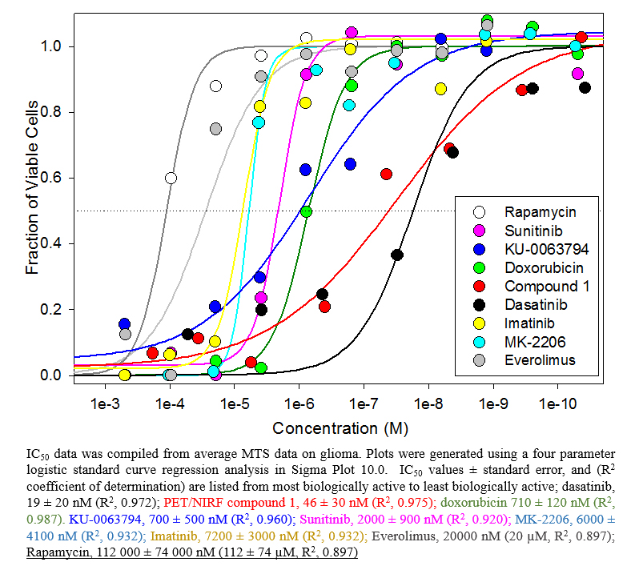

Supplementary Figure 7. Dasatinib and Compound 1 have a similar effect on mBSG cell cycle in vitro
Compound 1 and dasatinib have a similar effect on mBSG cell cycle. Untreated, and dasatinib or 1 treated (48 hours, 40 or 400 nM) mBSG cells were stained with propidium iodide (PI, 81845, Sigma Aldrich, USA), treated with RNase A (50 µg/mL, EN0531, Thermo Scientific, USA) and analyzed by flow cytometry to observe DNA content. A, Representative histograms show cell cycle distribution in G1, S, and G2/M phases. Left, control, untreated mBSG cells allowed to proliferate for 48 hours show a G1, S, G2/M phase distribution that is unique in comparison to dasatinib (Middle) and 1 (Right) 400 nM treatment groups. Dasatinib and 1 treated mBSG show a similar distribution in G1, S, and G2/M phases after 48 hours, suggesting a similar mechanism of drug action between Dasatinib and 1. These data, along with 40 nM treatment data are summarized in B. Both Dasatinib and Compound 1 increased the percentage of mBSG arrested in G0/G1 and reduces S and G2/M phase distribution, suggesting that cell proliferation is significantly inhibited by Dasatinib and 1. * represents a statistically significant difference between control group and dasatinib or 1 treated group. (*: p < 0.05, **: p < 0.01)

Supplementary Figure 8. Dasatinib and Compound 1 have similar cytotoxic and cytostatic effect on mBSG in vitro
Dasatinib and Compound 1 have similar cytotoxic and cytostatic effects on mBSG. Untreated, and dasatinib or 1 treated (48 hours, 400 nM) mBSG cells were doubly stained with Calcein AM (1 µg/mL, green, delineates live cells (trapped in live cells by esterases), 5 min staining, 354216, BD Biosciences, USA) and PI (5 µg/mL, red, delineates dead cells (impermeable to live cells), 5 min staining, 81845, Sigma Aldrich, USA). Representative fluorescent images were obtained using an EVOS fluorescent microscope. Two imaging windows are shown. Cells undergoing apoptosis are observed in the PI fluorescent channel. PI fluorescence is only observed in dasatinib and 1 treated cells. Dasatinib or Compound 1 treated mBSG also show morphological changes from long and thin to short and spherical. Treated cells undergo G1/G0 arrest, which is clear with Calcein AM staining. Compound 1 and dasatinib have similar cytostatic and cytotoxic mechanism of action on mBSG in vitro.

Supplementary Figure 9. Dasatinib and Compound 1 both inhibit in vitro mBSG proliferation
Effect of dasatinib and 1 on mBSG cell proliferation in vitro. mBSG cells were stained with a proliferation tracking dye (CellTraceTM Far Red Cell Proliferation kit (C34572, Invitrogen, USA)) prior to treatment with different concentrations of dasatinib or 1 for 48 hours and 72 hours at 37°C. A, Cells were analyzed by flow cytometry (FACS) and representative FACS histograms showing cell fluorescent intensity in each group. Left, control, representative control FACS traces showing profiles of cells that are not labeled with proliferation dye (red), cells labeled with proliferation dye that have not undergone division (0 hour) (green), and cells labeled with proliferation dye that have undergone uninhibited division (no drug control) for 48 hours (blue). The fluorescent intensity of labeled cells decreased with cell division. Middle and Right, the fluorescent intensity of cells labeled with proliferation dye after treatment with 0, 40, and 400 nM dasatinib or 1 for 48 hours. These data, along with 72-hour data, are summarized in B, where lower mean fluorescent intensities indicate uninhibited cell proliferation, while greater mean fluorescent intensities indicate dasatinib mediated inhibition of cell proliferation. Both Dasatinib and 1 inhibit cell proliferation. As expected, dasatinib is slightly superior to 1 in inhibiting mBSG cell proliferation. This is consistent with IC₅₀ determined in MTS assays. Dasatinib and 1 both have a concentration dependent effect on mBSG cell division.

Supplementary Figure 10. Western blots (AKT/pAKT/GAPDH) confirming activity of 1.

References
Liu, Z., Chao, D., Li, Y., Ting, R., Oh, J., Perrin, D.M., 2015. From Minutes to Years: Predicting Organotrifluoroborate Solvolysis Rates. Chemistry – A European Journal 21, 3924-3928.

Mujumdar, R.B., Ernst, L.A., Mujumdar, S.R., Lewis, C.J., Waggoner, A.S., 1993. Cyanine dye labeling reagents: sulfoindocyanine succinimidyl esters. Bioconjugate Chemistry 4, 105-111.

Ting, R., Harwig, C.W., Lo, J., Li, Y., Adam, M.J., Ruth, T.J., Perrin, D.M., 2008. Substituent effects on aryltrifluoroborate solvolysis in water: implications for Suzuki-Miyaura coupling and the design of stable (18)F-labeled aryltrifluoroborates for use in PET imaging. Journal of Organic Chemistry 73, 4662-4670.

