SUPPLEMENTARY METHODS

Genetic Analysis of NF2 Mutations in Human VS Samples
The NF2 MLPA Kit (MRC-Holland,Amsterdam, NL) provides a probe mixture for 17 NF2 exons, 11 control fragments from various chromosomes, one control probe specific for a chromosome 1 sequence to verify successful ligation reaction, and four ligation-independent probes for identification of samples with insufficient DNA. The amplicons were subjected to fragment analysis using capillary electrophoresis. Peak height of the electrophoretic trace was compared to control samples. Deletion regions are reflected as peaks with approximately ½x height or complete absence. Duplication regions are reflected as peaks with approximately 1½ to 2x height.
Creation of Human MD-SC Lines
Human SC (HSC) were purchased in 2013 (Lot # 7228) from ScienCell Research Laboratories (Carlsbad, CA) and HSC-PW were obtained in 2014 from Dr. Wallace (University of Florida). Cell lines were routinely tested for Mycoplasma contamination (LookOut® Mycoplasma PCR Detection Kit, Sigma). Lentiviral shRNA purchased from Sigma Mission (TRCN0000237845, 2014, St. Louis, MO) was used to knock down merlin in each of these cell lines as previously published (Petrilli et al 2017). All HSC were authenticated as previously published (Petrilli et al 2017).

SUPPLEMENTARY FIGURES

Supplementary Figure S1
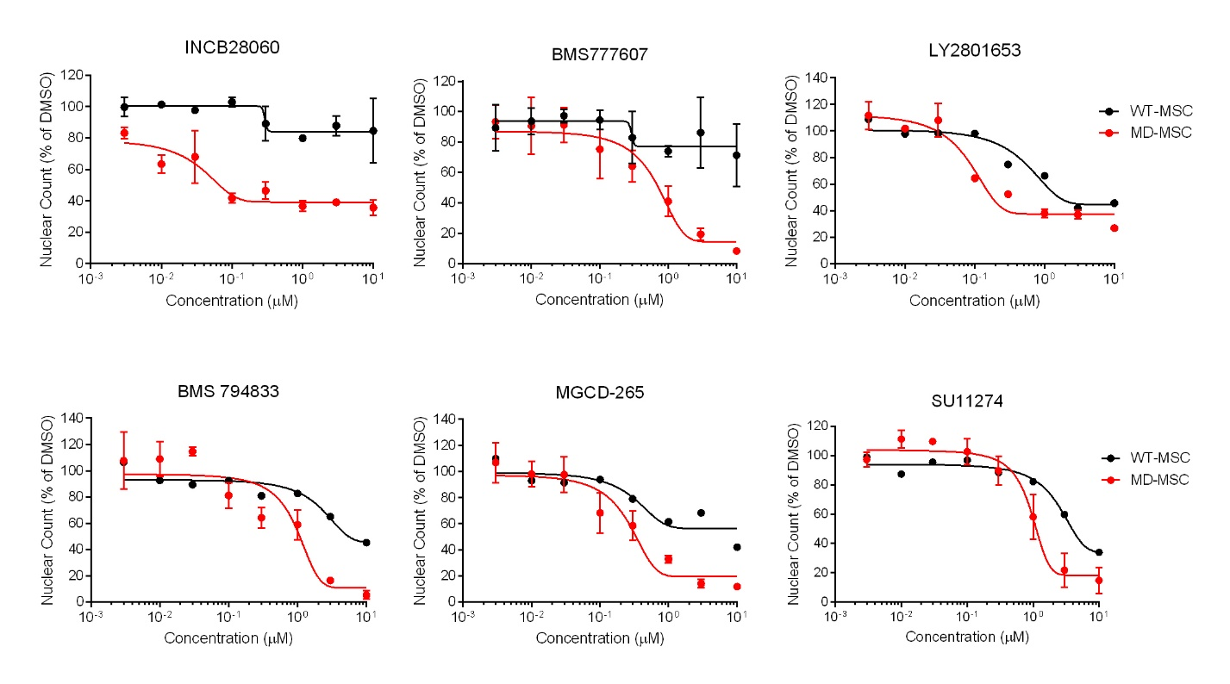

Supplementary Figure S1. C-Met inhibitors selectively reduce MD-MSC numbers. MD-MSCs were grown in 384-well plates and treated with increasing concentrations of the indicated c-Met inhibitors for 48 hours. Cell numbers were measured by Hoescht staining and reported as a percentage of the DMSO control.

Supplementary Figure S2
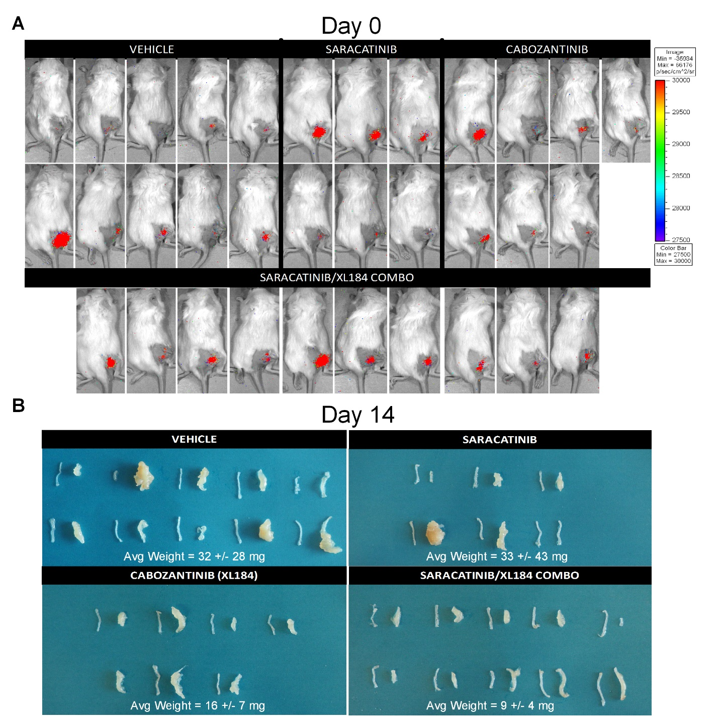

Supplementary Figure S2. MD-MSCs allografts prior to and after 2 weeks of treatment in NSG mice. A) BL images show graft establishment on Day 0 of treatment for each mouse studied. B) Images of allografts removed from mice after 14 days of treatment show smaller grafts in those treated with the drug combination compared to vehicle-treated mice.

Supplementary Figure S3
Supplementary Figure S3. MD-MSC express higher basal levels of Fas receptor than WT-MSC. A representative Western blot shows higher basal expression of Fas in MD-MSC compared to WT-MSC, with β-actin as a control for equal protein loading (n=2 separate extracts per cell type).

Supplementary Figure S4
Supplementary Figure S4. Src and c-Met inhibition reduces viability of human SCs. A) Combined inhibition of Src and c-Met with dasatinib or saracatinib and cabozantinib reduces viability of two independent human SC (HSC) lines (n = 1, 4 replicates each). There is little selectivity between WT and MD lines, but this has been observed for other drugs that showed selectivity in mouse but not human cells. B) Dasatinib, saracatinib and cabozantinib target the same pathways in HSC as we have shown in the MD-MSC. Dasatinib and saracatinib reduce phosphorylated levels of FAK(Y576) and paxillin(Y118), and cabozantinib reduces phosphorylation levels of c-Met(Y1234/1235) and ERK1/2. C) Dasatinib and cabozantinib also reduced the growth of human benign meningioma cells, as measured by a crystal violet assay (n=3 cultures with 3 replicates each).

