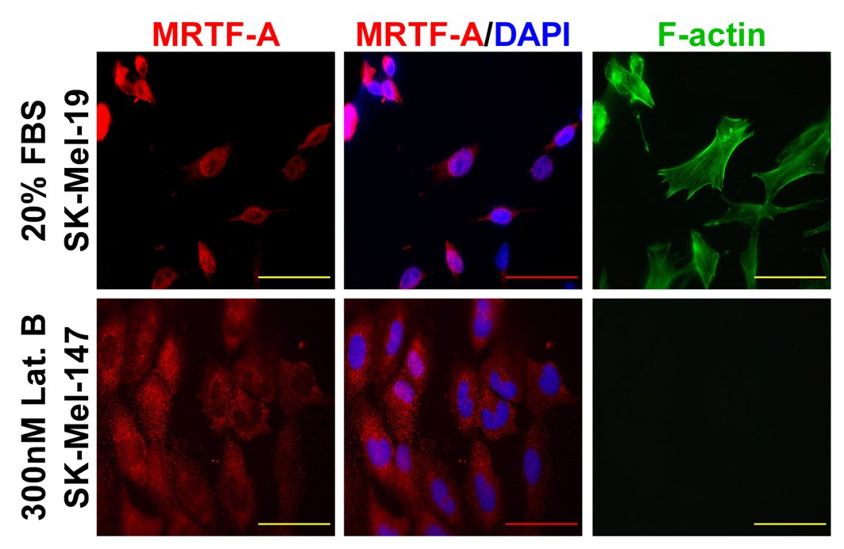

Figure S2. Regulation of MRTF-localization in serum-starved melanomas is determined by actin dynamics. Cellular localization of MRTF-A is observed with immunocytochemistry. Top, SK-Mel-19 cells, which exhibit almost exclusively cytosolic MRTF-A in the absence of serum were starved for 23.5 hours in 0.5% FBS DMEM and then stimulated with 20% FBS for 30 minutes before fixation and staining for MRTF-A and F-actin. Bottom, SK-Mel-147 cells, which exhibit nuclear MRTF-A under starved conditions were starved for 23.5 hours in 0.5% FBS DMEM and then treated with 300nM latrunculin B for 30 minutes before fixation and staining for MRTF-A and F-actin. Latrunculin B is a natural toxin that blocks F-actin formation. Scale bar shown represents 200µm. Shown are representative examples from triplicate experiments.

