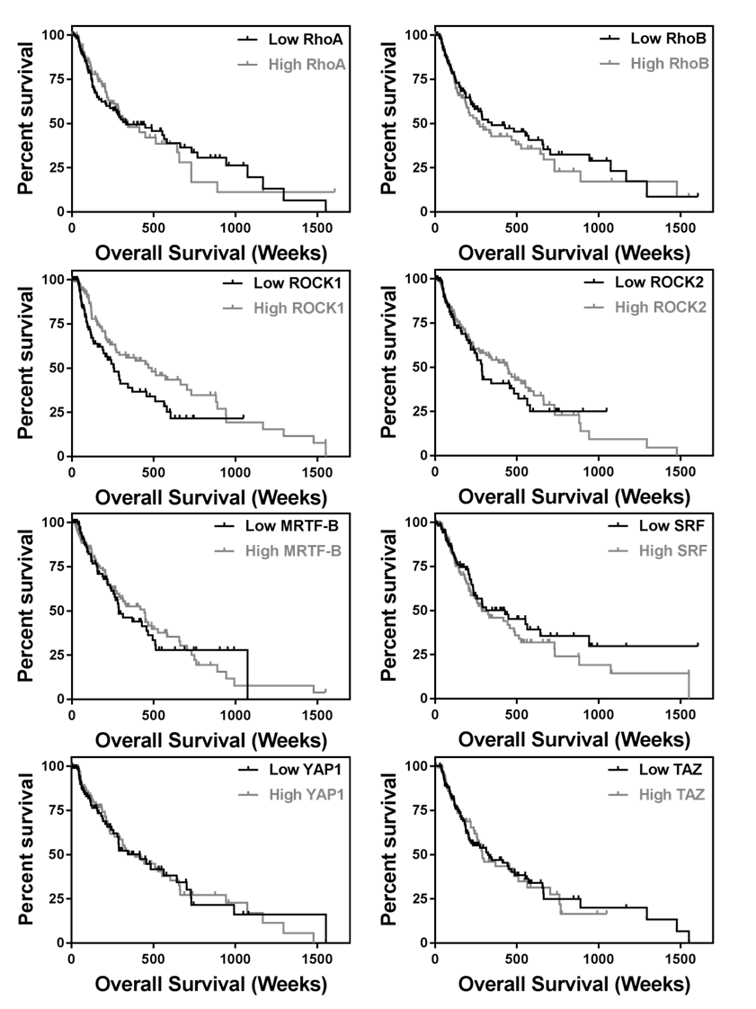
Figure S1. The Cancer Genome Atlas (TCGA) cutaneous melanoma dataset was stratified into quartiles based upon expression of indicated genes. Kaplan-Meier plots were generated from the highest (grey) and lowest (black) expressing quartiles. Survival curves were analyzed with the log-rank test with a cutoff of P < 0.05 as statistically significant.

