Supplementary Figures
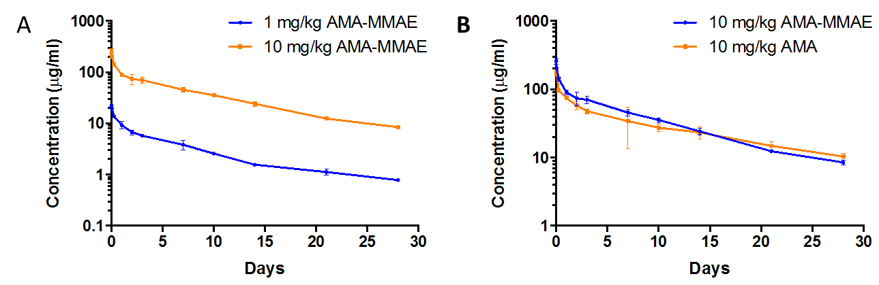
Supplementary Figure 1: Serum levels of AMA-MMAE.
Serum levels of AMA-MMAE in mice after a single injection of 1mg/kg (blue) or 10mg/kg (orange) AMA-MMAE show that this ADC has dose-linear pharmacokinetic properties in the 1- 10mg/kg range (A). Comparison between the pharmacokinetics of ADC and naked antibody show that the decreased clearance of AMA-MMAE is within two-fold of the value for the naked antibody AMA (B).
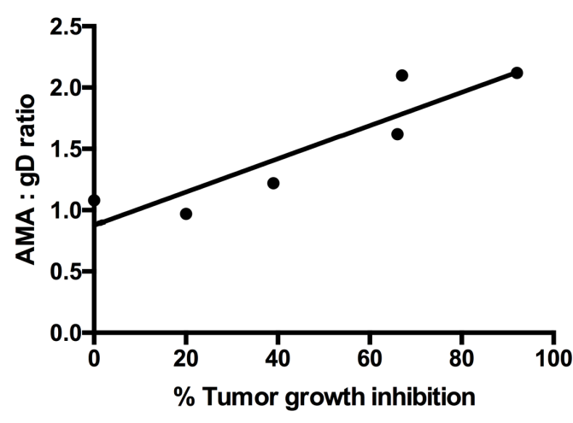
Supplementary Figure 2: Correlation plot of tumor growth inhibition versus specific tumor uptake.
A correlation plot of tumor growth inhibition versus specific tumor uptake (AMA : gD ratio) revealed a correlation (r²= 0.823).
Supplementary Table 1: Tumor growth inhibition study of mice bearing OVCAR3-X2.1.
Table 1: Tumor growth inhibition study of mice bearing OVCAR3-X2.1 cells comparing the efficacy of 5mg/kg and 20mg/kg doses (n=6 mice per group).
 | 5mg/kg AMA-MMAE |  | 20mg/kg AMA-MMAE
Day | Tumor size (mm³) | SD | Tumor size (mm³) | SD
0 | 351 | 82 | 330 | 76
5 | 408 | 112 | 315 | 64
10 | 272 | 69 | 183 | 62
14 | 205 | 66 | 109 | 50
18 | 158 | 35 | 70 | 28

Supplementary Table 2: Overview results.
Table 2: Overview results of tumor growth inhibition studies (5mg/kg), tumor tracer uptake of ⁸⁹Zr-AMA and ⁸⁹Zr-anti-gD 6 days after tracer injection. Tumor-to-blood ratios of ⁸⁹Zr-AMA and ⁸⁹Zr-anti-gD, AMA:gD ratio and mesothelin expression as determined by FACS analysis and immunohistochemistry are also presented. *indicates a significant difference (p < 0.05) between ⁸⁹Zr-AMA and ⁸⁹Zr-anti-gD.
Tumor | % Tumor growth inhibition | ⁸⁹Zr-AMA  (%ID/g) | ⁸⁹Zr-anti-gD  (%ID/g) | Tumor-to-blood ratio  ⁸⁹Zr-AMA | Tumor-to-blood ratio  ⁸⁹Zr-anti-gD | AMA:gD ratio | Mesothelin expression by FACS | Mesothelin expression by IHC
OVCAR-3X2.1 | 92 | 10.4 ± 0.8* | 4.9 ± 0.7 | 2.0 ± 0.4* | 0.7 ± 0.1 | 2.1 | 3+ | 3+
Capan-2 | 67 | 8.8 ± 1.0* | 4.2 ± 0.6 | 1.4 ± 0.3* | 0.6 ± 0.1 | 2.1 | 2+ | 2-3+
HPAC | 66 | 6.0 ± 1.2* | 3.7 ± 0.9 | 1.8 ± 0.3* | 0.6 ± 0.1 | 1.6 | 2+ | 3+
AsPC-1 | 39 | 6.0 ± 0.7 | 4.9 ± 0.4 | 0.8 ± 0.1 | 0.5 ± 0.1 | 1.2 | 2+ | 3+
HPAF-II | 20 | 5.9 ± 0.3 | 6.1 ± 0.7 | 1.0 ± 0.1 | 0.8 ± 0.1 | 1.0 | 1-2+ | 2+
MSTO-211H | 0 | 9.0 ± 2.8 | 8.3 ± 1.5 | 1.1 ± 0.3 | 1.3 ± 0.3 | 1.1 | 0.5+ | 1+

